**The Pennsylvania State University**



**SIMBA Hands-On Guide**

**ZAM_TRANSFERRETIRE_Asset Transfer and Retirement Form Off Campus**



© 2020 The Pennsylvania State University  
© Copyright 2020 Labyrinth Solutions, Inc. All rights reserved. Labyrinth Solutions, Inc., the LSI logo, and CampusOneTM are trademarks of Labyrinth Consulting, Inc.   
SAP, R/3, SAP NetWeaver, and other SAP products and services mentioned herein as well as their respective logos are trademarks or registered trademarks of SAP AG in Germany and other countries.   
Business Objects and the Business Objects logo, BusinessObjects, Crystal Reports, Crystal Decisions, Web Intelligence, Xcelsius, and other Business Objects products and services mentioned herein as well as their respective logos are trademarks or registered trademarks of Business Objects S.A. in the United States and in other countries. Business Objects is an SAP company.

# ZAM_TRANSFERRETIRE_Asset Transfer and Retirement Form Off Campus

## 

## Overview

**Transaction Description:**

This form and workflow will enable users in business areas and departments to transfer an asset off campus.

**Penn State Purpose:**

This smart form and workflow is for departments and business areas to populate when the need arises to retire, transfer or trade-in an asset.

Use cases include:

* Transferring an asset from one business area to another, e.g., OPP centrally buys equipment for a campus then transfers it to that campus.
* Sending equipment that needs to be disposed of through Lion Surplus, e.g., ARL has obsolete equipment to send to Lion Surplus.
* Reporting equipment that is lost, stolen, or destroyed.
* Returning equipment to a customer or sponsor that has been loaned or relocated.

## Process Steps

### Asset Transfer & Retirement Form

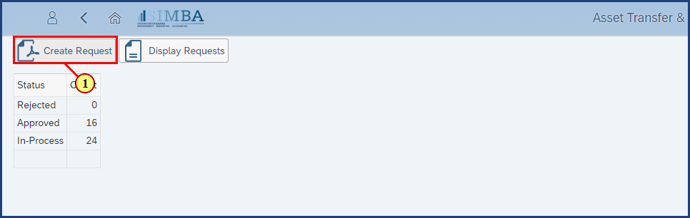

| Step | Action |
| --- | --- |
| 1. | The **Create Request** button is clicked. |

### Asset Transfer & Retirement Form

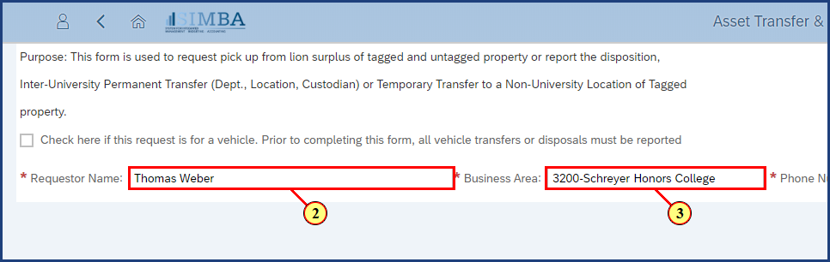

| Step | Action |
| --- | --- |
|  | Enter the Requestor Name, Business Area, and Phone number. |
| 2. | **Thomas Weber** is entered in the **Requestor Name** field. |
| 3. | **3200 - Schreyer Honors College** is entered in the **Business Area**field. |

### Asset Transfer & Retirement Form

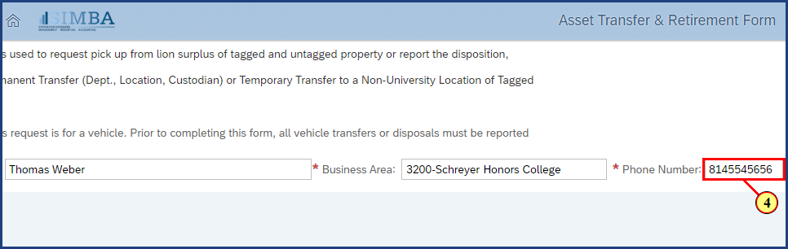

| Step | Action |
| --- | --- |
| 4. | **814-554-5656** is typed into the **Phone Number** field. |

### Asset Transfer & Retirement Form

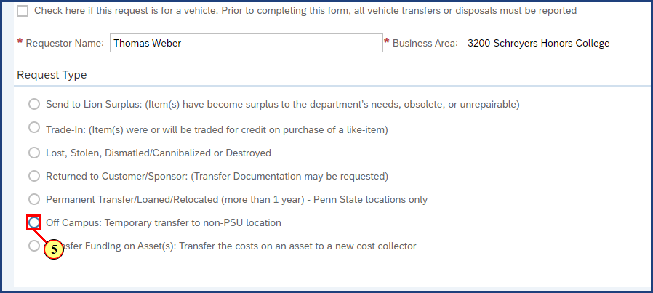

| Step | Action |
| --- | --- |
| 5. | The **Off Campus: Temporary transfer to non-PSU location** radio button is clicked. |

### Asset Transfer & Retirement Form

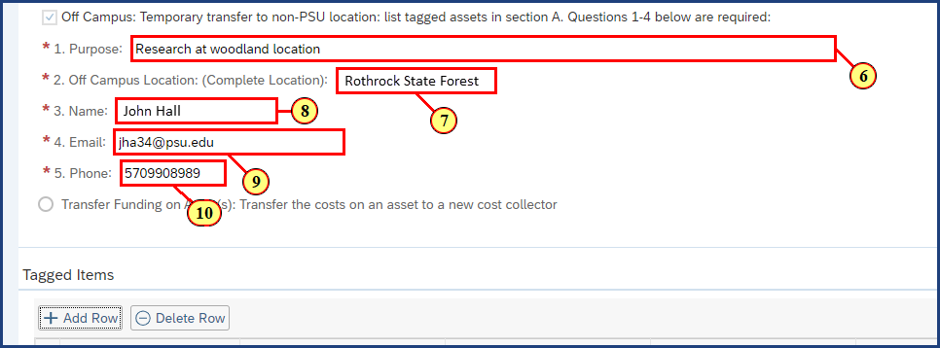

| Step | Action |
| --- | --- |
| 6. | **Research at woodland location** is typed into the **Purpose** field. |
| 7. | **Rothrock State Forest**is typed into the **Off campus location** field. |
| 8. | **John Hall** is typed into the **Name** field. |
| 9. | **jha34@psu.edu**is typed into the **Email** field. |
| 10. | **570-990-8989** is typed into the **Phone** field. |

### Asset Transfer & Retirement Form

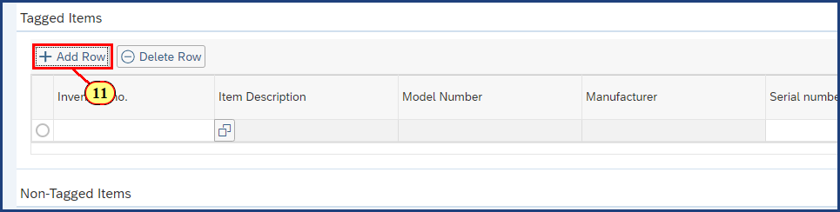

| Step | Action |
| --- | --- |
|  | We need to list the amplifier under Tagged Items and to do so, we must add a row. |
| 11. | The **Add Row** button is clicked. |

### Asset Transfer & Retirement Form

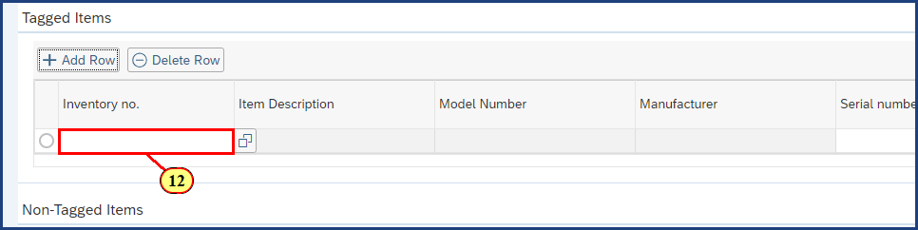

| Step | Action |
| --- | --- |
| 12. | The **Inventory No** field is clicked. |
|  | The **F4** key is pressed. |

### Asset Transfer & Retirement Form

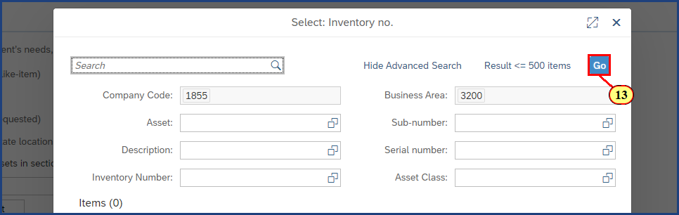

| Step | Action |
| --- | --- |
| 13. | The **Go** button is clicked. |

### Asset Transfer & Retirement Form

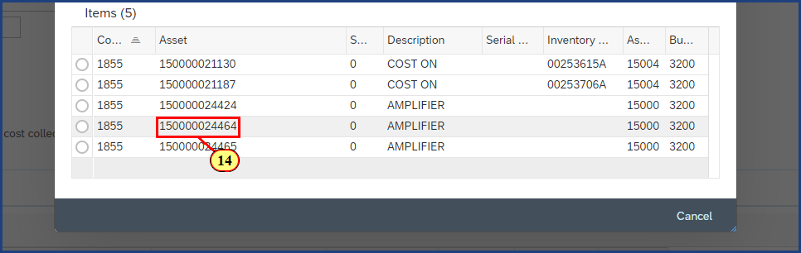

| Step | Action |
| --- | --- |
|  | Select the amplifier asset from the results returned. |
| 14. | The **150000024464 Asset** is clicked. |

### Asset Transfer & Retirement Form

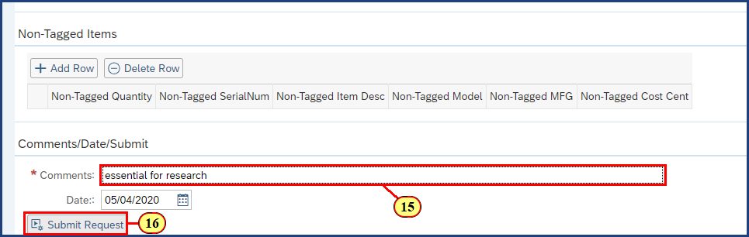

| Step | Action |
| --- | --- |
| 15. | **Essential for research** is typed into the **Comments** field. |
| 16. | The **Submit Request** button is clicked. |

### Asset Transfer & Retirement Form



| Step | Action |
| --- | --- |
|  | The Asset Transfer & Retirement Form confirmation dialog is displayed along with the request reference number, which should be recorded. |

**Disclaimer**

**Alternative Format Statement**   
This publication is available in alternative media upon request. 

**Statement of Non-Discrimination**

The University is committed to equal access to programs, facilities, admission, and employment for all persons. It is the policy of the University to maintain an environment free of harassment and free of discrimination against any person because of age, race, color, ancestry, national origin, religion, creed, service in uniformed services (as defined in state and federal law), veteran status, sex, sexual orientation, marital or family status, pregnancy, pregnancy-related conditions, physical or mental disability, gender, perceived gender, gender identity, genetic information, or political ideas. Discriminatory conduct and harassment, as well as sexual misconduct and relationship violence, violates the dignity of individuals, impedes the realization of the University’s educational mission, and will not be tolerated. Direct all inquiries regarding the nondiscrimination policy to Affirmative Action Office, The Pennsylvania State University, 328 Boucke Building, University Park, PA 16802-5901; Email: [aao@psu.edu](mailto:aao@psu.edu); Tel: 814-863-0471.