**The Pennsylvania State University**



**SIMBA Hands-On Guide**

**Shopping Cart - Standard Lion Marketplace Punch-Out Catalog**



© 2020 The Pennsylvania State University  
© Copyright 2020 Labyrinth Solutions, Inc. All rights reserved. Labyrinth Solutions, Inc., the LSI logo, and CampusOneTM are trademarks of Labyrinth Consulting, Inc.   
SAP, R/3, SAP NetWeaver, and other SAP products and services mentioned herein as well as their respective logos are trademarks or registered trademarks of SAP AG in Germany and other countries.   
Business Objects and the Business Objects logo, BusinessObjects, Crystal Reports, Crystal Decisions, Web Intelligence, Xcelsius, and other Business Objects products and services mentioned herein as well as their respective logos are trademarks or registered trademarks of Business Objects S.A. in the United States and in other countries. Business Objects is an SAP company.

# Shopping Cart - Standard Lion Marketplace Punch-Out Catalog

## Overview

**Transaction Description:**

This transaction is a standard shopping cart with expanded functionality.

**Penn State Purpose:**

This transaction facilitates purchases made from one or more punchout catalogs in Lion Marketplace.

## Process Steps

| Step | Action |
| --- | --- |
|  | **The Four Step Shopping Process**    While shoppers differ in their shopping responsibilities, and the items purchased may vary widely, the shopping process itself remains consistent:     1. Configure Shop OnLion Settings 2. Search for Item Availability 3. **Create Shopping Cart** (**Lion Marketplace**, PSU Contracts, or Free Text) 4. Provide Goods Confirmation upon Receiving Goods     In this simulation, we are on Step 3, and the demonstration and practice provided assume the previous completion of Steps 1 and 2. If you have not already done so, please complete these simulations:     * Personal Settings - Default Delivery Address (to learn how to configure your Shop OnLion settings) * Shopping Cart - Catalog and Contracts Search (to learn how to search for item availability) |

| Step | Action |
| --- | --- |
|  | The purpose of a Standard Lion Marketplace shopping cart is to facilitate purchases made from one or more punchout catalogs. This simulation will demonstrate the purchase of three items known to be available from a previous recent search of Lion Marketplace. Particular attention will be paid to:   * setting useful default values for the shopping cart * quickly locating desired items in the catalogs * adding items to the catalog cart * ensuring the cart contents transfer properly to SIMBA as line items |

| Step | Action |
| --- | --- |
|  | If you have completed the Lion Marketplace segment of the **Shopping Cart - Catalog and Contracts Search** simulation, the context of this demonstration will be familiar. This simulation picks up right where that segment left off. Having canceled out of Lion Marketplace, we are back on the Shop in 3 Steps screen. Recall that we use Step 1 of the Shop in 3 Steps function **ONLY** to confirm the availability of items. If you aren't familiar with catalog searching, we recommend completing the **Shopping Cart - Catalog and Contracts Search** simulation now.    As we found each item in Lion Marketplace, we wrote down which catalog the item was found in and the item number (or other descriptive information). So, we are ready to purchase the items using a Standard Lion Marketplace Punch-Out Catalog Shopping Cart. |

### Shop in 3 steps: Step 1 (Select Goods/Service)

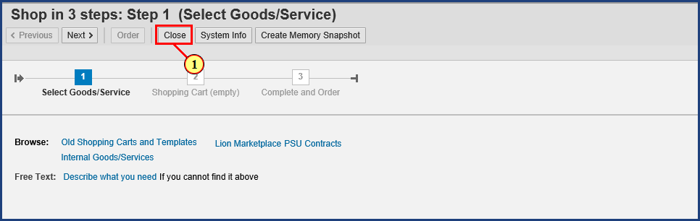

| Step | Action |
| --- | --- |
| 1. | The **Close** button is clicked. |

### Shop in 3 steps: Step 1 (Select Goods/Service)



| Step | Action |
| --- | --- |
|  | Since we have the catalog and item numbers recorded, we have no further use for this 3 Step cart. Click OK here to close out of Shop in 3 Steps. |
| 2. | The **OK** button is clicked. |

### Home

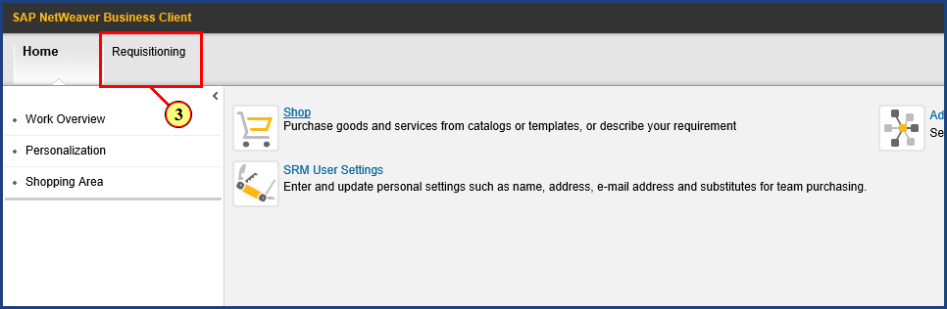

| Step | Action |
| --- | --- |
| 3. | The **Requisitioning** button is clicked. |

### Requisitioning

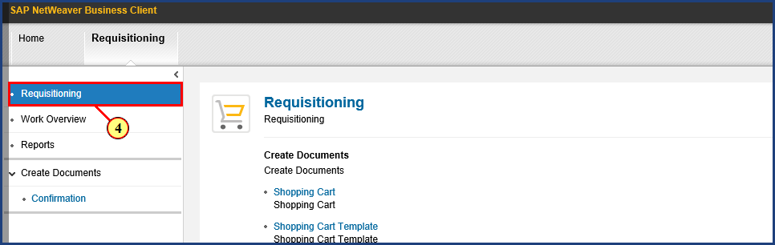

| Step | Action |
| --- | --- |
| 4. | The **Requisitioning** button is clicked. |

### Requisitioning

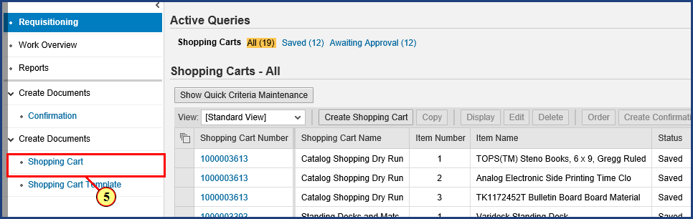

| Step | Action |
| --- | --- |
| 5. | The **Shopping Cart** button is clicked. |

### Create Shopping Cart

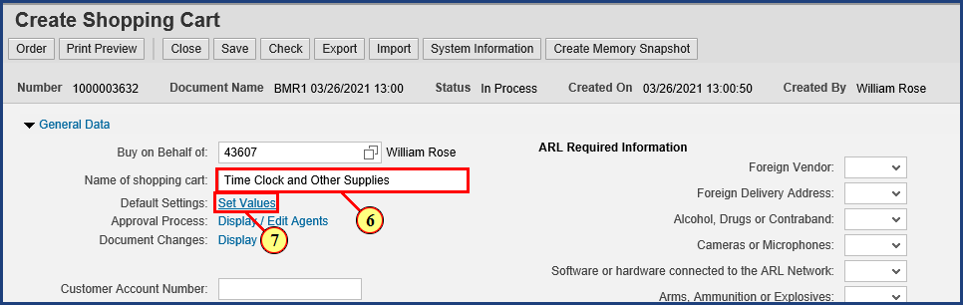

| Step | Action |
| --- | --- |
|  | It is a good idea to rename the cart to something meaningful that we can easily find later on. I will name mine “Time Clock and Other Supplies.” |
| 6. | **Time Clock and Other Supplies** is typed into the **Name of shopping cart** field. |

| Step | Action |
| --- | --- |
|  | **Important note!** By setting some default values now, before any line items have been created, you can make a single entry that will be carried forward to every line item in your order. This saves time by eliminating repeated information entry. The most common example is adding additional delivery address details. Rather than enter the same delivery address details five times (in a five line item order), the additional delivery address details can be supplied just once in the beginning. |
| 7. | The **Set Values** button is clicked. |

### Create Shopping Cart

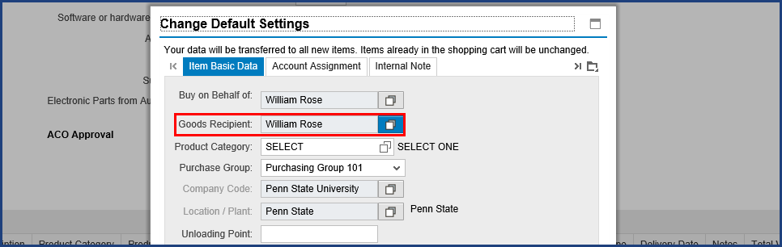

| Step | Action |
| --- | --- |
|  | This order will be a modest one of only a few hundred dollars. Note that Lion Marketplace orders under $5,000 do not require a goods confirmation/receipt, and the invoice will be received electronically, so no additional steps need to be taken on these orders. I do, however, want all three items to go to the same person, so I need to set her as the Goods Recipient. |

| Step | Action |
| --- | --- |
|  | Since I am the creator of this shopping cart, Shop OnLion shows me as the Goods Recipient by default. The assumption is that, most often, I am shopping for myself and expecting the items to be delivered to me. In this case, however, I am the shopper, but I want the items in this order to be delivered to a colleague instead. So I need to change the default setting for the Goods Recipient for this shopping cart. This is important because we are indicating to Shop OnLion who the Goods Recipient is, that is, the person who will later complete the goods confirmation in the system. |

### Create Shopping Cart

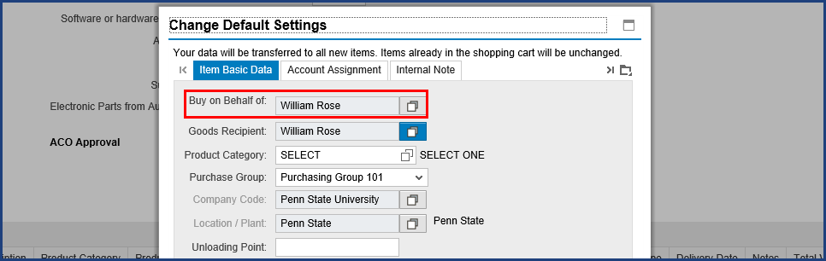

| Step | Action |
| --- | --- |
|  | Some shoppers, in attempting to transact a cart where items are delivered to someone else, have mistakenly changed the value of the "Buy on Behalf of" field to the name of the intended recipient. This is an understandable mistake, since the field name seems to describe what we are doing. But "Buy on Behalf of" instead refers to who the Shopping cart will **actually** belong to. While you may be the one to create the cart and submit it into the workflow approval process, from that point on, only the other person will see the cart or be able to monitor its progress through workflow. "Buy on Behalf of" means that you are merely initiating the process for another person. |

### Create Shopping Cart

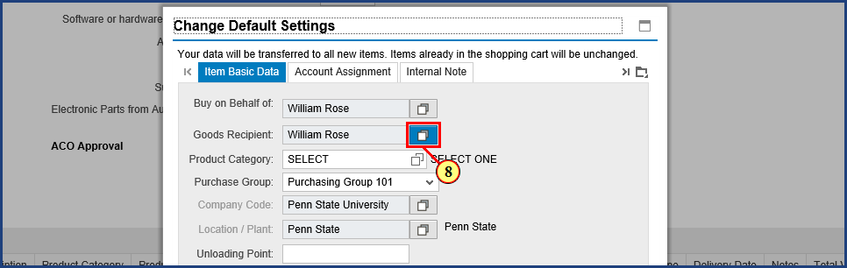

| Step | Action |
| --- | --- |
| 8. | The **Possible Values** button is clicked for **Goods Recipient**. |

### Create Shopping Cart

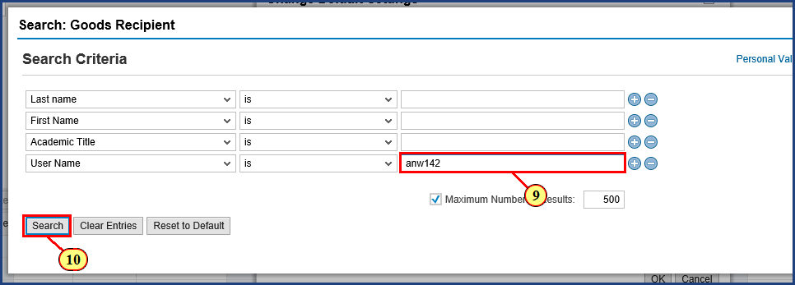

| Step | Action |
| --- | --- |
|  | Use whatever search criteria you are most comfortable with. If you know the User Name, this is often the most direct search. |
| 9. | **anw142** is typed into the **Search Criteria** field. |
| 10. | The **Search** button is clicked. |

| Step | Action |
| --- | --- |
|  | Note that this process can take awhile, because the request has to cross systems to find the data. |

### Create Shopping Cart

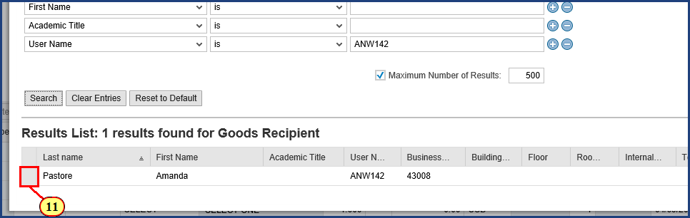

| Step | Action |
| --- | --- |
|  | One result is found from the User Name entered. |
| 11. | The **Item Select** button is clicked. |

### Create Shopping Cart

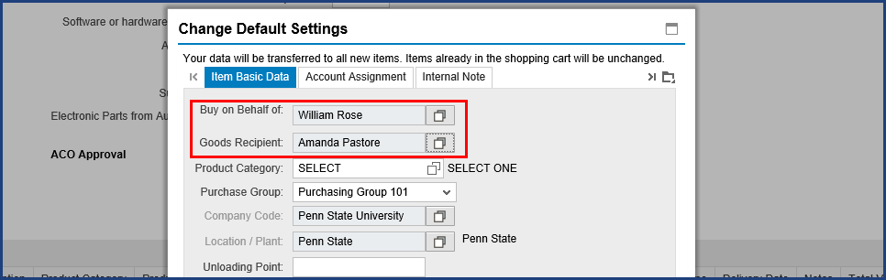

| Step | Action |
| --- | --- |
|  | Back on the Change Default Settings dialog box, we can see that Amanda is now the default Goods Recipient. Also note that I am still shown as the "Buy on Behalf of" person. This is exactly what we want: I am the shopper and the cart is mine, but Amanda will receive the items and will be the one to perform the Goods Confirmation for them. |

### Create Shopping Cart

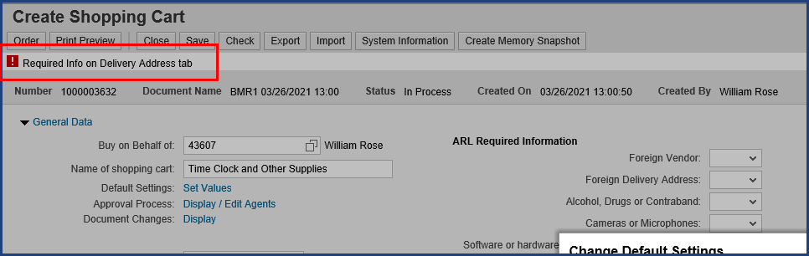

| Step | Action |
| --- | --- |
|  | You can see that we have a red-level error because we haven’t yet supplied the required information on the Delivery Address tab. This tab is found by clicking on the Display More Tabs button. Let's go fill in the required information. |

### Create Shopping Cart

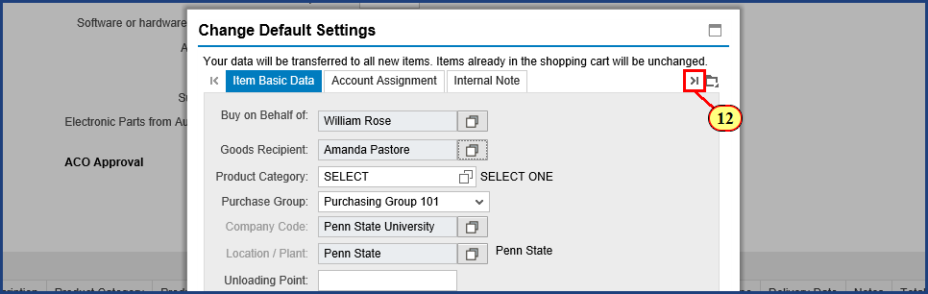

| Step | Action |
| --- | --- |
| 12. | The **Display More Tabs** button is clicked. |

### Create Shopping Cart

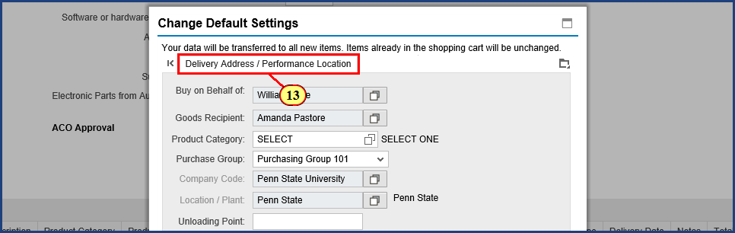

| Step | Action |
| --- | --- |
| 13. | The **Delivery Address / Performance Location** button is clicked. |

### Create Shopping Cart

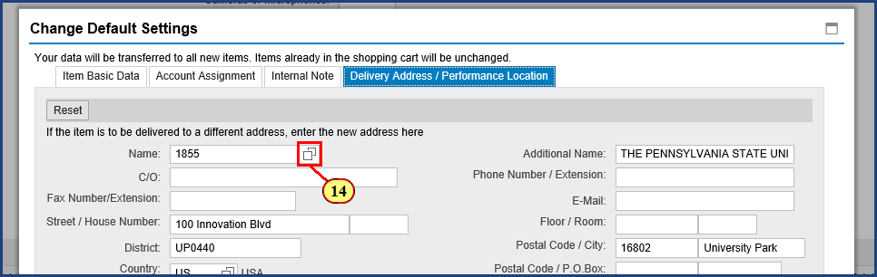

| Step | Action |
| --- | --- |
| 14. | The **Possible Values** button is clicked for **Name**. |

### Create Shopping Cart

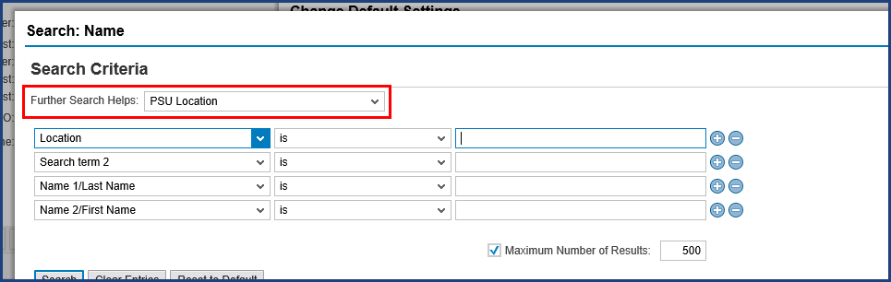

| Step | Action |
| --- | --- |
|  | The Further Search helps near the top of the screen should be set to PSU Location to maximize the customized search. |

### Create Shopping Cart

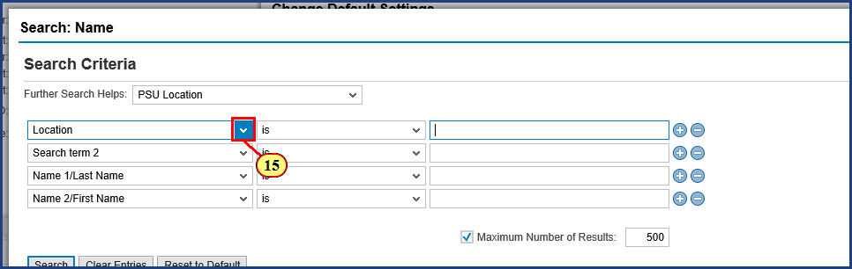

| Step | Action |
| --- | --- |
| 15. | The **Search Criteria** dropdown is clicked. |

### Create Shopping Cart

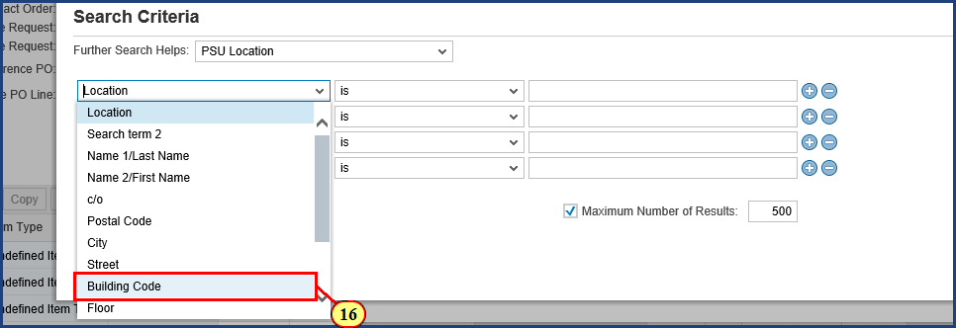

| Step | Action |
| --- | --- |
|  | We have quite a range of search criteria available, and you should feel free to use whatever works for you. In this case, I'd like to search for a particular building, so I will set the filter to search by Building Code. |
| 16. | The **Building Code** menu item is clicked. |

### Create Shopping Cart

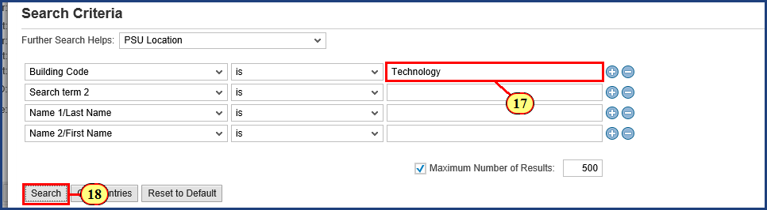

| Step | Action |
| --- | --- |
|  | I know that the building is named "Technology"-something. Let's just enter "Technology". |
| 17. | **Technology** is typed into the **Search Criteria** field. |
| 18. | The **Search** button is clicked. |

### Create Shopping Cart

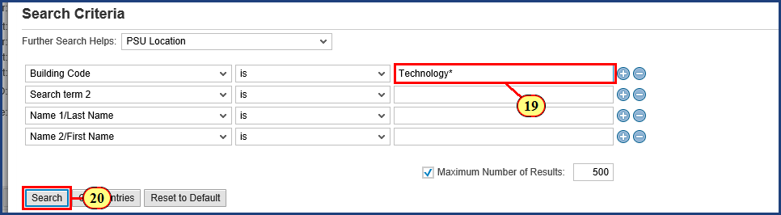

| Step | Action |
| --- | --- |
|  | No results for that search. Note that the middle option is set for "is", not "contains", which means that unless the Building Code is EXACTLY "Technology", no match will be made. Let's add an asterisk at the end to match any Building Code that begins with "Technology". |
| 19. | **Technology\*** is typed into the **Search Criteria** field. |
| 20. | The **Search** button is clicked. |

### Create Shopping Cart

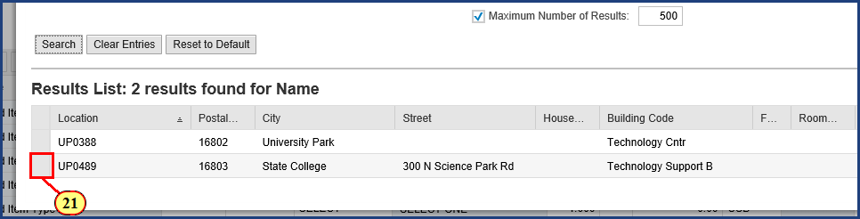

| Step | Action |
| --- | --- |
|  | There it is. The Technology Support Building. |
| 21. | The **Item Select** button is clicked. |

### Create Shopping Cart

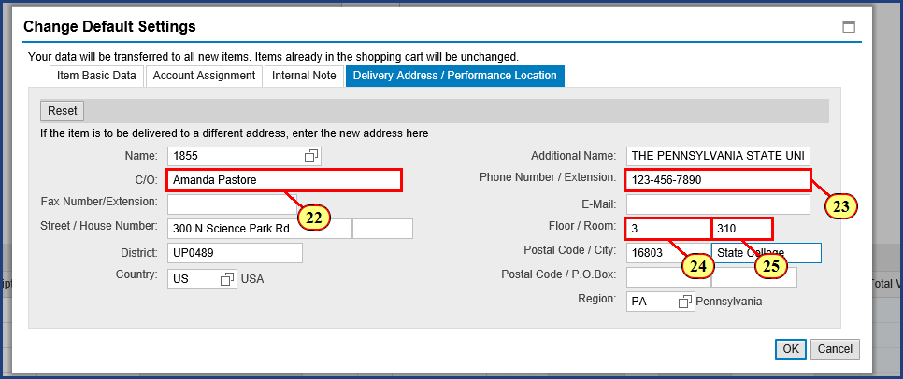

| Step | Action |
| --- | --- |
|  | You may notice something unusual in the information displayed here. Although we selected the Technology Support Building just now, we do not see the building name displayed. Rest assured that it will be included as part of the delivery address details.    Now I just need to add the In Care Of information by completing the details for Amanda. If I were the Goods Recipient, I would supply my own name and information here instead. |
| 22. | **Amanda Pastore** is typed into the **C/O** field. |
| 23. | **123-456-7890** is typed into the **Phone Number / Extension** field. |

| Step | Action |
| --- | --- |
|  | The Floor and Room fields allow alpha numeric characters, so "N/A" is a valid field entry if a specific room number or floor is not applicable. |
| 24. | **3** is typed into the **Floor** field. |
| 25. | **310** is typed into the **Room** field. |

### Create Shopping Cart

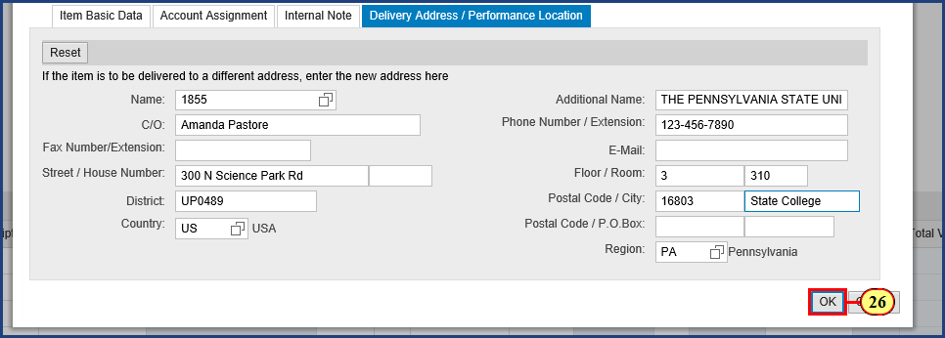

| Step | Action |
| --- | --- |
| 26. | The **OK** button is clicked. |

### Shopping Cart

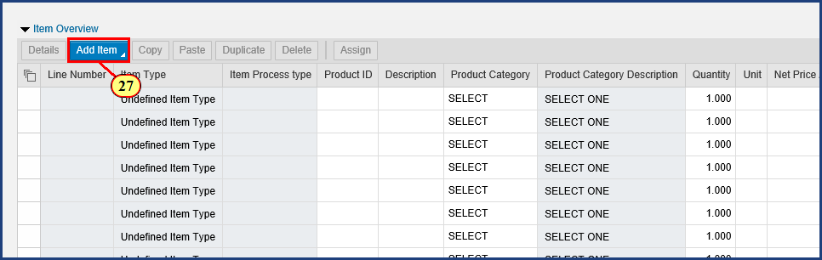

| Step | Action |
| --- | --- |
|  | As we will see, that was time well spent that will pay us back later. The error at the top of our screen has also been resolved. On to our first line item. |
| 27. | The **Add Item to Shopping Cart** button is clicked. |

### Shopping Cart

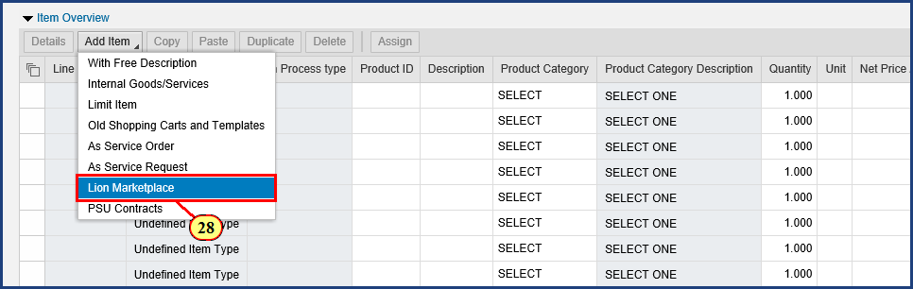

| Step | Action |
| --- | --- |
|  | Here is where Lion Marketplace comes back in. When we select this option from the menu, Lion Marketplace will open. |

| Step | Action |
| --- | --- |
|  | **Important!** Each and every line item in a Lion Marketplace shopping cart must be "Lion Marketplace." Standard shopping carts should **never** contain a mix of line item types.     * Lion Marketplace shopping cart -- only use "Lion Marketplace" line items * PSU Contracts shopping cart -- only use "PSU Contracts" line items * Free Text shopping cart -- only use "With Free Description" line items |
| 28. | The **Lion Marketplace** menu item is clicked. |

### Shopping Cart

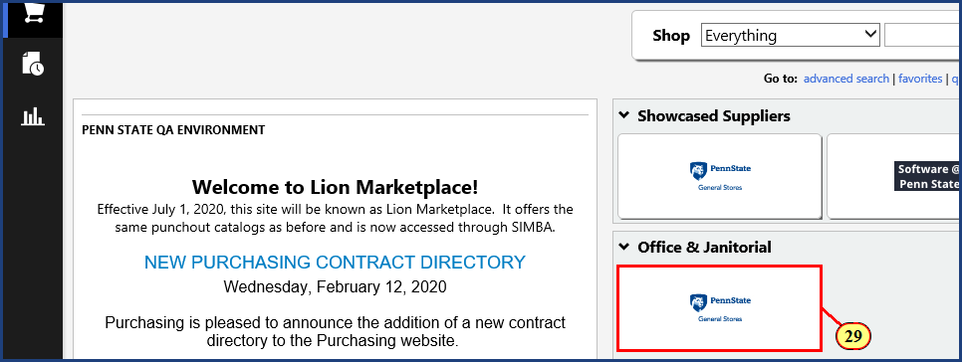

| Step | Action |
| --- | --- |
|  | It doesn't matter which catalog we start with. In the Lion Marketplace segment of the **Shopping Cart - Catalog and Contracts Search** simulation we found an item in Penn State General Stores, so I'll start with ordering an item from the Penn State General Stores catalog. |
| 29. | The **Penn State General Stores** button is clicked. |

### Office Supplies: Office Products and Office Furniture: Office Depot

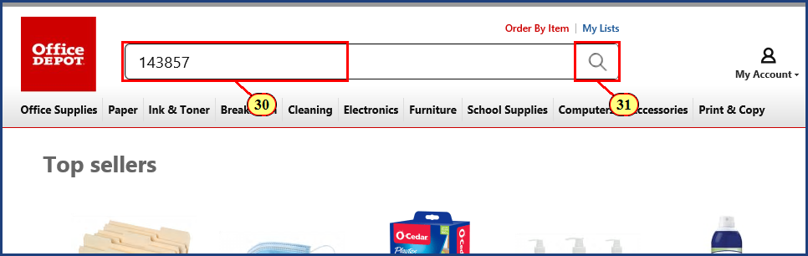

| Step | Action |
| --- | --- |
|  | You can enter keywords here, but a specific Item Number is best. In the Lion Marketplace segment of the **Shopping Cart - Catalog and Contracts Search** simulation, we wrote down an item number of 143857. |
| 30. | **143857** is typed into the **Search** field. |
| 31. | The **Start Search** button is clicked. |

### TOPS Steno Books 6 x 9 Gregg Ruled 70 Sheets White Pack Of 12 - Office Depot

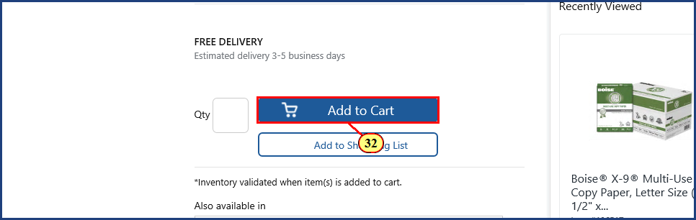

| Step | Action |
| --- | --- |
|  | In a catalog, Adding to Cart means adding the item to the catalog's cart. Later, when we checkout, the item will automatically be transferred to our SIMBA Shopping Cart. |
| 32. | The **Add to Cart** button is clicked. |

### Office Supplies: Office Products and Office Furniture: Office Depot

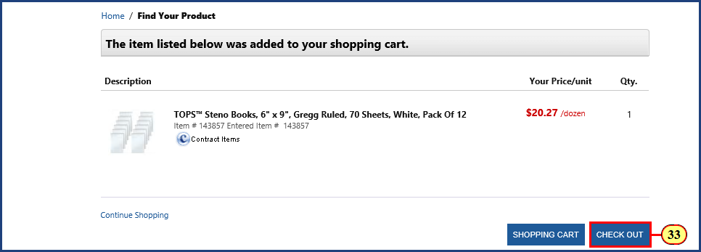

| Step | Action |
| --- | --- |
|  | With the item in the cart, we are ready to check out. |
| 33. | The **Check Out** button is clicked. |

### Shopping Cart

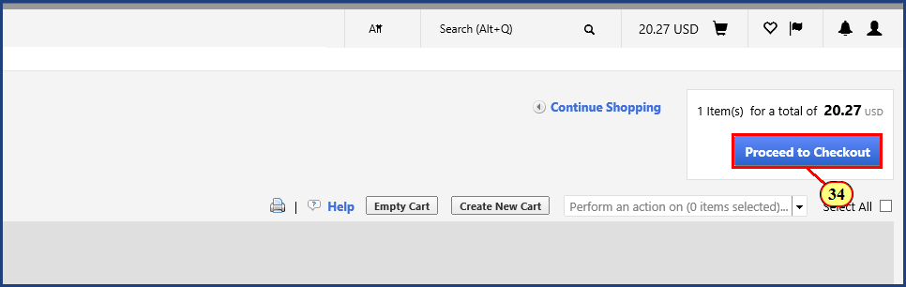

| Step | Action |
| --- | --- |
|  | The item and the quantity are correct, so let's proceed to checkout. |
| 34. | The **Proceed to Checkout** button is clicked. |

### Shopping Cart

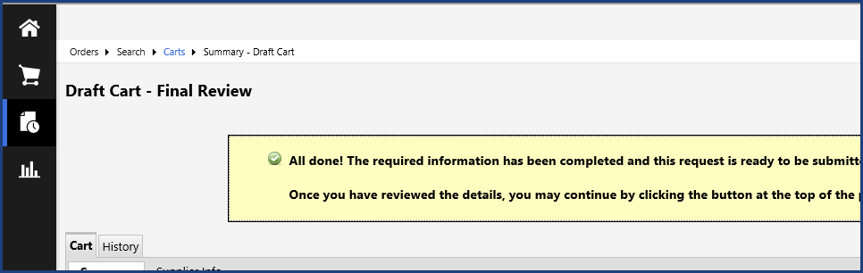

| Step | Action |
| --- | --- |
|  | Be sure that you see the green checkmark and "All done!" message before you return to SIMBA. Also, doublecheck the details here as a final review. |

| Step | Action |
| --- | --- |
|  | **IMPORTANT! Known Web Browser Issue**    Because the major vendors have begun to change how their browsers handle cookies (small data files stored on computers during browsing), clicking the Return to SIMBA button may generate an error message. These changes can cause some sites that rely on "third-party" cookies to malfunction. **NOTE: This impacts all sites on the web that use legitimate cookies, not just SIMBA.** To learn more about this issue and the settings you should change in your browser, see the [Return to SIMBA - Shop OnLion Error](https://pennstate.service-now.com/kb?id=kb_article_view&sysparm_article=KB0016615&sys_kb_id=aa67d14cdbc760906ff9e1f5ca9619ed&spa=1)knowledge base article for detailed instructions.    Also, be aware that clicking Return to SIMBA may open the Create Shopping Cart window behind other windows, or may open it in a new tab (depending on your browser settings). Other common issues include receiving an error message or a timeout notification, in which case you should clear your browser cookies and cache, or try another browser.    Most users should not typically experience problems. That said, we encourage you to take a proactive approach to reviewing the information on the SIMBA website about browser settings to ensure the best Lion Marketplace experience. |

### Shopping Cart

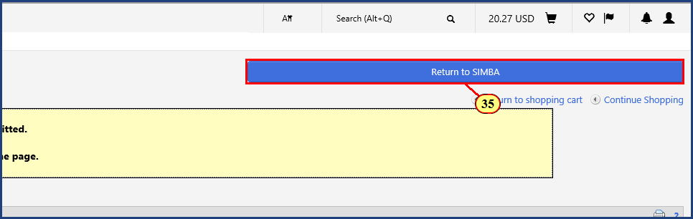

| Step | Action |
| --- | --- |
|  | The Return to SIMBA button is clicked to transfer the catalog cart item to the SIMBA shopping cart. |
| 35. | The **Return to SIMBA** button is clicked. |

### Shopping Cart

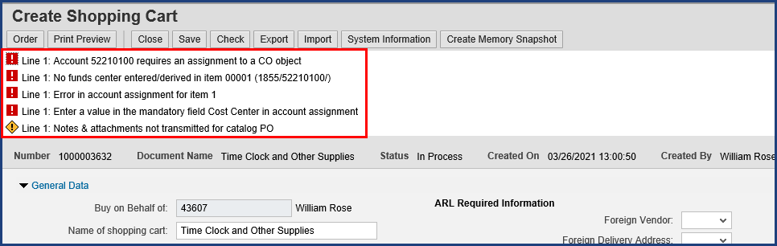

| Step | Action |
| --- | --- |
|  | Once the Lion Marketplace items are transferred back to the SIMBA shopping cart, various errors and warnings will appear in the top messages. Many of these can be resolved by entering budget information for the shopping cart, which we will do after all line items have been added. |

### Shopping Cart

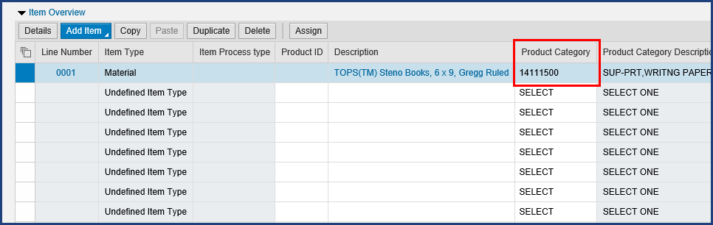

| Step | Action |
| --- | --- |
|  | Items added from Lion Marketplace catalogs will have a Product Category code determined by the supplier. Catalog item product categories **may not** be changed by the shopper. If the University does not have an exact match for the category identified by the supplier, you may see “00000001 – Undefined” in the Product category field. This will not prevent you from ordering your cart. |

### Shopping Cart

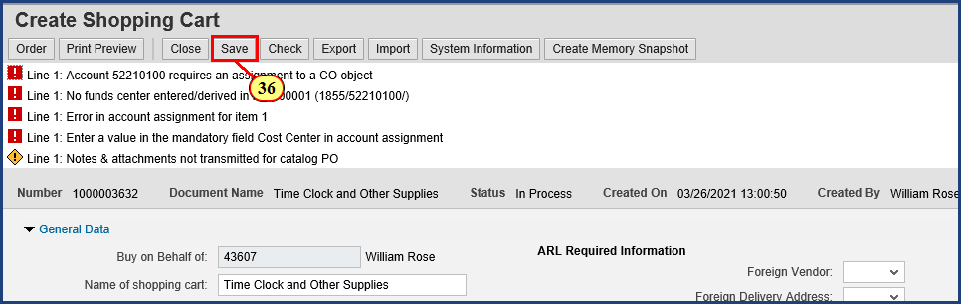

| Step | Action |
| --- | --- |
|  | A best practice:    **Always Save the cart immediately after returning items from Lion Marketplace.**    Bear in mind that Shop OnLion does not continuously auto-save your information. So, periodically save your cart. Should you get pulled away from your shopping by other tasks, your session may time-out. The addition of line items is a natural point in the process to save your progress. |
| 36. | The **Save** button is clicked. |

### Shopping Cart

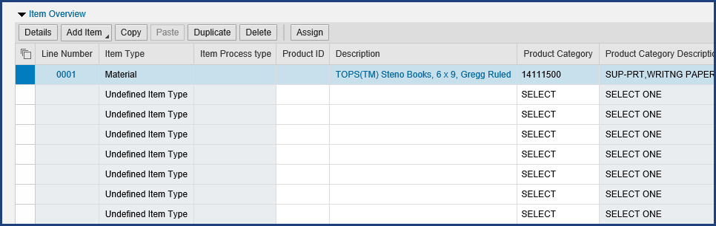

| Step | Action |
| --- | --- |
|  | **Note: After the Save button on the shopping cart is clicked, the cart will go from “Create” mode into “Display” mode.** No further changes to the cart can be made while it is in Display mode. You must click the Edit button in the top ribbon to continue working. |
| 37. | The **Edit** button is clicked. |

### Shopping Cart

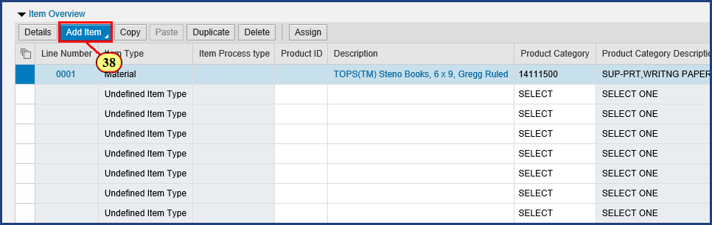

| Step | Action |
| --- | --- |
|  | Let's add another line item that we previously searched for. |
| 38. | The **Add Item to Shopping Cart** button is clicked. |

### Shopping Cart

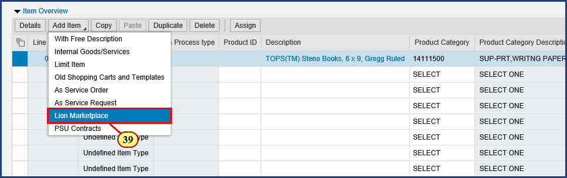

| Step | Action |
| --- | --- |
|  | **Important!** Each and every line item in a Lion Marketplace shopping cart must be "Lion Marketplace." Standard shopping carts should **never** contain a mix of line item types. |
| 39. | The **Lion Marketplace** menu item is clicked. |

| Step | Action |
| --- | --- |
|  | We have an item that we found in the Fastenal catalog that we want to add to our shopping cart. We need to scroll down a bit to see the button for the Fastenal catalog. |

### Shopping Cart

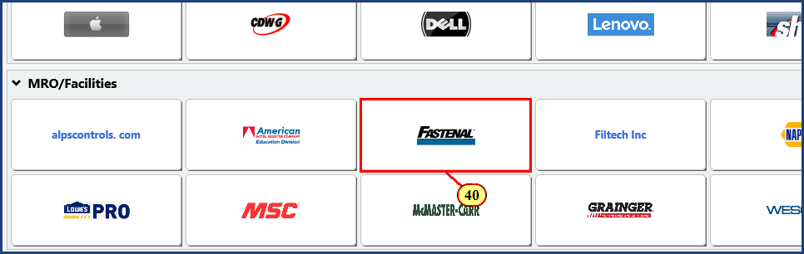

| Step | Action |
| --- | --- |
| 40. | The **Fastenal** button is clicked. |

### Shopping Cart

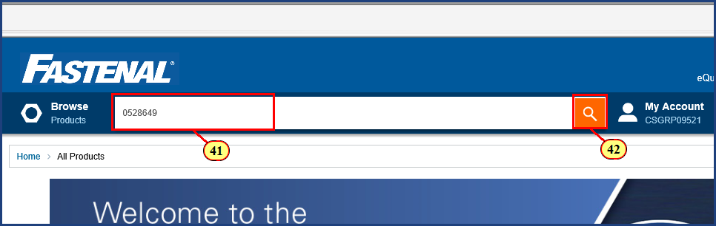

| Step | Action |
| --- | --- |
|  | In the Lion Marketplace segment of the **Shopping Cart - Catalog and Contracts Search** simulation, we wrote down an item number of 0528649. |
| 41. | **0528649** is typed into the **Search** field. |
| 42. | The **Start Search** button is clicked. |

### Shopping Cart

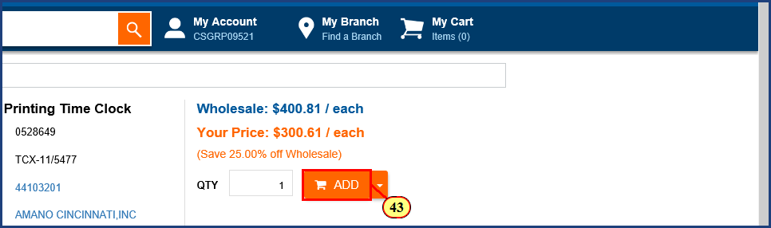

| Step | Action |
| --- | --- |
|  | As before, we add the item to the catalog cart. |
| 43. | The **Add** button is clicked. |

### Shopping Cart

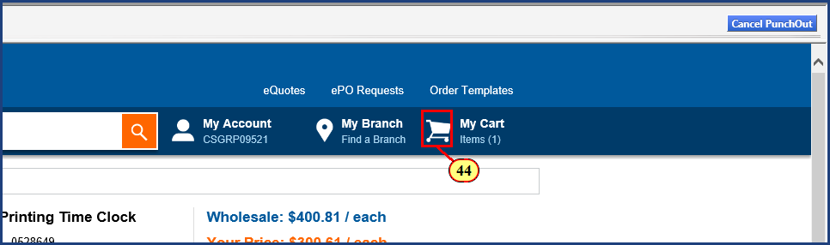

| Step | Action |
| --- | --- |
| 44. | The **My Cart** button is clicked. |

### Shopping Cart

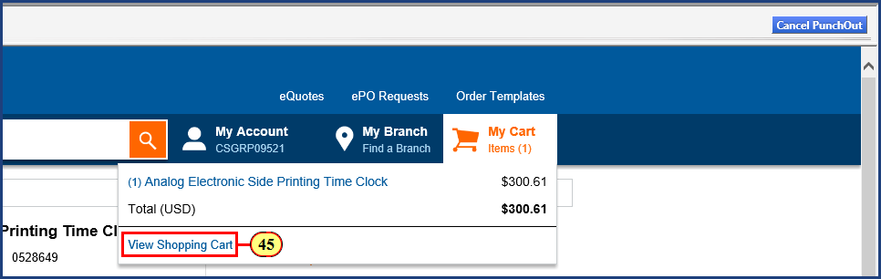

| Step | Action |
| --- | --- |
|  | Another click is required in the Fastenal catalog to actually navigate to the cart. |
| 45. | The **View Shopping Cart** button is clicked. |

### Shopping Cart

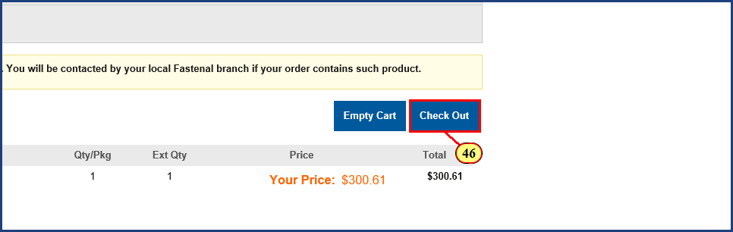

| Step | Action |
| --- | --- |
| 46. | The **Check Out** button is clicked. |

### Shopping Cart

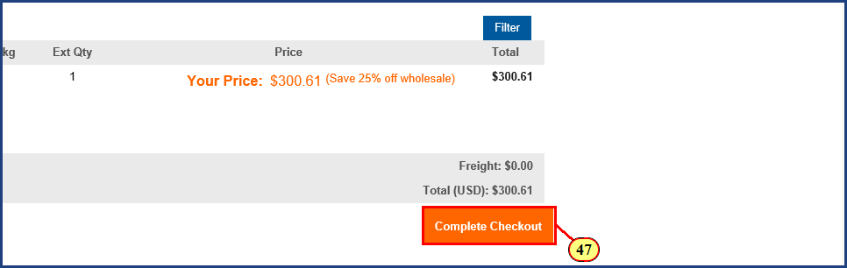

| Step | Action |
| --- | --- |
| 47. | The **Complete Checkout** button is clicked. |

### Shopping Cart

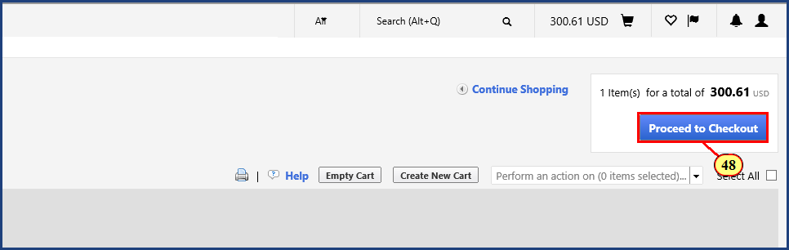

| Step | Action |
| --- | --- |
|  | Everything looks good here; let's proceed to checkout. |
| 48. | The **Proceed to Checkout** button is clicked. |

### Shopping Cart



| Step | Action |
| --- | --- |
|  | There is the green checkmark and "All done!" message. Back to SIMBA. |

### Shopping Cart

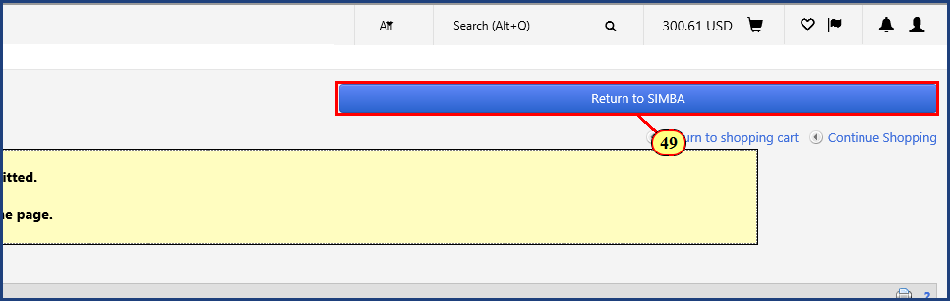

| Step | Action |
| --- | --- |
| 49. | The **Return to SIMBA** button is clicked. |

### Shopping Cart

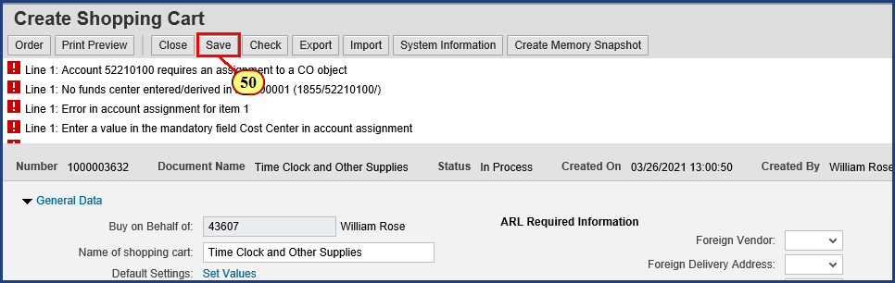

| Step | Action |
| --- | --- |
|  | Remember, we want to save at regular intervals. With Line item 2 added, let's do that now. |
| 50. | The **Save** button is clicked. |

### Shopping Cart

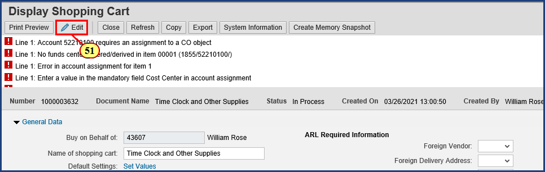

| Step | Action |
| --- | --- |
|  | **Note: After the Save button on the shopping cart is clicked, the cart will go from “Create” mode into “Display” mode.** No further changes to the cart can be made while it is in Display mode. You must click the Edit button in the top ribbon to continue working. |
| 51. | The **Edit** button is clicked. |

### Shopping Cart

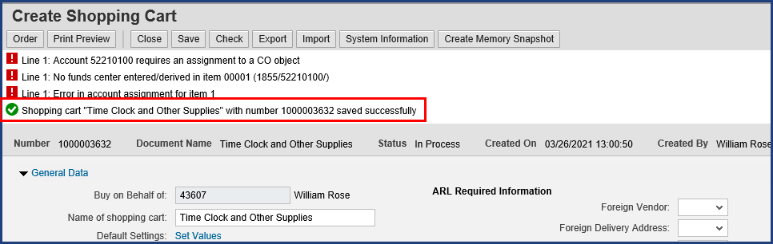

| Step | Action |
| --- | --- |
|  | Note the system confirmation that our cart saved successfully. |

### Shopping Cart

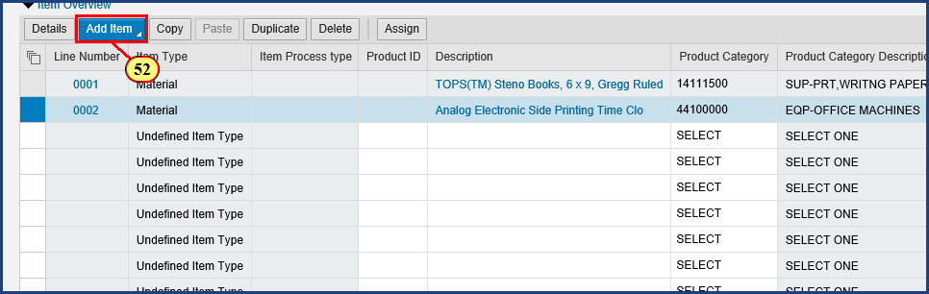

| Step | Action |
| --- | --- |
|  | Let's add one more item to our cart from our previous Lion Marketplace search. |
| 52. | The **Add Item to Shopping Cart** button is clicked. |

### Shopping Cart

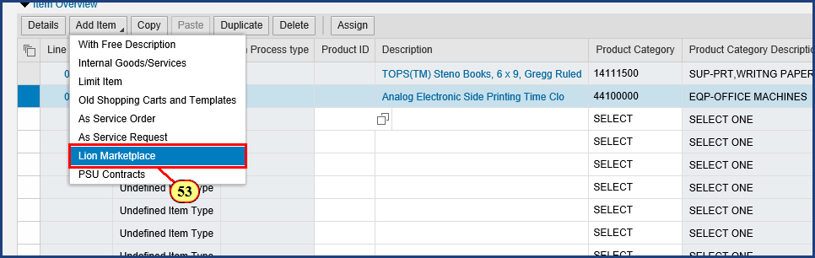

| Step | Action |
| --- | --- |
| 53. | The **Lion Marketplace** menu item is clicked. |

| Step | Action |
| --- | --- |
|  | The last item we want to add was found in the Grainger catalog. We need to scroll down a bit to see the button for the Grainger catalog. |

### Shopping Cart

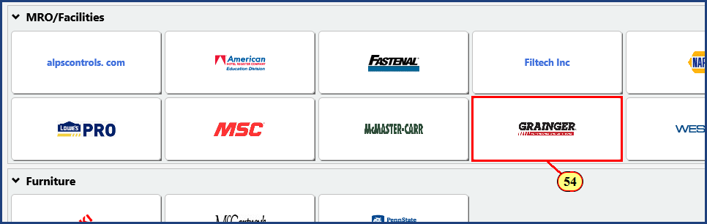

| Step | Action |
| --- | --- |
| 54. | The **Grainger** button is clicked. |

### Shopping Cart

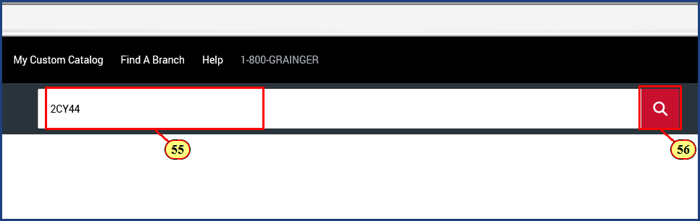

| Step | Action |
| --- | --- |
|  | In the Lion Marketplace segment of the **Shopping Cart - Catalog and Contracts Search** simulation, we wrote down an item number of 2CY44. |
| 55. | **2CY44** is typed into the **Search** field. |
| 56. | The **Start Search** button is clicked. |

### Shopping Cart

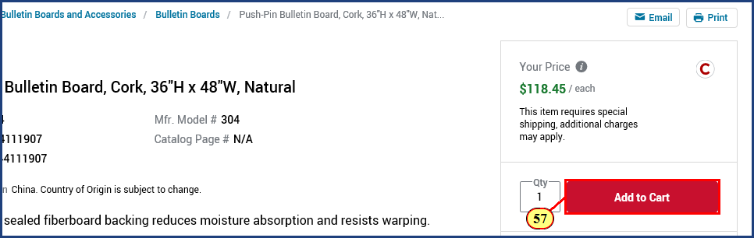

| Step | Action |
| --- | --- |
|  | That is the right item. Let's add it to the cart. |
| 57. | The  **Add to Cart** button is clicked. |

### Shopping Cart

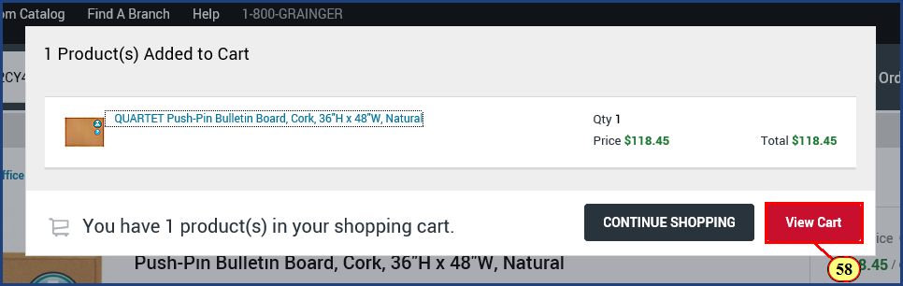

| Step | Action |
| --- | --- |
| 58. | The **View Cart** button is clicked. |

### Shopping Cart

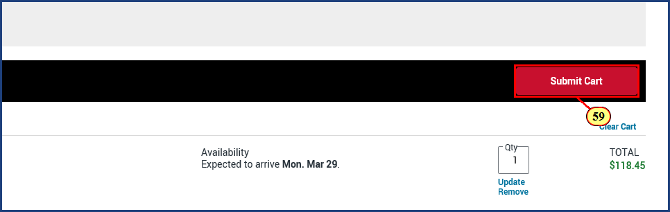

| Step | Action |
| --- | --- |
| 59. | The **Submit Cart** button is clicked. |

### Shopping Cart

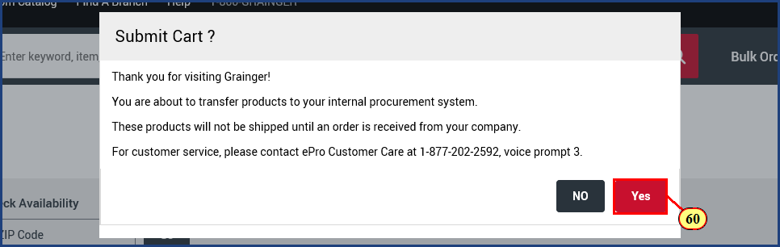

| Step | Action |
| --- | --- |
|  | This is just a courtesy confirmation from the vendor. Click Yes. |
| 60. | The **Yes** button is clicked. |

### Shopping Cart

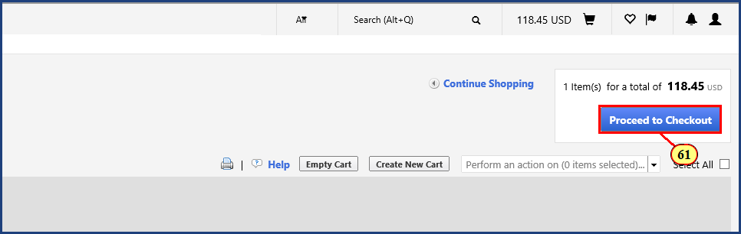

| Step | Action |
| --- | --- |
| 61. | The **Proceed to Checkout** button is clicked. |

### Shopping Cart

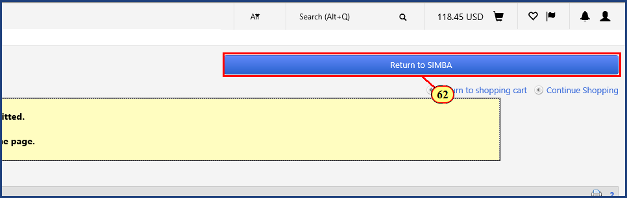

| Step | Action |
| --- | --- |
| 62. | The **Return to SIMBA** button is clicked. |

### Shopping Cart

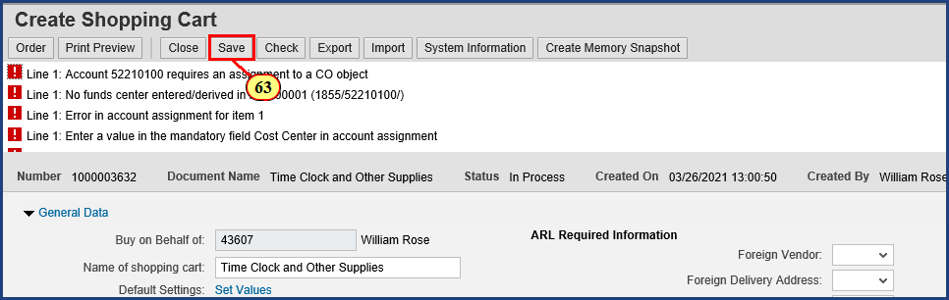

| Step | Action |
| --- | --- |
|  | With Line item 3 added, let's save again. |
| 63. | The **Save** button is clicked. |

### Shopping Cart

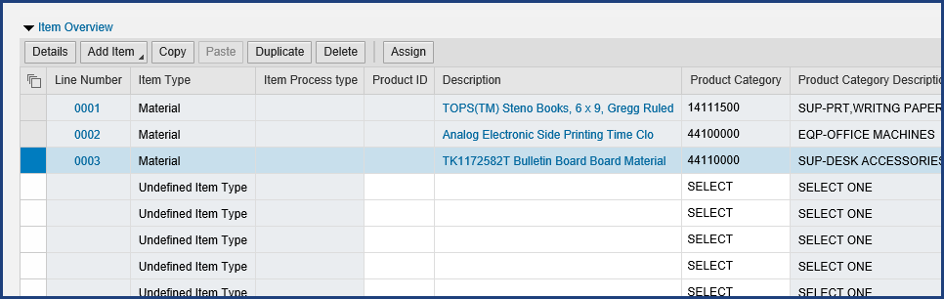

| Step | Action |
| --- | --- |
|  | **Note: After the Save button on the shopping cart is clicked, the cart will go from “Create” mode into “Display” mode.** No further changes to the cart can be made while it is in Display mode. You must click the Edit button in the top ribbon to continue working. |
| 64. | The **Edit** button is clicked. |

### Shopping Cart

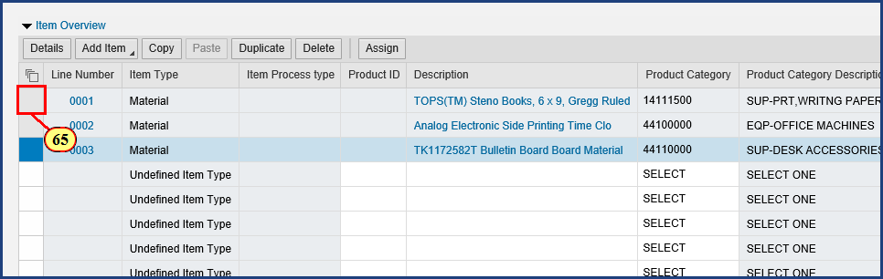

| Step | Action |
| --- | --- |
|  | Now it's time to start resolving these errors! |
| 65. | The **Line Item Select** button is clicked for **Line Item 0001**. |

### Shopping Cart

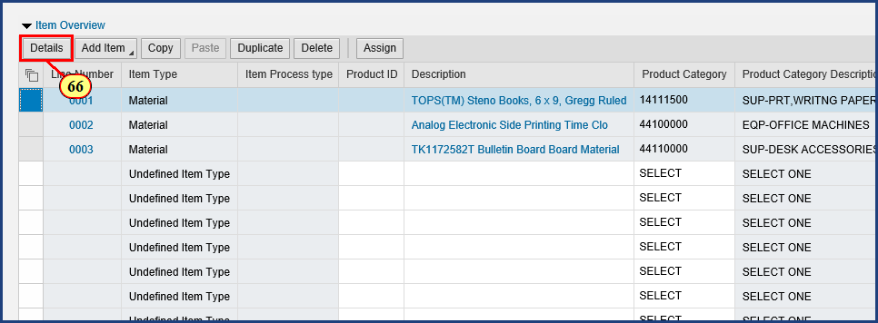

| Step | Action |
| --- | --- |
|  | Once the line item is selected, clicking the Details button will reveal additional information to view, add, and edit. |
| 66. | The **Item Details** button is clicked. |

### Shopping Cart

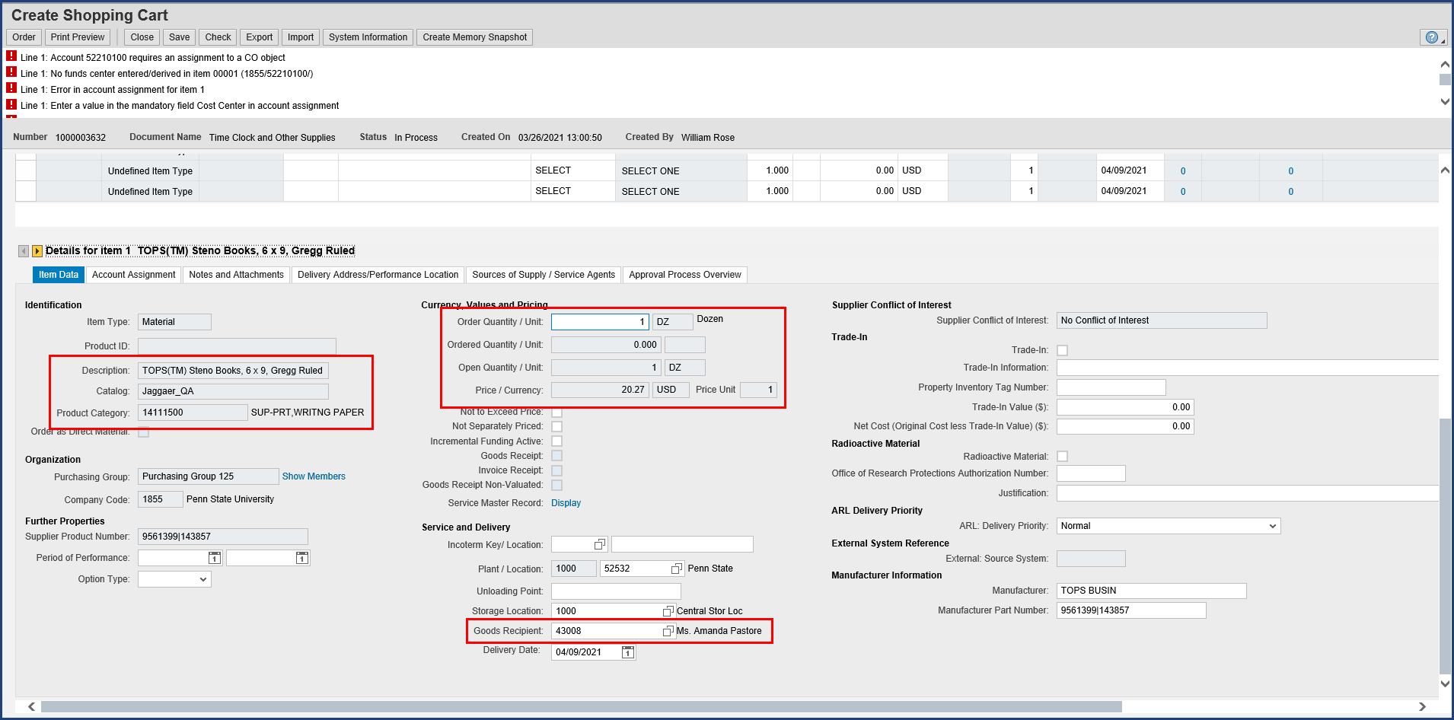

| Step | Action |
| --- | --- |
|  | Here we can see quite a bit of detail for Item 1 that we have supplied up to this point. On the left side under Identification, we see the Product Category number and Description for the Steno Books we ordered. In the upper middle under Currency, Values and Pricing, we see that we have a dozen books valued at $20.27. And in the lower middle under Service and Delivery, we see that Amanda Pastore is the Goods Recipient, which confirms the default setting we made earlier. |

| Step | Action |
| --- | --- |
|  | This Item Data tab may appear a bit overwhelming, but you won’t need to enter that much information. Remember that not every field is required in every case; just fill in what pertains to your situation.    **Tip**: Establish a consistent routine for supplying item details to maximize your accuracy and efficiency:     * Work through the line item tabs from left to right (Item Data through Delivery Address/Performance Location) * On each tab, supply information from top to bottom     That said, don't worry about missing details. The system's error messages will alert you to omitted and/or incorrect data. |

| Step | Action |
| --- | --- |
|  | Note that the Create Shopping Cart window has been automatically scrolled down to the Item Details area. To return to the General Data or header information, just scroll back up. |

### Shopping Cart

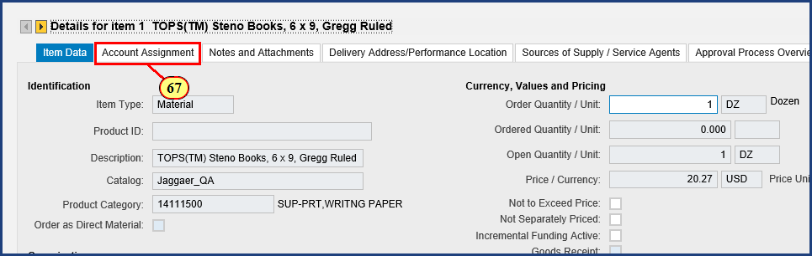

| Step | Action |
| --- | --- |
| 67. | The **Account Assignment** button is clicked. |

### Shopping Cart

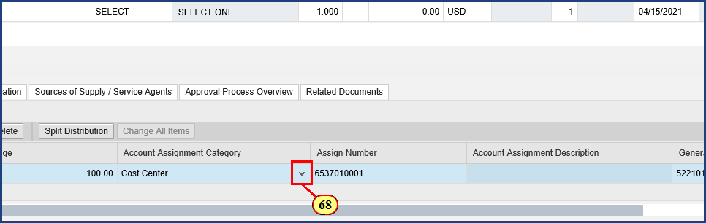

| Step | Action |
| --- | --- |
| 68. | The **Account Assignment Category** dropdown is clicked. |

### Shopping Cart

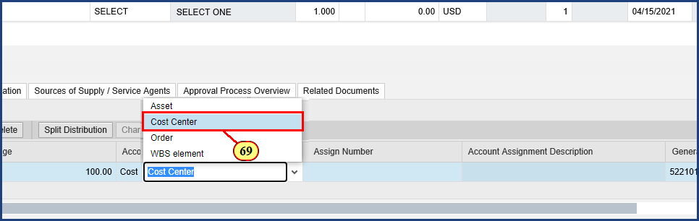

| Step | Action |
| --- | --- |
|  | The Account Assignment Category drop down menu allows you to choose from Asset, Cost Center, Order, and Work Breakdown Structure Element. In Shop OnLion, an Internal Order is simply referred to as Order in the Account Assignment Category. We will stay with a Cost Center and enter the Cost Center for our area. |
| 69. | The **Cost Center** menu item is clicked. |

### Shopping Cart

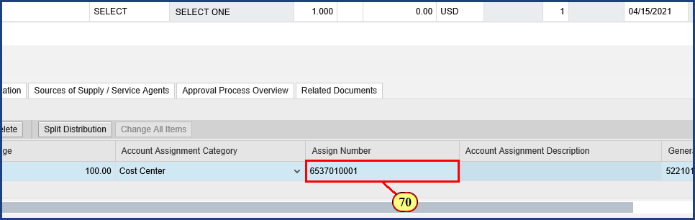

| Step | Action |
| --- | --- |
|  | In this example, we'll enter the cost center that we have previously determined to be correct for our shopping. To identify a cost object, use the Possible Values icon to search for one, or consult your financial office to determine the cost object you should utilize for shopping. |
| 70. | **6537010001** is typed into the **Assign Number** field and **Enter** is pressed. |

### Shopping Cart

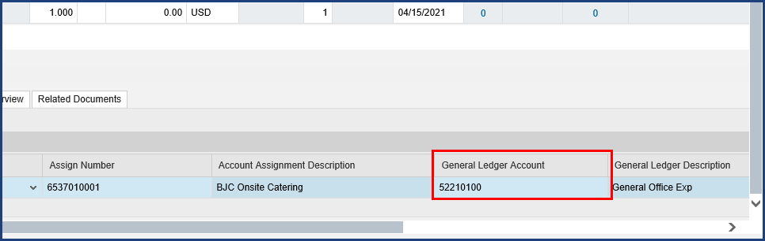

| Step | Action |
| --- | --- |
|  | To date, approximately 85% of product categories have been matched to the most likely General Ledger Account to classify the expense. You should always review the G/L Account to ensure it is appropriate for your purchase. If no G/L Account has populated by default, you must enter one, as this is a required field. |

### Shopping Cart

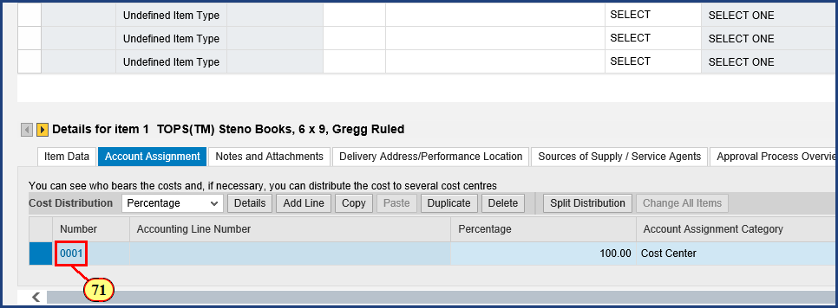

| Step | Action |
| --- | --- |
|  | We can get a more detailed view of the account assignment details derivation just completed. We will click on the blue number 0001 to view those details below. |
| 71. | The **Line Number 0001** button is clicked. |

### Shopping Cart

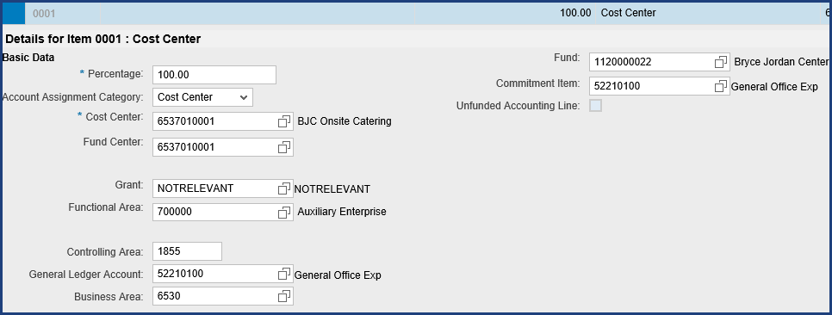

| Step | Action |
| --- | --- |
|  | Now we can see additional detail for this Cost Center derived from master data, including the Fund Center, General Ledger Account, Business Area, Fund, and Commitment Item. This system derived information should not be edited directly by the shopper. This detailed view allows me to confirm this account assignment is exactly what I am going to need for line item 2. We will copy that in a moment, but first we have to scroll right to click the close box for this detailed view. |

### Shopping Cart

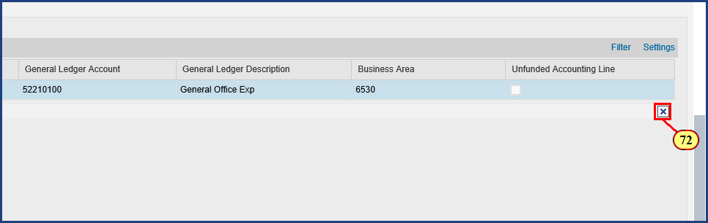

| Step | Action |
| --- | --- |
| 72. | The **Close Tray** button is clicked. |

### Shopping Cart

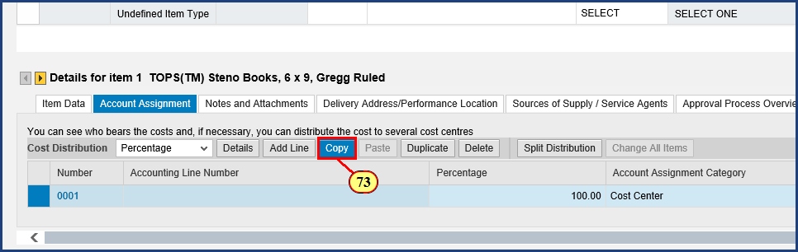

| Step | Action |
| --- | --- |
|  | Helpful hint: if you need to split the cost of the items across multiple accounts, enter all details of the cost distribution prior to copying to the clipboard.    Clicking the Copy button will populate the clipboard and display it at the bottom of the screen. |
| 73. | The **Copy to Clipboard** button is clicked. |

### Shopping Cart

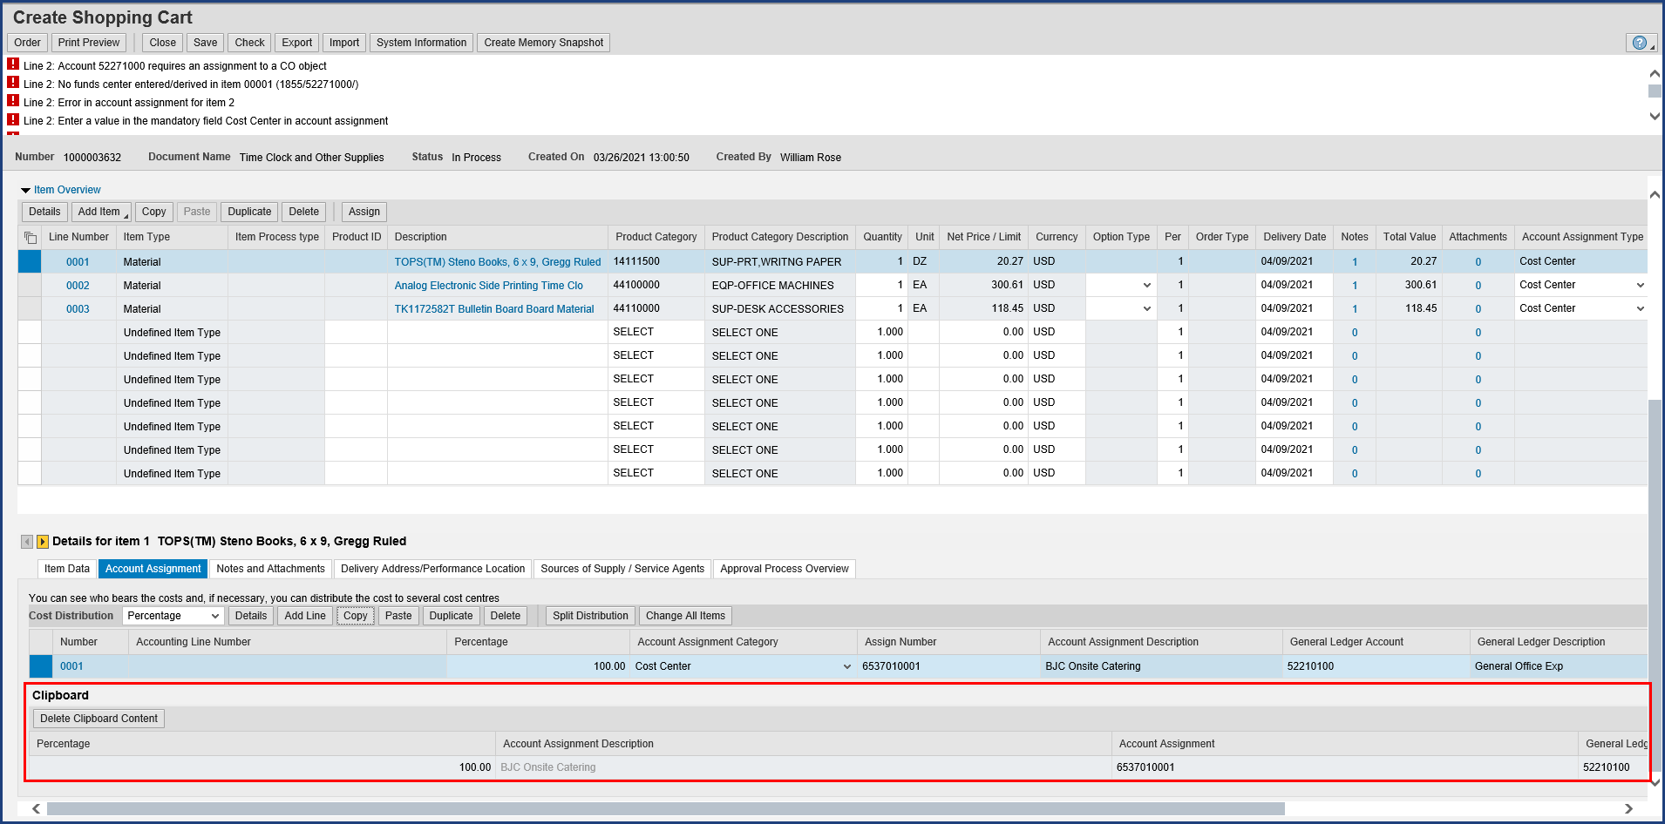

| Step | Action |
| --- | --- |
|  | The clipboard is opened and populated with the Account Assignment data. |

### Shopping Cart

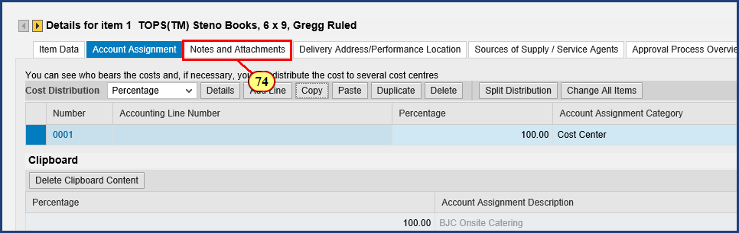

| Step | Action |
| --- | --- |
| 74. | The **Notes and Attachments** button is clicked. |

### Shopping Cart

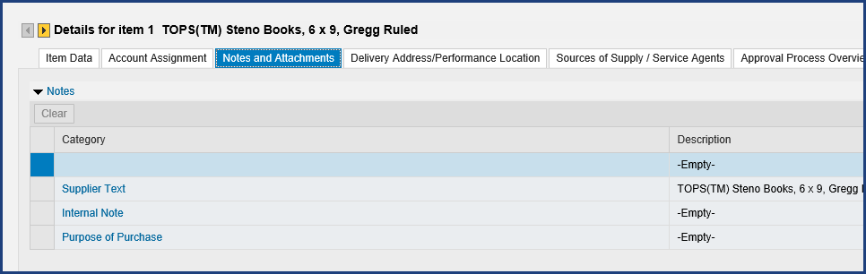

| Step | Action |
| --- | --- |
|  | Supplier Text is not transmitted for the majority of catalog purchase orders, so Notes are not required. If your departmental approvers request or require Internal Notes, this is where you should add them. |

### Shopping Cart

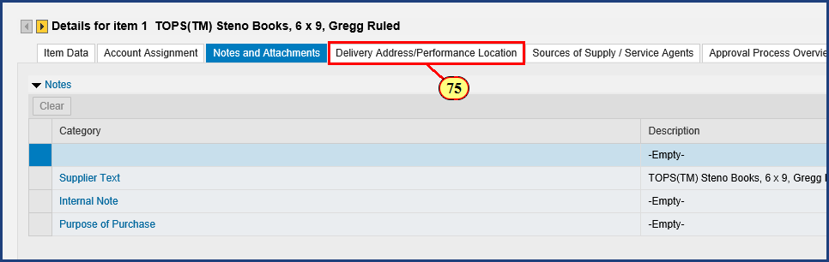

| Step | Action |
| --- | --- |
| 75. | The **Delivery Address/Performance Location** button is clicked. |

### Shopping Cart

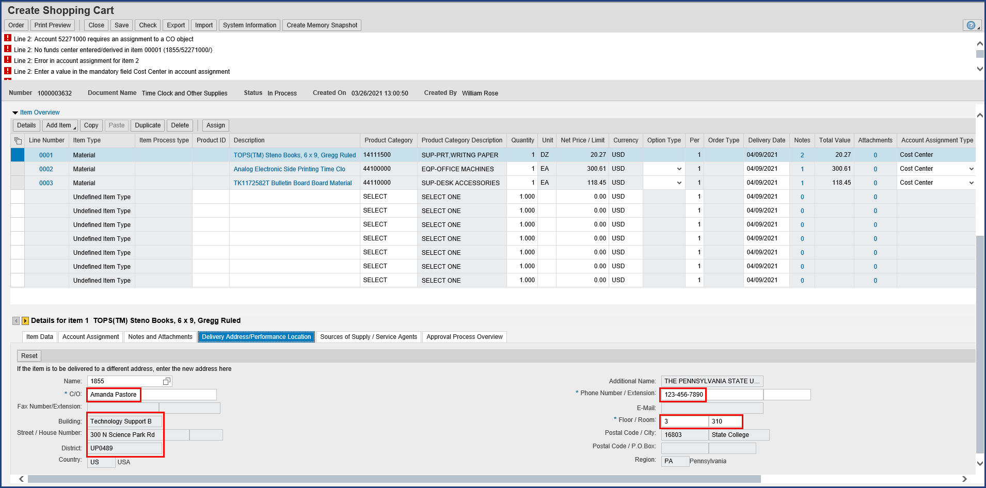

| Step | Action |
| --- | --- |
|  | The default settings we entered at the start of this shopping cart, in the header, are showing.    Unlike a Free Text shopping cart, Lion Marketplace orders do not require you to indicate a preferred supplier, since the suplier is already known. We can skip the Sources of Supply / Service Agents tab.    That does it for Line Item 1. Let's navigate to Item 2. |

### Shopping Cart

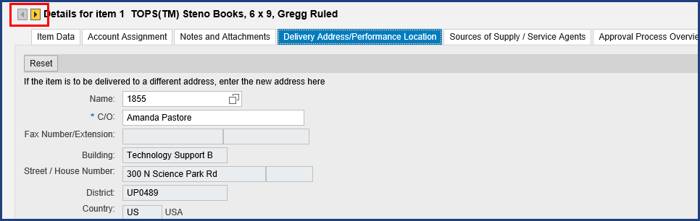

| Step | Action |
| --- | --- |
|  | The Next Item and Previous Item buttons allow us to move to particular line items in the shopping cart. |

### Shopping Cart

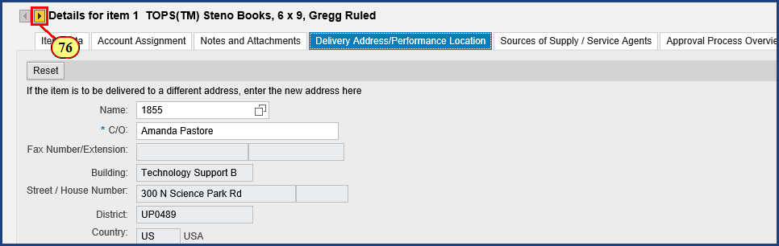

| Step | Action |
| --- | --- |
| 76. | The **Next Item** button is clicked. |

### Shopping Cart

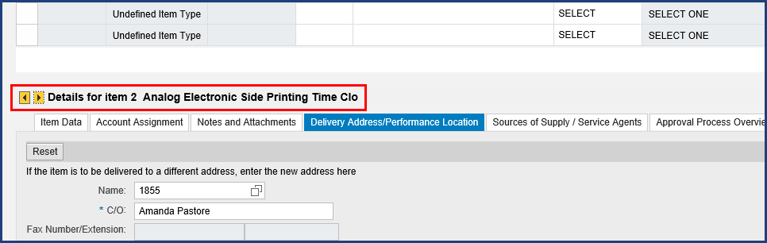

| Step | Action |
| --- | --- |
|  | Now we are working with Item 2, the time clock. |

### Shopping Cart

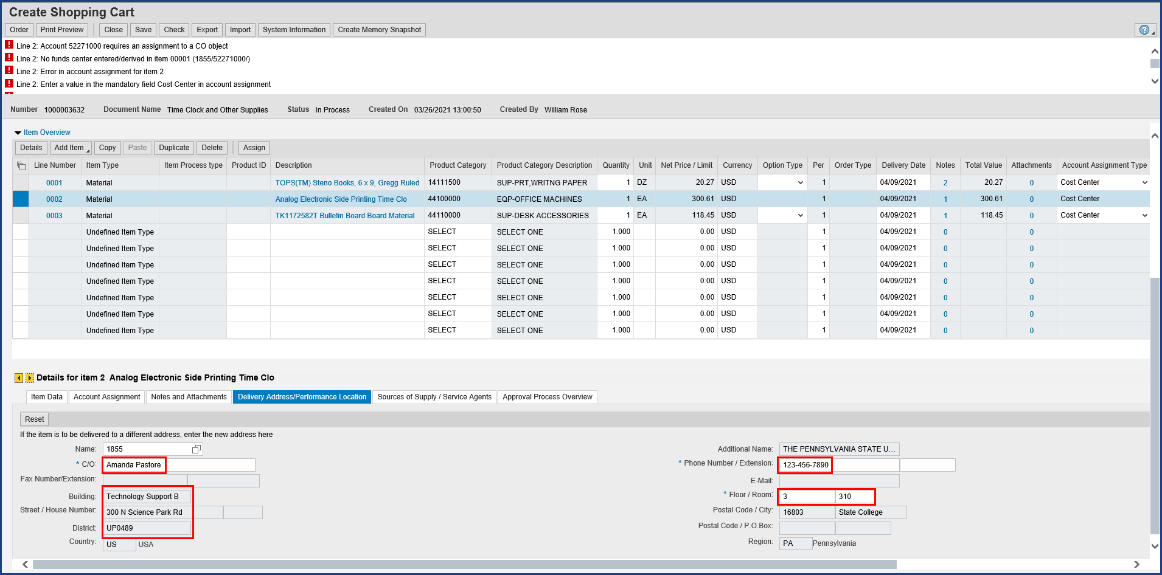

| Step | Action |
| --- | --- |
|  | We see the default values already applied here as well. |

### Shopping Cart

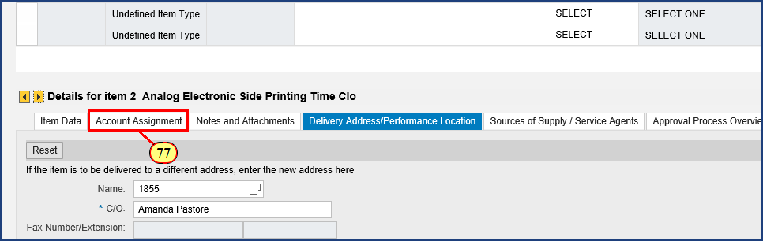

| Step | Action |
| --- | --- |
| 77. | The **Account Assignment** button is clicked. |

### Shopping Cart

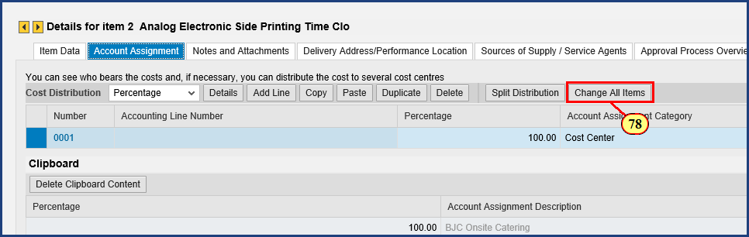

| Step | Action |
| --- | --- |
|  | Incidentally, if you have a larger number of line items and you want to use the same Account Assignment information copied to your clipboard for all of them, click the Change All Items button. |
| 78. | The **Change All Items** button is clicked. |

### Shopping Cart

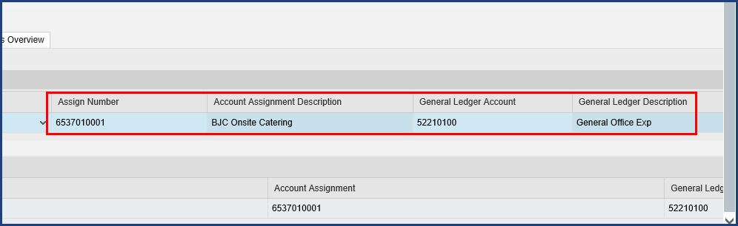

| Step | Action |
| --- | --- |
|  | Note the updated information for Item 2. You will see it displayed for Item 3 as well. |

### Shopping Cart

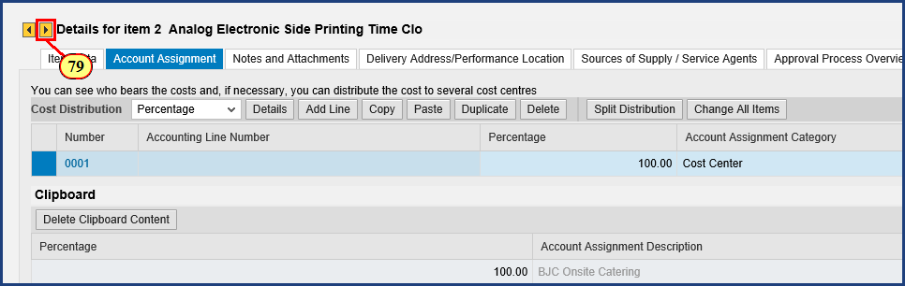

| Step | Action |
| --- | --- |
| 79. | The **Next Item** button is clicked. |

### Shopping Cart

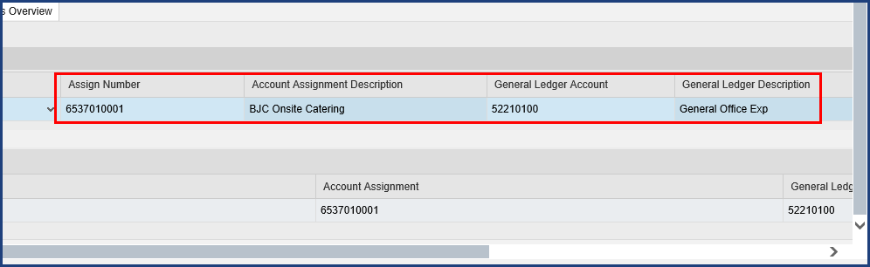

| Step | Action |
| --- | --- |
|  | The Account Assignment information has been supplied automatically for Item 3. |

### Shopping Cart

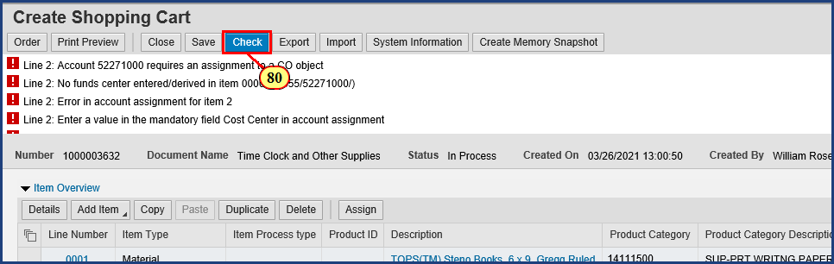

| Step | Action |
| --- | --- |
|  | With all three line items complete, our red-level error message status is outdated and in need of a refresh. |
| 80. | The **Check** button is clicked. |

### Shopping Cart

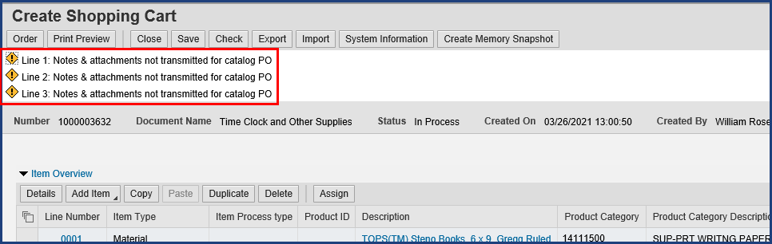

| Step | Action |
| --- | --- |
|  | That's better. We are simply reminded that notes and attachments will not be transmitted for catalog purchase orders. We may proceed. |

### Shopping Cart

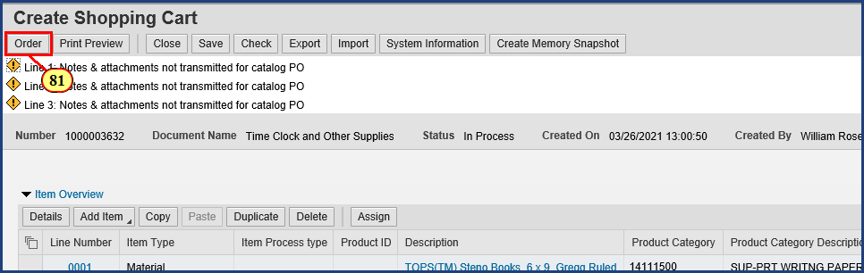

| Step | Action |
| --- | --- |
|  | **IMPORTANT!** You **MUST** click Order and **see a system confirmation** before you close out of the transaction. |
| 81. | The **Order Shopping Cart** button is clicked. |

### Shopping Cart

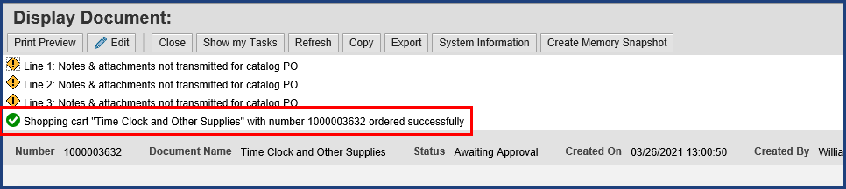

| Step | Action |
| --- | --- |
|  | This order has been successfully submitted into workflow for approval. Every shopping cart will be evaluated by the system to determine the necessary workflow steps. In some cases, the system may determine that the shopper is pre-approved and the cart will show "system" as the approval step. If not pre-authorized, it will go to the budget and financial approvers. Write down the shopping cart number shown in the system status. In this case, the number is 1000003632. |

### Shopping Cart

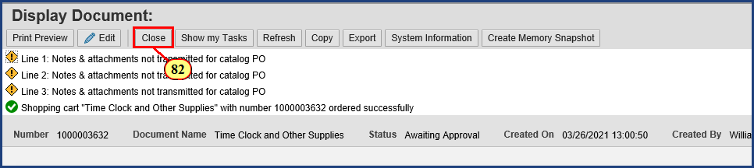

| Step | Action |
| --- | --- |
|  | **One final tip:** To close the Create Shopping Cart window, always click the Close button, not the X-box that closes the window. |
| 82. | The **Close** button is clicked. |

### Requisitioning

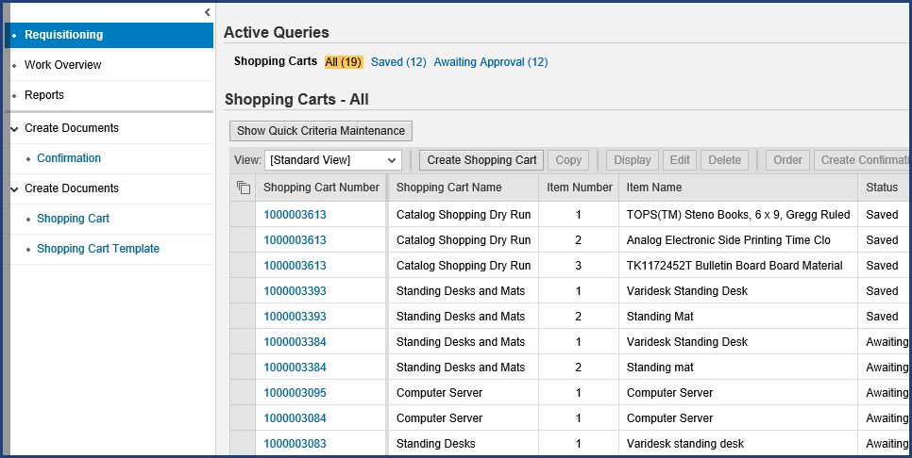

| Step | Action |
| --- | --- |
|  | Back on the Active Queries screen, we don't see the items from Shopping Cart 1000003632 listed. We need to click the Refresh button to get an updated listing. |

### Requisitioning

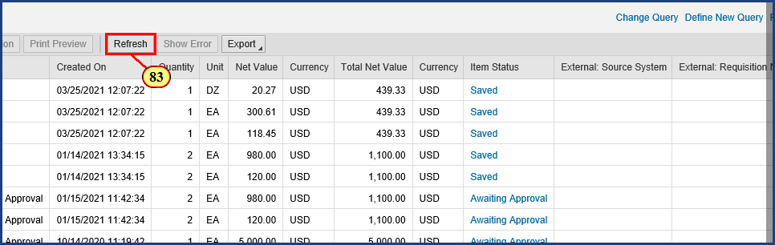

| Step | Action |
| --- | --- |
| 83. | The **Refresh** button is clicked. |

### Requisitioning

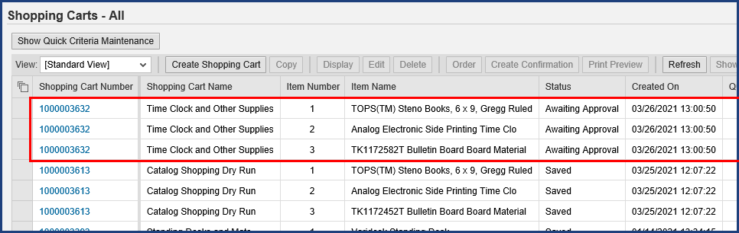

| Step | Action |
| --- | --- |
|  | **Note:** Because this shopping cart included items from three different supplier catalogs, three different purchase orders (one to each supplier) will be created from the approved cart. SIMBA's flexibility allows you to combine supplies from multiple catalogs into a single cart, and SIMBA is smart enough to send each supplier a purchase order only for the items ordered from their catalog. |

| Step | Action |
| --- | --- |
|  | The approval workflow for a Lion Marketplace shopping cart (punchout catalogs) will determine whether the shopper is pre-authorized for the cost object being charged and dollar value of the order, or if Budget and Finance Approvals (Policy FN18) approvals are required.    Most Lion Marketplace carts under $25,000 automatically create a purchase order that is sent to the supplier, rather than routing to Purchasing. Very efficient process. |

| Step | Action |
| --- | --- |
|  | Lion Marketplace orders under $5,000 do not require a goods confirmation/receipt, and the invoice will be received electronically. No additional steps are required on them. Orders of $5,000 or more will require the shopper (or goods recipient) to complete a goods confirmation/receipt. |

| Step | Action |
| --- | --- |
|  | **The Four Step Shopping Process**    Step 3 of the shopping process is now complete.     1. Configure Shop OnLion Settings 2. Search for Item Availability 3. Create Shopping Cart (Lion Marketplace, PSU Contracts, or Free Text) 4. **Provide Goods Confirmation upon Receiving Goods**      * See **Goods Confirmation** (to learn the fourth step in the shopping process) * See the SIMBA Short: **Resolving Rejected Shopping Carts** (to learn how to correct a rejected cart and get it moving forward again) |

**Disclaimer**

**Alternative Format Statement**   
This publication is available in alternative media upon request. 

**Statement of Non-Discrimination**

The University is committed to equal access to programs, facilities, admission, and employment for all persons. It is the policy of the University to maintain an environment free of harassment and free of discrimination against any person because of age, race, color, ancestry, national origin, religion, creed, service in uniformed services (as defined in state and federal law), veteran status, sex, sexual orientation, marital or family status, pregnancy, pregnancy-related conditions, physical or mental disability, gender, perceived gender, gender identity, genetic information, or political ideas. Discriminatory conduct and harassment, as well as sexual misconduct and relationship violence, violates the dignity of individuals, impedes the realization of the University’s educational mission, and will not be tolerated. Direct all inquiries regarding the nondiscrimination policy to Affirmative Action Office, The Pennsylvania State University, 328 Boucke Building, University Park, PA 16802-5901; Email: [aao@psu.edu](mailto:aao@psu.edu); Tel: 814-863-0471.