**The Pennsylvania State University**



**SIMBA Hands-On Guide**

**Shopping Cart - Standard PSU Contracts**



© 2020 The Pennsylvania State University  
© Copyright 2020 Labyrinth Solutions, Inc. All rights reserved. Labyrinth Solutions, Inc., the LSI logo, and CampusOneTM are trademarks of Labyrinth Consulting, Inc.   
SAP, R/3, SAP NetWeaver, and other SAP products and services mentioned herein as well as their respective logos are trademarks or registered trademarks of SAP AG in Germany and other countries.   
Business Objects and the Business Objects logo, BusinessObjects, Crystal Reports, Crystal Decisions, Web Intelligence, Xcelsius, and other Business Objects products and services mentioned herein as well as their respective logos are trademarks or registered trademarks of Business Objects S.A. in the United States and in other countries. Business Objects is an SAP company.

# Shopping Cart - Standard PSU Contracts

## Overview

**Transaction Description:**

This transaction is a standard shopping cart with expanded functionality.

**Penn State Purpose:**

This transaction describes the standard shopping function and screens used to shop from PSU Contracts. Contracts may be University-wide or department-specific.

## Process Steps

| Step | Action |
| --- | --- |
|  | **The Four Step Shopping Process**    While shoppers differ in their shopping responsibilities, and the items purchased may vary widely, the shopping process itself remains consistent:     1. Configure Shop OnLion Settings 2. Search for Item Availability 3. **Create Shopping Cart** (Lion Marketplace, **PSU Contracts**, or Free Text) 4. Provide Goods Confirmation upon Receiving Goods     In this simulation, we are on Step 3, and the demonstration and practice provided assume the previous completion of Steps 1 and 2. If you have not already done so, please complete these simulations:     * Personal Settings - Default Delivery Address (to learn how to configure your Shop OnLion settings) * Shopping Cart - Catalog and Contracts Search (to learn how to search for item availability) |

### Shop in 3 steps: Step 1 (Select Goods/Service)

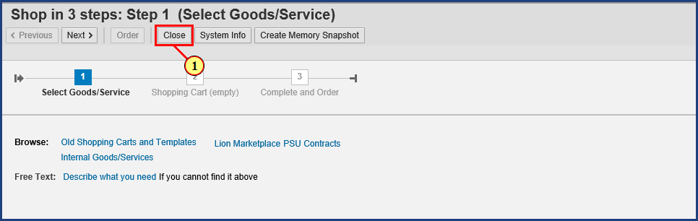

| Step | Action |
| --- | --- |
|  | The purpose of a Standard PSU Contracts shopping cart is to facilitate purchases made from one or more University-approved contracts. This simulation will demonstrate the purchase of two items known to be available from a previous recent search of PSU Contracts. Particular attention will be paid to:     * setting useful default values for the shopping cart * quickly locating desired items in the contracts * adding items to the contracts cart * ensuring the cart contents transfer properly to SIMBA as line items. |

| Step | Action |
| --- | --- |
|  | If you have completed the PSU Contracts segment of the **Shopping Cart - Catalog and Contracts Search simulation**, the context of this demonstration will be familiar. This simulation picks up right where that segment left off. Having canceled out of PSU Contracts, we are back on the Shop in 3 Steps screen. Recall that we use Step 1 of the Shop in 3 Steps function **ONLY** to confirm the availability of items. If you aren't familiar with Contract searching, we recommend completing the **Shopping Cart - Catalog and Contracts Search** simulation now.    As we found each item in PSU Contracts, we wrote down its **Contract ID Number** and the specific **Item Number**. So, we are ready to purchase the items using a Standard PSU Contracts Shopping Cart. |
| 1. | The **Close**  button is clicked. |

### Shop in 3 steps: Step 1 (Select Goods/Service)



| Step | Action |
| --- | --- |
|  | Since we have the information we need in the Contract ID Numbers and the specific Item Numbers we recorded, we have no further use for this 3 Step cart. Click OK here to close out of Shop in 3 Steps. |
| 2. | The **OK**  button is clicked. |

### Home

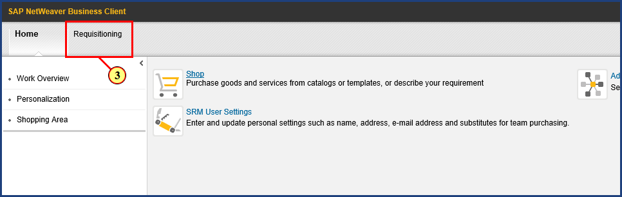

| Step | Action |
| --- | --- |
| 3. | The **Requisitioning** button is clicked. |

### Requisitioning

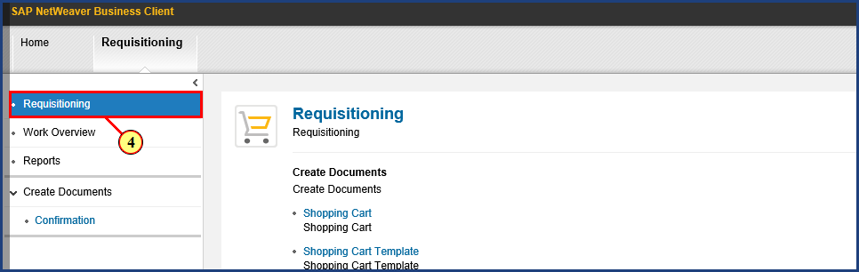

| Step | Action |
| --- | --- |
| 4. | The **Requisitioning** button is clicked. |

### Requisitioning

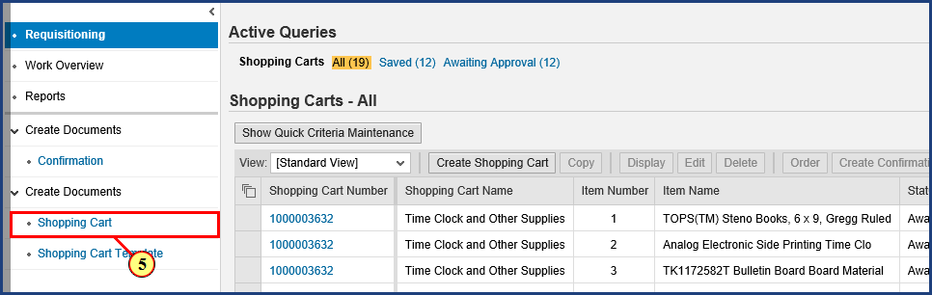

| Step | Action |
| --- | --- |
| 5. | The **Shopping Cart** button is clicked. |

### Create Shopping Cart

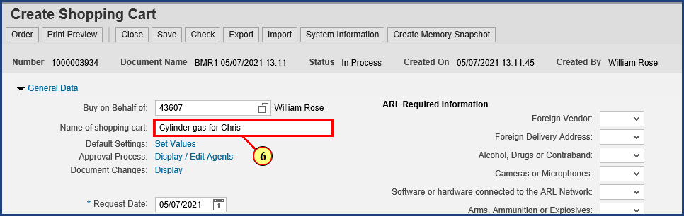

| Step | Action |
| --- | --- |
|  | It is a good idea to rename the cart to something meaningful that we can easily find later on. I will name mine “Cylinder gas for Chris.” |
| 6. | **Cylinder gas for Chris** is typed into the **Name of shopping cart** field. |

| Step | Action |
| --- | --- |
|  | **Important note!** By setting some default values now, before any line items have been created, you can make a single entry that will be carried forward to every line item in your order. This saves time by eliminating repeated information entry. The most common example is adding additional delivery address details. Rather than enter the same delivery address details five times (in a five line item order), the additional delivery address details can be supplied just once in the beginning. |

### Create Shopping Cart

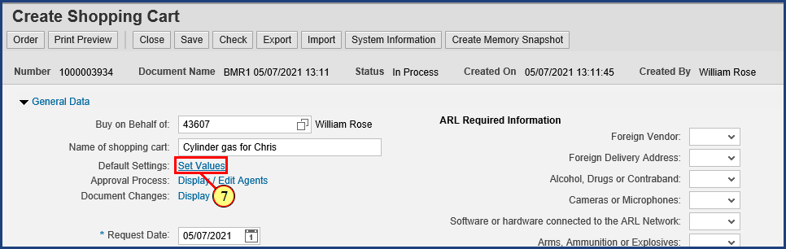

| Step | Action |
| --- | --- |
| 7. | The **Set Values** button is clicked. |

### Create Shopping Cart

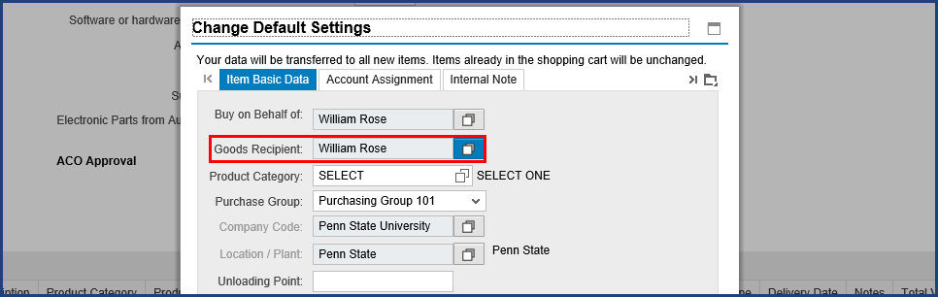

| Step | Action |
| --- | --- |
|  | In this case, I want these items to be delivered to another person, so I need to set him as the Goods Recipient. |

| Step | Action |
| --- | --- |
|  | Since I am the creator of this shopping cart, Shop OnLion shows me as the Goods Recipient by default. The assumption is that, most often, I am shopping for myself and expecting the items to be delivered to me. In this case, however, I am the shopper, but I want the items in this order to be delivered to a colleague instead. So I need to change the default setting for the Goods Recipient for this shopping cart. This is important because we are indicating to Shop OnLion who the Goods Recipient is, that is, the person who will later complete the goods confirmation in the system. |

### Create Shopping Cart

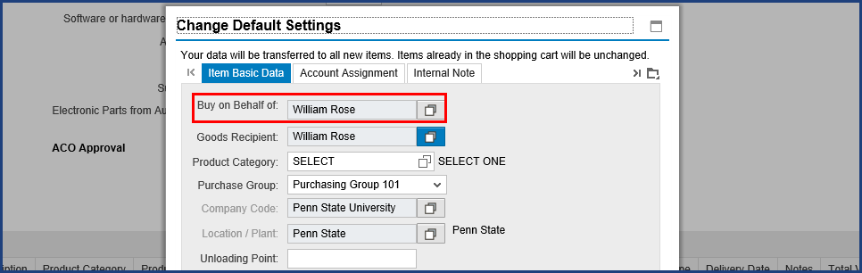

| Step | Action |
| --- | --- |
|  | Some shoppers, in attempting to transact a cart where items are delivered to someone else, have mistakenly changed the value of the "Buy on Behalf of" field to the name of the intended recipient. This is an understandable mistake, since the field name seems to describe what we are doing. But "Buy on Behalf of" instead refers to who the Shopping cart will **actually** belong to. While you may be the one to create the cart and submit it into the workflow approval process, from that point on, only the other person will see the cart or be able to monitor its progress through workflow. "Buy on Behalf of" means that you are merely initiating the process for another person. |

### Create Shopping Cart

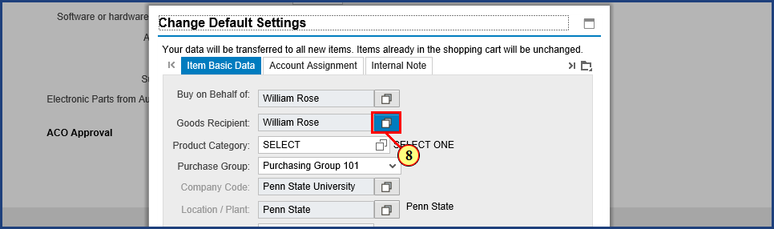

| Step | Action |
| --- | --- |
| 8. | The **Possible Values** button is clicked for **Goods Recipient**. |

### Create Shopping Cart

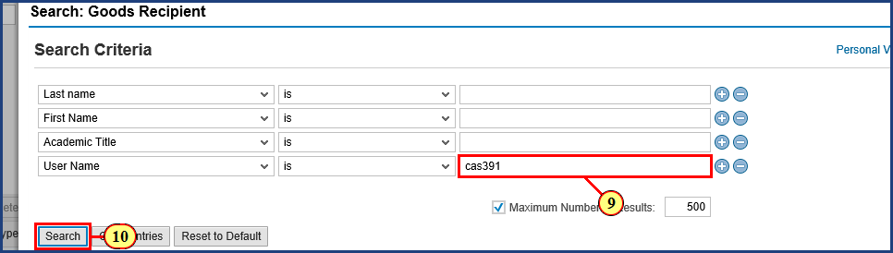

| Step | Action |
| --- | --- |
|  | While you are free to use whatever search criteria you like, the person's User Name (if known) is the most direct search. |
| 9. | **cas391** is typed into the field. |
| 10. | The **Search**  button is clicked. |

| Step | Action |
| --- | --- |
|  | Note that this process can take awhile, because the request has to cross systems to find the data. |

### Create Shopping Cart

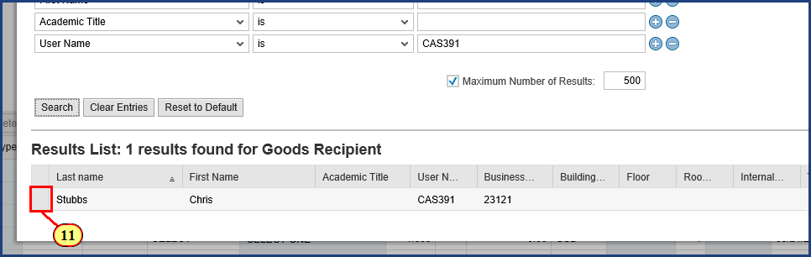

| Step | Action |
| --- | --- |
|  | One result is found from the User Name entered. |
| 11. | The **Item Select** box is clicked. |

### Create Shopping Cart

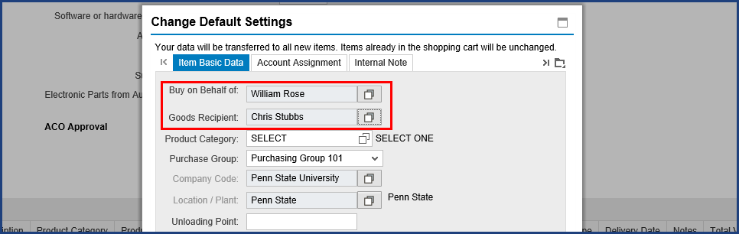

| Step | Action |
| --- | --- |
|  | Back on the Change Default Settings dialog box, we can see that Chris is now the default Goods Recipient. Also note that I am still shown as the "Buy on Behalf of" person. This is exactly what we want: I am the shopper and the cart is mine, but Chris will receive the items and will be the one to perform the Goods Confirmation for them. |

### Create Shopping Cart

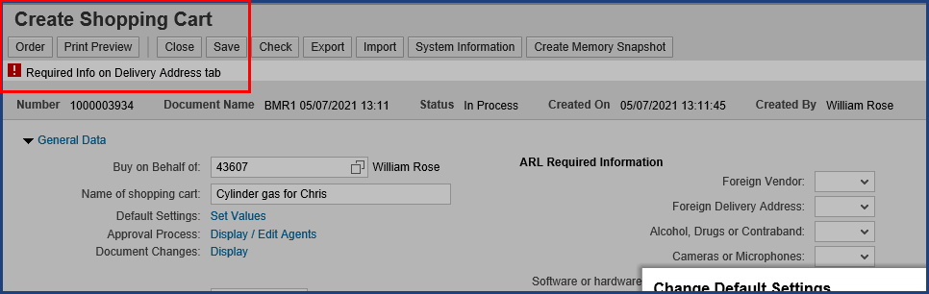

| Step | Action |
| --- | --- |
|  | Next, we will enter Delivery Address information. You may have noticed a red-level error message on the screen. That will be resolved after we provide required information. The Delivery Address tab is found by clicking on the Display More Tabs button. |

### Create Shopping Cart

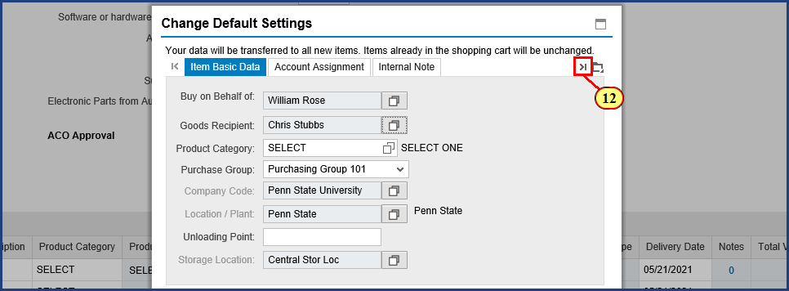

| Step | Action |
| --- | --- |
| 12. | The **Display More Tabs** button is clicked. |

### Create Shopping Cart

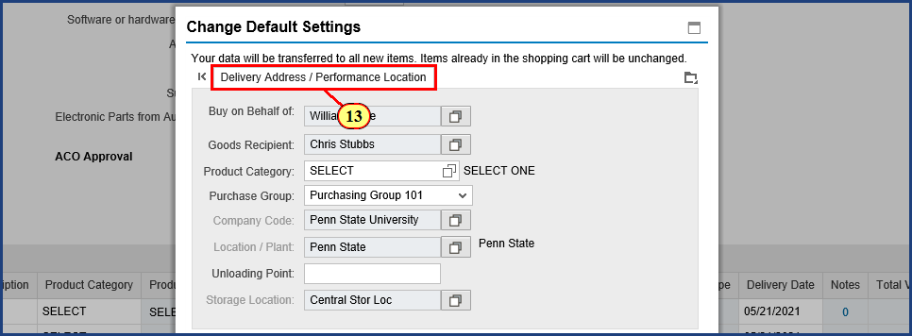

| Step | Action |
| --- | --- |
| 13. | The **Delivery Address / Performance Location** tab is clicked. |

### Create Shopping Cart

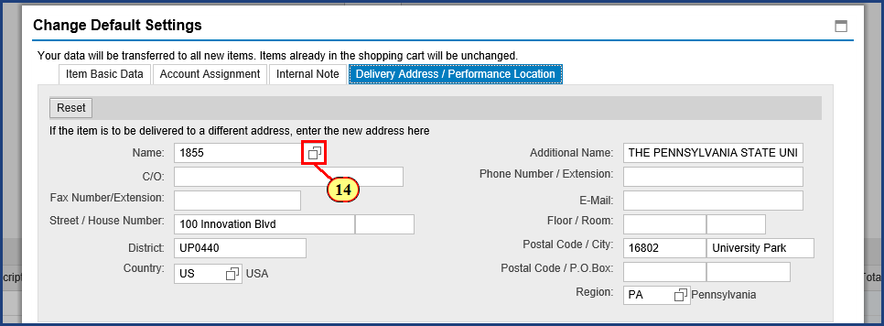

| Step | Action |
| --- | --- |
| 14. | The **Possible Values** button is clicked for **Name**. |

### Create Shopping Cart

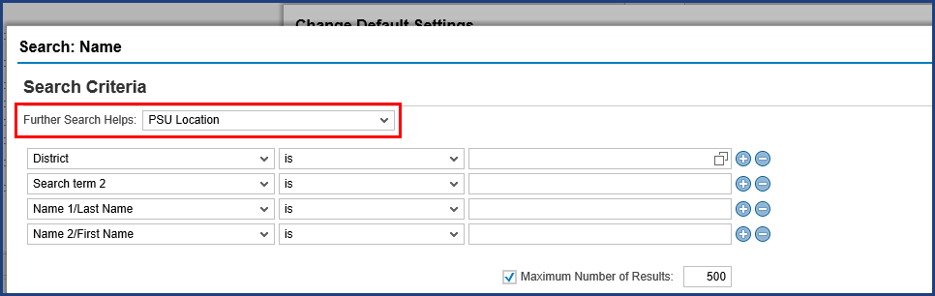

| Step | Action |
| --- | --- |
|  | The Further Search helps near the top of the screen should be set to PSU Location to maximize the customized search. |

### Create Shopping Cart

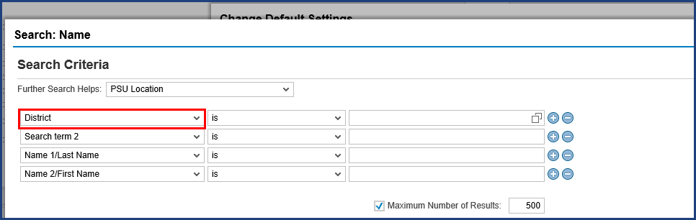

| Step | Action |
| --- | --- |
|  | The District search criterion is used to search for Location Codes, which you can look up in the Shop OnLion Delivery Address Excel Workbook on the SIMBA website. Similar to the SAP Address Number (which is used to establish your default delivery address when modifying your personal settings), the Location Code is routinely used to provide a unique Penn State address for a given shopping cart.    In our example, we will look for the Borland Building on the University Park campus, then make a note of its Location Code. Then we will return to enter that code (UP0047) into the search field here. |

### Create Shopping Cart

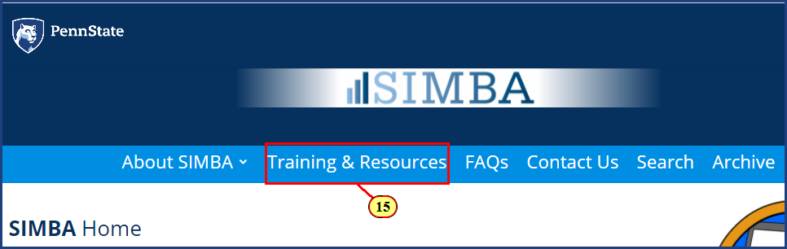

| Step | Action |
| --- | --- |
|  | On the SIMBA website, first navigate to the Training and Resources page. |
| 15. | Click the **Training & Resources** button. |

### Create Shopping Cart

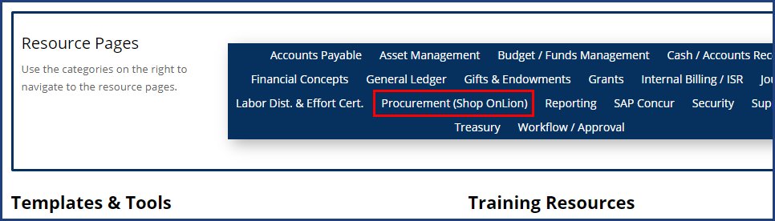

| Step | Action |
| --- | --- |
|  | Then navigate to the Procurement (Shop OnLion) Resource Page. |

### Create Shopping Cart

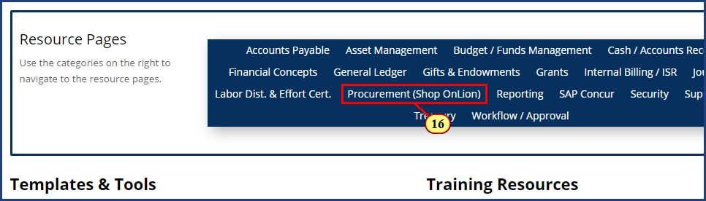

| Step | Action |
| --- | --- |
| 16. | Click the **Procurement (Shop OnLion)** button. |

### Create Shopping Cart

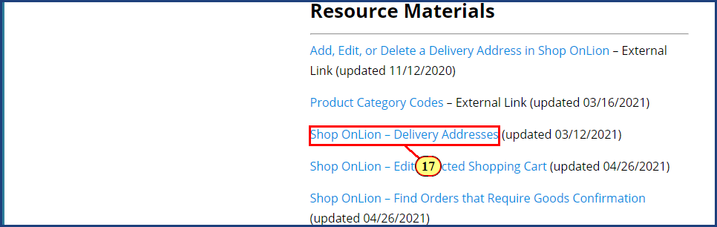

| Step | Action |
| --- | --- |
|  | When you click the Shop OnLion - Delivery Addresses link, you will be redirected to the Knowledge Base article for this resource. |
| 17. | The **Shop OnLion - Delivery Addresses** link is clicked. |

### Create Shopping Cart

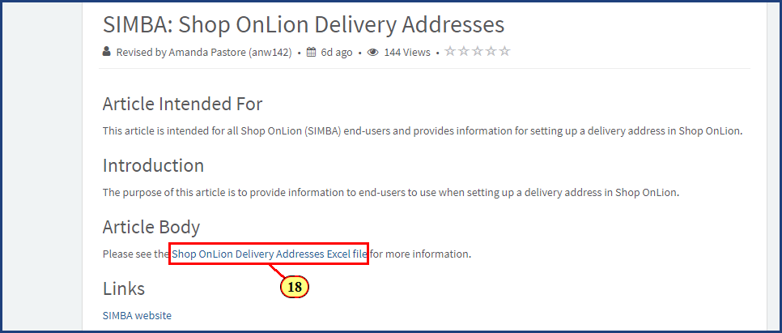

| Step | Action |
| --- | --- |
|  | Now you can see the link to the Excel file, which you should click to download. Then open this Excel file on your computer. |
| 18. | The **Shop OnLion - Delivery Addresses Excel file** link is clicked. |

### Delivery Addresses - Excel Workbook

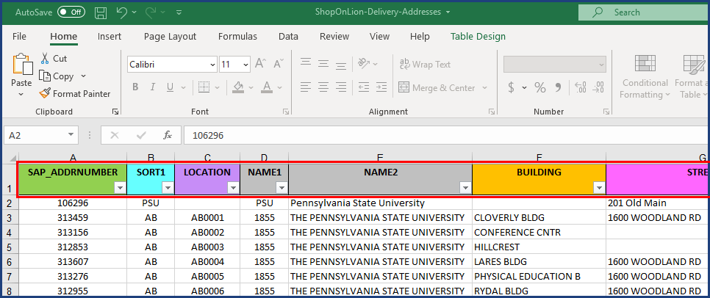

| Step | Action |
| --- | --- |
|  | The file will open to the Instructions tab, which you should read. Then switch tabs to the Shop OnLion Delivery Addresses tab, shown here.    This tab lists delivery addresses across every campus of the University (over 1,000 in total). Each address-related field or identifier has been isolated into its own column, enabling searching and sorting on that specific data. The Instructions tab clearly and concisely explains what each of these columns means and how to use them in searching.    This page might look a bit overwhelming at first, but the proper use of Excel features changes all that. We recommend that you search for a given delivery address by using the filter features on the column headings. You can quickly get to a short list of results by filtering on building names, cities, and campus abbreviations. |

### Delivery Addresses - Excel Workbook

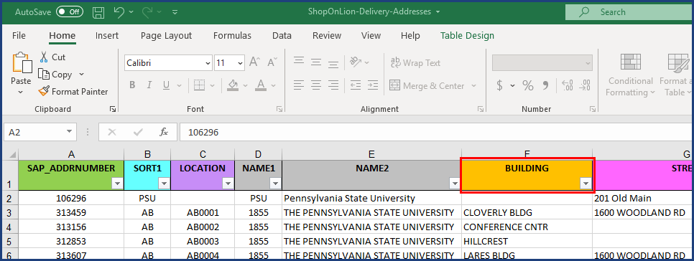

| Step | Action |
| --- | --- |
|  | In this case, I am looking for the Location code that corresponds to the Borland Building on the University Park campus. A Building search on "Borland" should find that in one step. |

### Delivery Addresses - Excel Workbook

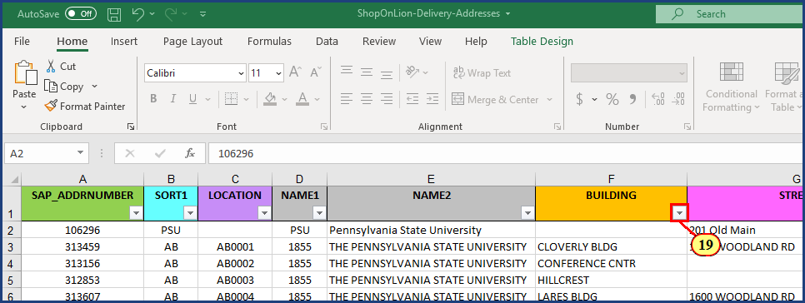

| Step | Action |
| --- | --- |
| 19. | The **Building** dropdown menu is clicked. |

### Delivery Addresses - Excel Workbook

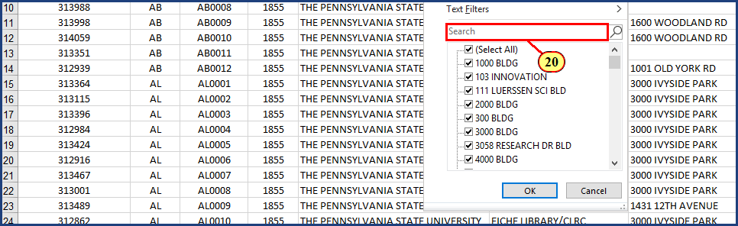

| Step | Action |
| --- | --- |
|  | Here we can see just the beginning of a very long list of buildings across the entire Penn State system. Let's type "Borland" into the Search field. |
| 20. | **Borland** is typed into the **Search** field. |

### Delivery Addresses - Excel Workbook

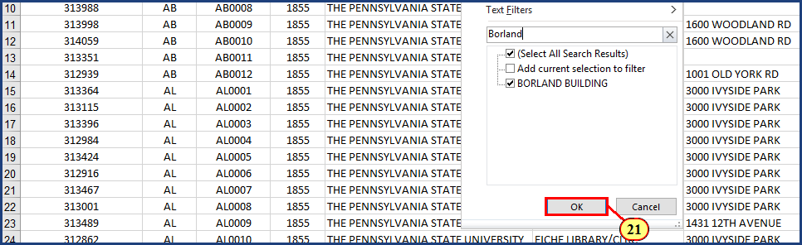

| Step | Action |
| --- | --- |
|  | As we have typed, Excel has automatically updated the list to show only buildings that match our Search field entry. The checkbox for Borland Building is already selected, so we can just click OK to choose it. |
| 21. | The **OK** button is clicked. |

### Delivery Addresses - Excel Workbook

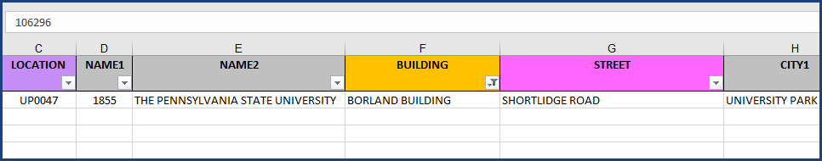

| Step | Action |
| --- | --- |
|  | This is the building I was looking for, the Borland Building on Shortlidge Road on the University Park campus. Now we will write down or copy UP0047 as the Location Code we need to enter in our District search. Back to Shop OnLion. |

### Create Shopping Cart

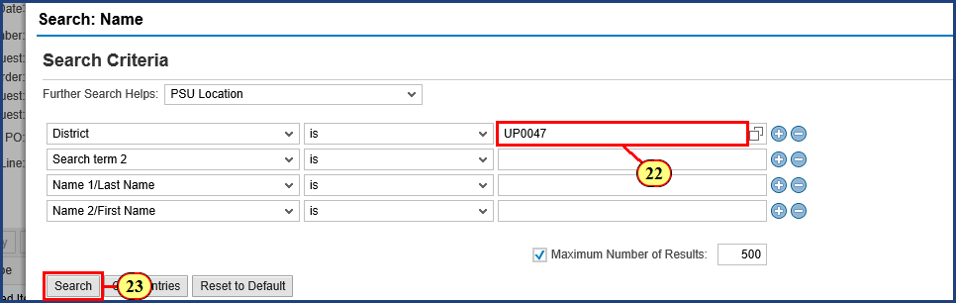

| Step | Action |
| --- | --- |
| 22. | **UP0047** is typed into the **Search Term** field. |
| 23. | The **Search**  button is clicked. |

### Create Shopping Cart

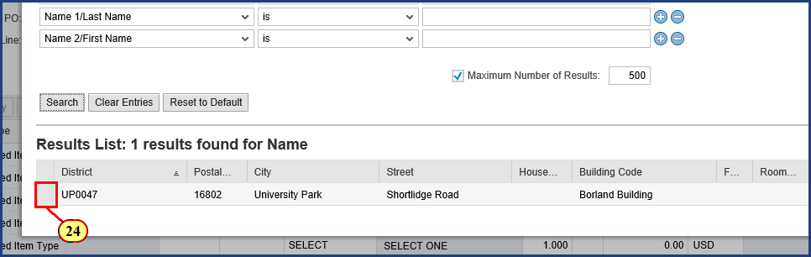

| Step | Action |
| --- | --- |
| 24. | The **Item Select** box is clicked. |

### Create Shopping Cart

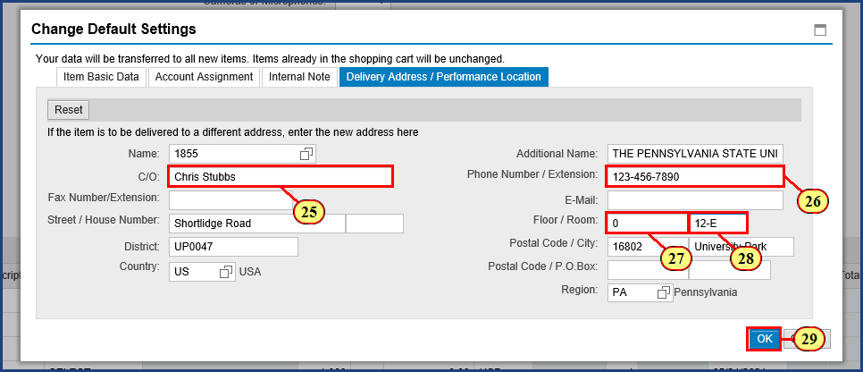

| Step | Action |
| --- | --- |
|  | You may notice something unusual in the information displayed here. Although we selected the Borland Building just now, we do not see the building name displayed. Rest assured that it will be included as part of the delivery address details.    Now I just need to add the In Care Of information by completing the details for Chris. If I were the Goods Recipient, I would supply my own name and information here instead. |
| 25. | **Chris Stubbs** is typed into the **Care Of (C/O)** field. |
| 26. | **123-456-7890** is typed into the **Phone Number / Extension** field. |

| Step | Action |
| --- | --- |
|  | The Floor and Room fields allow alpha numeric characters, so "N/A" is a valid field entry if a specific room number or floor is not applicable. |
| 27. | **0** is typed into the **Floor** field. |
| 28. | **12-E** is typed into the **Room** field. |
| 29. | The **OK**  button is clicked. |

### Shopping Cart

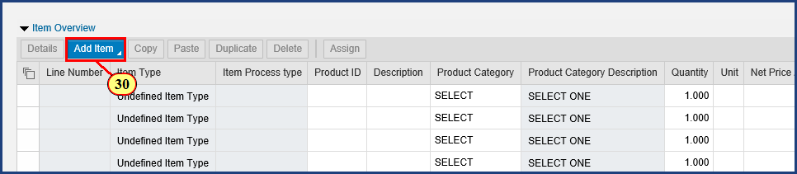

| Step | Action |
| --- | --- |
|  | As we will see, that was time well spent that will pay us back later. The error on our screen has also been resolved. On to our first line item. |
| 30. | The **Add Item to Shopping Cart**  button is clicked. |

### Shopping Cart

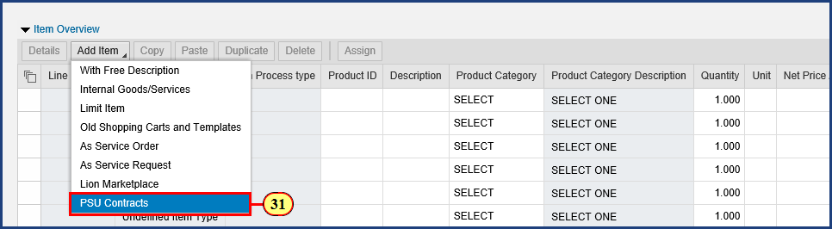

| Step | Action |
| --- | --- |
|  | Here is where PSU Contracts comes back in. When we select this option from the menu, PSU Contracts will open. |

| Step | Action |
| --- | --- |
|  | **Important!** Each and every line item in a PSU Contracts shopping cart must be "PSU Contracts." Standard shopping carts should **never** contain a mix of line item types.     * Lion Marketplace shopping cart -- only use "Lion Marketplace" line items * PSU Contracts shopping cart -- only use "PSU Contracts" line items * Free Text shopping cart -- only use "With Free Description" line items |
| 31. | The **PSU Contracts** menu item is clicked. |

### Shopping Cart

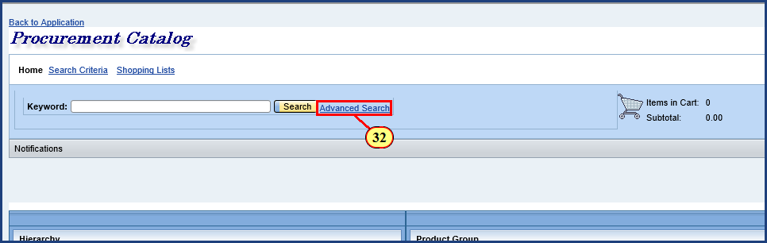

| Step | Action |
| --- | --- |
|  | Because we already have the Contract Number and the Contract Item Number from the PSU Contracts segment of the Shopping Cart – Catalog and Contracts Search, we can quickly order the item by using the Advanced Search link. |
| 32. | The **Advanced Search** button is clicked. |

### Shopping Cart

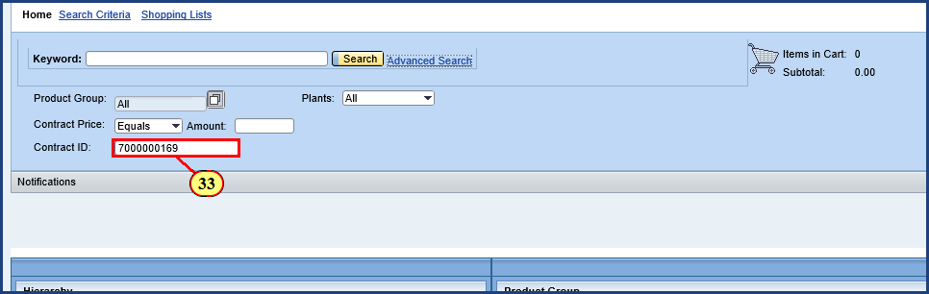

| Step | Action |
| --- | --- |
|  | In the PSU Contracts segment of the Shopping Cart - Catalog and Contracts Search simulation, we wrote down a Contract Number of 7000000169. This is the value we enter in the Contract ID field here. |
| 33. | **7000000169** is typed into the **Contract ID** field. |

### Shopping Cart

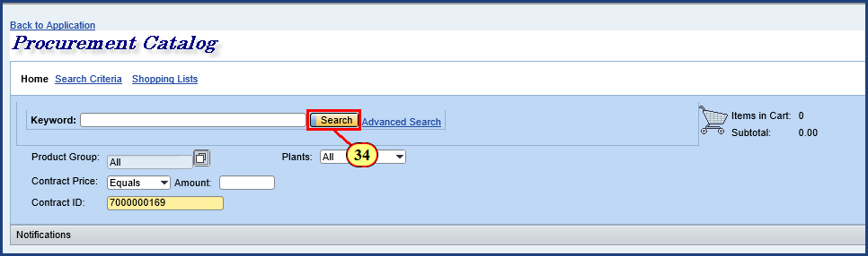

| Step | Action |
| --- | --- |
| 34. | The **Search button** button is clicked. |

### Shopping Cart

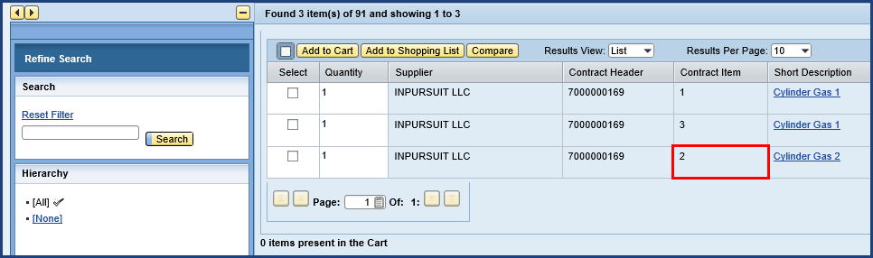

| Step | Action |
| --- | --- |
|  | This contract has three items, and some have many more. Fortunately, we wrote down the Contract Item Number, which is 2. |

### Shopping Cart

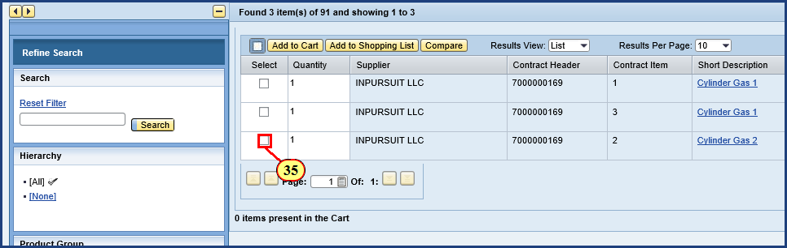

| Step | Action |
| --- | --- |
| 35. | The **Item Select** checkbox is clicked. |

### Shopping Cart

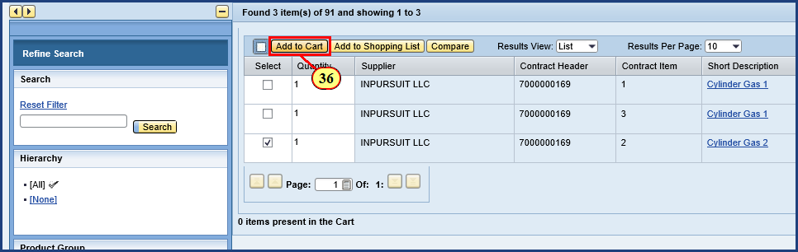

| Step | Action |
| --- | --- |
|  | In PSU Contracts, "Adding to Cart" means adding the item to the Contracts cart. Later, when we checkout, the items will automatically be transferred to our SIMBA Shopping Cart. |
| 36. | The **Add to Cart** button is clicked. |

### Shopping Cart

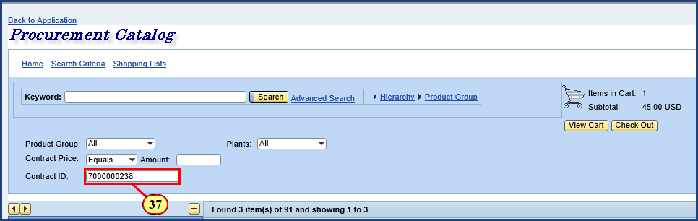

| Step | Action |
| --- | --- |
|  | You will recall that we searched for and found a second cylinder of gas on another contract. We wrote down a Contract Number of 7000000238. |
| 37. | **7000000238** is typed into the **Contract ID** field. |

### Shopping Cart

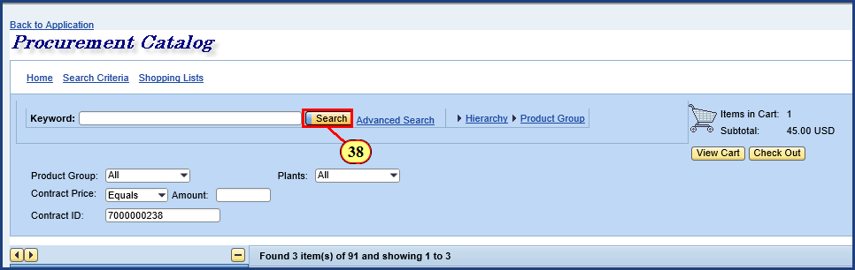

| Step | Action |
| --- | --- |
| 38. | The **Search** button is clicked. |

### Shopping Cart

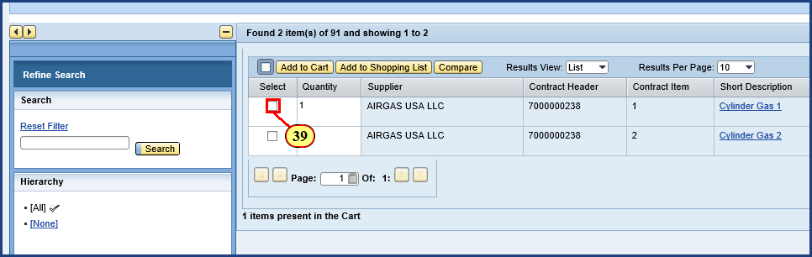

| Step | Action |
| --- | --- |
|  | This Airgas contract has two items. We wrote down a Contract Item Number of 1. |
| 39. | The **Item Select** checkbox is clicked. |

### Shopping Cart

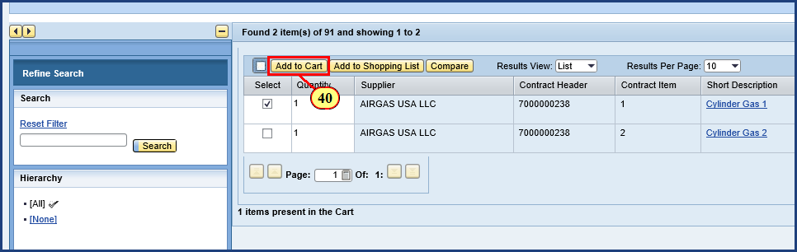

| Step | Action |
| --- | --- |
| 40. | The **Add to Cart** button is clicked. |

### Shopping Cart

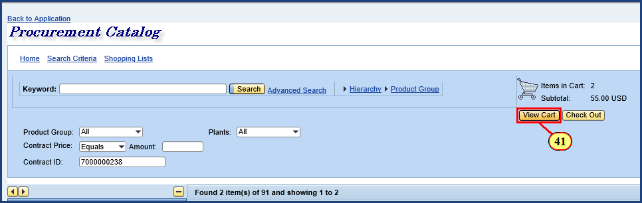

| Step | Action |
| --- | --- |
|  | Now we should review the cart before checking out to be sure everything is right. |
| 41. | The **View Cart** button is clicked. |

### Shopping Cart

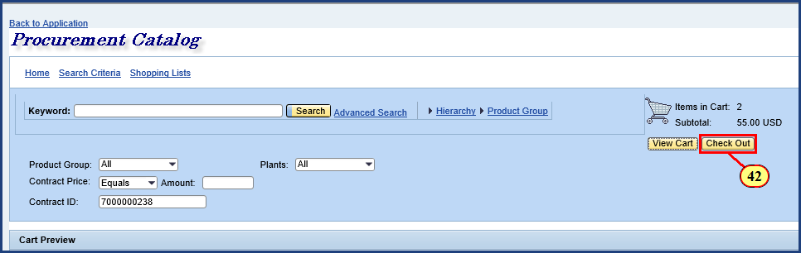

| Step | Action |
| --- | --- |
|  | The items and quantities are correct, so let's proceed to Check Out. The Check Out button is clicked to transfer the Contracts cart items to the SIMBA shopping cart. |
| 42. | The **Check Out** button is clicked. |

### Shopping Cart

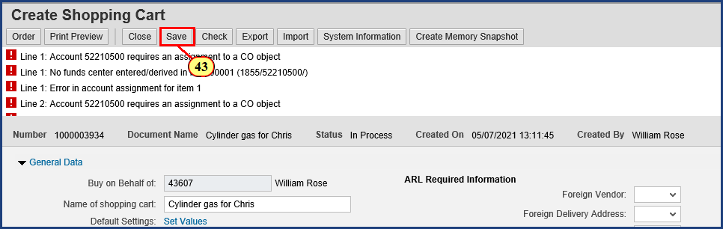

| Step | Action |
| --- | --- |
|  | Once the PSU Contracts items are transferred back to the SIMBA shopping cart, various errors and warnings will appear in the top messages. Many of these can be resolved by entering budget information for the shopping cart, which we will proceed to do. |

| Step | Action |
| --- | --- |
|  | A best practice:    **Always Save the cart immediately after returning items from PSU Contracts.**    Bear in mind that Shop OnLion does not continuously auto-save your information. So, periodically save your cart. Should you get pulled away from your shopping by other tasks, your session may time-out. The addition of line items is a natural point in the process to save your progress. |
| 43. | The **Save** button is clicked. |

### Shopping Cart

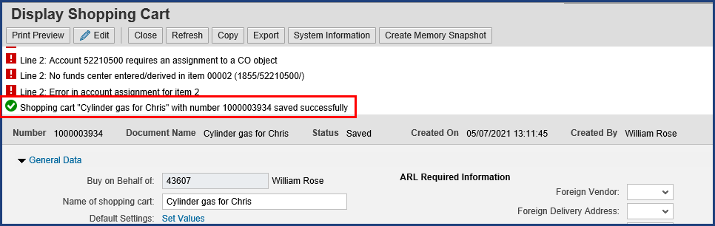

| Step | Action |
| --- | --- |
|  | Note the system confirmation that our cart saved successfully. |

### Shopping Cart

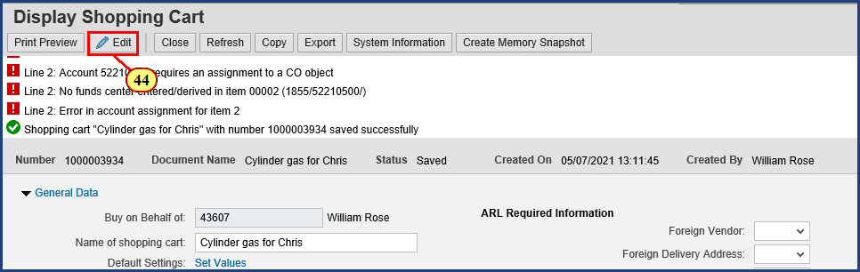

| Step | Action |
| --- | --- |
|  | Now it's time to start resolving these errors! |

| Step | Action |
| --- | --- |
|  | **Note: After the Save button on the shopping cart is clicked, the cart will go from “Create” mode into “Display” mode.** No further changes to the cart can be made while it is in Display mode. You must click the Edit button in the top ribbon to continue working. |
| 44. | The **Edit** button is clicked. |

### Shopping Cart

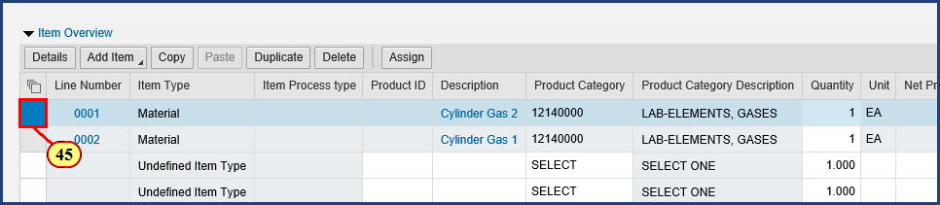

| Step | Action |
| --- | --- |
| 45. | The **Line Number Select** button is clicked for **Line Item 0001**. |

### Shopping Cart

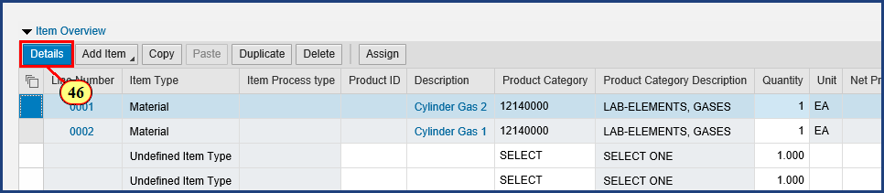

| Step | Action |
| --- | --- |
|  | Once the line item is selected, clicking the Details button will reveal additional information to view, add, and edit. |
| 46. | The **Item Details**  button is clicked. |

### Shopping Cart

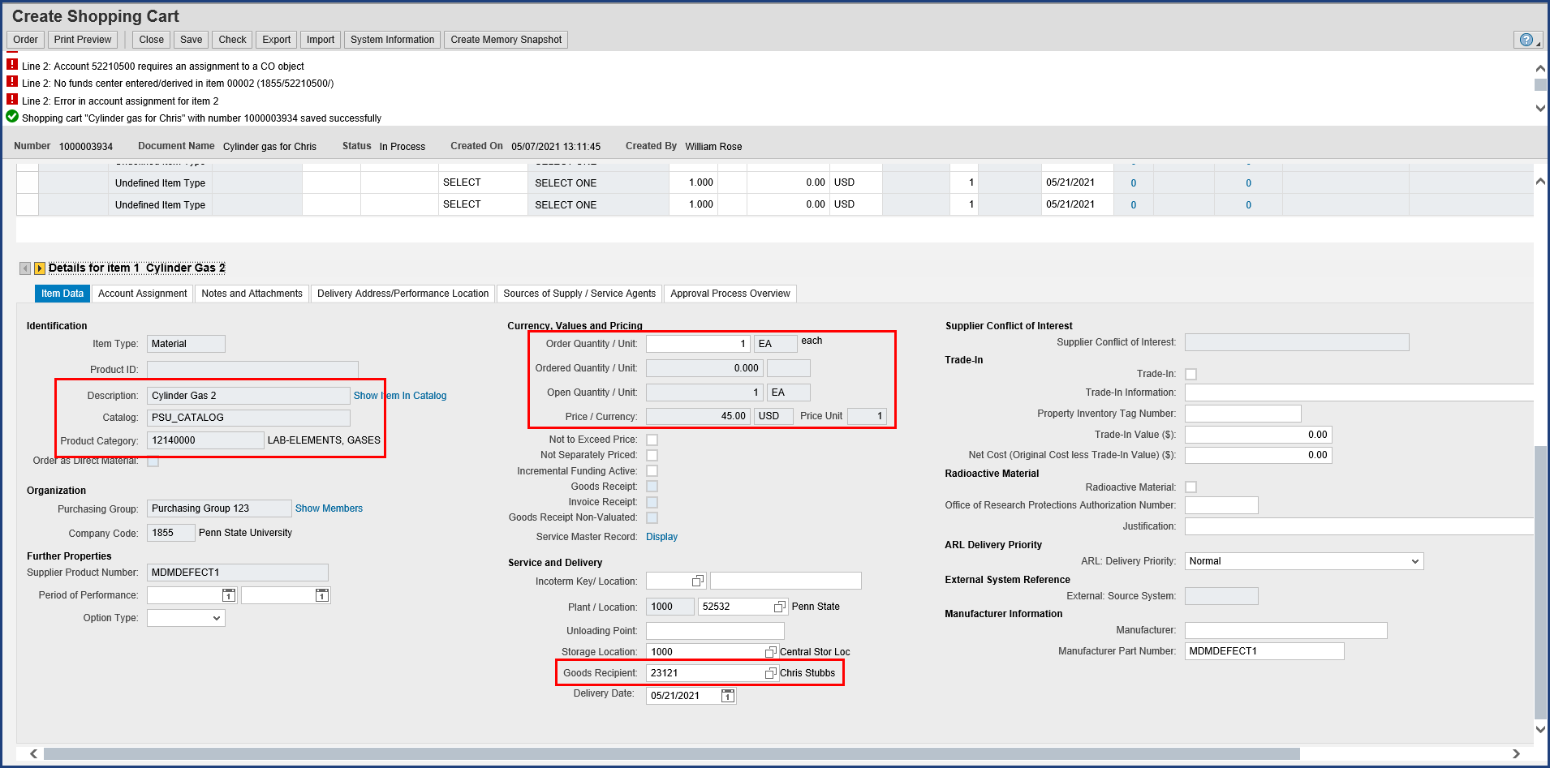

| Step | Action |
| --- | --- |
|  | Here we can see quite a bit of Item Data detail for Item 1 that has been populated from the PSU contract. On the left side under Identification, we see the item Description and Product Category number with description for the first type of cylinder gas we ordered. In the upper middle under Currency, Values and Pricing, we see that we have a single unit valued at $45.00. And in the lower middle under Service and Delivery, we see that Chris Stubbs is the Goods Recipient, which confirms the default setting we made earlier. |

| Step | Action |
| --- | --- |
|  | This Item Data tab may appear a bit overwhelming, but you won’t need to enter that much information. Remember that not every field is required in every case; just fill in what pertains to your situation.    **Tip**: Establish a consistent routine for supplying item details to maximize your accuracy and efficiency:     * Work through the line item tabs from left to right (Item Data through Delivery Address/Performance Location) * On each tab, supply information from top to bottom     That said, don't worry about missing details. The system's error messages will alert you to omitted and/or incorrect data. |

| Step | Action |
| --- | --- |
|  | Note that the Create Shopping Cart window has been automatically scrolled down to the Item Details area. To return to the General Data or header information, just scroll back up. |

### Shopping Cart

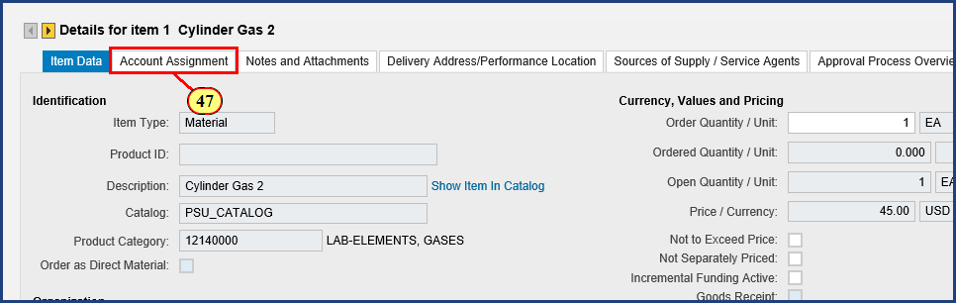

| Step | Action |
| --- | --- |
| 47. | The **Account Assignment** button is clicked. |

### Shopping Cart

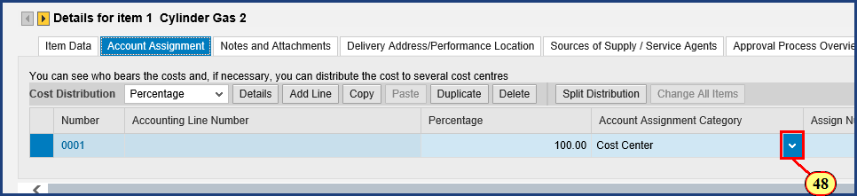

| Step | Action |
| --- | --- |
| 48. | The **Account Assignment Category** dropdown is clicked. |

### Shopping Cart

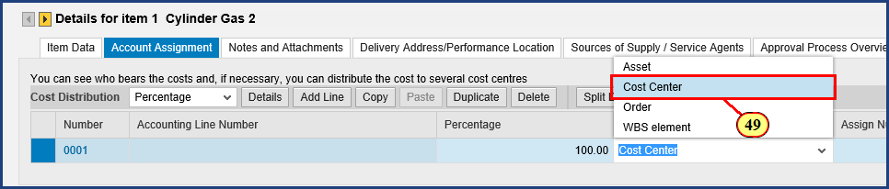

| Step | Action |
| --- | --- |
|  | The Account Assignment Category drop down menu allows you to choose from Asset, Cost Center, Order, and Work Breakdown Structure Element. In Shop OnLion, an Internal Order is simply referred to as Order in the Account Assignment Category. We will stay with a Cost Center and enter the Cost Center for our area. |
| 49. | The **Cost Center** menu item is clicked. |

### Shopping Cart

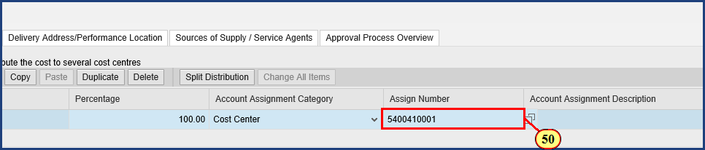

| Step | Action |
| --- | --- |
|  | In this example, we'll enter the cost center that we have previously determined to be correct for our shopping. To identify a cost object, use the Possible Values icon to search for one, or consult your financial office to determine the cost object you should utilize for shopping. |
| 50. | **5400410001** is typed into the **Assign Number** field and **Enter** is pressed. |

### Shopping Cart

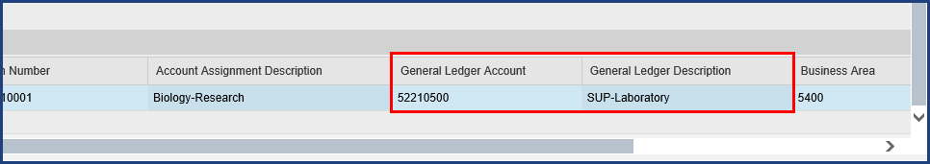

| Step | Action |
| --- | --- |
|  | To date, approximately 85% of product categories have been matched to the most likely General Ledger Account to classify the expense. You should always review the G/L Account to ensure it is appropriate for your purchase. If no G/L Account has populated by default, you must enter one, as this is a required field. |

### Shopping Cart

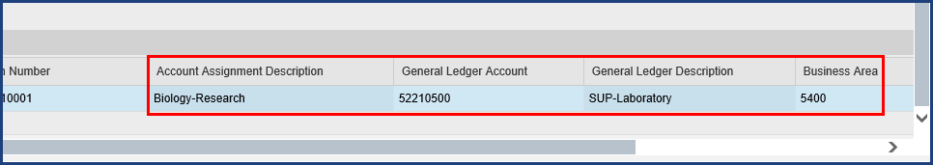

| Step | Action |
| --- | --- |
|  | Notice that the Account Assignment Description and Business Area have auto-populated from the master data associated with the Cost Center entered. |

### Shopping Cart

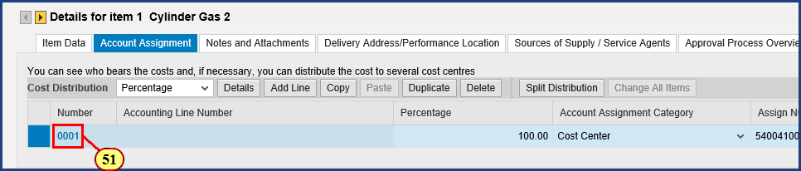

| Step | Action |
| --- | --- |
|  | We can get a more detailed view of the account assignment details derivation just completed. We will click on the blue number 0001 to view those details below. |
| 51. | The **Line Number 0001** button is clicked. |

### Edit Shopping Cart

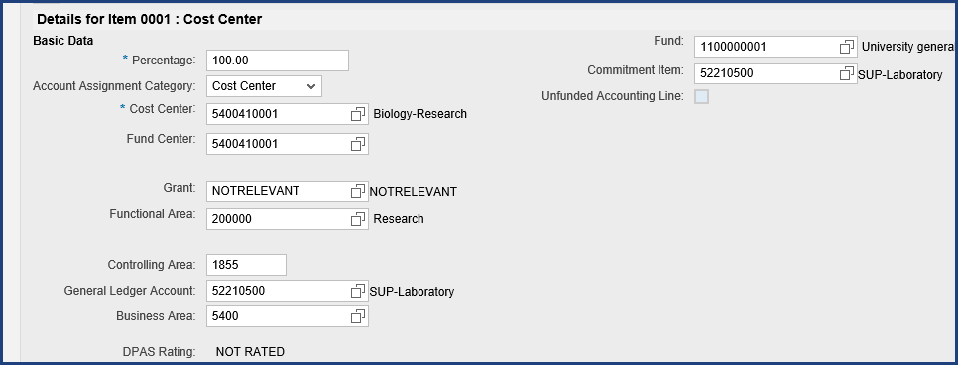

| Step | Action |
| --- | --- |
|  | Now we can see additional detail for this Cost Center derived from master data, including the Fund Center, General Ledger Account, Business Area, Fund, and Commitment Item. This system derived information should not be edited directly by the shopper. This detailed view allows me to confirm this account assignment is exactly what I am going to need for line item 2. We will copy that in a moment, but first we have to scroll right to click the close box for this detailed view. |

### Edit Shopping Cart

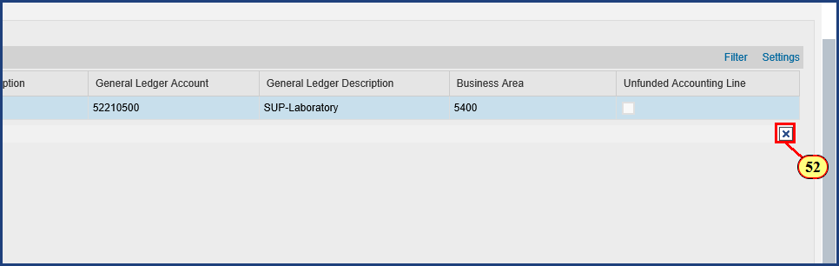

| Step | Action |
| --- | --- |
| 52. | The **Close Tray**  button is clicked. |

### Shopping Cart

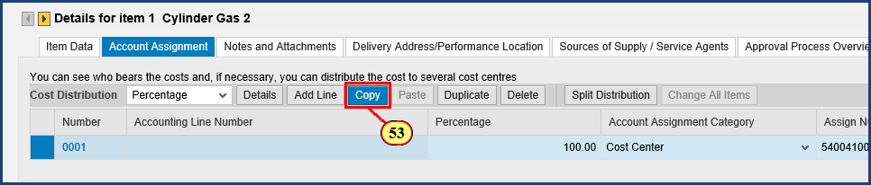

| Step | Action |
| --- | --- |
|  | Helpful hint: if you need to split the cost of the items across multiple accounts, enter all details of the cost distribution prior to copying to the clipboard.    Clicking the Copy button will populate the clipboard and display it at the bottom of the screen. |
| 53. | The **Copy to Clipboard**  button is clicked. |

### Shopping Cart

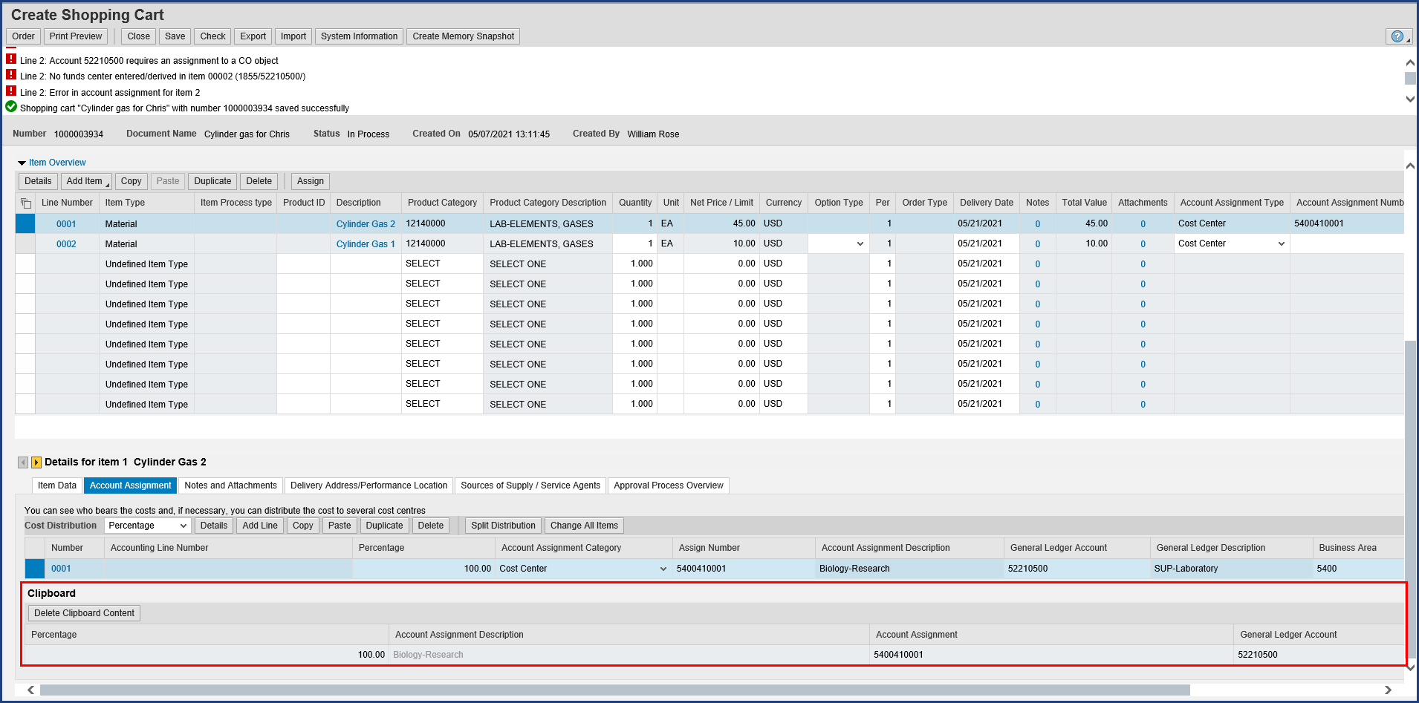

| Step | Action |
| --- | --- |
|  | The clipboard is opened and populated with the Account Assignment data. |

### Shopping Cart

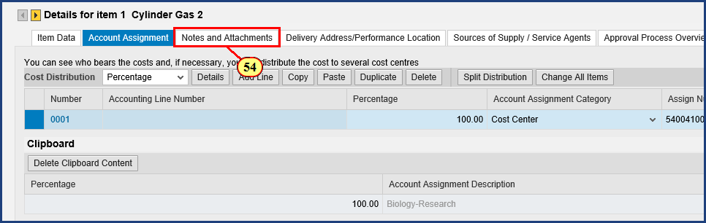

| Step | Action |
| --- | --- |
| 54. | The **Notes and Attachments** button is clicked. |

### Shopping Cart

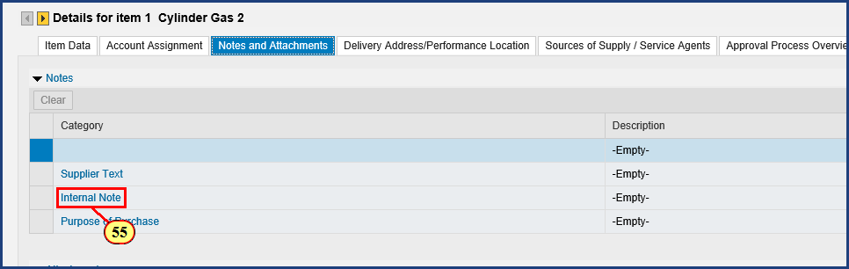

| Step | Action |
| --- | --- |
|  | PSU Contracts have been negotiated by Purchasing, so Supplier Text is not required unless your situation is unique. If your departmental approvers request or require Internal Notes or Purpose of Purchase, this is where you should add them. |
| 55. | The **Internal Note** button is clicked. |

### Shopping Cart

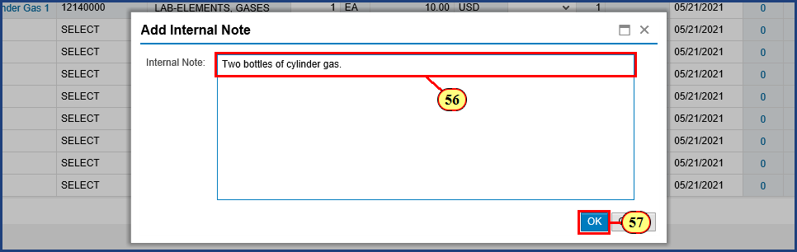

| Step | Action |
| --- | --- |
| 56. | **Two bottles of cylinder gas.** is typed into the **Internal Note** field. |
| 57. | The **OK**  button is clicked. |

### Shopping Cart

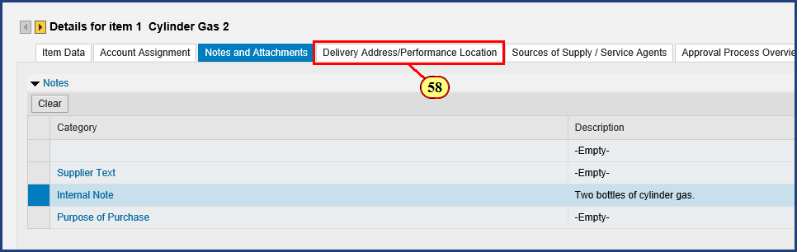

| Step | Action |
| --- | --- |
| 58. | The **Delivery Address/Performance Location** button is clicked. |

### Shopping Cart

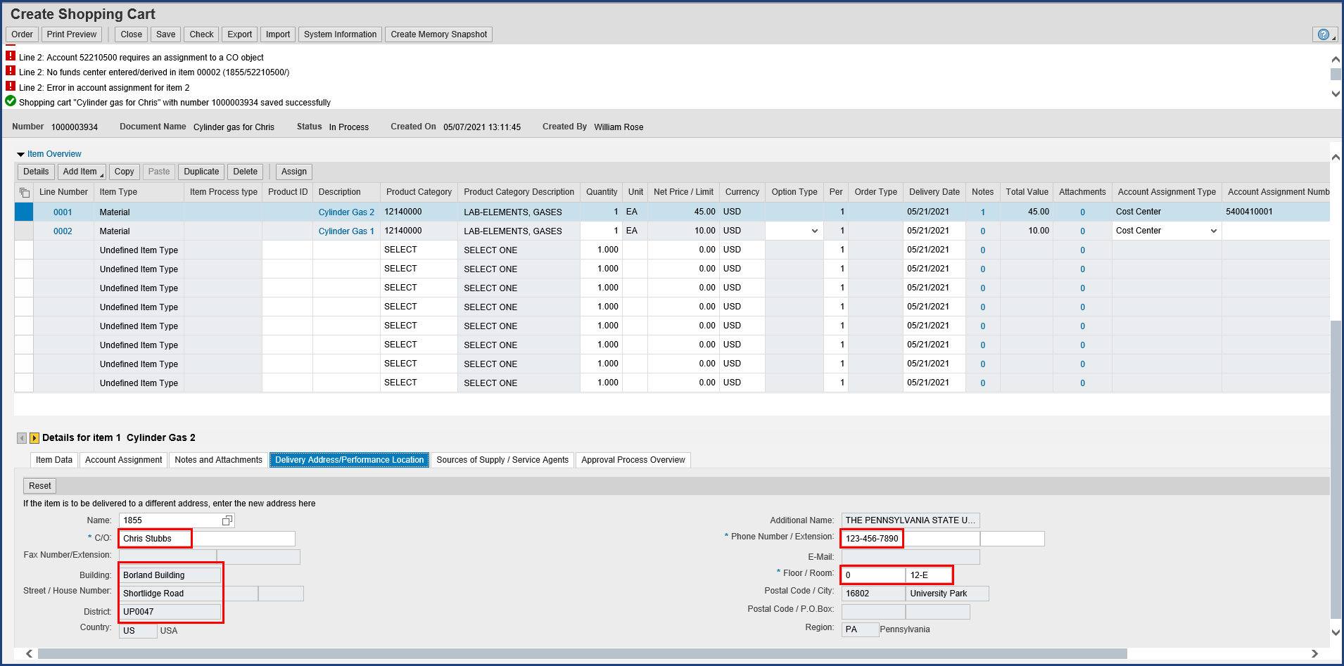

| Step | Action |
| --- | --- |
|  | The default settings we entered at the start of this shopping cart, in the header, are showing.    Unlike a Free Text shopping cart, PSU Contract orders do not require you to indicate a preferred supplier, since the supplier is already known. We can skip the Sources of Supply / Service Agents tab.    That does it for Line Item 1. Let's navigate to Item 2. |

### Shopping Cart

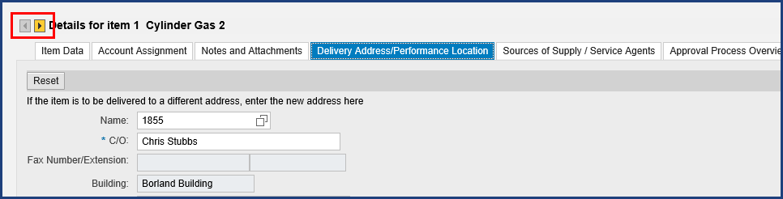

| Step | Action |
| --- | --- |
|  | The Next Item and Previous Item buttons allow us to move to particular line items in the shopping cart. |

### Shopping Cart

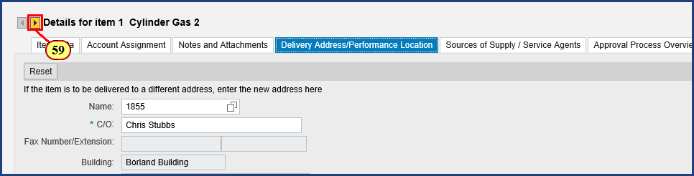

| Step | Action |
| --- | --- |
| 59. | The **Next Item**  button is clicked. |

### Shopping Cart

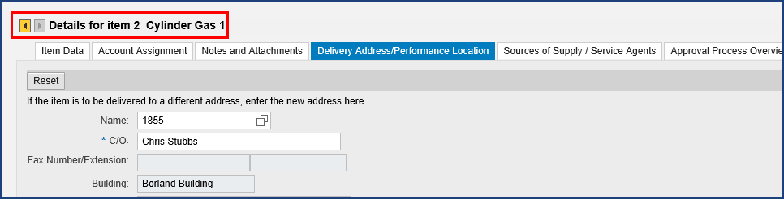

| Step | Action |
| --- | --- |
|  | Now we are working with Item 2, the other type of cylinder gas. |

### Shopping Cart

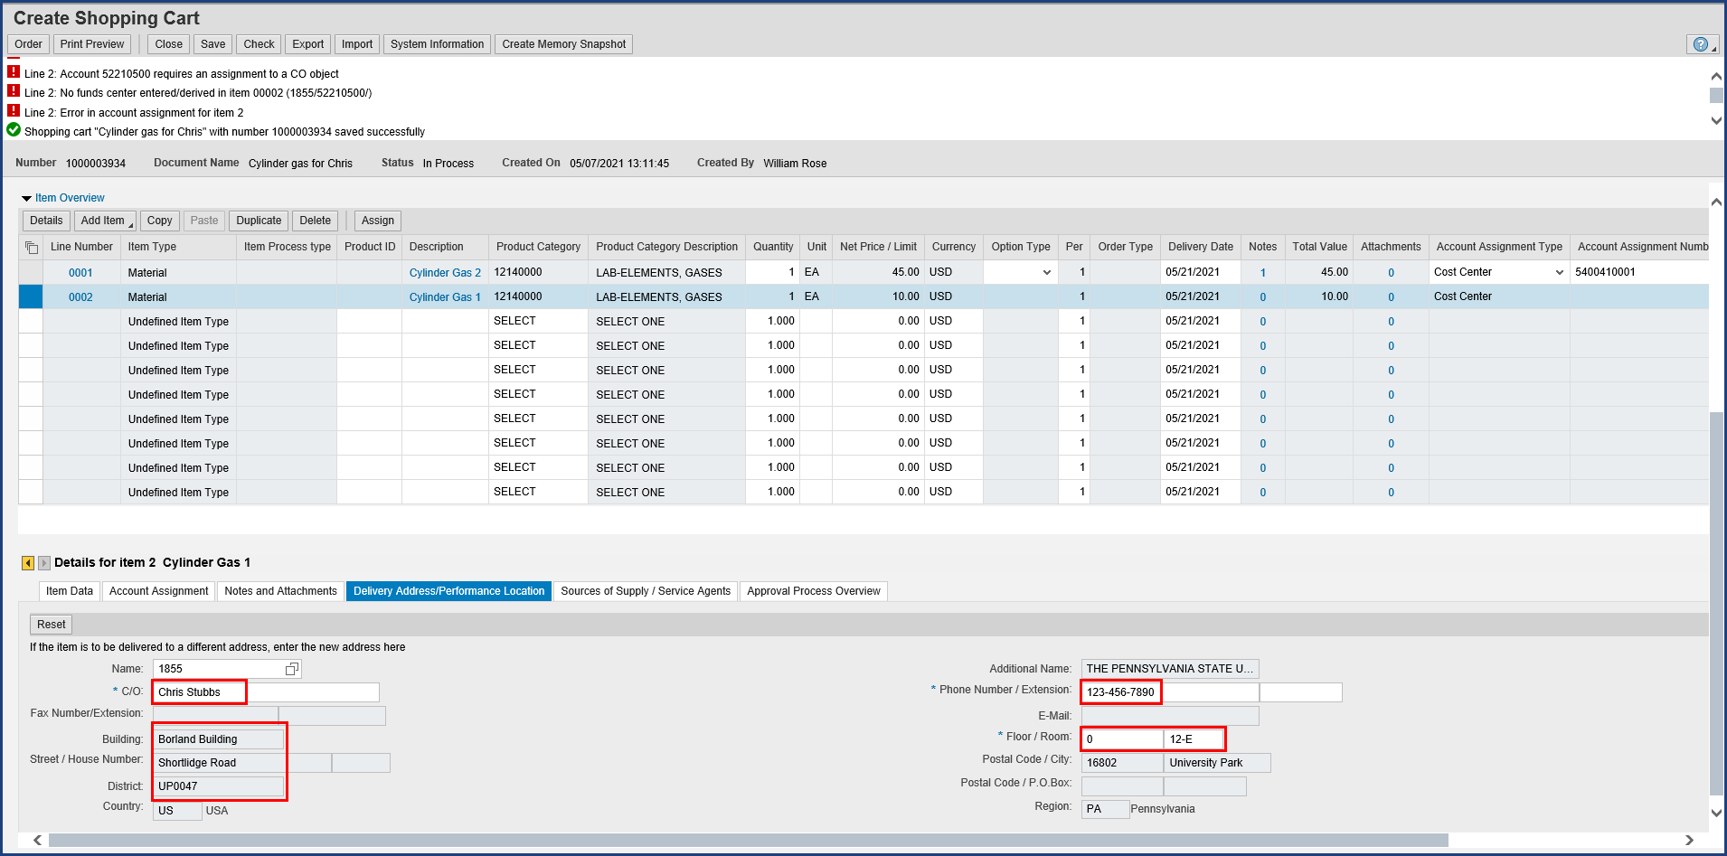

| Step | Action |
| --- | --- |
|  | The default settings we entered at the start of this shopping cart, in the header, are showing here for Item 2 as well. For Item 2, the only tasks remaining are to review the Item Data Tab for accuracy, and to complete the Account Assignment. You are already familiar with the Item Data tab review, so we won't demonstrate that again, but in an actual transaction you would confirm the accuracy and completeness of that tab. On to the Account Assignment. |

### Shopping Cart

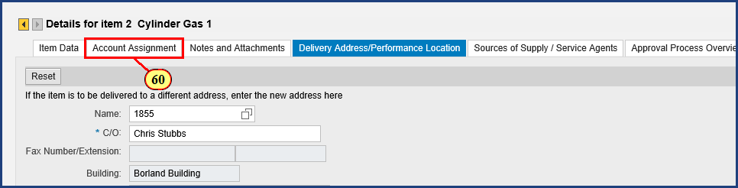

| Step | Action |
| --- | --- |
| 60. | The **Account Assignment** button is clicked. |

### Shopping Cart

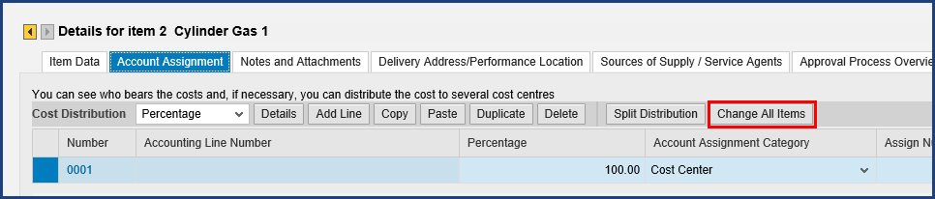

| Step | Action |
| --- | --- |
|  | Incidentally, if you have a larger number of line items and you want to use the same Account Assignment information copied to your clipboard for all of them, click the Change All Items button. Since we only have two items, we will just click Paste instead. |

### Shopping Cart

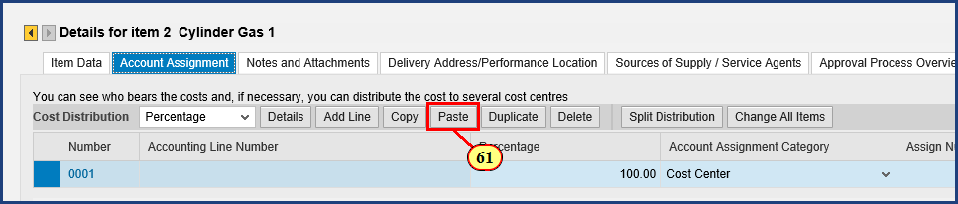

| Step | Action |
| --- | --- |
| 61. | The **Paste** button is clicked. |

### Shopping Cart

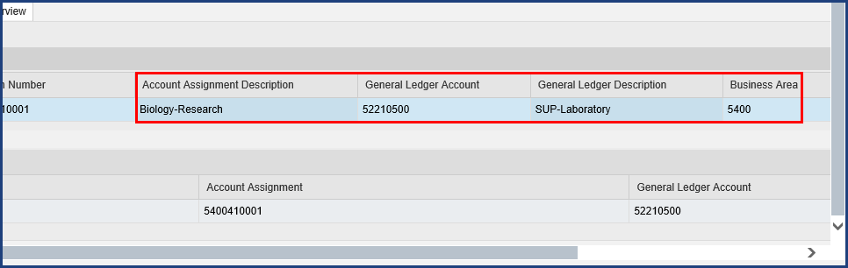

| Step | Action |
| --- | --- |
|  | Note the updated information for Item 2. |

### Shopping Cart

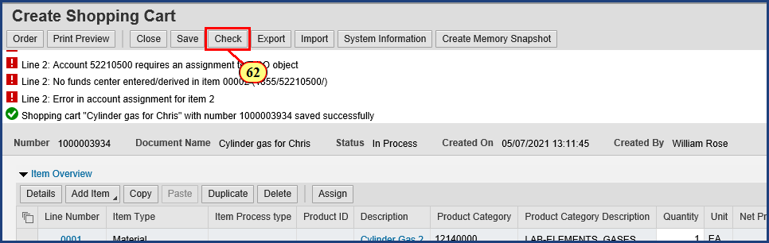

| Step | Action |
| --- | --- |
|  | With both line items complete, our red-level error message status is outdated and in need of a refresh. |
| 62. | The **Check** button is clicked. |

### Shopping Cart

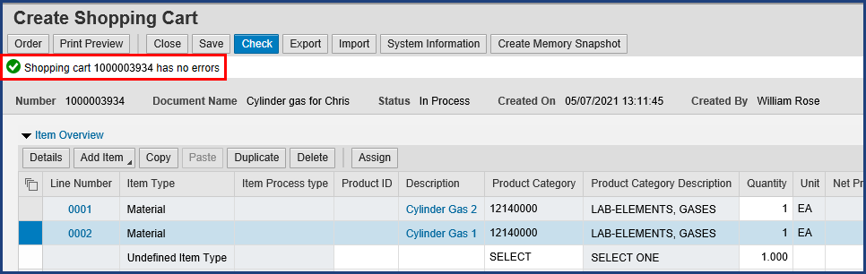

| Step | Action |
| --- | --- |
|  | **IMPORTANT!** You **MUST** click Order and **see a system confirmation** before you close out of the transaction. |

### Shopping Cart

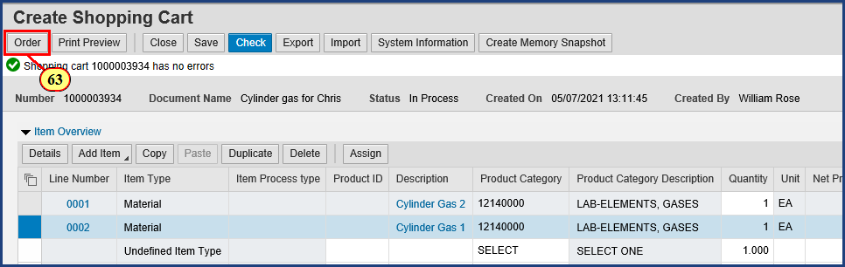

| Step | Action |
| --- | --- |
| 63. | The **Order** button is clicked. |

### Shopping Cart

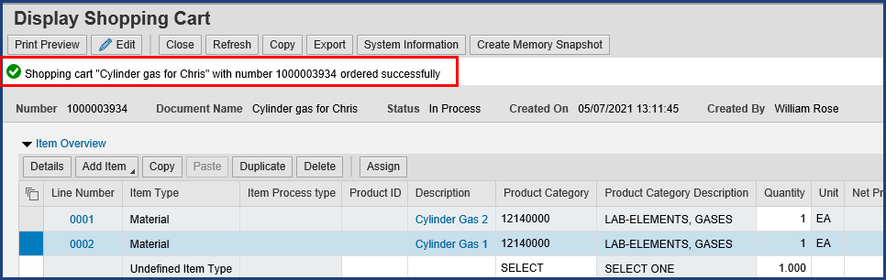

| Step | Action |
| --- | --- |
|  | This order has been successfully submitted into workflow for approval. Every shopping cart will be evaluated by the system to determine the necessary workflow steps. Write down the shopping cart number shown in the system status. In this case, the number is 1000003934. |

### Shopping Cart

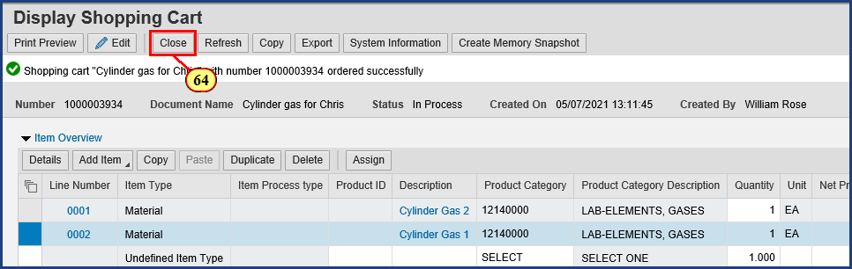

| Step | Action |
| --- | --- |
|  | **One final tip:** To close the Create Shopping Cart window, always click the Close button, not the X-box that closes the window. |
| 64. | The **Close**  button is clicked. |

### Requisitioning

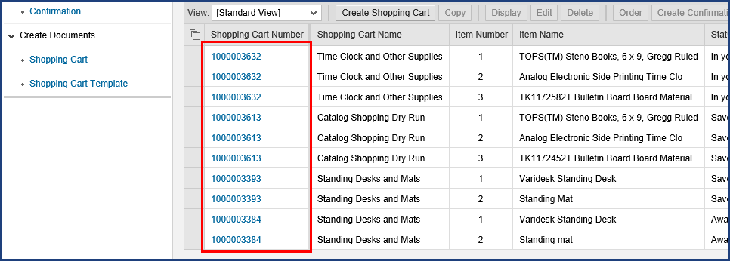

| Step | Action |
| --- | --- |
|  | Back on the Active Queries screen, we don't see the items from Shopping Cart 1000003934 listed. We need to click the Refresh button to get an updated listing. |

### Requisitioning

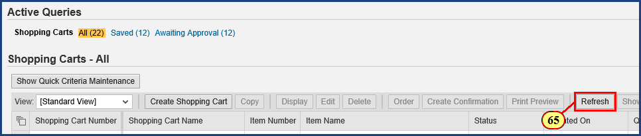

| Step | Action |
| --- | --- |
| 65. | The **Refresh**  button is clicked. |

### Requisitioning

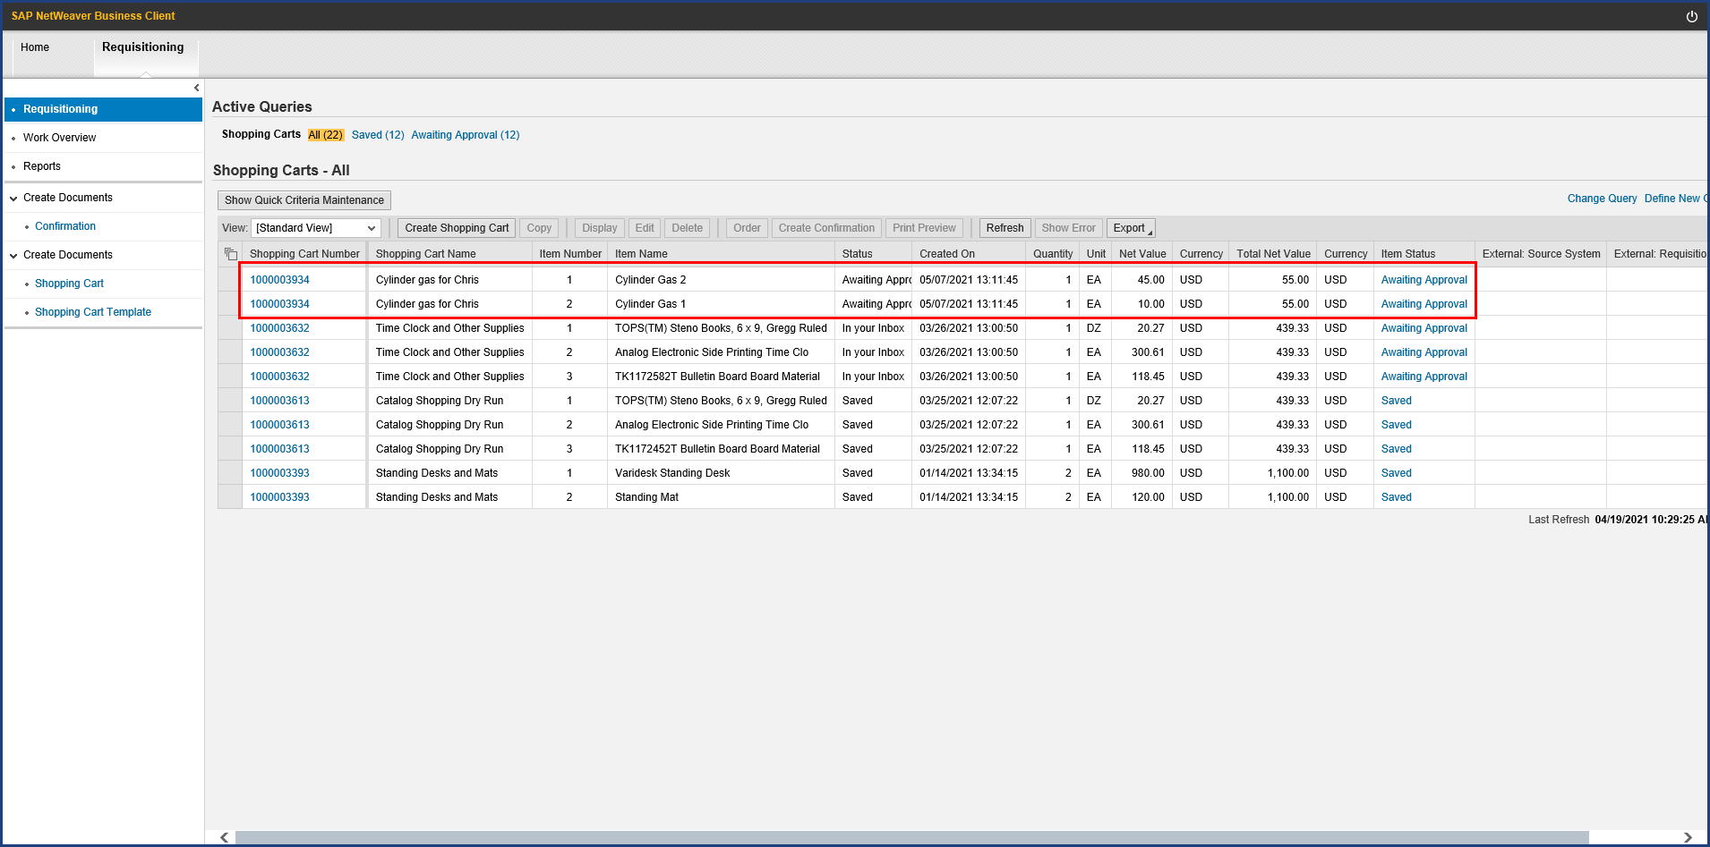

| Step | Action |
| --- | --- |
|  | **Note:** Because this shopping cart includes items from two different contracts, two different purchase orders (one to each supplier) will be created from the approved cart. SIMBA's flexibility allows you to combine purchases from multiple contracts into a single cart, and SIMBA is smart enough to send each supplier a purchase order only for the items ordered from their contract. |

| Step | Action |
| --- | --- |
|  | Most PSU Contract carts under $25,000 automatically create a purchase order that is sent to the supplier, rather than routing to Purchasing for sourcing after the shopping cart approval workflow is complete. Very efficient process. |

| Step | Action |
| --- | --- |
|  | Note that PSU Contracts orders require the shopper or goods recipient to create a goods confirmation/receipt when goods or services are received from the supplier. |

| Step | Action |
| --- | --- |
|  | **The Four Step Shopping Process**    Step 3 of the shopping process is now complete.     1. Configure Shop OnLion Settings 2. Search for Item Availability 3. Create Shopping Cart (Lion Marketplace, PSU Contracts, or Free Text) 4. **Provide Goods Confirmation upon Receiving Goods**      * See **Goods Confirmation** (to learn the fourth step in the shopping process) * See the SIMBA Short: **Resolving Rejected Shopping Carts** (to learn how to correct a rejected cart and get it moving forward again) |

**Disclaimer**

**Alternative Format Statement**   
This publication is available in alternative media upon request. 

**Statement of Non-Discrimination**

The University is committed to equal access to programs, facilities, admission, and employment for all persons. It is the policy of the University to maintain an environment free of harassment and free of discrimination against any person because of age, race, color, ancestry, national origin, religion, creed, service in uniformed services (as defined in state and federal law), veteran status, sex, sexual orientation, marital or family status, pregnancy, pregnancy-related conditions, physical or mental disability, gender, perceived gender, gender identity, genetic information, or political ideas. Discriminatory conduct and harassment, as well as sexual misconduct and relationship violence, violates the dignity of individuals, impedes the realization of the University’s educational mission, and will not be tolerated. Direct all inquiries regarding the nondiscrimination policy to Affirmative Action Office, The Pennsylvania State University, 328 Boucke Building, University Park, PA 16802-5901; Email: [aao@psu.edu](mailto:aao@psu.edu); Tel: 814-863-0471.