**The Pennsylvania State University**



**SIMBA Hands-On Guide**

**Shopping Cart - Standard Free Text**



© 2020 The Pennsylvania State University  
© Copyright 2020 Labyrinth Solutions, Inc. All rights reserved. Labyrinth Solutions, Inc., the LSI logo, and CampusOneTM are trademarks of Labyrinth Consulting, Inc.   
SAP, R/3, SAP NetWeaver, and other SAP products and services mentioned herein as well as their respective logos are trademarks or registered trademarks of SAP AG in Germany and other countries.   
Business Objects and the Business Objects logo, BusinessObjects, Crystal Reports, Crystal Decisions, Web Intelligence, Xcelsius, and other Business Objects products and services mentioned herein as well as their respective logos are trademarks or registered trademarks of Business Objects S.A. in the United States and in other countries. Business Objects is an SAP company.

# Shopping Cart - Standard Free Text

## Overview

**Transaction Description:**

This transaction is the standard shopping cart process with expanded functionality.

**Penn State Purpose:**

This transaction provides basic and complex free-text item purchasing using the standard shopping cart function and screens. When Lion Marketplace and PSU Contracts have been searched and items determined to be unavailable there, the Standard Free Text shopping cart is used to purchase items from vendor quotes.

## Process Steps

| Step | Action |
| --- | --- |
|  | **The Four Step Shopping Process**    While shoppers differ in their shopping responsibilities, and the items purchased may vary widely, the shopping process itself remains consistent:     1. Configure Shop OnLion Settings 2. Search for Item Availability 3. **Create Shopping Cart** (Lion Marketplace, PSU Contracts, or **Free Text**) 4. Provide Goods Confirmation upon Receiving Goods     In this simulation, we are on Step 3, and the demonstration and practice provided assume the previous completion of Steps 1 and 2. If you have not already done so, please complete these simulations:     * **Personal Settings - Default Delivery Address** (to learn how to supply your Shop OnLion settings) * **Shopping Cart - Catalog and Contracts Search** (to learn how to search for item availability) |

### Home

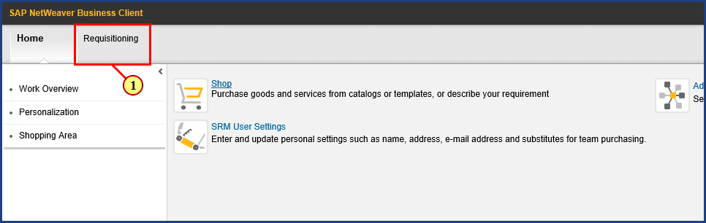

| Step | Action |
| --- | --- |
|  | The purpose of a standard free text shopping cart is to facilitate purchases made from a non-catalog vendor’s quote. This simulation will demonstrate the process of ordering a pair of standing desks and mats using a standard free text shopping cart. Particular attention will be paid to process steps that eliminate redundant information entry, and to avoiding a couple of common pitfalls. |
| 1. | The **Requisitioning** button is clicked. |

### Requisitioning

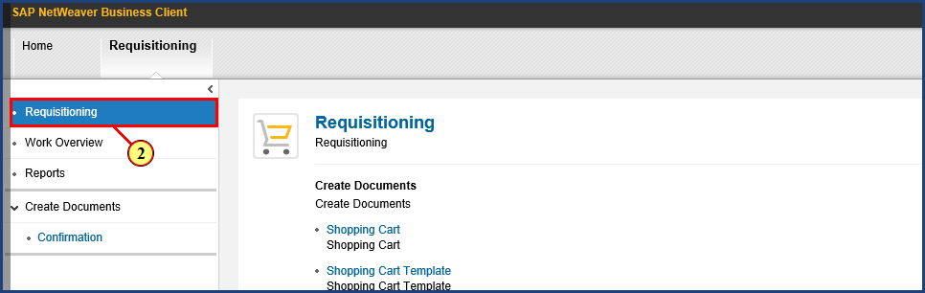

| Step | Action |
| --- | --- |
| 2. | The **Requisitioning** button is clicked. |

### Requisitioning

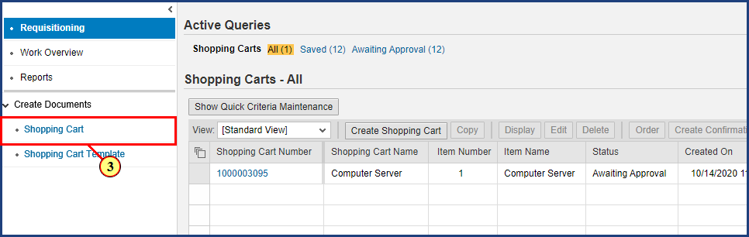

| Step | Action |
| --- | --- |
| 3. | The **Shopping Cart** button is clicked. |

### Create Shopping Cart

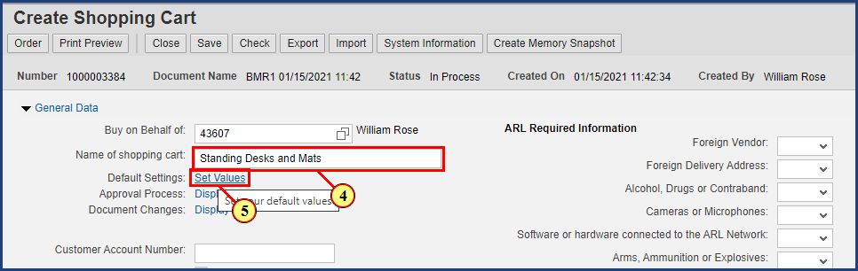

| Step | Action |
| --- | --- |
|  | It is a good idea to rename the cart to something meaningful that we can easily find later on. I will name mine “Standing Desks and Mats.” |
| 4. | **Standing Desks and Mats** is typed into the **Name of shopping cart** field. |

| Step | Action |
| --- | --- |
|  | **Important note!** By setting some default values now, before any line items have been created, you can make a single entry that will be carried forward to every line item in your order. This saves time by eliminating repeated information entry. The most common example is adding additional delivery address details. Rather than enter the same delivery address details five times (in a five line item order), the additional delivery address details can be supplied just once in the beginning. |
| 5. | The **Set Values** button is clicked. |

### Create Shopping Cart

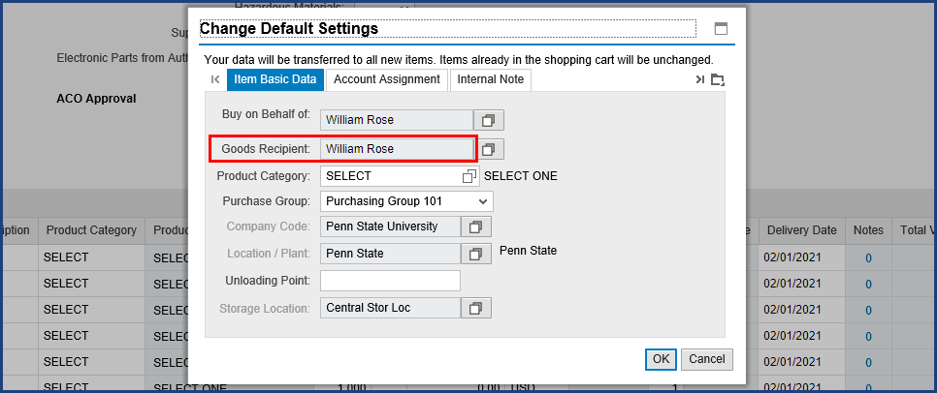

| Step | Action |
| --- | --- |
|  | Since I am the creator of this shopping cart, Shop OnLion shows me as the Goods Recipient by default. The assumption is that, most often, I am shopping for myself and expecting the items to be delivered to me. In this case, however, I am the shopper, but I want the items in this order to be delivered to a colleague instead. So I need to change the default setting for the Goods Recipient for this shopping cart. This is important because we are indicating to Shop OnLion who the Goods Recipient is, that is, the person who will later complete the goods confirmation in the system. |

### Create Shopping Cart

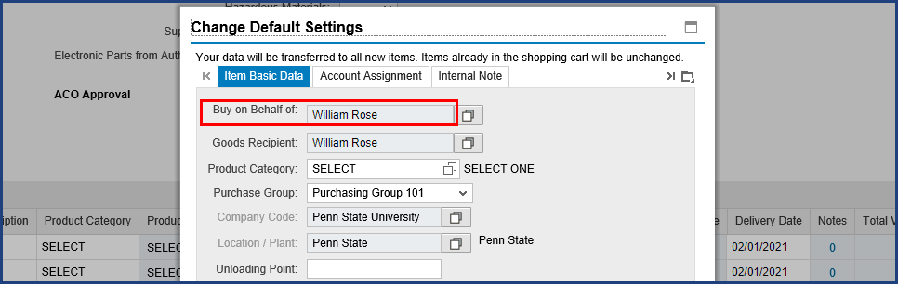

| Step | Action |
| --- | --- |
|  | Some shoppers, in attempting to transact a cart where items are delivered to someone else, have mistakenly changed the value of the "Buy on Behalf of" field to the name of the intended recipient. This is an understandable mistake, since the field name seems to describe what we are doing. But "Buy on Behalf of" instead refers to who the Shopping cart will **actually** belong to. While you may be the one to create the cart and submit it into the workflow approval process, from that point on, only the other person will see the cart or be able to monitor its progress through workflow. "Buy on Behalf of" means that you are merely initiating the process for another person. |

### Create Shopping Cart

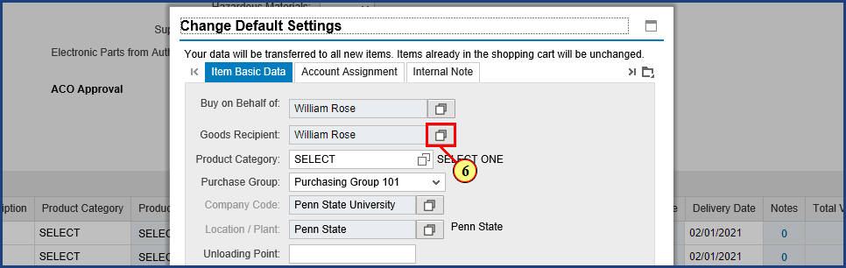

| Step | Action |
| --- | --- |
| 6. | The **Possible Values** button is clicked for **Goods Recipient.** |

### Create Shopping Cart

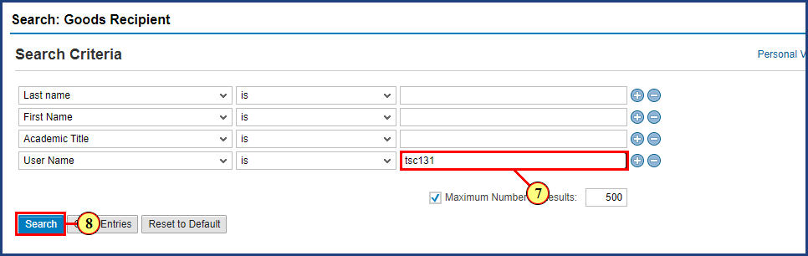

| Step | Action |
| --- | --- |
|  | Use whatever search criteria you are most comfortable with. If you know the User Name, this is often the most direct search. |
| 7. | **tsc131** is typed into the **Search Term** field. |
| 8. | The **Search** button is clicked. |

| Step | Action |
| --- | --- |
|  | Note that this process can take awhile, because the request has to cross systems to find the data. |

### Create Shopping Cart

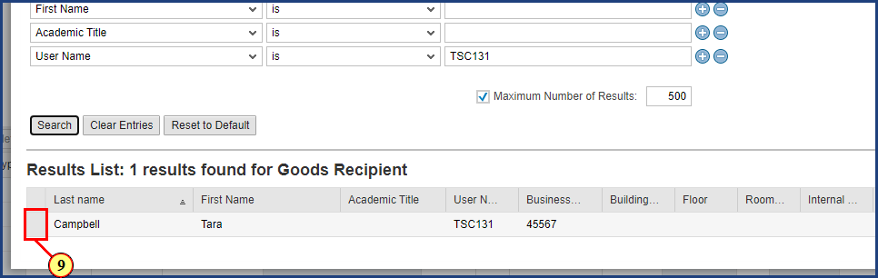

| Step | Action |
| --- | --- |
|  | One result is found from the User Name entered. |
| 9. | The **Select** button is clicked. |

### Create Shopping Cart

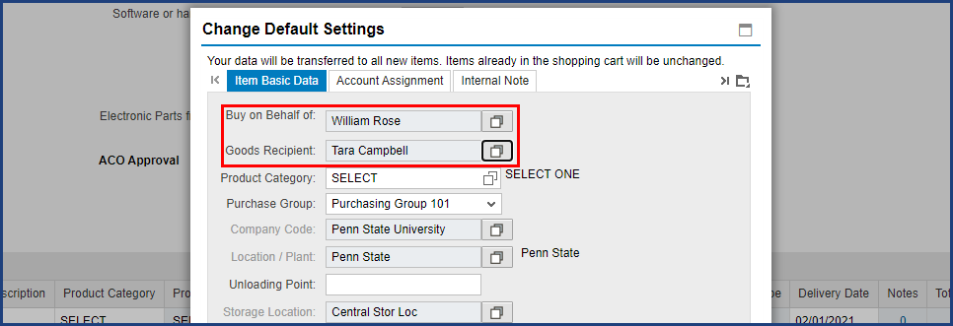

| Step | Action |
| --- | --- |
|  | Back on the Change Default Settings dialog box, we can see that Tara is now the default Goods Recipient. Also note that I am still shown as the "Buy on Behalf of" person. This is exactly what we want: I am the shopper and the cart is mine, but Tara will receive the items and will be the one to perform the Goods Confirmation for them. |

### Create Shopping Cart

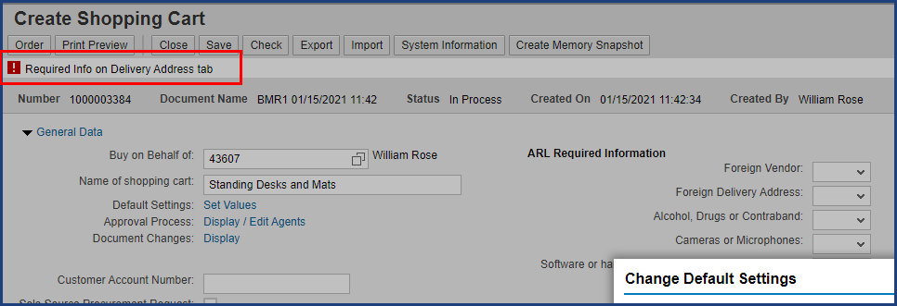

| Step | Action |
| --- | --- |
|  | Next we will enter Delivery Address information. You may have noticed a red-level error message on the screen. That will be resolved after we provide required information. The Delivery Address tab is found by clicking on the Display More Tabs button. |

### Create Shopping Cart

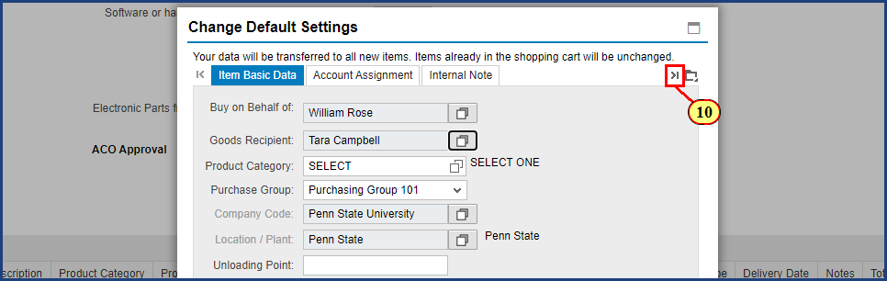

| Step | Action |
| --- | --- |
| 10. | The **Display More Tabs** button is clicked. |

### Create Shopping Cart

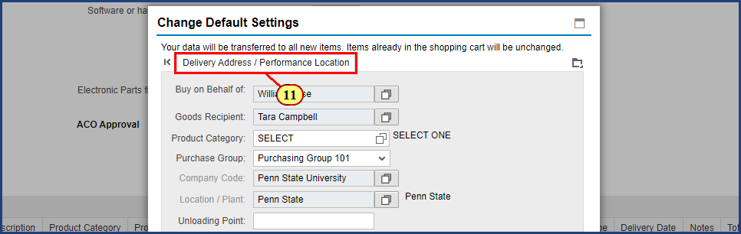

| Step | Action |
| --- | --- |
| 11. | The **Delivery Address / Performance Location** tab is clicked. |

### Create Shopping Cart

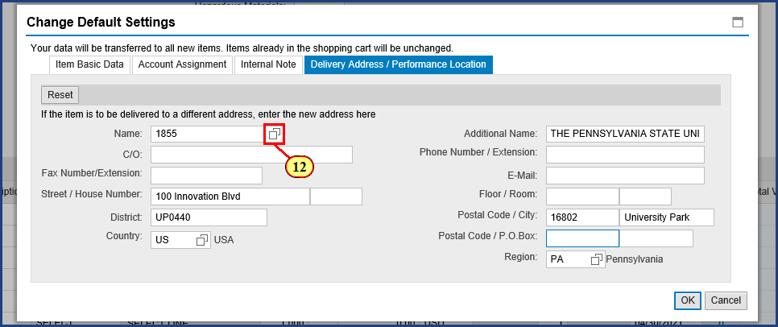

| Step | Action |
| --- | --- |
| 12. | The **Possible Values** button is clicked for **Name**. |

### Create Shopping Cart

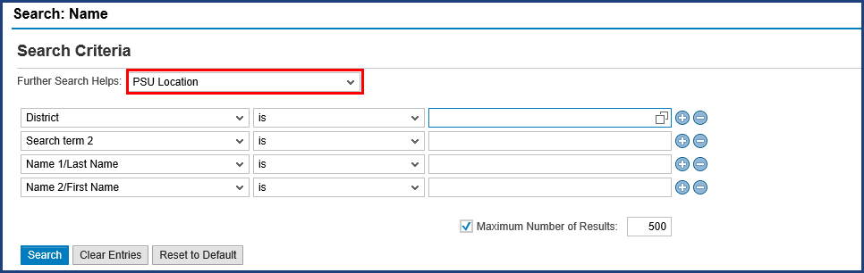

| Step | Action |
| --- | --- |
|  | Ensure the Further Search Helps dropdown selection is set to PSU Location to utilize helpful features for Penn State specific searching. |

### Create Shopping Cart

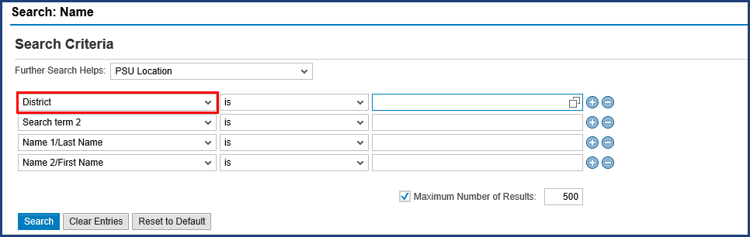

| Step | Action |
| --- | --- |
|  | The District search criterion is used to search for Location Codes, which you can look up in the Shop OnLion Delivery Address Excel Workbook linked to the SIMBA website. Similar to the SAP Address Number (which is used to establish your default delivery address when modifying your personal settings), the Location Code is routinely used to provide a unique Penn State address for a given shopping cart.    In our example, we will look for the Cloverly Building on the Abington campus, then make a note of its Location Code. Then we will return to enter that code (AB0001) into the search field here. |

### Create Shopping Cart

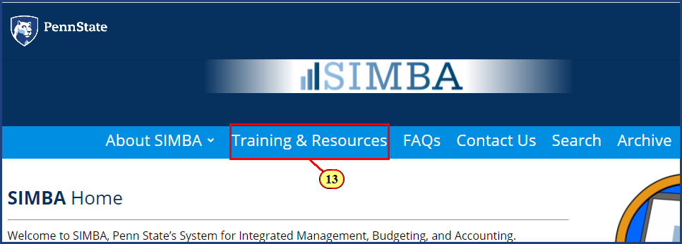

| Step | Action |
| --- | --- |
|  | On the SIMBA website, first navigate to the Training and Resources page. |
| 13. | The **Training & Resources** button is clicked. |

| Step | Action |
| --- | --- |
|  | Then navigate to the Procurement (Shop OnLion) Resource Page. |

### Create Shopping Cart

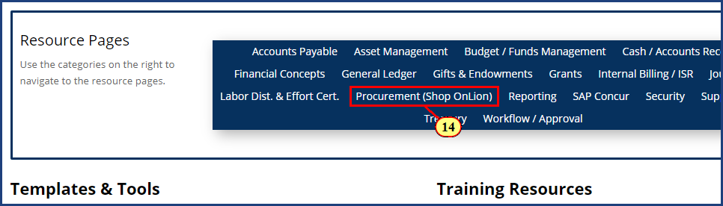

| Step | Action |
| --- | --- |
| 14. | The **Procurement (Shop OnLion)** button is clicked. |

### Create Shopping Cart

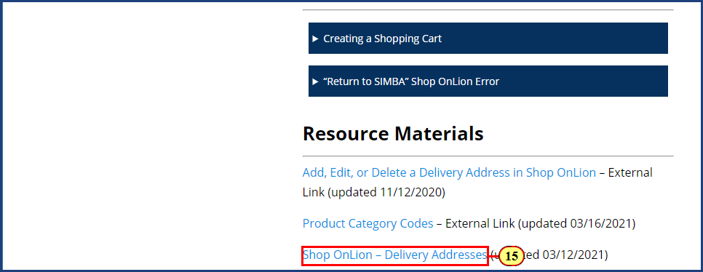

| Step | Action |
| --- | --- |
|  | When you click the Shop OnLion - Delivery Addresses link, you will be redirected to the Knowledge Base article for this resource. |
| 15. | The **Shop OnLion - Delivery Addresses** link is clicked. |

### Create Shopping Cart

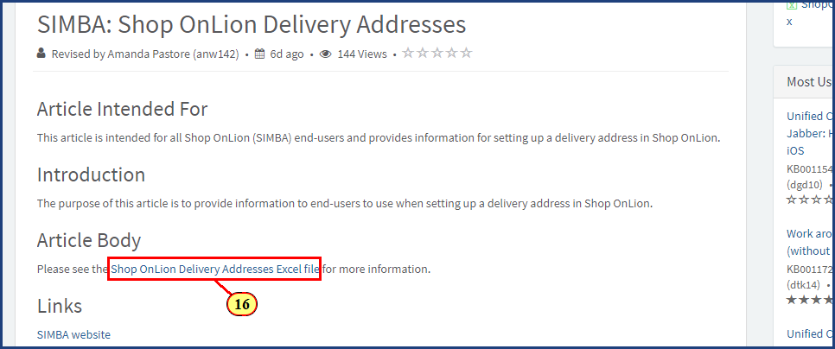

| Step | Action |
| --- | --- |
|  | Now you can see the link to the Excel file, which you should click to download. Then open this Excel file on your computer. |
| 16. | The **Shop OnLion - Delivery Addresses Excel file** link is clicked. |

### Delivery Addresses - Excel Workbook

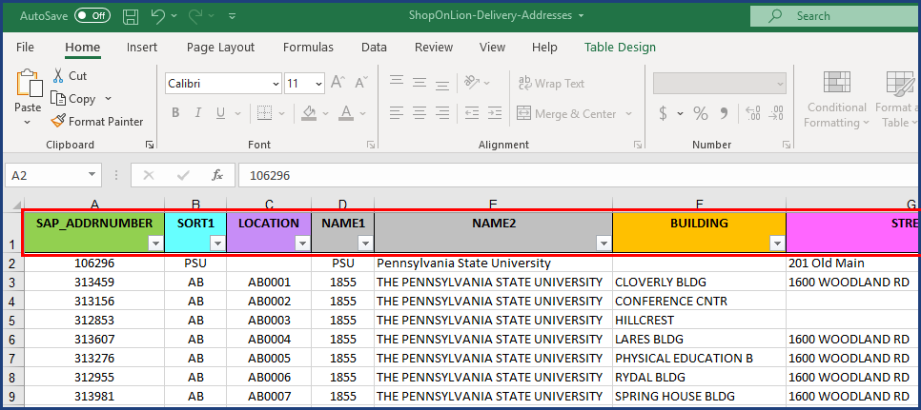

| Step | Action |
| --- | --- |
|  | The file will open to the Instructions tab, which you should read. Then switch tabs to the Shop OnLion Delivery Addresses tab, shown here.    This tab lists delivery addresses across every campus of the University (over 1,000 in total). Each address-related field or identifier has been isolated into its own column, enabling searching and sorting on that specific data. The Instructions tab clearly and concisely explains what each of these columns means and how to use them in searching.    This page might look a bit overwhelming at first, but a proper use of Excel features changes all that. We recommend that you search for a given delivery address by using the filter features on the column headings. You can quickly get to a short list of results by filtering on building names, cities, and campus abbreviations. |

### Delivery Addresses - Excel Workbook

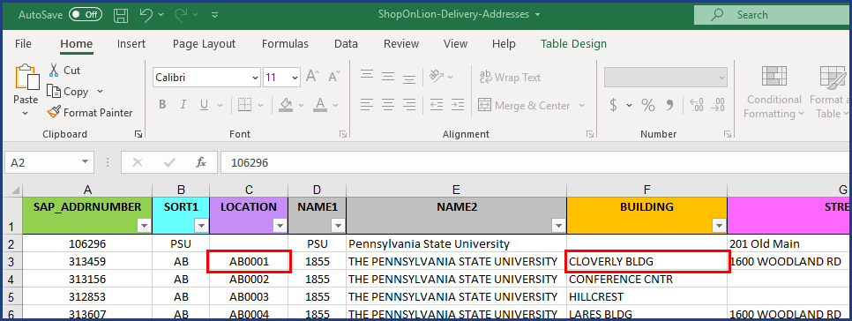

| Step | Action |
| --- | --- |
|  | In this case, it is even easier than that. Since Abington addresses appear at the top of the list in alphabetical order, and since the Cloverly Building is the first building listed, we don't need to filter. Now we will write down or copy AB0001 as the Location Code we need to enter in our search. Back to Shop Onlion. |

### Create Shopping Cart

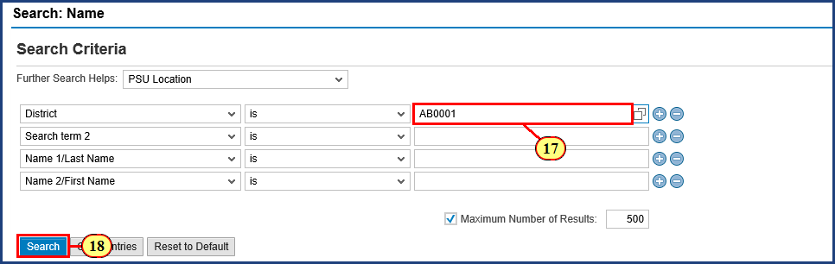

| Step | Action |
| --- | --- |
| 17. | **AB0001** is typed into the **Search Term** field. |
| 18. | The **Search**  button is clicked. |

### Create Shopping Cart

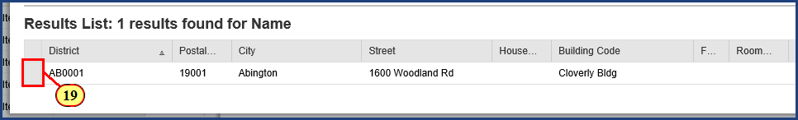

| Step | Action |
| --- | --- |
| 19. | The **Item Select** check box is clicked. |

### Create Shopping Cart

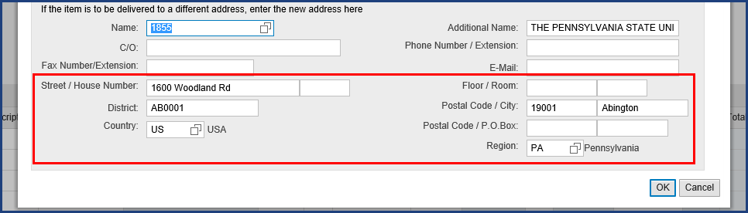

| Step | Action |
| --- | --- |
|  | Now we can see the change in delivery address. I just need to add the In Care Of information by completing the details for Tara, the goods recipient for this shopping cart. If I were the Goods Recipient, I would supply my own name and information here instead. |

### Create Shopping Cart

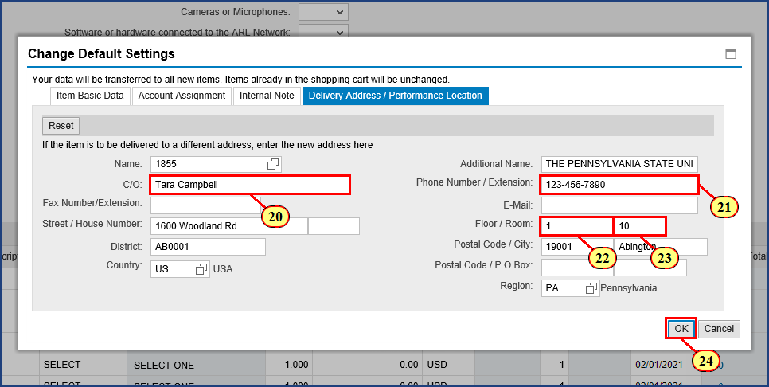

| Step | Action |
| --- | --- |
| 20. | **Tara Campbell** is typed into the **C/O** field. |
| 21. | **123-456-7890** is typed into the **Phone Number / Extension** field. |

| Step | Action |
| --- | --- |
|  | The Floor and Room fields allow alpha numeric characters, so "N/A" is a valid field entry if a specific room number or floor is not applicable. |
| 22. | **1** is typed into the **Floor** field. |
| 23. | **10** is typed into the **Room** field. |
| 24. | The **OK**  button is clicked. |

### Shopping Cart

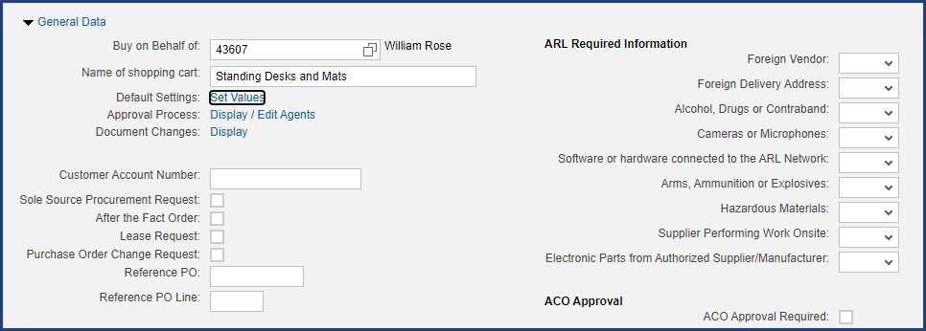

| Step | Action |
| --- | --- |
|  | To learn how to complete additional fields in this General Data section, refer to the [Shop OnLion - Shopping Cart Field Descriptions](https://pennstate.service-now.com/kb?id=kb_article_view&sys_kb_id=327207dedb48fc9029b24a281396197c)resource available on the SIMBA website. |

### Shopping Cart

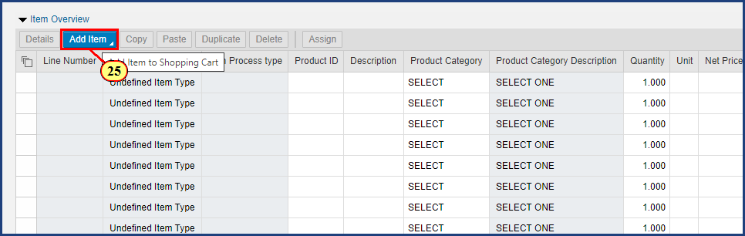

| Step | Action |
| --- | --- |
|  | Now that we have our delivery information and other general data completed, we can go shopping. There are two ways to add line items to the cart, and I will show you both ways. The first method uses the Add Item button to add new line items. |
| 25. | The **Add Item** button is clicked. |

### Shopping Cart

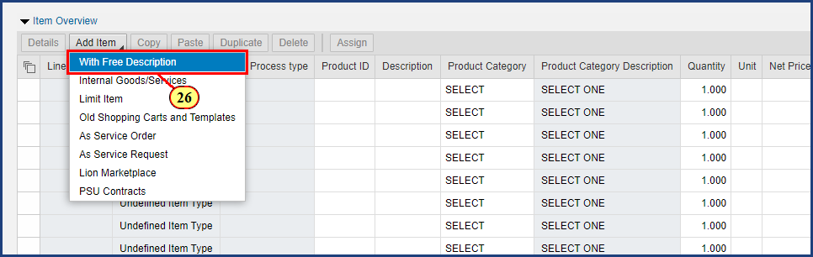

| Step | Action |
| --- | --- |
|  | **Important!** Each and every line item in a Free Text shopping cart must be "With Free Description." Standard shopping carts should **never** contain a mix of line item types.     * Lion Marketplace shopping cart -- only use "Lion Marketplace" line items * PSU Contracts shopping cart -- only use "PSU Contracts" line items * Free Text shopping cart -- only use "With Free Description" line items |
| 26. | The **With Free Description** menu item is clicked. |

### Shopping Cart

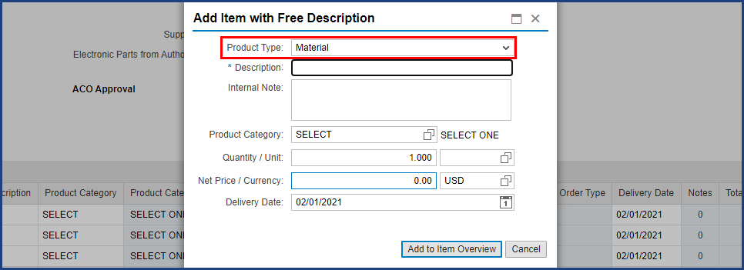

| Step | Action |
| --- | --- |
|  | A word of caution here to avoid a common pitfall. The Product Type dropdown offers a choice of Material or Service. Please note that even if you are intending to purchase services, you **never** want to select Service here; **always** leave the Product Type set to Material. |

### Shopping Cart

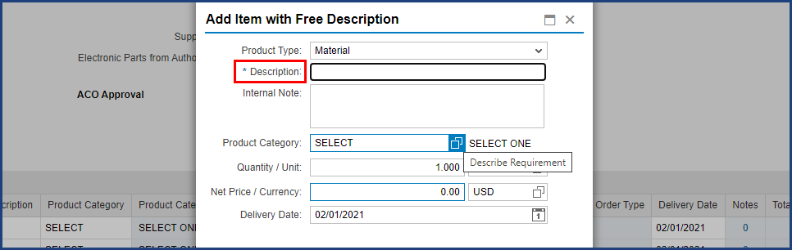

| Step | Action |
| --- | --- |
|  | The asterisk indicates that Description is a required field. This field is limited to 40 characters, so you may want to abbreviate the words in your item description.    The Internal Note field can be used to supplement the Description with additional information; however, this field is internal to Shop OnLion and will not be included on the purchase order sent to the supplier. |

### Shopping Cart

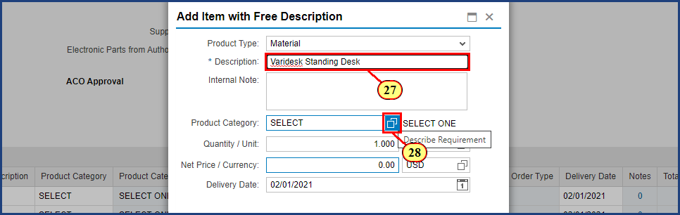

| Step | Action |
| --- | --- |
| 27. | **Varidesk Standing Desk** is typed into the **Description** field. |

| Step | Action |
| --- | --- |
|  | The Penn State Purchasing web site contains a number of useful resource links for Shop OnLion. One such resource is the [Product Category Codes](https://purchasing.psu.edu/product-category-codes).The Product Category Description column in that table contains clear and complete descriptions that allow you to pinpoint the correct Product Category to be used. Just use the Find command as directed on the page. Once you know the 8-digit Product Category code, return to Shop OnLion and enter it here.    Alternatively, you may also search for a Product Category using the Possible Values button. |
| 28. | The **Possible Values** button is clicked for **Product Category**. |

### Shopping Cart

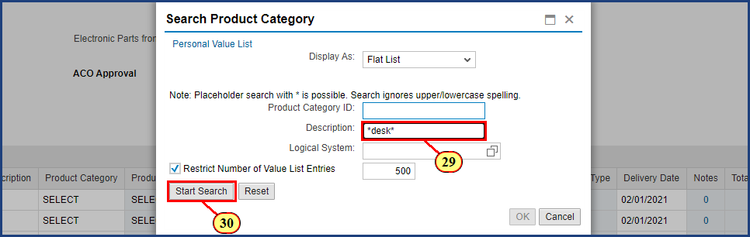

| Step | Action |
| --- | --- |
|  | Sometimes searches fail because the search terms entered in the Description field are too literal and rigid. In our case, if we enter "desk" as our search term, the results returned will be a small portion of the desk-related items available. We need greater flexibility in the search to account for the various ways a desk-related item might be described. |

| Step | Action |
| --- | --- |
|  | To be certain that we get every possible match for the item we are searching for, we will bracket the search term with asterisks (*). The asterisk is a "wildcard" character that matches any character(s) in the position we have indicated. So, in our example, entering "*desk" means that ALL descriptions ending in "desk" will match, regardless of the characters that might precede "desk" in the description. Likewise, there may be characters in desk item descriptions that follow the word "desk", and we want to make sure we match all those, too. Entering "*desk*" makes this a very robust search that should hit all items with "desk" anywhere in the description. |
| 29. | **\*desk\*** is typed into the **Description** field. |
| 30. | The **Start Search** button is clicked. |

### Shopping Cart

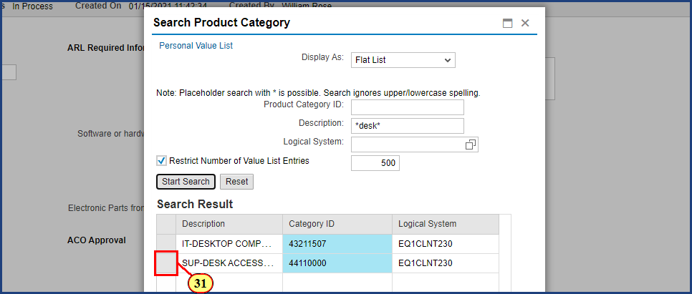

| Step | Action |
| --- | --- |
|  | The first product category result here refers to desktop computers, while the “SUP” in the second refers to supplies, specifically desk accessories supplies. Our standing desk falls into the desk accessories supplies category, so we will select it and click OK. |
| 31. | The **Select** button is clicked. |

### Shopping Cart

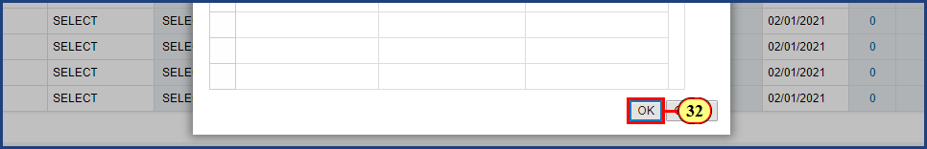

| Step | Action |
| --- | --- |
| 32. | The **OK** button is clicked. |

### Shopping Cart

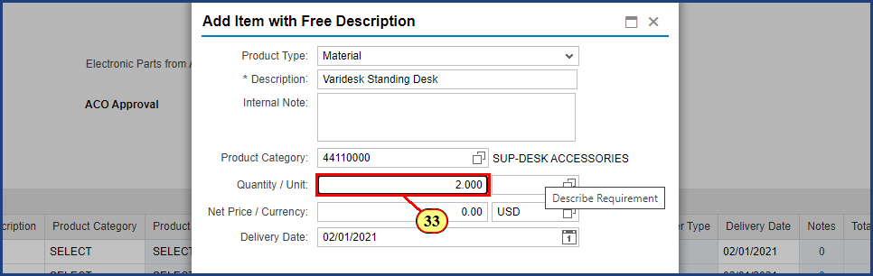

| Step | Action |
| --- | --- |
| 33. | **2.000** is typed into the **Quantity** field. |

### Shopping Cart

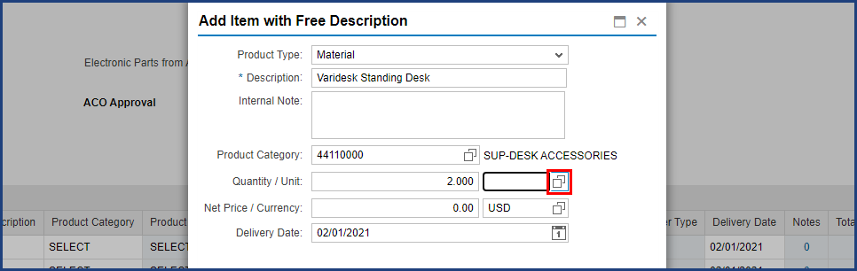

| Step | Action |
| --- | --- |
|  | Note that there is a Possible Values button associated with the Unit of Measure field. Commonly used units include EA (for "each") and HR (for "hour").    If you are uncertain of the Unit of Measure to use, click the Possible Values button and enter a single asterisk in the search field to see the complete list. |

### Shopping Cart

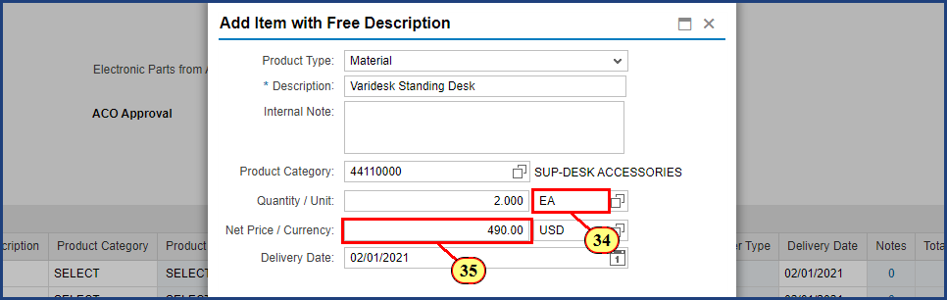

| Step | Action |
| --- | --- |
| 34. | **EA** is typed into the **Unit** field. |

| Step | Action |
| --- | --- |
|  | From the quote we received from the vendor, we know the price of a desk: $490.00. |
| 35. | **490.00** is typed into the **Net Price** field. |

### Shopping Cart

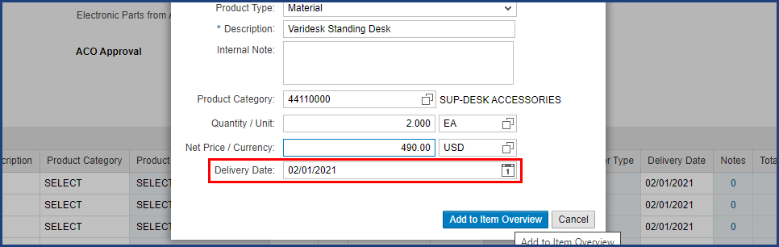

| Step | Action |
| --- | --- |
|  | Notice that the system has pre-populated the delivery date field with a date ten days from today. This represents the approximate timeframe required for the cart to be approved and for Purchasing to process the Purchase Order. Please do not adjust the delivery date to a shorter timeframe than the default. |

### Shopping Cart

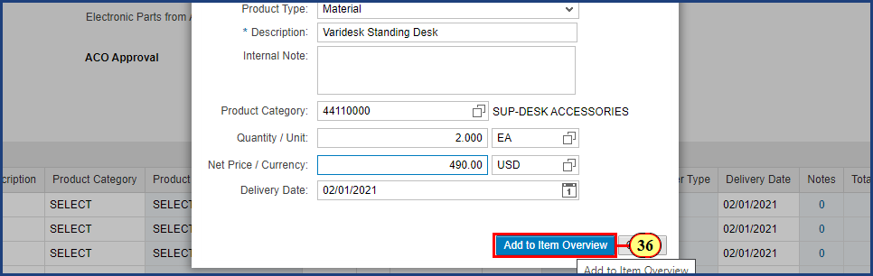

| Step | Action |
| --- | --- |
| 36. | The **Add to Item Overview** button is clicked. |

### Shopping Cart

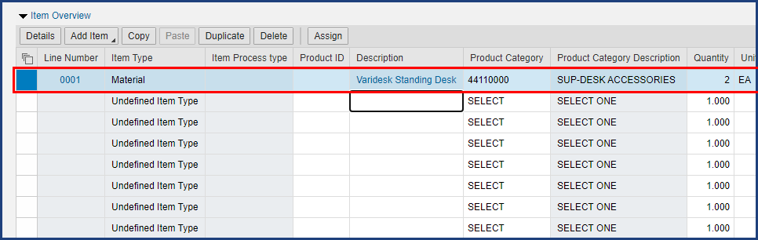

| Step | Action |
| --- | --- |
|  | Back on the Create Shopping Cart window, we can see the Line Item 1 display. |

### Shopping Cart

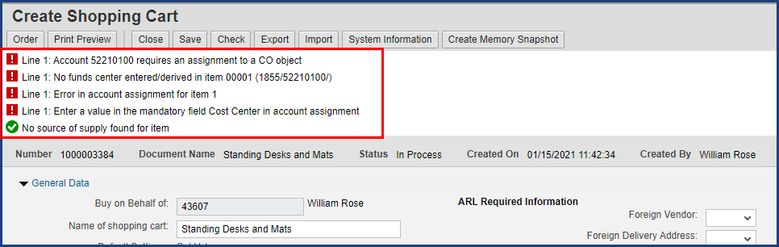

| Step | Action |
| --- | --- |
|  | The red-level errors and warnings that appear in the upper left are no cause for concern. As we supply additional details, these will be resolved by the time we are ready to order. |

### Shopping Cart

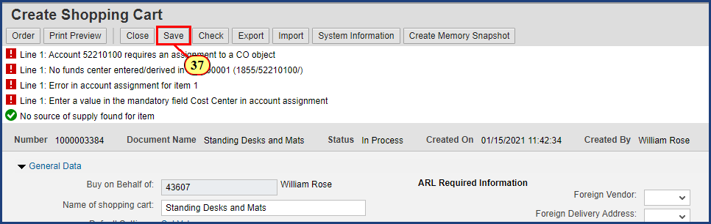

| Step | Action |
| --- | --- |
|  | **A best practice: Save your cart at regular intervals, such as after the addition of a new line item.**    Bear in mind that Shop OnLion does not continuously auto-save your information. So, periodically save your cart. Should you get pulled away from your shopping by other tasks, your session may time-out. The addition of line items is a natural point in the process to save your progress. |
| 37. | The **Save** button is clicked. |

### Shopping Cart

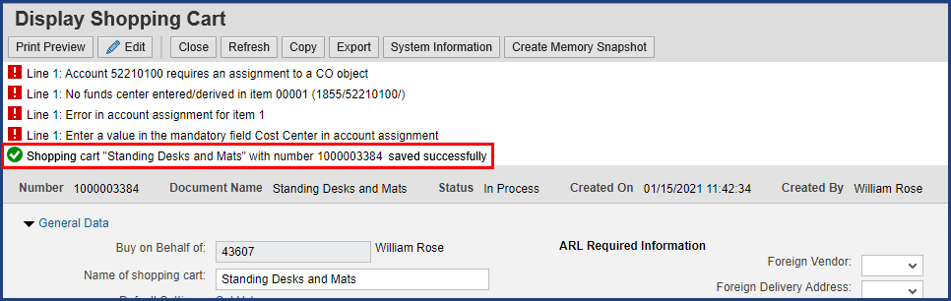

| Step | Action |
| --- | --- |
|  | **Note: After the Save button on the shopping cart is clicked, the cart will go from “Create” mode into “Display” mode.** No further changes to the cart can be made while it is in Display mode. You must click the Edit button in the top ribbon to continue working. |

### Shopping Cart

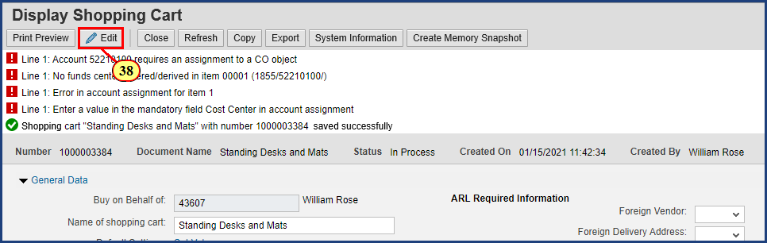

| Step | Action |
| --- | --- |
| 38. | The **Edit** button is clicked. |

### Shopping Cart

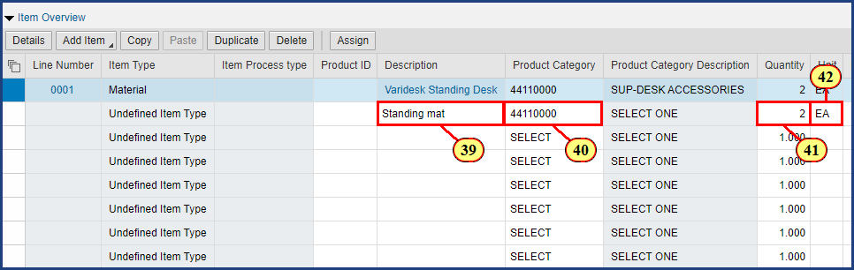

| Step | Action |
| --- | --- |
|  | The second method for adding line items is direct entry into the Item Overview area, just as you would populate an Excel spreadsheet. |
| 39. | **Standing mat** is typed into the **Description** field. |

| Step | Action |
| --- | --- |
|  | Because standing mats reside in the same Product Category as standing desks, we can use the same number used for Line Item 1. If this were our first entry, we would click on the Possible Values button to find the Product Category number. |
| 40. | **44110000** is typed into the **Product Category** field. |
| 41. | **2** is typed into the **Quantity** field. |
| 42. | **EA** is typed into the **Unit** field. |

### Shopping Cart

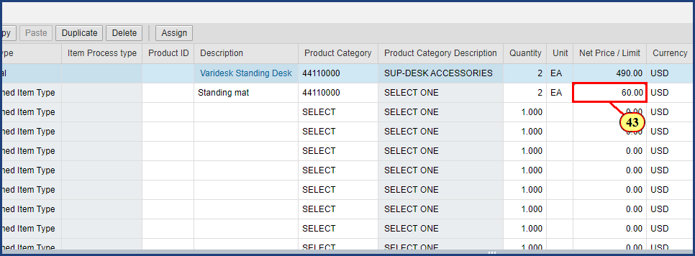

| Step | Action |
| --- | --- |
|  | From the quote we received from the vendor, we know the price of a mat: $60.00. **Important**: After entering the price, we must press Enter to validate our entries against master data. |
| 43. | **60.00** is typed into the **Net Price / Limit** field and **Enter** is pressed. |

### Shopping Cart

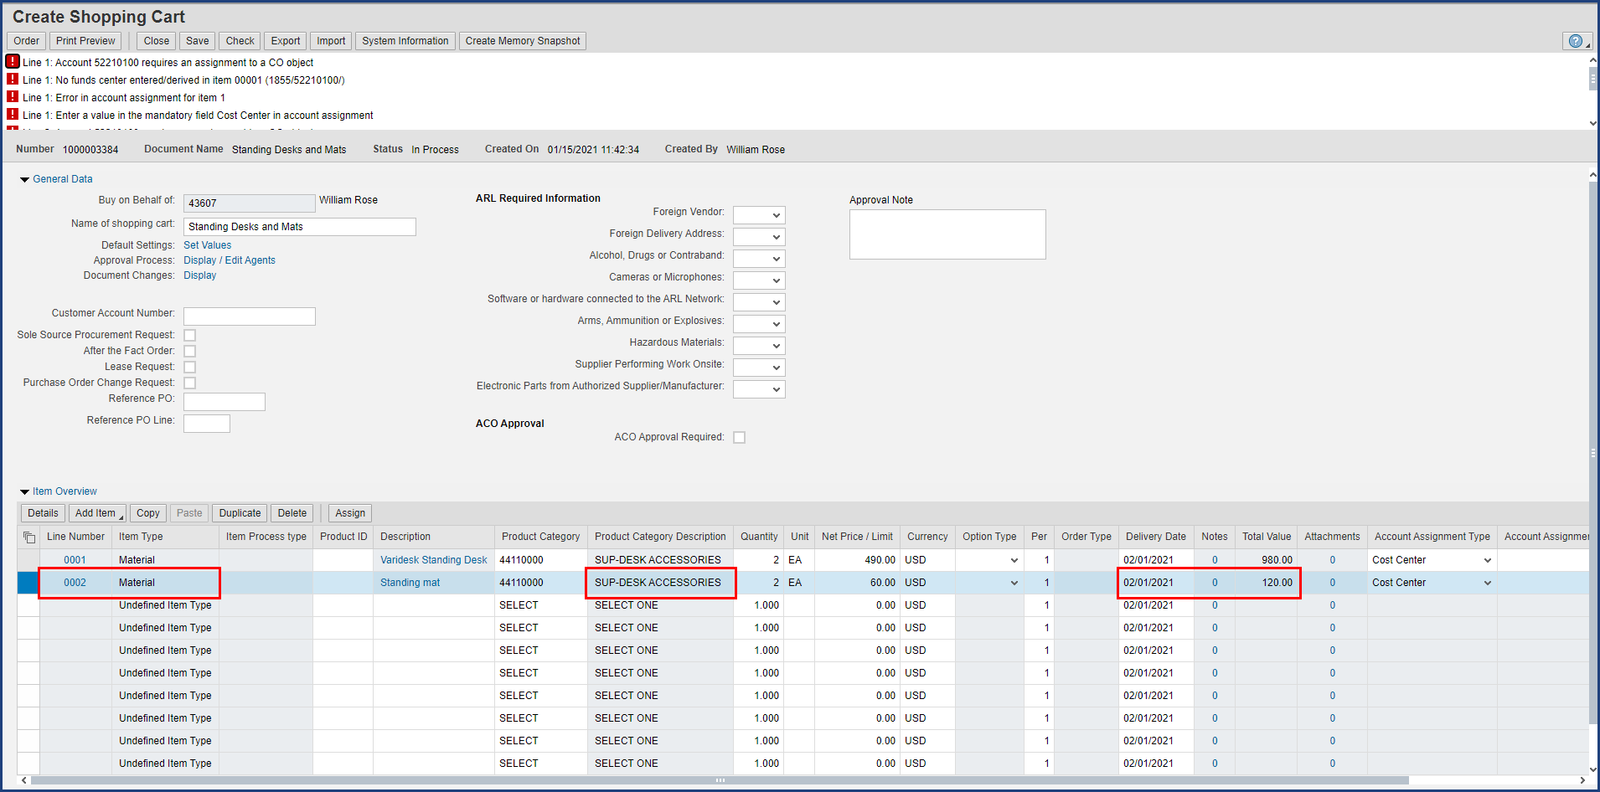

| Step | Action |
| --- | --- |
|  | With the validation complete, notice that the Product Category Description has been filled in and some additional cells in the row have updated. So, we used two different methods to enter our line items, but we have the same result for both: valid line items. |

### Shopping Cart

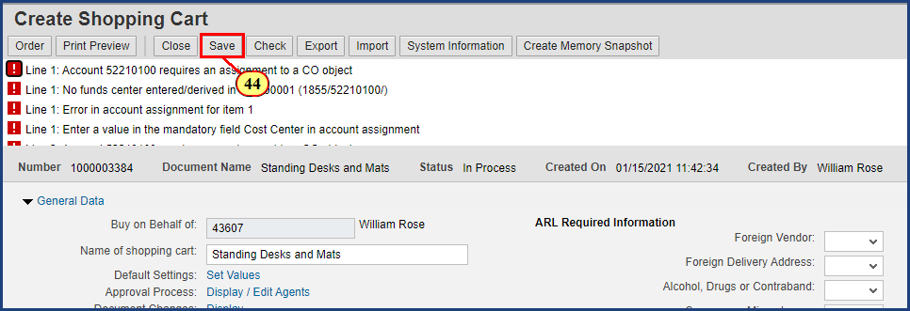

| Step | Action |
| --- | --- |
|  | Time to save the cart again. |
| 44. | The **Save** button is clicked. |

### Shopping Cart

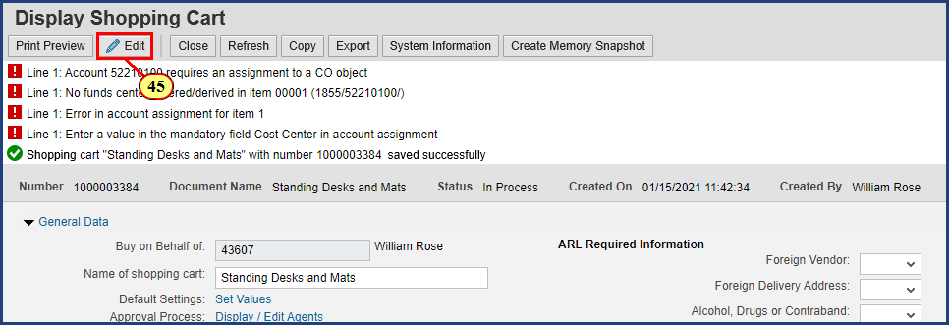

| Step | Action |
| --- | --- |
|  | The save was successful and we have been returned to Display mode. As before, we must click the Edit button in the top ribbon to continue working. |
| 45. | The **Edit** button is clicked. |

### Shopping Cart

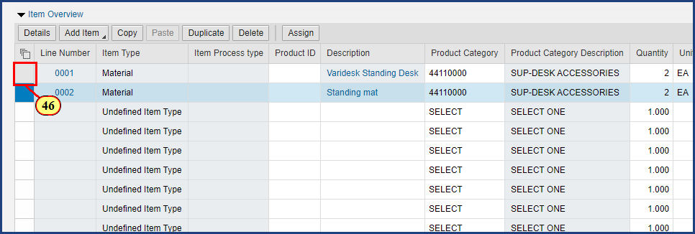

| Step | Action |
| --- | --- |
|  | To continue, we select the first line item and click the Details button to reveal additional information to view, add, and edit. |
| 46. | The **Line Select** button is clicked for **Line Item 1**. |

### Shopping Cart

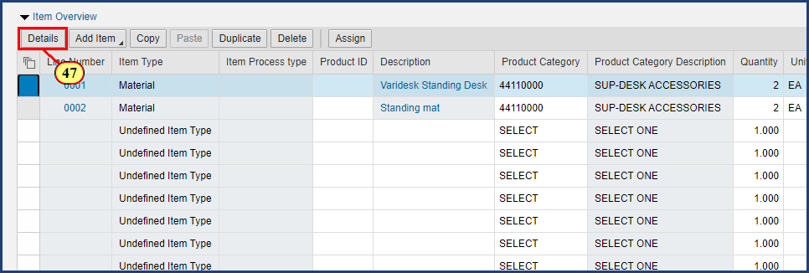

| Step | Action |
| --- | --- |
| 47. | The **Details** button is clicked. |

### Shopping Cart

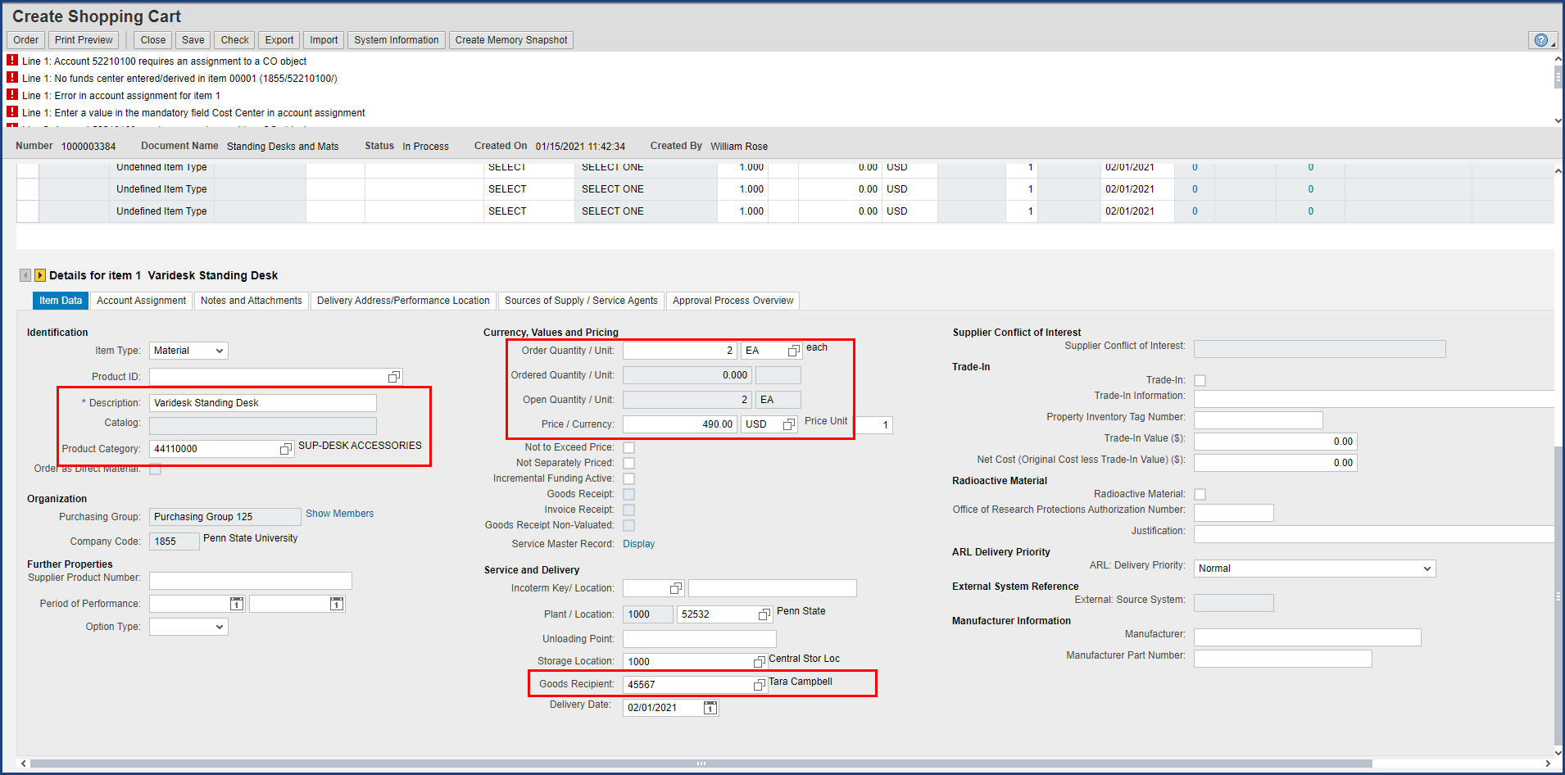

| Step | Action |
| --- | --- |
|  | Here we can see quite a bit of Item Data detail for Item 1 that we have supplied up to this point. On the left side under Identification, we see the item Description and Product Category number with description. In the upper middle under Currency, Values and Pricing, we see two desks at $490.00 each. And in the lower middle under Service and Delivery, we see that Tara Campbell is the Goods Recipient, which confirms the default setting we made earlier. |

| Step | Action |
| --- | --- |
|  | This Item Data tab may appear a bit overwhelming, but you won’t need to enter that much information. Remember that not every field is required in every case; just fill in what pertains to your situation.    **Tip**: Establish a consistent routine for supplying item details to maximize your accuracy and efficiency:     * Work through the line item tabs from left to right (Item Data through Sources of Supply/Service Agents) * On each tab, supply information from top to bottom     That said, don't worry about missing details. The system's error messages will alert you to omitted and/or incorrect data. |

| Step | Action |
| --- | --- |
|  | Note that the Create Shopping Cart window has been automatically scrolled down to the Item Details area. To return to the General Data or header information, just scroll back up. |

### Shopping Cart

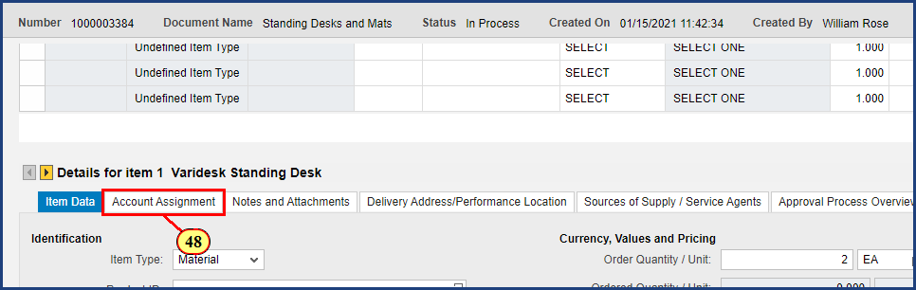

| Step | Action |
| --- | --- |
| 48. | The **Account Assignment** tab is clicked. |

### Shopping Cart

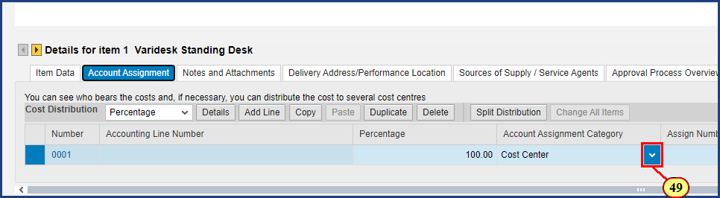

| Step | Action |
| --- | --- |
| 49. | The **Account Assignment Category** dropdown is clicked. |

### Shopping Cart

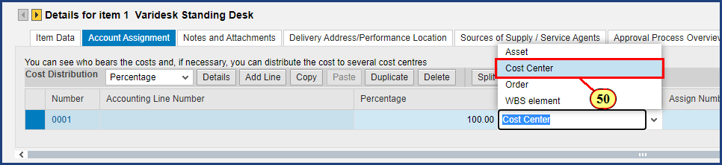

| Step | Action |
| --- | --- |
|  | The Account Assignment Category drop down menu allows you to choose from Asset, Cost Center, Order, and Work Breakdown Structure Element. In Shop OnLion, an Internal Order is simply referred to as Order in the Account Assignment Category. We will stay with a Cost Center and enter the Cost Center for our area. |
| 50. | The **Cost Center** menu item is clicked. |

### Shopping Cart

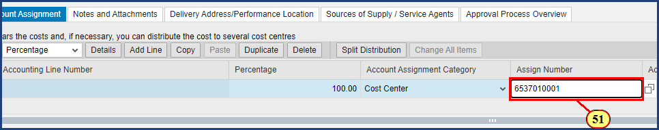

| Step | Action |
| --- | --- |
|  | To identify a cost object, use the Possible Values button to search for one, or consult your financial office to determine the cost object you should use for shopping. In this case, we will enter the Cost Center we have previously determined to be correct. |
| 51. | **6537010001** is typed into the **Assign Number** field and **Enter** is pressed. |

### Shopping Cart

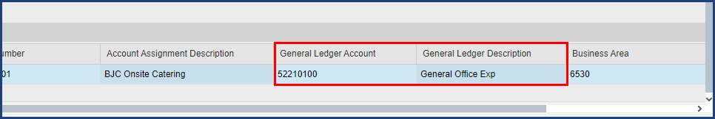

| Step | Action |
| --- | --- |
|  | To date, approximately 85% of product categories have been matched to the most likely General Ledger Account to classify the expense. You should always review the G/L Account to ensure it is appropriate for your purchase. If no G/L Account has populated by default, you must enter one, as this is a required field. |

### Shopping Cart

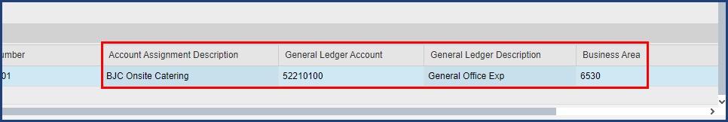

| Step | Action |
| --- | --- |
|  | Notice that the Account Assignment Description and Business Area have auto-populated from master data held in the system. This information is exactly what I will need to provide for line item 2.    Clicking the Copy button will populate the clipboard and display it at the bottom of the screen. Then we can paste the information into line item 2 later in the process. |

### Shopping Cart

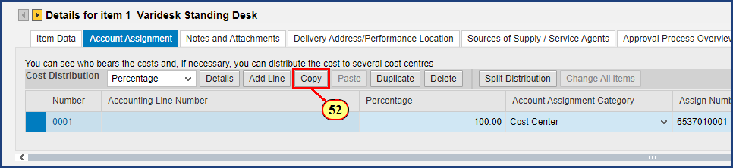

| Step | Action |
| --- | --- |
| 52. | The **Copy** button is clicked. |

### Shopping Cart

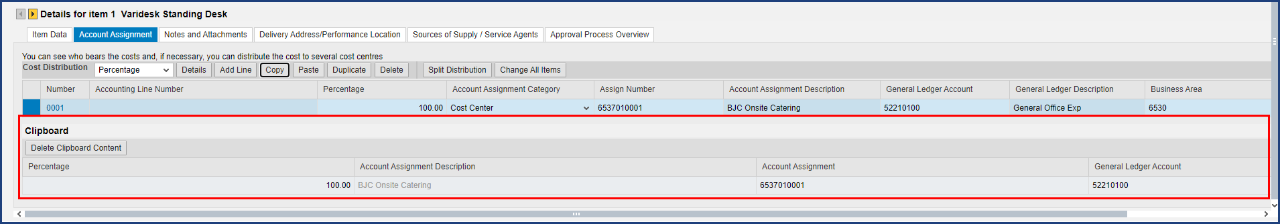

| Step | Action |
| --- | --- |
|  | The clipboard is opened and populated with the Account Assignment data. |

### Shopping Cart

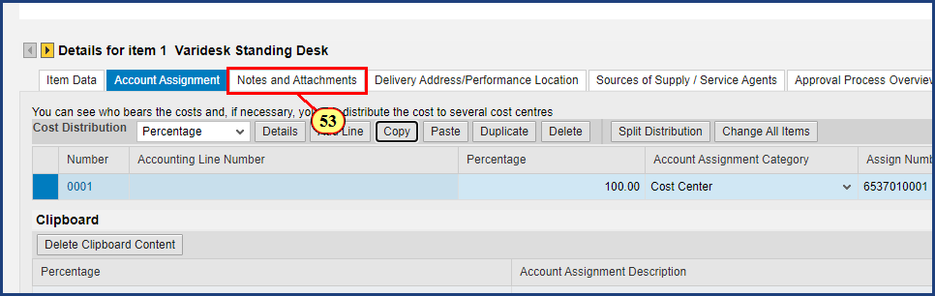

| Step | Action |
| --- | --- |
| 53. | The **Notes and Attachments** tab is clicked. |

### Shopping Cart

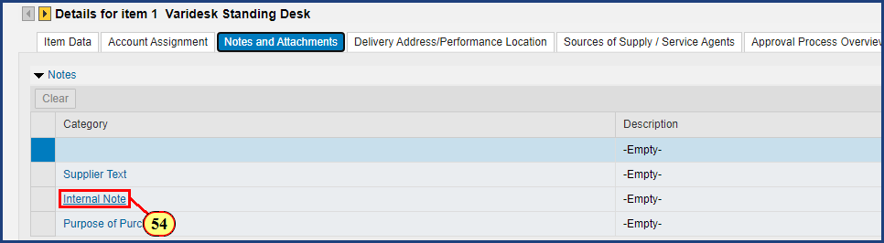

| Step | Action |
| --- | --- |
|  | As a reminder, all notes and attachments provided for a purchase should always be associated with line item 1, regardless of which line item they pertain to. Following this convention is important for the accuracy and efficiency of everyone involved. |

| Step | Action |
| --- | --- |
|  | There are three categories of Notes in ShopOnlion. Supplier text will be printed on the purchase order for the supplier. Internal notes are visible only within Shop OnLion (internal to SIMBA users). Your department may offer guidance for using Purpose of Purchase. For this example, we will add an internal note. |
| 54. | The **Internal Note** button is clicked. |

### Shopping Cart

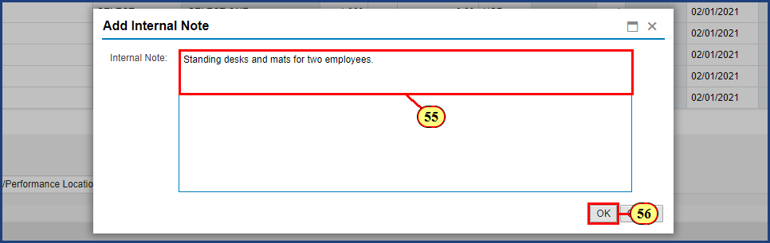

| Step | Action |
| --- | --- |
| 55. | **Standing desks and mats for two employees.** is typed into the **Internal Note** field. |
| 56. | The **OK** button is clicked. |

### Shopping Cart

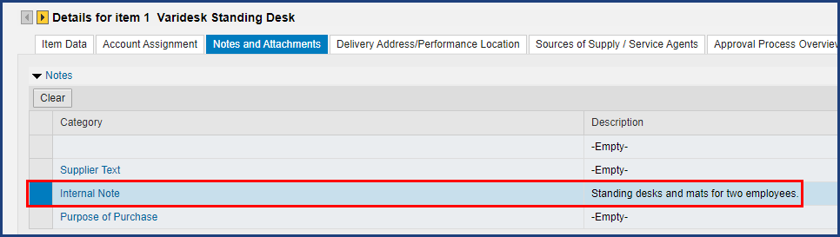

| Step | Action |
| --- | --- |
|  | The Notes pane displays the text of our Internal Note. |

### Shopping Cart

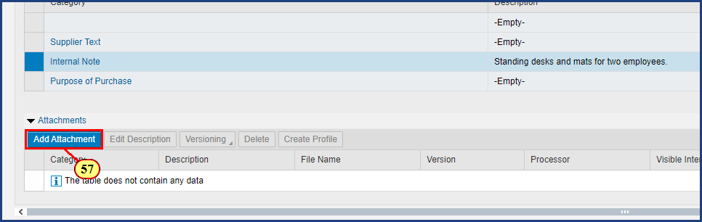

| Step | Action |
| --- | --- |
|  | To avoid shopping cart rejection by approvers, shoppers should add attachments to free text shopping carts.  Examples of supporting documentation to attach include supplier quotes, item specifications, required university forms, and purchase justifications. |
| 57. | The **Add Attachment** button is clicked. |

### Shopping Cart

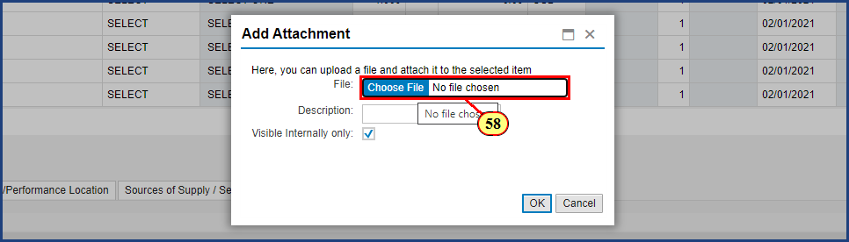

| Step | Action |
| --- | --- |
| 58. | The **Choose File** button is clicked. |

### Shopping Cart

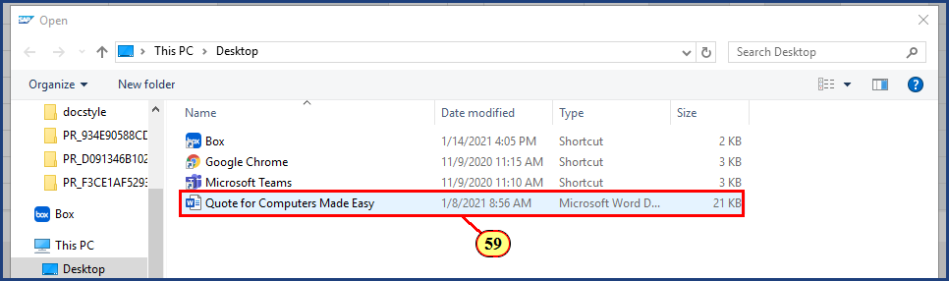

| Step | Action |
| --- | --- |
| 59. | The **Quote for Computers Made Easy** filename is clicked. |

### Shopping Cart

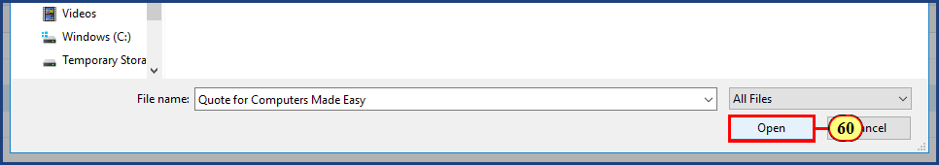

| Step | Action |
| --- | --- |
| 60. | The **Open** button is clicked. |

### Shopping Cart

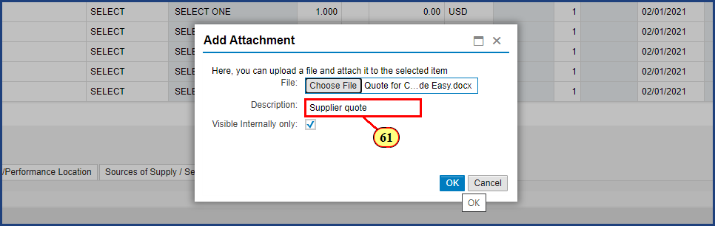

| Step | Action |
| --- | --- |
|  | Provide a description for the attachment such as "supplier quote" or "sole source justification". |
| 61. | **Supplier quote** is typed into the **Description** field. |

### Shopping Cart

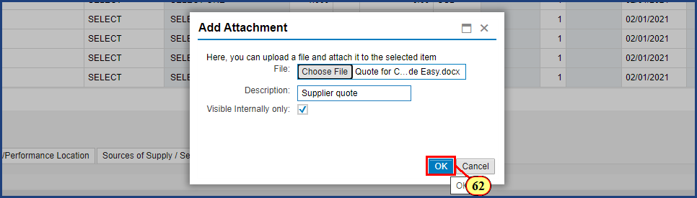

| Step | Action |
| --- | --- |
|  | Note the Visible Internally only check box.  Checking this box means only Shop OnLion users will be able to view the attachment.  Deselect the box if the document attached should be sent with the purchase order to the supplier. |
| 62. | The **OK** button is clicked. |

### Shopping Cart

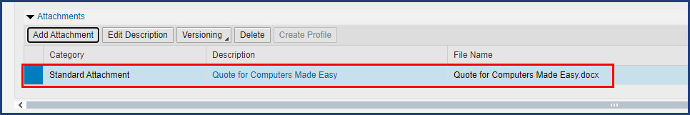

| Step | Action |
| --- | --- |
|  | Note that the Attachments pane displays our file information. |

### Shopping Cart

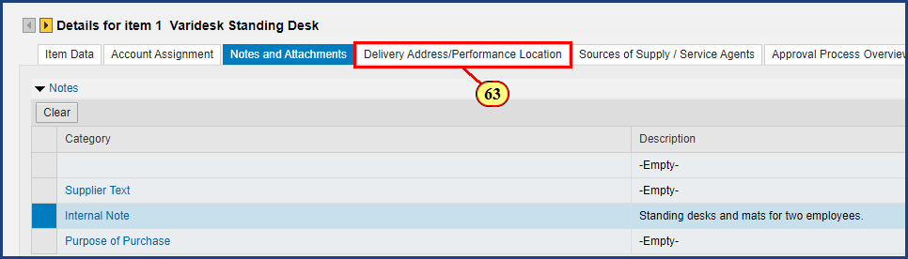

| Step | Action |
| --- | --- |
| 63. | The **Delivery Address/Performance Location** tab is clicked. |

### Shopping Cart

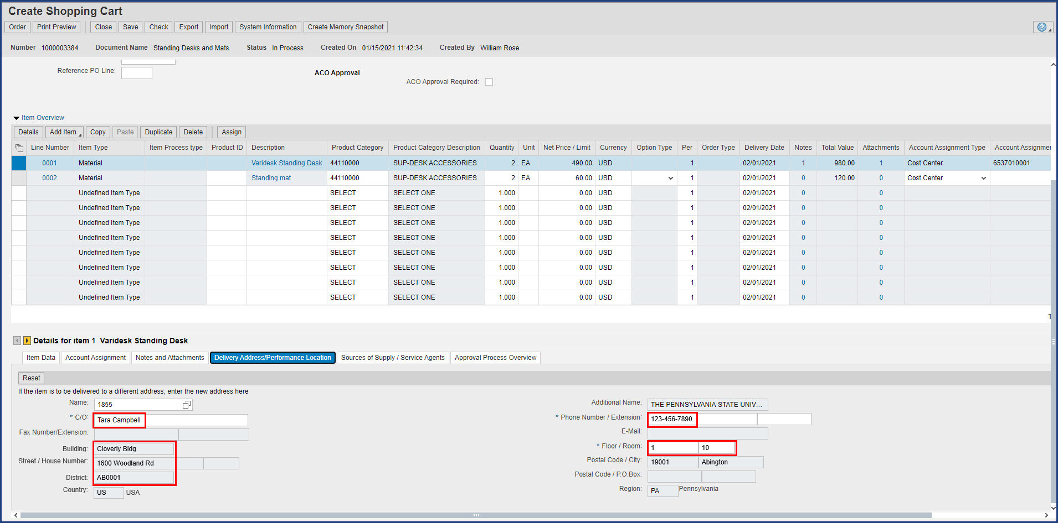

| Step | Action |
| --- | --- |
|  | The default settings we entered at the start of this shopping cart, in the header, are showing. Nothing more to do here. |

### Shopping Cart

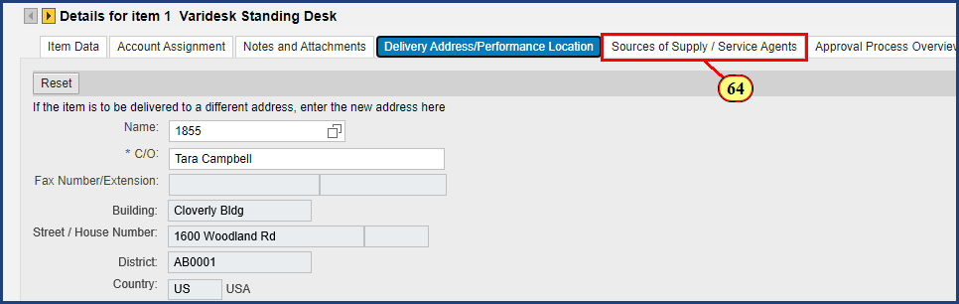

| Step | Action |
| --- | --- |
| 64. | The **Sources of Supply / Service Agents** tab is clicked. |

### Shopping Cart

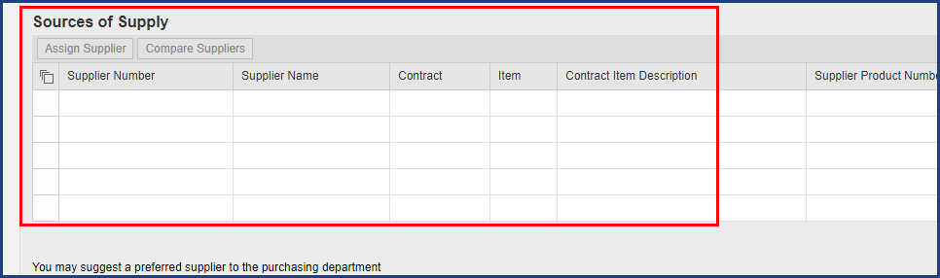

| Step | Action |
| --- | --- |
|  | Notice there are no suggested sources of supply shown, so we will proceed with identifying our preferred supplier. If Purchasing has negotiated a contract (available through PSU Contracts) that corresponds to the product category you have selected, that information may be presented here. If so, save your cart, record the contract and item numbers shown, and determine whether there is a more efficient method of purchase available through PSU Contracts. |

### Shopping Cart

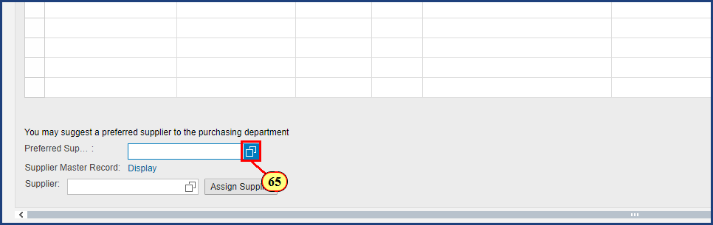

| Step | Action |
| --- | --- |
|  | We will search for an existing supplier using the Possible Values button. |
| 65. | The **Possible Values** button is clicked for **Preferred Supplier**. |

### Shopping Cart

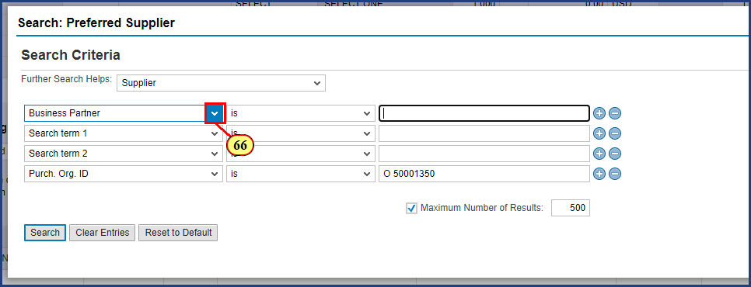

| Step | Action |
| --- | --- |
|  | The majority of suppliers in the database have their company name in the Name 1/Last Name field,  so we will select Name1/last name as the search field. |
| 66. | The **Search Criteria**dropdown is clicked. |

### Shopping Cart

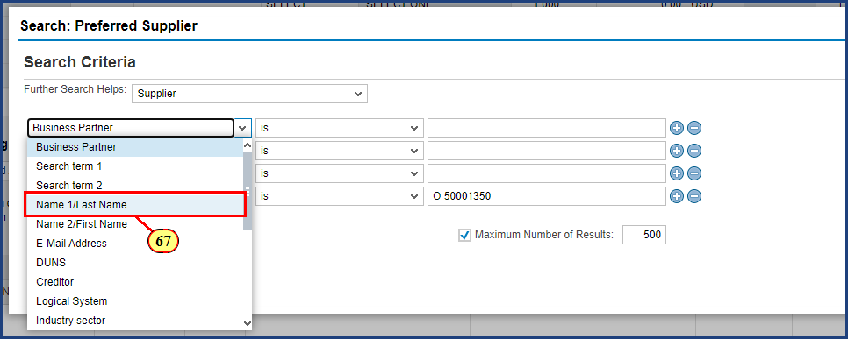

| Step | Action |
| --- | --- |
| 67. | The **Name 1/Last Name** menu item is clicked. |

### Shopping Cart

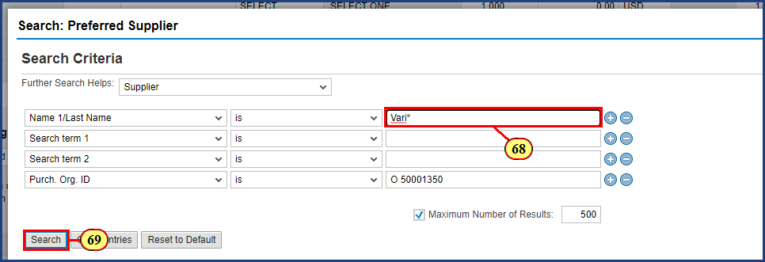

| Step | Action |
| --- | --- |
|  | As before, we should take advantage of the asterisk wildcard character to avoid missing results.  We will look for all suppliers whose name begins with "Vari". |
| 68. | **Vari\*** is typed into the **Search Term** field. |
| 69. | The **Search** button is clicked. |

### Shopping Cart

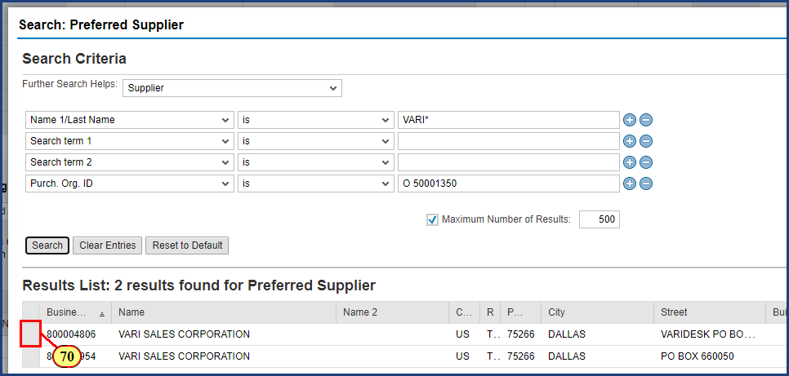

| Step | Action |
| --- | --- |
|  | **Helpful Hint:** If multiple results are returned, look for the name and address that most closely matches the information on the vendor quote. |
| 70. | The **Select** button is clicked. |

### Shopping Cart

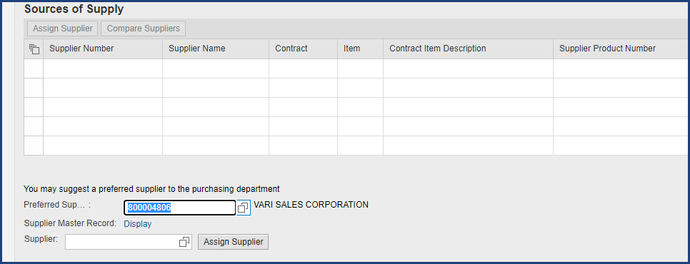

| Step | Action |
| --- | --- |
|  | We want this preferred supplier information for line item 2 also. Just as we copied the Account Assignment details earlier, we can copy the Preferred Supplier information. The one difference is that no button is provided. Select the supplier number, then use the shortcut keypress for Copy on your computer. For PC users, that is Control-C. For Mac users, that is Command-C. The keys should be pressed simultaneously. |
|  | **Control-C** is pressed. |

### Shopping Cart

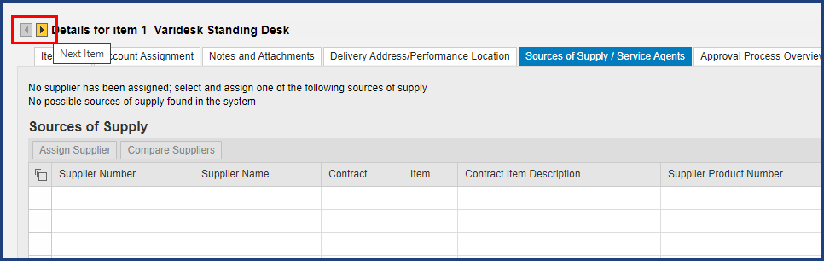

| Step | Action |
| --- | --- |
|  | The Next Item and Previous Item buttons allow us to move to particular line items in the shopping cart. |

### Shopping Cart

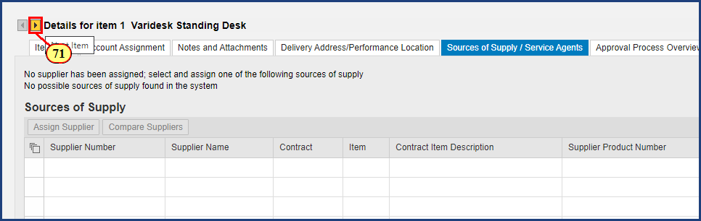

| Step | Action |
| --- | --- |
| 71. | The **Next Item** button is clicked. |

### Shopping Cart

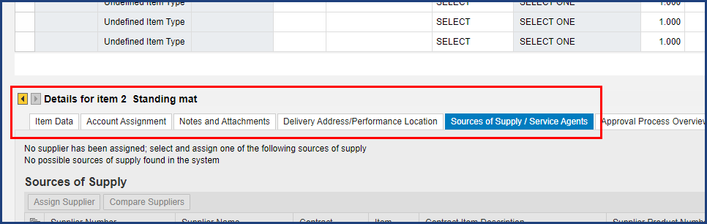

| Step | Action |
| --- | --- |
|  | You'll notice when you switch to Line 2 that you're already on the Sources of Supply tab - let's go ahead and paste in that supplier number before we move to another tab. |

### Shopping Cart

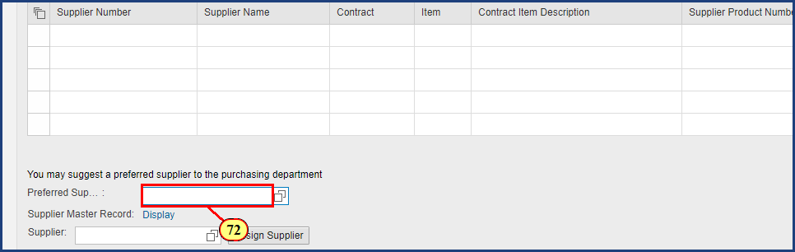

| Step | Action |
| --- | --- |
| 72. | The **Preferred Supplier** field is clicked. |
|  | **Control-V** (PC Paste shortcut) is pressed to paste in the entry. |
|  | **Enter** is pressed to validate the entry and to populate the Supplier name. |

### Shopping Cart

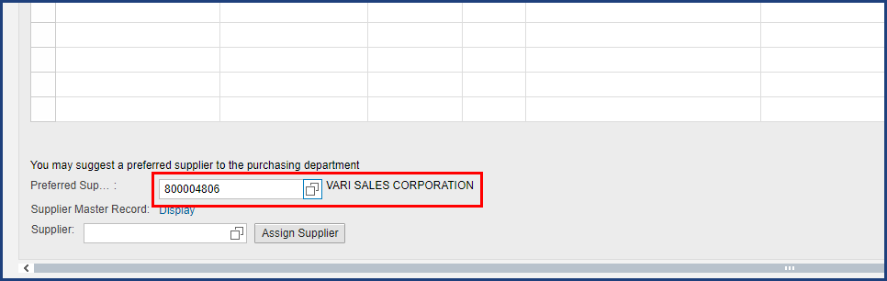

| Step | Action |
| --- | --- |
|  | Seeing the VARI SALES CORPORATION display confirms the Preferred Supplier validation. |

### Shopping Cart

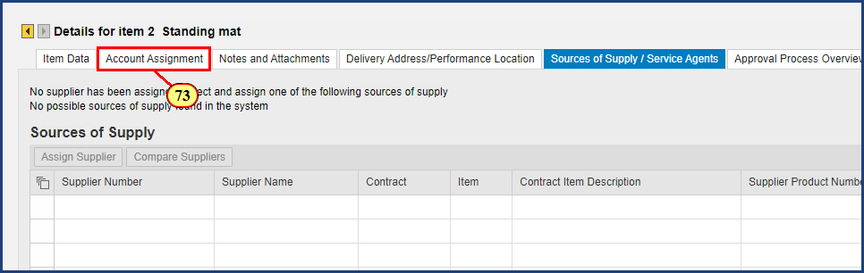

| Step | Action |
| --- | --- |
| 73. | The **Account Assignment** tab is clicked. |

### Shopping Cart

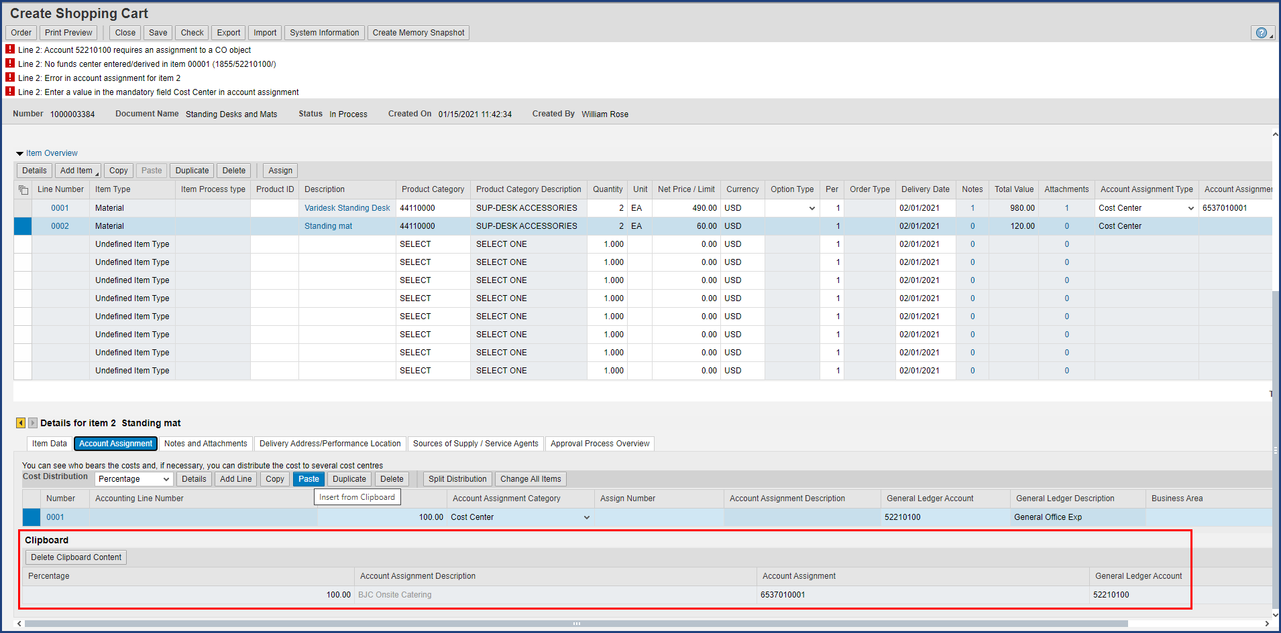

| Step | Action |
| --- | --- |
|  | Here is another payoff moment. The clipboard is displaying the Account Assignment information we copied there earlier, so we are going to click the paste button to easily input that information for line 2. |

### Shopping Cart

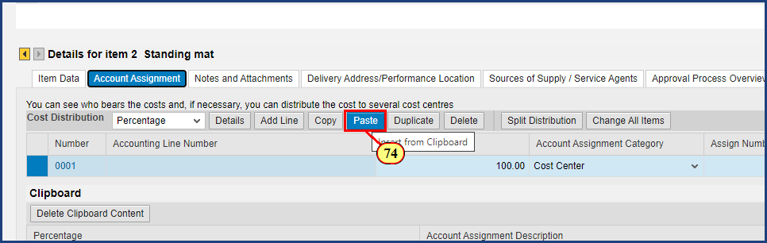

| Step | Action |
| --- | --- |
| 74. | The **Paste** button is clicked. |

### Shopping Cart

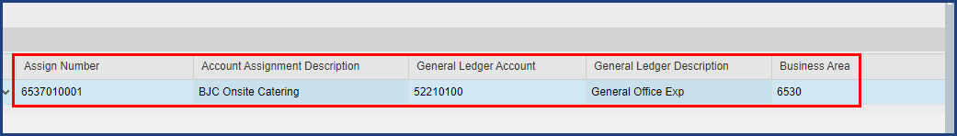

| Step | Action |
| --- | --- |
|  | Note the updated information following the paste. |

### Shopping Cart

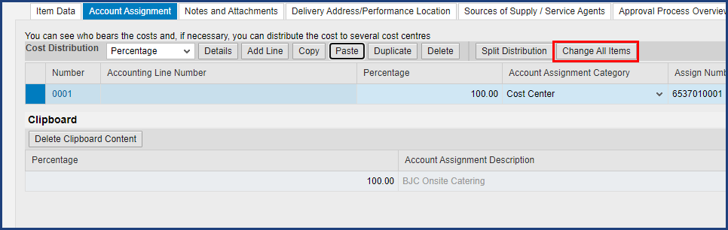

| Step | Action |
| --- | --- |
|  | Incidentally, if you have account assignment data stored in the clipboard that you wish to assign to all line items in the cart, click the Change All Items button and all line items will be updated with the saved Account Assignment information. This includes the cost object as well as the general ledger account information. |

### Shopping Cart

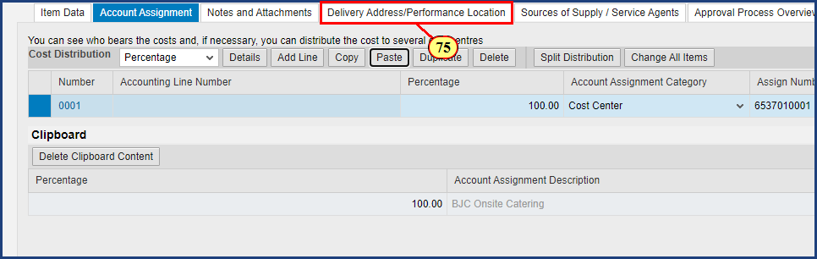

| Step | Action |
| --- | --- |
| 75. | The **Delivery Address/Performance Location** tab is clicked. |

### Shopping Cart

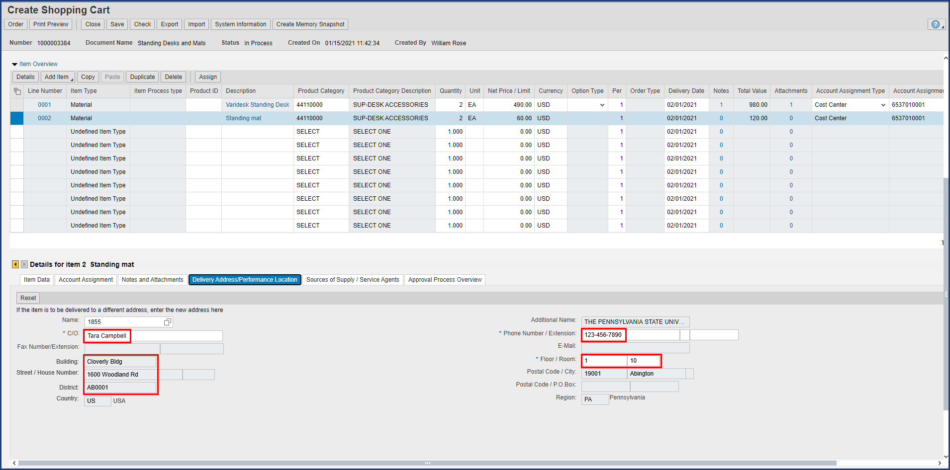

| Step | Action |
| --- | --- |
|  | Default Settings pays off once again. There is nothing to enter or change on this screen. |

### Shopping Cart

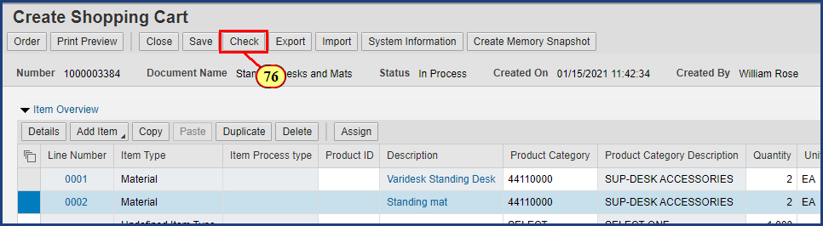

| Step | Action |
| --- | --- |
|  | With both line items complete, notice that no red-level error messages remain. Only red warning messages will prevent the cart from being ordered successfully. Yellow-level messages should be noted by the shopper, but will not prevent the cart from being ordered.    Nevertheless, we **always** want to run one last check before we actually submit the order. This refreshes the system’s error message status based on all information entered. |
| 76. | The **Check** button is clicked. |

### Shopping Cart

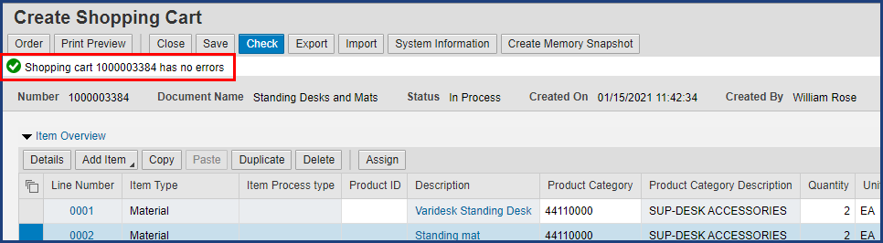

| Step | Action |
| --- | --- |
|  | This shopping cart has no errors. Note the shopping cart number in the system status; it is a good idea to write this number down. Let’s go ahead and submit this order. |

### Shopping Cart

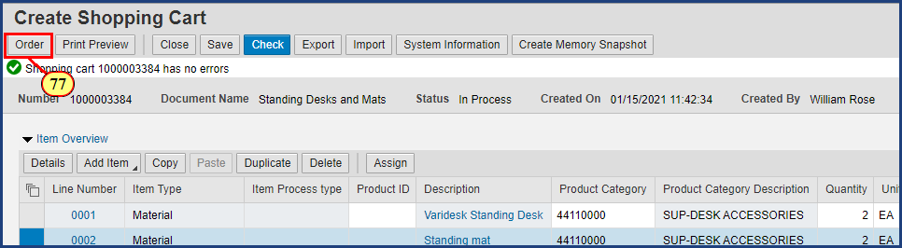

| Step | Action |
| --- | --- |
| 77. | The **Order** button is clicked. |

### Shopping Cart

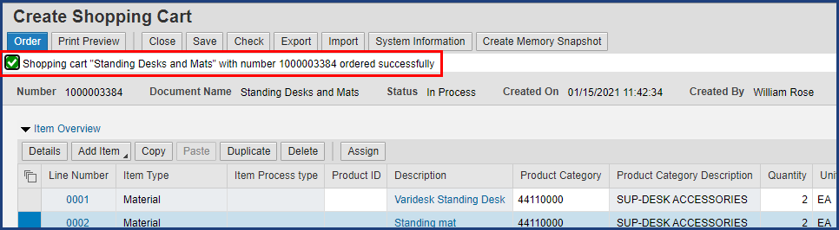

| Step | Action |
| --- | --- |
|  | This order has been successfully submitted into workflow for approval. One final tip: To close the Create Shopping Cart window, always click the Close button, not the X-box that closes the wIndow. |

### Shopping Cart

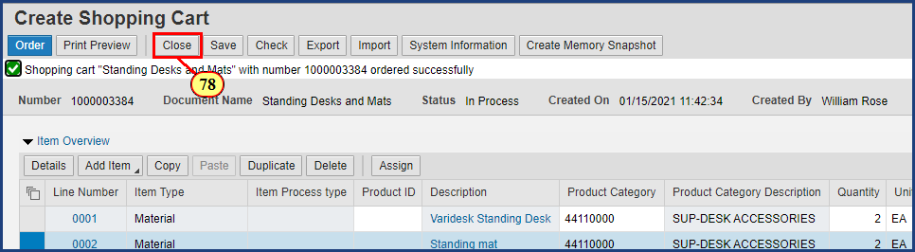

| Step | Action |
| --- | --- |
| 78. | The **Close** button is clicked. |

### Requisitioning

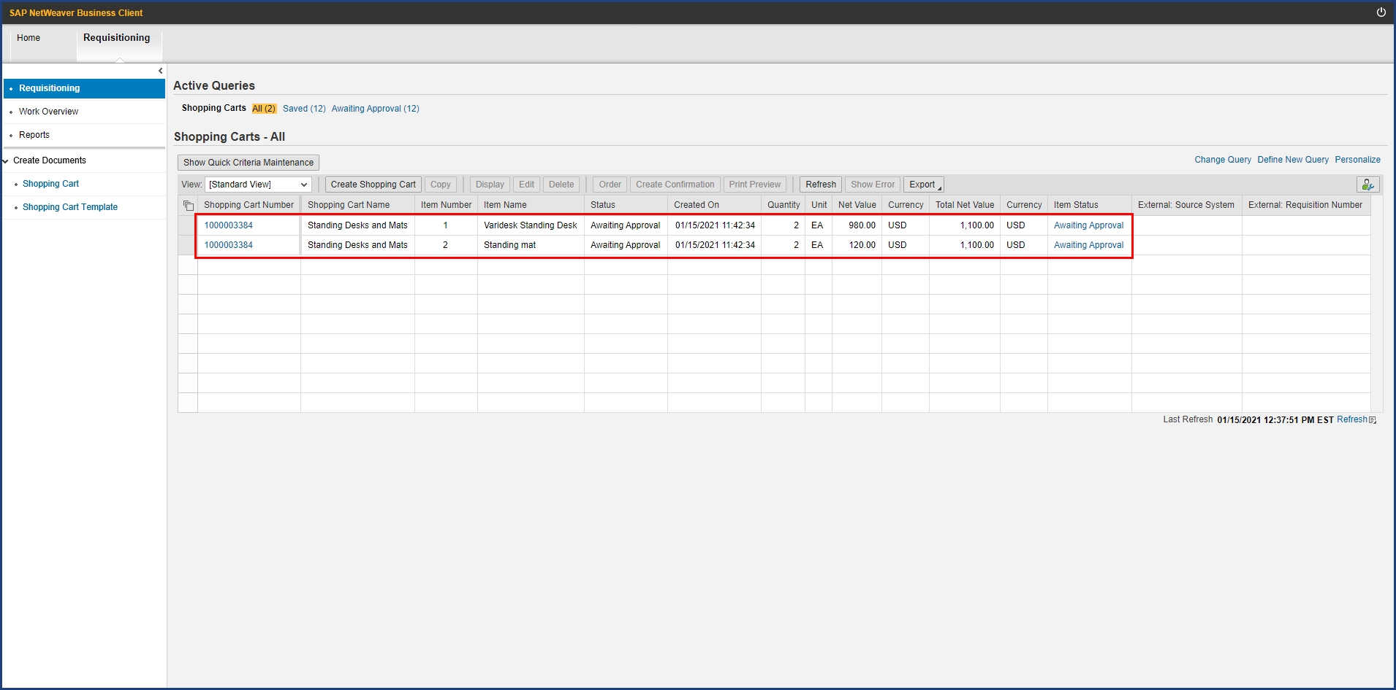

| Step | Action |
| --- | --- |
|  | Back on the Active Queries screen, these items are showing a status of Awaiting Approval. This means the cart has entered workflow. The designated processor receives an email notification and will approve (or reject) the cart. After an initial review by Purchasing, the cart proceeds through a series of approvals related to budget and finance.    If at any point your cart is determined to possess incorrect or incomplete information (vendor quote not attached is a common example), the cart will be rejected back to you for correction. As resolving a rejected shopping cart is beyond the scope of this simulation, see the SIMBA Short **Resolving Rejected Shopping Carts**. Note that only fully approved shopping carts are sent to Purchasing for sourcing onto a purchase order. |

### Requisitioning

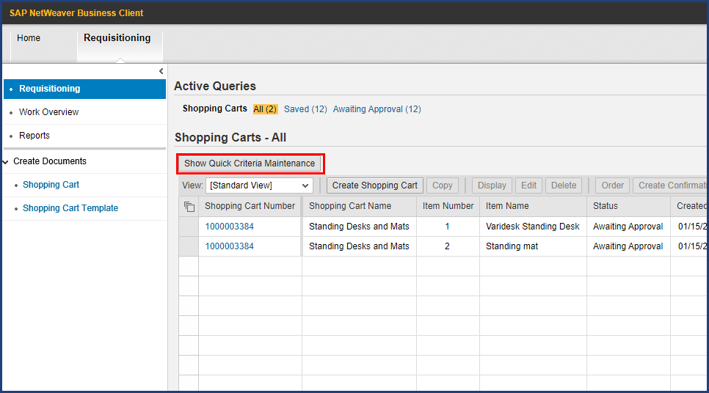

| Step | Action |
| --- | --- |
|  | Remember, if you don't see your cart listed on Active Queries, click the Refresh button to get an updated listing. If you still don't see it listed, it may be that search criteria (accessed via the Show Quick Criteria Maintenance button) are restricting your display and need to be cleared. Look in the Training Resources section of the SIMBA website for the SIMBA Short **Using Quick Criteria Maintenance** for more detail. |

| Step | Action |
| --- | --- |
|  | **The Four Step Shopping Process**    Step 3 of the shopping process is now complete. Occasionally, you may make a mistake in data entry, or forget to provide an attachment, that causes your cart to be rejected back to you to resolve the issue. Generally, though, you can expect that the cart will proceed normally through the approval process, that a purchase order will be created and submitted to the supplier, and that soon your goods will be delivered to you (or the designated Goods Recipient).     1. Configure Shop OnLion Settings 2. Search for Item Availability 3. Create Shopping Cart (Lion Marketplace, PSU Contracts, or Free Text) 4. **Provide Goods Confirmation upon Goods Receipt**      * See **Goods Confirmation** (to learn the fourth step in the shopping process) * See the SIMBA Short: **Resolving Rejected Shopping Carts** (to learn how to correct a rejected cart and get it moving forward again) |

**Disclaimer**

**Alternative Format Statement**   
This publication is available in alternative media upon request. 

**Statement of Non-Discrimination**

The University is committed to equal access to programs, facilities, admission, and employment for all persons. It is the policy of the University to maintain an environment free of harassment and free of discrimination against any person because of age, race, color, ancestry, national origin, religion, creed, service in uniformed services (as defined in state and federal law), veteran status, sex, sexual orientation, marital or family status, pregnancy, pregnancy-related conditions, physical or mental disability, gender, perceived gender, gender identity, genetic information, or political ideas. Discriminatory conduct and harassment, as well as sexual misconduct and relationship violence, violates the dignity of individuals, impedes the realization of the University’s educational mission, and will not be tolerated. Direct all inquiries regarding the nondiscrimination policy to Affirmative Action Office, The Pennsylvania State University, 328 Boucke Building, University Park, PA 16802-5901; Email: [aao@psu.edu](mailto:aao@psu.edu); Tel: 814-863-0471.