**The Pennsylvania State University**



**SIMBA Hands-On Guide**

**PR8_Shopping Cart - Radioactive Materials**



© 2020 The Pennsylvania State University  
© Copyright 2020 Labyrinth Solutions, Inc. All rights reserved. Labyrinth Solutions, Inc., the LSI logo, and CampusOneTM are trademarks of Labyrinth Consulting, Inc.   
SAP, R/3, SAP NetWeaver, and other SAP products and services mentioned herein as well as their respective logos are trademarks or registered trademarks of SAP AG in Germany and other countries.   
Business Objects and the Business Objects logo, BusinessObjects, Crystal Reports, Crystal Decisions, Web Intelligence, Xcelsius, and other Business Objects products and services mentioned herein as well as their respective logos are trademarks or registered trademarks of Business Objects S.A. in the United States and in other countries. Business Objects is an SAP company.

# PR8_Shopping Cart - Radioactive Materials

## Overview

**Transaction Description:**

This transaction is a standard shopping cart with expanded functionality.

**Penn State Purpose:**

This transaction uses shopping cart fields to request the purchase of radioactive materials.

## Process Steps

### Home

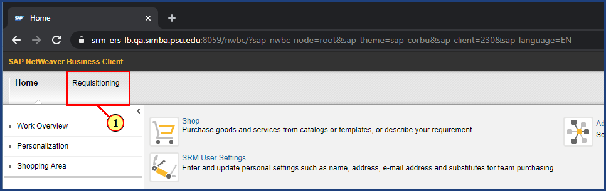

| Step | Action |
| --- | --- |
| 1. | The **Requisitioning** button is clicked. |

### Requisitioning

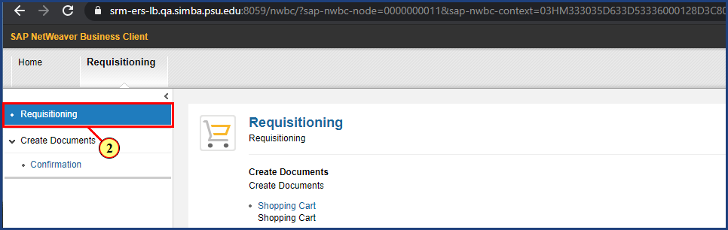

| Step | Action |
| --- | --- |
| 2. | The **Requisitioning** button is clicked. |

### Requisitioning

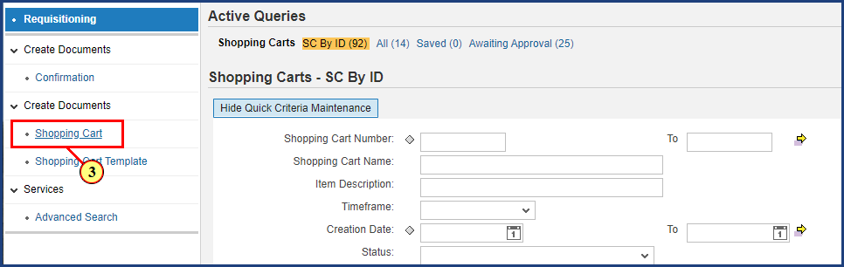

| Step | Action |
| --- | --- |
| 3. | The **Shopping Cart** button is clicked. |

### Create Shopping Cart

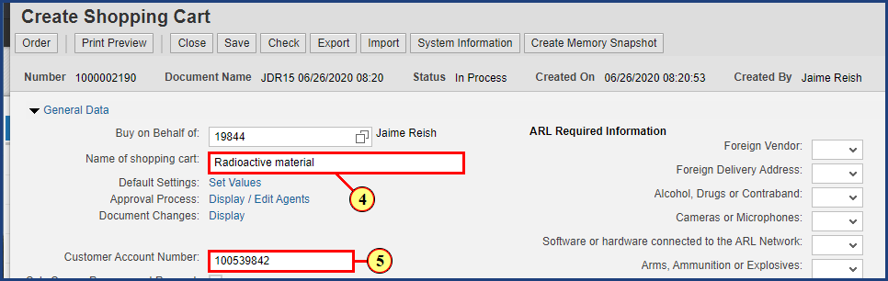

| Step | Action |
| --- | --- |
|  | The system will populate the Name of shopping cart field with your PSU User ID and the date and time your cart was created.  You can leave the default value or edit the cart name to help you identify it more easily. |
| 4. | **Radioactive material** is entered into the **Name of shopping cart** field. |

| Step | Action |
| --- | --- |
|  | Use the optional Customer Account Number field to identify your account with the Supplier. |
| 5. | **100539842** is entered into the **Customer Account Number** field. |

### Create Shopping Cart

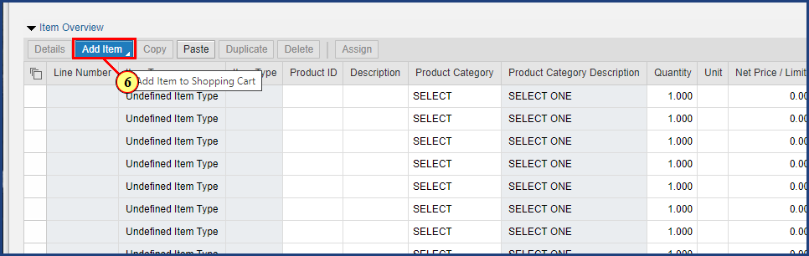

| Step | Action |
| --- | --- |
|  | To add line items, click the Add Item button. |
| 6. | The **Add Item** dropdown is clicked. |

### Create Shopping Cart

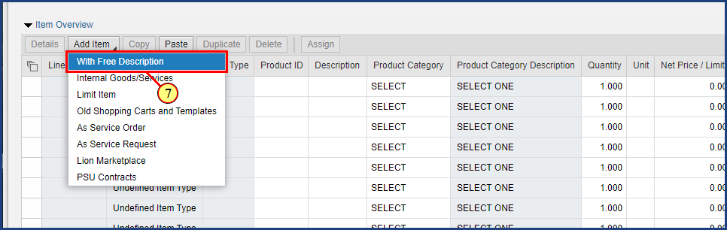

| Step | Action |
| --- | --- |
| 7. | The **With Free Description**  menu item is clicked. |

### Create Shopping Cart

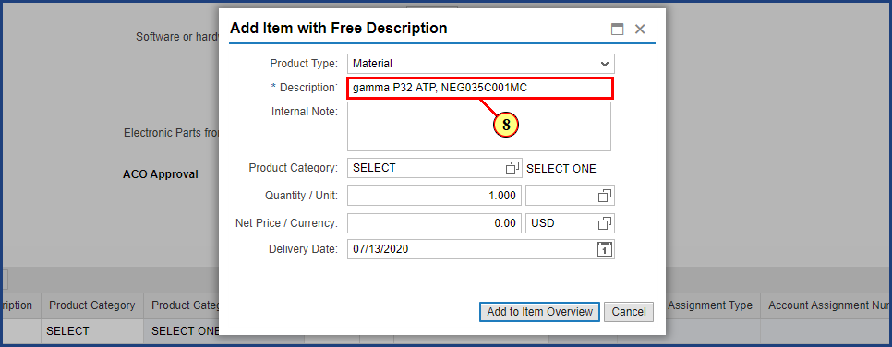

| Step | Action |
| --- | --- |
|  | Enter an item description and any internal notes here. Note the Description field is only 40 characters long, so the Internal Note can be used to provide additional details about the line item. |
| 8. | **gamma P32 ATP, NEG035C001MC** is entered into the **Description** field. |

### Create Shopping Cart

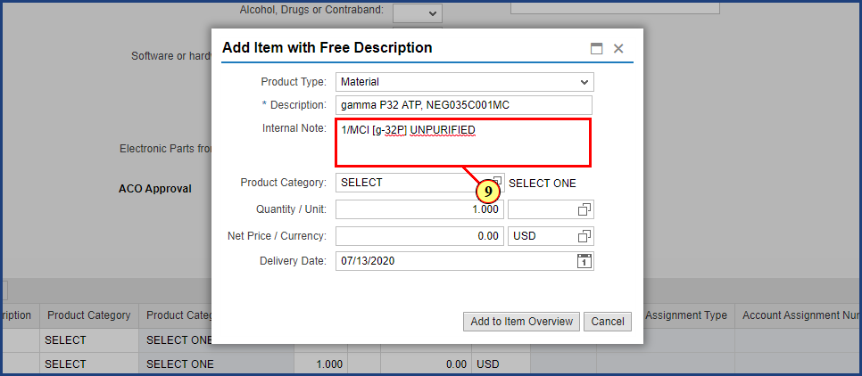

| Step | Action |
| --- | --- |
|  | The radioactivity information should be entered into the Internal Note. |
| 9. | **1/MCI [g-32P] UNPURIFIED** is entered into the **Internal Note** field. |

### Create Shopping Cart

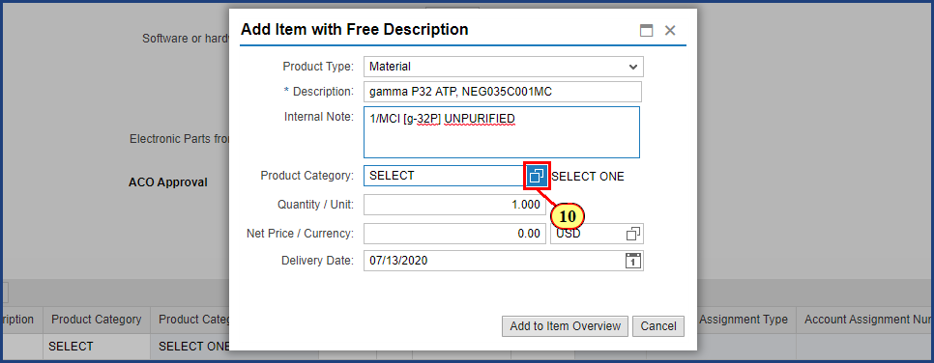

| Step | Action |
| --- | --- |
|  | If you know the 8-digit Product Category code enter it here; otherwise, search for a Product Category using the Possible Values button. |
| 10. | The **Possible Values** button is clicked. |

### Create Shopping Cart

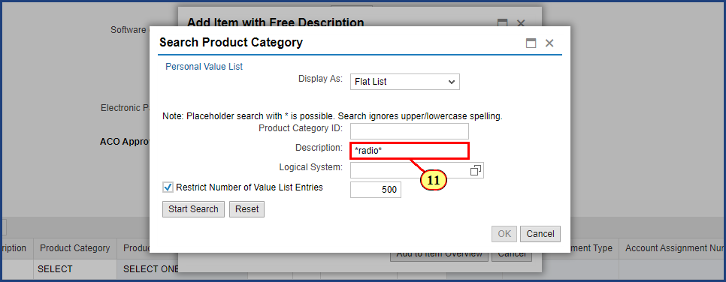

| Step | Action |
| --- | --- |
|  | Enter your search description here. Using the asterisk (*) or wildcard generates a list of search results that contain the keyword anywhere in the description. |
| 11. | **\*radio\*** is typed into the **Description** field. |

### Create Shopping Cart

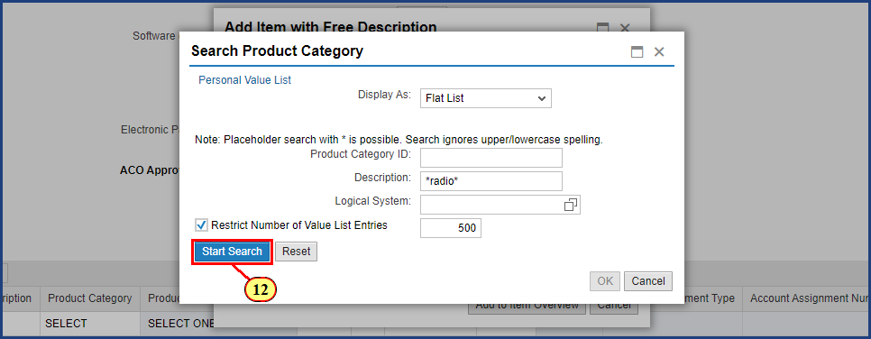

| Step | Action |
| --- | --- |
| 12. | The **Start Search** button is clicked. |

### Create Shopping Cart

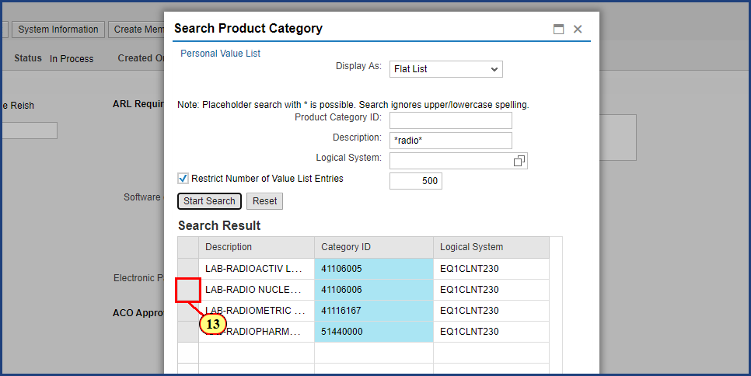

| Step | Action |
| --- | --- |
|  | Select the Product Category that most accurately describes the product or service to be purchased and click OK to populate the Product Category field in the Add Item with Free Description window. |
| 13. | The **Line Item Selection** button is clicked. |

### Create Shopping Cart

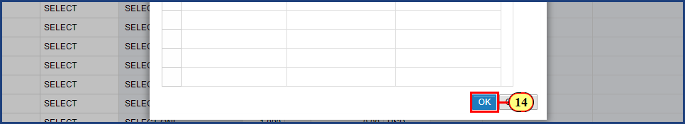

| Step | Action |
| --- | --- |
| 14. | The **OK** button is clicked. |

### Create Shopping Cart

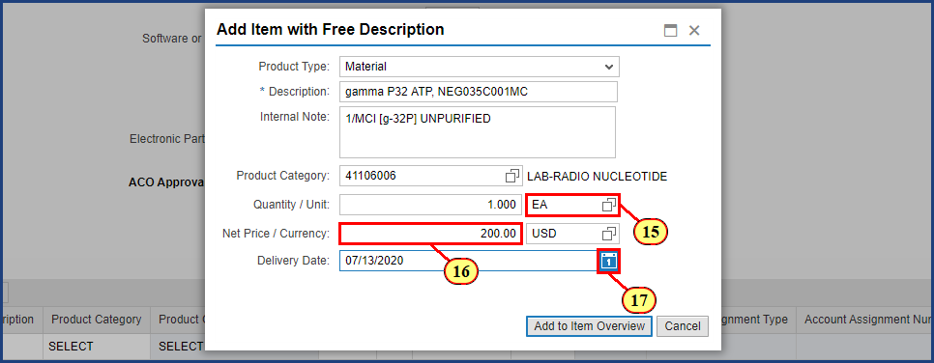

| Step | Action |
| --- | --- |
| 15. | **EA** is typed into the **Unit** field. |
| 16. | **200.00** is typed into the **Net Price** field. |

| Step | Action |
| --- | --- |
|  | The delivery date will auto-populate to two weeks out. This can be changed by either typing in the new date or selecting it on the calender icon. |
| 17. | The **Delivery Date date picker** button is clicked. |

### Create Shopping Cart

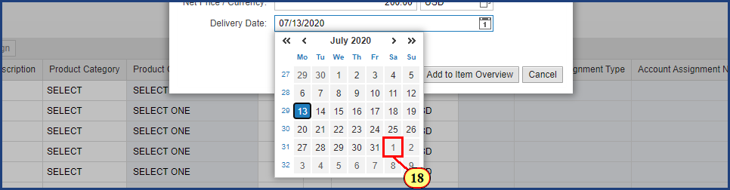

| Step | Action |
| --- | --- |
| 18. | The **Date** is selected. |

### Create Shopping Cart

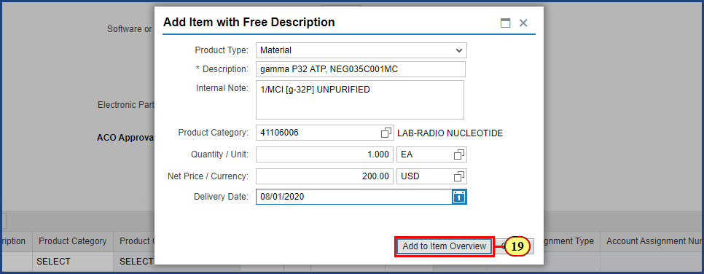

| Step | Action |
| --- | --- |
|  | When the item information is complete, select Add to Item Overview to create the line item in your Shopping Cart. |
| 19. | The **Add to Item Overview** button is clicked. |

### Shopping Cart

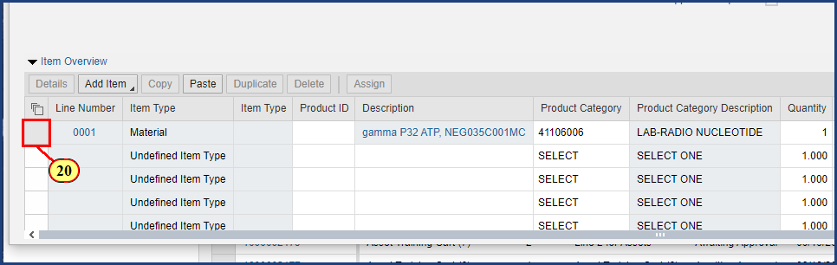

| Step | Action |
| --- | --- |
| 20. | The **Line Item Selection** button is clicked. |

### Shopping Cart

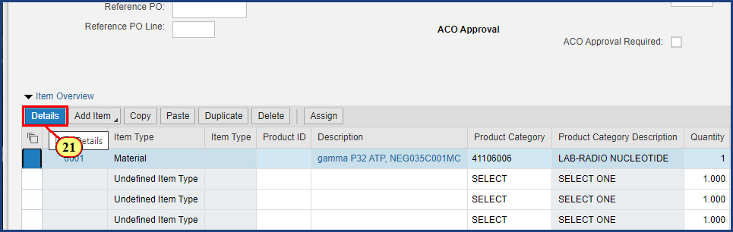

| Step | Action |
| --- | --- |
|  | Once the line item is selected, clicking the Details button will reveal additional information to view, add, and edit. |
| 21. | The **Details** button is clicked. |

### Shopping Cart

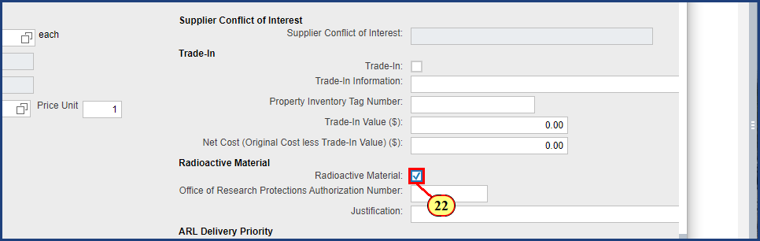

| Step | Action |
| --- | --- |
|  | The Item Data tab contains details specific to the line item selected. In this example, we will complete the Radioactive Materials information. |
| 22. | The **Radioactive Material** checkbox is clicked. |

### Shopping Cart

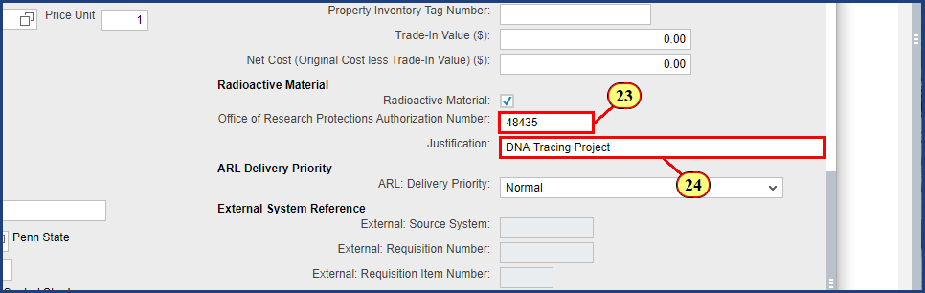

| Step | Action |
| --- | --- |
| 23. | **48435** is typed into the **Office of Research Protections Authorization Number** field. |
| 24. | **DNA Tracing Project** is entered into the **Justification** field. |

### Shopping Cart

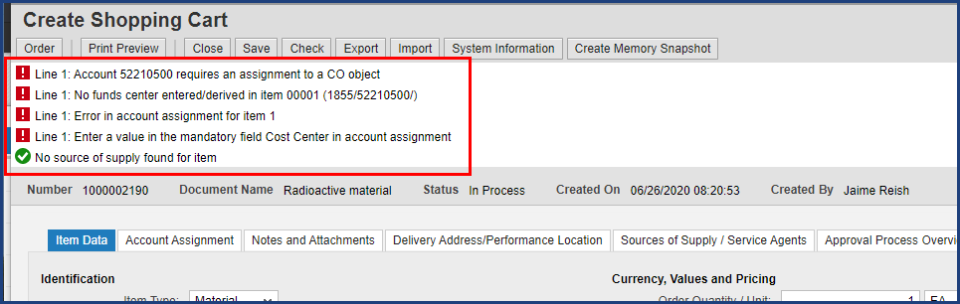

| Step | Action |
| --- | --- |
|  | You may have noticed various errors and warnings in the message area at the top of the screen. Many of these can be resolved by entering funding information for the shopping cart on the Account Assignment tab. |

### Shopping Cart

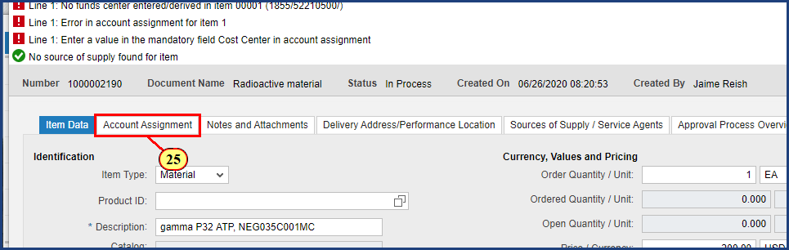

| Step | Action |
| --- | --- |
| 25. | The **Account Assignment** tab is clicked. |

### Shopping Cart

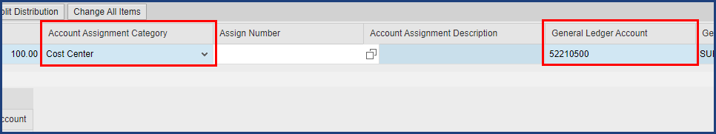

| Step | Action |
| --- | --- |
|  | The Account Assignment Category can be changed by selecting the drop down and selecting the desired Account Assignment Category type. This example uses a Cost Center. Enter the cost center number in the Assign Number field. Note that the General Ledger Account has been auto-populated based on the line item. |

### Shopping Cart

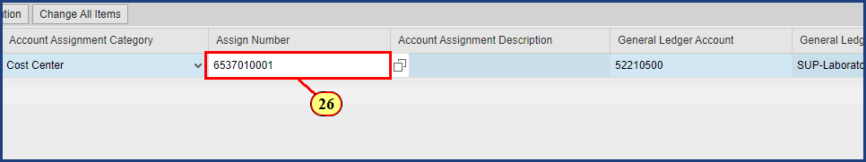

| Step | Action |
| --- | --- |
| 26. | **6537010001** is typed into the **Assign Number** field. |
|  | **Enter** is pressed. |

### Shopping Cart

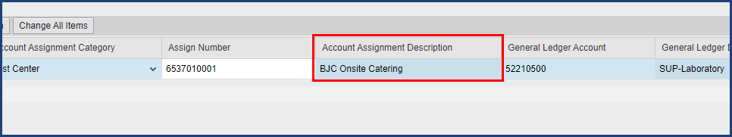

| Step | Action |
| --- | --- |
|  | Pressing Enter in Shop OnLion validates user entries against master data.  In this example, notice that the Account Assignment Description is filled in after Enter is pressed. Additionally, the warning messages related to accounting at the top of the screen have now been cleared. |

### Shopping Cart

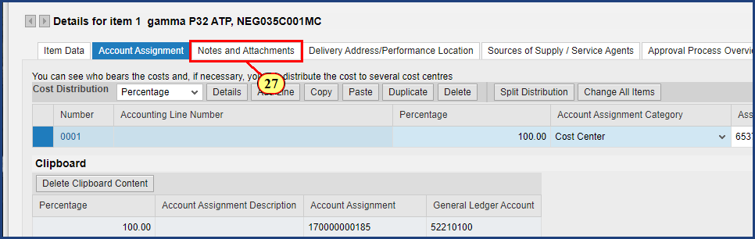

| Step | Action |
| --- | --- |
|  | To add notes and attachments to the shopping cart, click the Notes and Attachments tab.  As best practice, all attachments should be added on the first line item. |
| 27. | The **Notes and Attachments** tab is clicked. |

### Shopping Cart

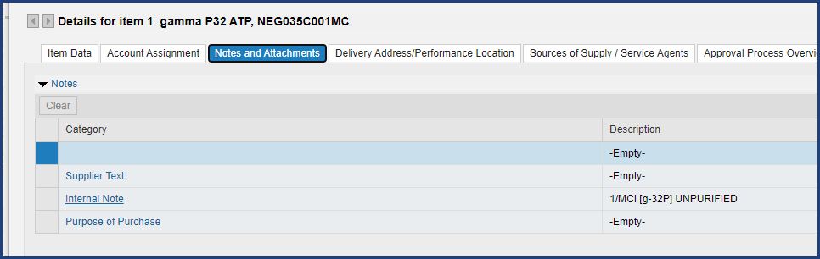

| Step | Action |
| --- | --- |
|  | Shop OnLion offers three categories of Notes.  Supplier text will be printed on the purchase order for the supplier. Internal notes are only for PSU to view. Your department may offer guidance on how to use Purpose of Purchase. In this example the internal note added during line item creation has already been populated. Additional information can be added by opening the Internal Note. |

### Shopping Cart

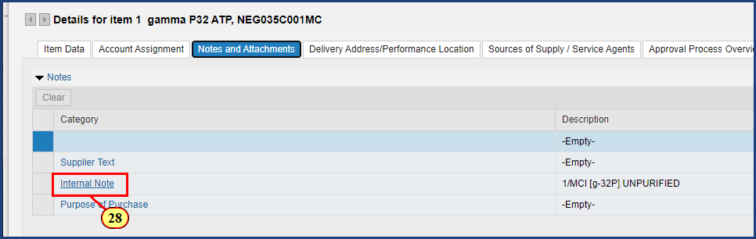

| Step | Action |
| --- | --- |
| 28. | The **Internal Note** button is clicked. |

### Shopping Cart

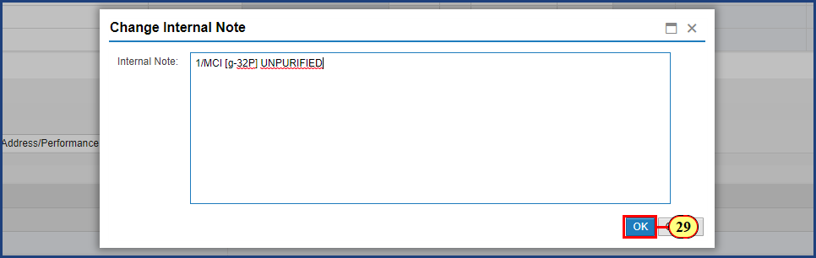

| Step | Action |
| --- | --- |
|  | The Internal Note is now editable. After all of the important item information has been entered, proceed by clicking OK. |
| 29. | The **OK** button is clicked. |

### Shopping Cart

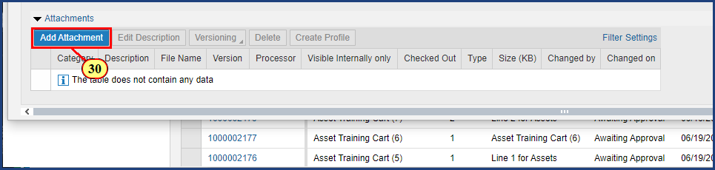

| Step | Action |
| --- | --- |
|  | Shoppers and approvers may add attachments to the shopping cart. Examples of shopping cart attachments include supporting documentation such as supplier quotes, item specifications, required university forms, and purchase justifications. |
| 30. | The **Add Attachment** button is clicked. |

### Shopping Cart

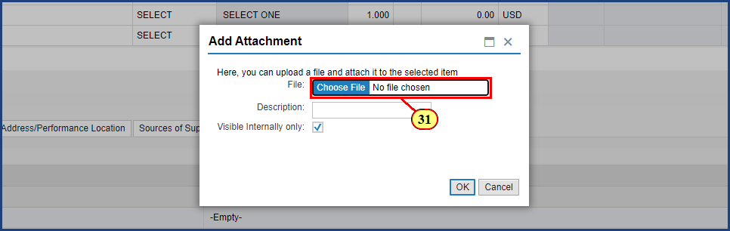

| Step | Action |
| --- | --- |
|  | Click the Choose File button in the Add Attachment pop up window to browse your computer for a file to attach. |
| 31. | The **Choose File** button is clicked. |

### Open

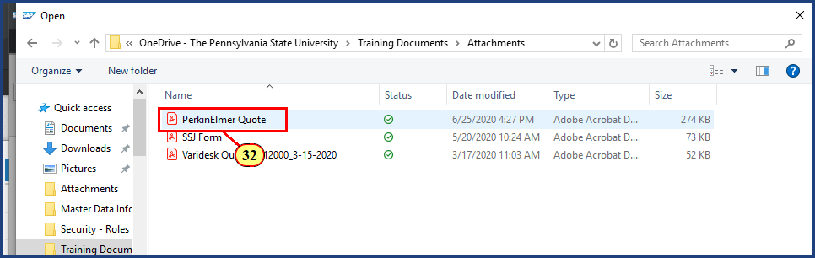

| Step | Action |
| --- | --- |
| 32. | The **document filename** button is **double-clicked**. |

### Shopping Cart

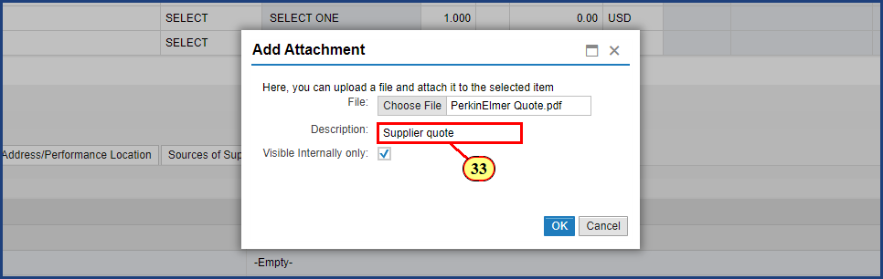

| Step | Action |
| --- | --- |
|  | Provide a description for the attachment such as "supplier quote" or "sole source justification". |
| 33. | **Supplier quote** is entered into the field. |

### Shopping Cart

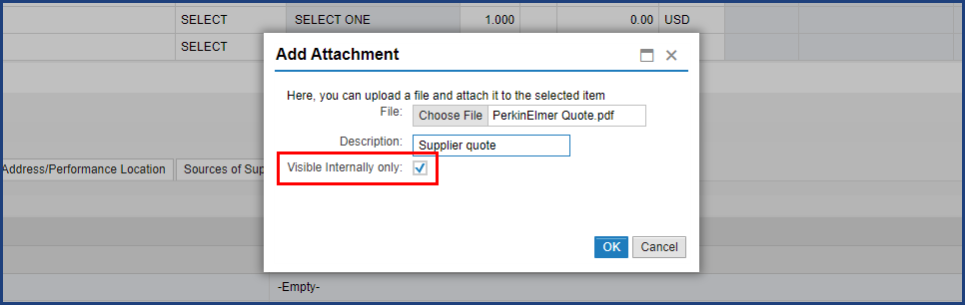

| Step | Action |
| --- | --- |
|  | Note the Visible Internally only check box.  Checking this box means only PSU users will be able to view the attachment.  Deselect the box if the document attached should be sent with the purchase order to the supplier. |

### Shopping Cart

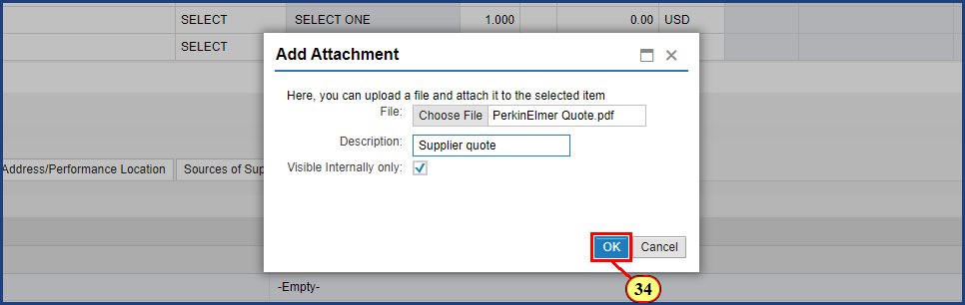

| Step | Action |
| --- | --- |
| 34. | The **OK** button is clicked. |

### Shopping Cart

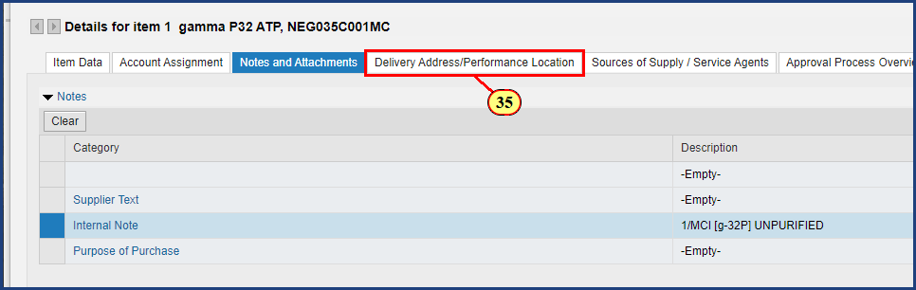

| Step | Action |
| --- | --- |
|  | Next a delivery address will be selected for line item 1. |
| 35. | The **Delivery Address/Performance Location** tab is clicked. |

### Shopping Cart

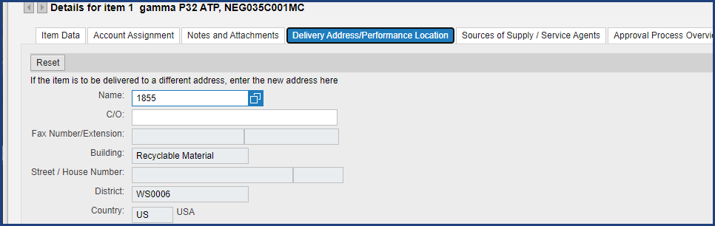

| Step | Action |
| --- | --- |
|  | The shopping cart delivery address will default to the address in your user profile. In this example the radioactive material must be delivered to Room 228 of the Academic Projects Building. Use the Possible Values button to search all delivery addresses. |

### Shopping Cart

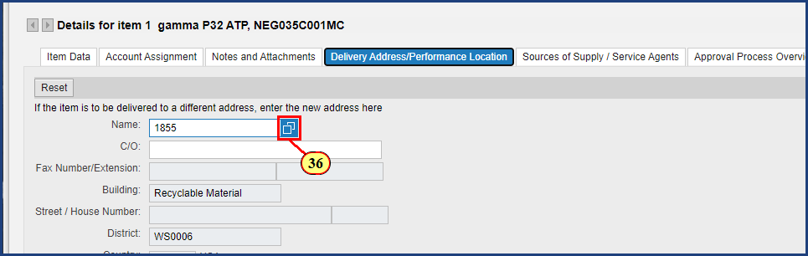

| Step | Action |
| --- | --- |
| 36. | The **Possible Values** button is clicked. |

### Shopping Cart

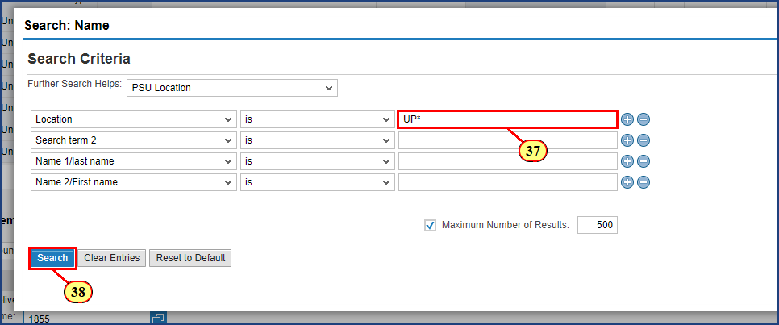

| Step | Action |
| --- | --- |
|  | Use the Location search option to search by campus or location code. In this example the campus code for University Park is used with an asterisk (*) to return relevant location codes. |
| 37. | **UP\*** is typed into the **Location** field. |
| 38. | The **Search** button is clicked. |

### Shopping Cart

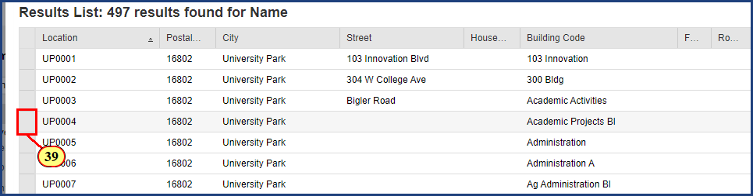

| Step | Action |
| --- | --- |
|  | Results are returned for all University Park campus delivery addresses.    Academic Projects Building has been abreviated in SIMBA as Academic Projects Bl. |
| 39. | The **Line Selection** button is clicked. |

### Shopping Cart

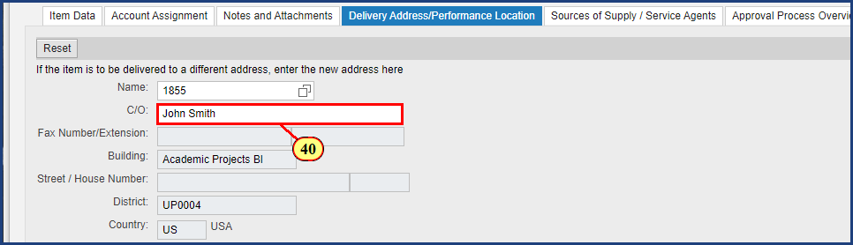

| Step | Action |
| --- | --- |
|  | Address information has been populated and additional details such as a Care Of, Phone Number, Floor and Room number can be added to ensure the supplier delivery is correct. |
| 40. | **John Smith** is entered into the **Care Of** field. |

### Shopping Cart

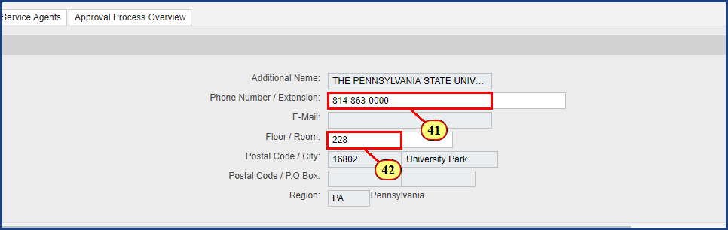

| Step | Action |
| --- | --- |
| 41. | **814-863-0000** is typed into the **Phone Number** field. |
| 42. | **228** is entered into the **Room** field. |

| Step | Action |
| --- | --- |
|  | It is important to remember that the Delivery Address must be specified / updated for every line item on the shopping cart. |

### Shopping Cart

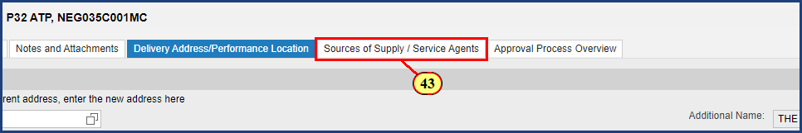

| Step | Action |
| --- | --- |
|  | Next the Source of Supply tab will be reviewed and edited. |
| 43. | The **Sources of Supply / Service Agents** tab is clicked. |

### Shopping Cart

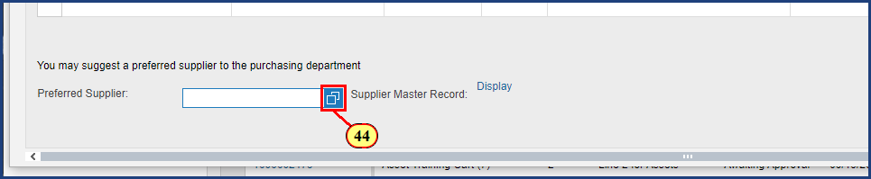

| Step | Action |
| --- | --- |
|  | To suggest a preferred supplier, search the supplier database by selecting the Possible Values icon. This will prompt the Search: Preferred Supplier window to open. |
| 44. | The **Possible Values** button is clicked. |

### Shopping Cart

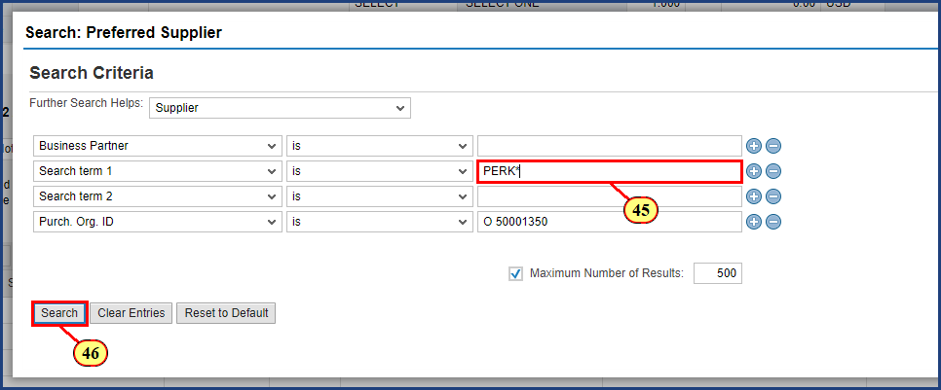

| Step | Action |
| --- | --- |
|  | Enter the supplier name you wish to find here. Adding * to the search broadens the results to contain the text. |
| 45. | **PERK\*** is typed into the **Search term 1** field. |
| 46. | The **Search** button is clicked. |

### Shopping Cart

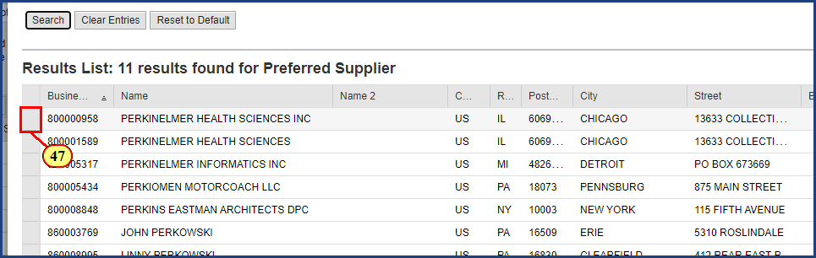

| Step | Action |
| --- | --- |
|  | Select the line with your desired supplier. This will auto-populate the supplier into the preferred supplier field in the Sources of Supply Tab. |
| 47. | The **Line Selection** button is clicked. |

### Shopping Cart

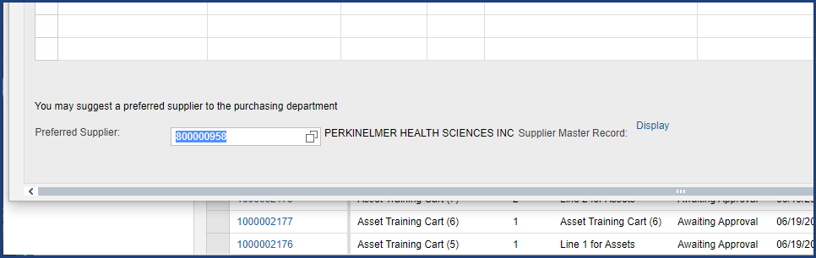

| Step | Action |
| --- | --- |
|  | SAP uses a unique 9-digit business partner number to identify each supplier. Please note the supplier number shown in this simulation is test data and may not correspond to the actual supplier number. |

### Shopping Cart

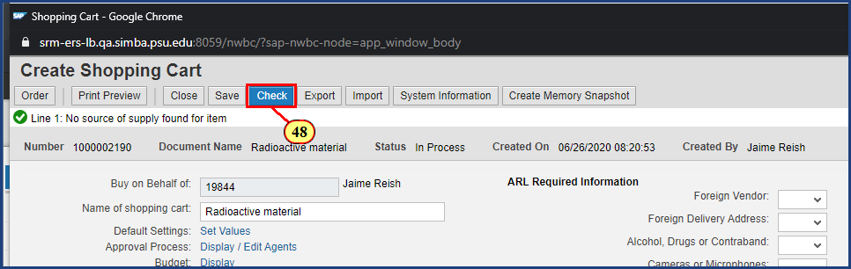

| Step | Action |
| --- | --- |
|  | Clicking the Check button refreshes the system’s error messages and updates based on newly entered information. Only red warning messages will prevent the cart from being ordered successfully. Yellow messages should be noted and considered by the shopper but will not prevent the cart from being ordered. |
| 48. | The **Check** button is clicked. |

### Shopping Cart

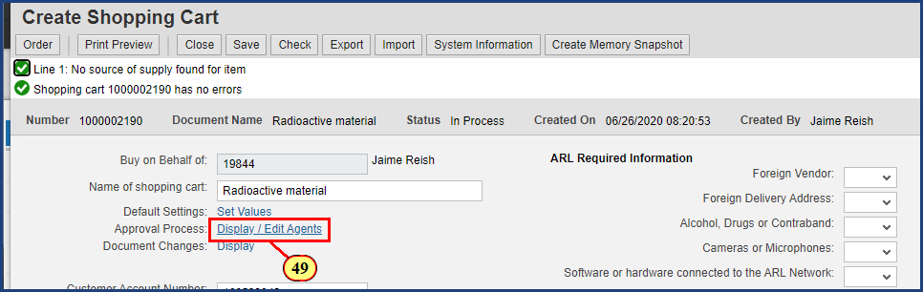

| Step | Action |
| --- | --- |
|  | To view the shopping cart approval workflow, press the Display / Edit Agents link next to Approval Process. |
| 49. | The **Display / Edit Agents** button is clicked. |

### Shopping Cart

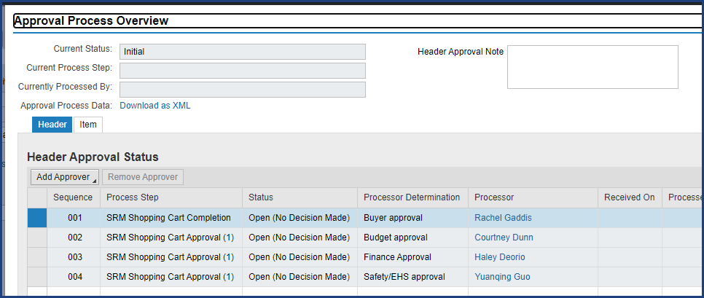

| Step | Action |
| --- | --- |
|  | The approval routing indictes shopping cart will route to EHS for approval as required by PSU policy. |

### Shopping Cart

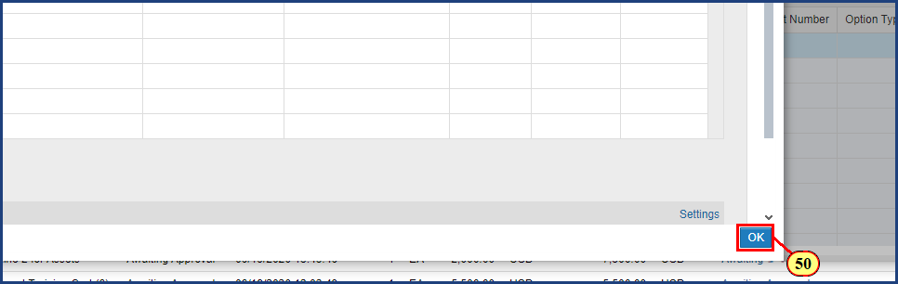

| Step | Action |
| --- | --- |
| 50. | The **OK** button is clicked. |

### Shopping Cart

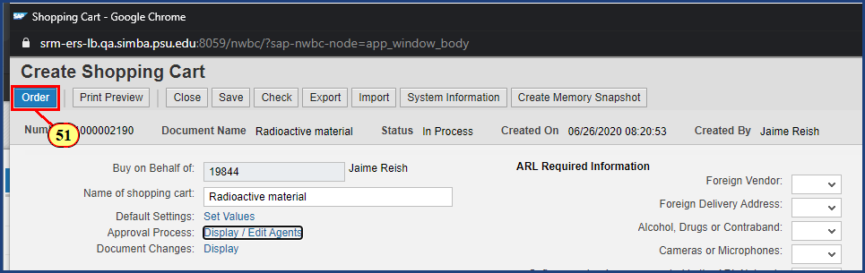

| Step | Action |
| --- | --- |
|  | Click Order to complete the shopping cart.  If you are not yet ready to order the cart click Save to revisit it later. |
| 51. | The **Order** button is clicked. |

### Display Document

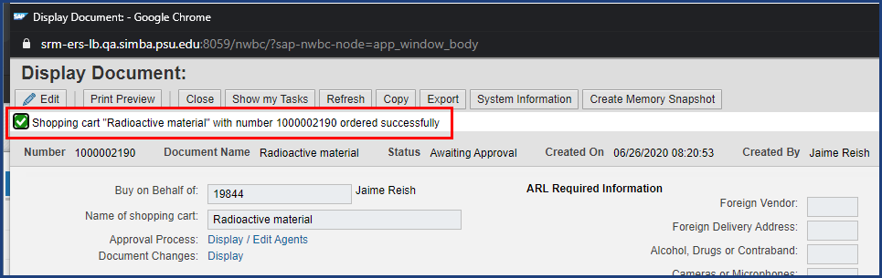

| Step | Action |
| --- | --- |
|  | The System Status Bar Confirmation shows the shopping cart has been ordered successfully. |

### Display Document

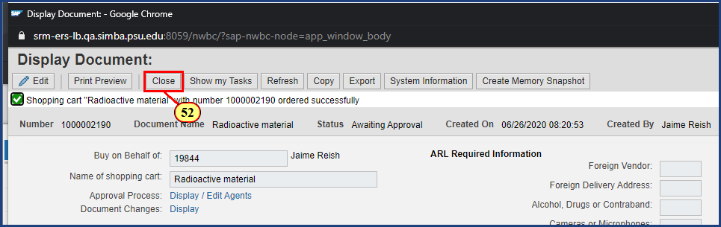

| Step | Action |
| --- | --- |
| 52. | The **Close** button is clicked. |

### Requisitioning

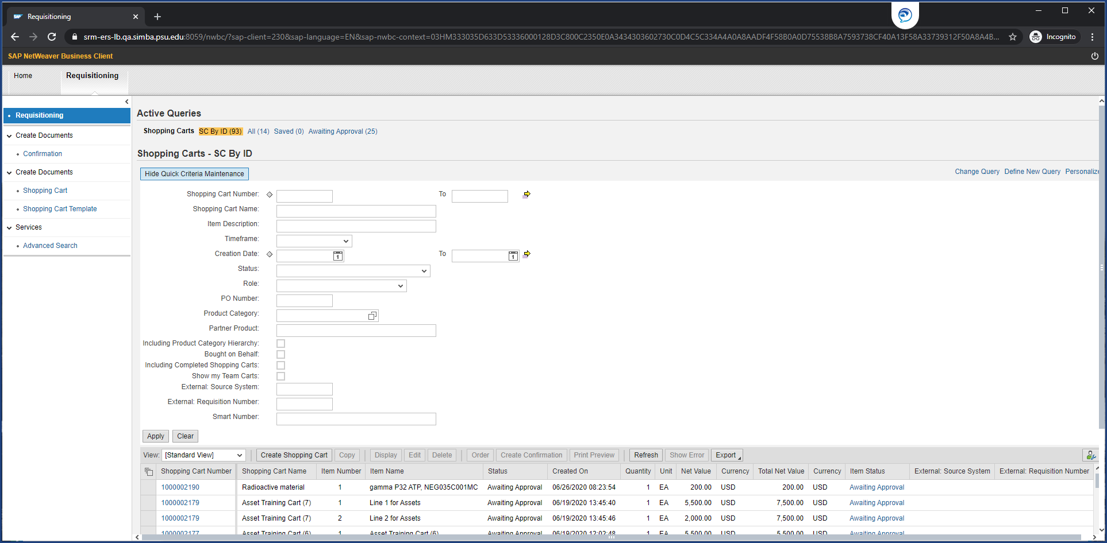

| Step | Action |
| --- | --- |
|  | Closing the shopping cart window returns you to the Active Queries screen. Using the various search criteria and Refresh button will update the search results and allow for monitoring of shopping cart status. |

**Disclaimer**

**Alternative Format Statement**   
This publication is available in alternative media upon request. 

**Statement of Non-Discrimination**

The University is committed to equal access to programs, facilities, admission, and employment for all persons. It is the policy of the University to maintain an environment free of harassment and free of discrimination against any person because of age, race, color, ancestry, national origin, religion, creed, service in uniformed services (as defined in state and federal law), veteran status, sex, sexual orientation, marital or family status, pregnancy, pregnancy-related conditions, physical or mental disability, gender, perceived gender, gender identity, genetic information, or political ideas. Discriminatory conduct and harassment, as well as sexual misconduct and relationship violence, violates the dignity of individuals, impedes the realization of the University’s educational mission, and will not be tolerated. Direct all inquiries regarding the nondiscrimination policy to Affirmative Action Office, The Pennsylvania State University, 328 Boucke Building, University Park, PA 16802-5901; Email: [aao@psu.edu](mailto:aao@psu.edu); Tel: 814-863-0471.