**The Pennsylvania State University**



**SIMBA Hands-On Guide**

**PR7_Shopping Cart - PO Change Request**



© 2020 The Pennsylvania State University  
© Copyright 2020 Labyrinth Solutions, Inc. All rights reserved. Labyrinth Solutions, Inc., the LSI logo, and CampusOneTM are trademarks of Labyrinth Consulting, Inc.   
SAP, R/3, SAP NetWeaver, and other SAP products and services mentioned herein as well as their respective logos are trademarks or registered trademarks of SAP AG in Germany and other countries.   
Business Objects and the Business Objects logo, BusinessObjects, Crystal Reports, Crystal Decisions, Web Intelligence, Xcelsius, and other Business Objects products and services mentioned herein as well as their respective logos are trademarks or registered trademarks of Business Objects S.A. in the United States and in other countries. Business Objects is an SAP company.

# PR7_Shopping Cart - PO Change Request

## Overview

**Transaction Description:**

This transaction is a standard shopping cart with expanded functionality.

**Penn State Purpose:**

This transaction uses the standard shopping cart to process a change request to increase an existing purchase order.

## Process Steps

### Home - Google Chrome

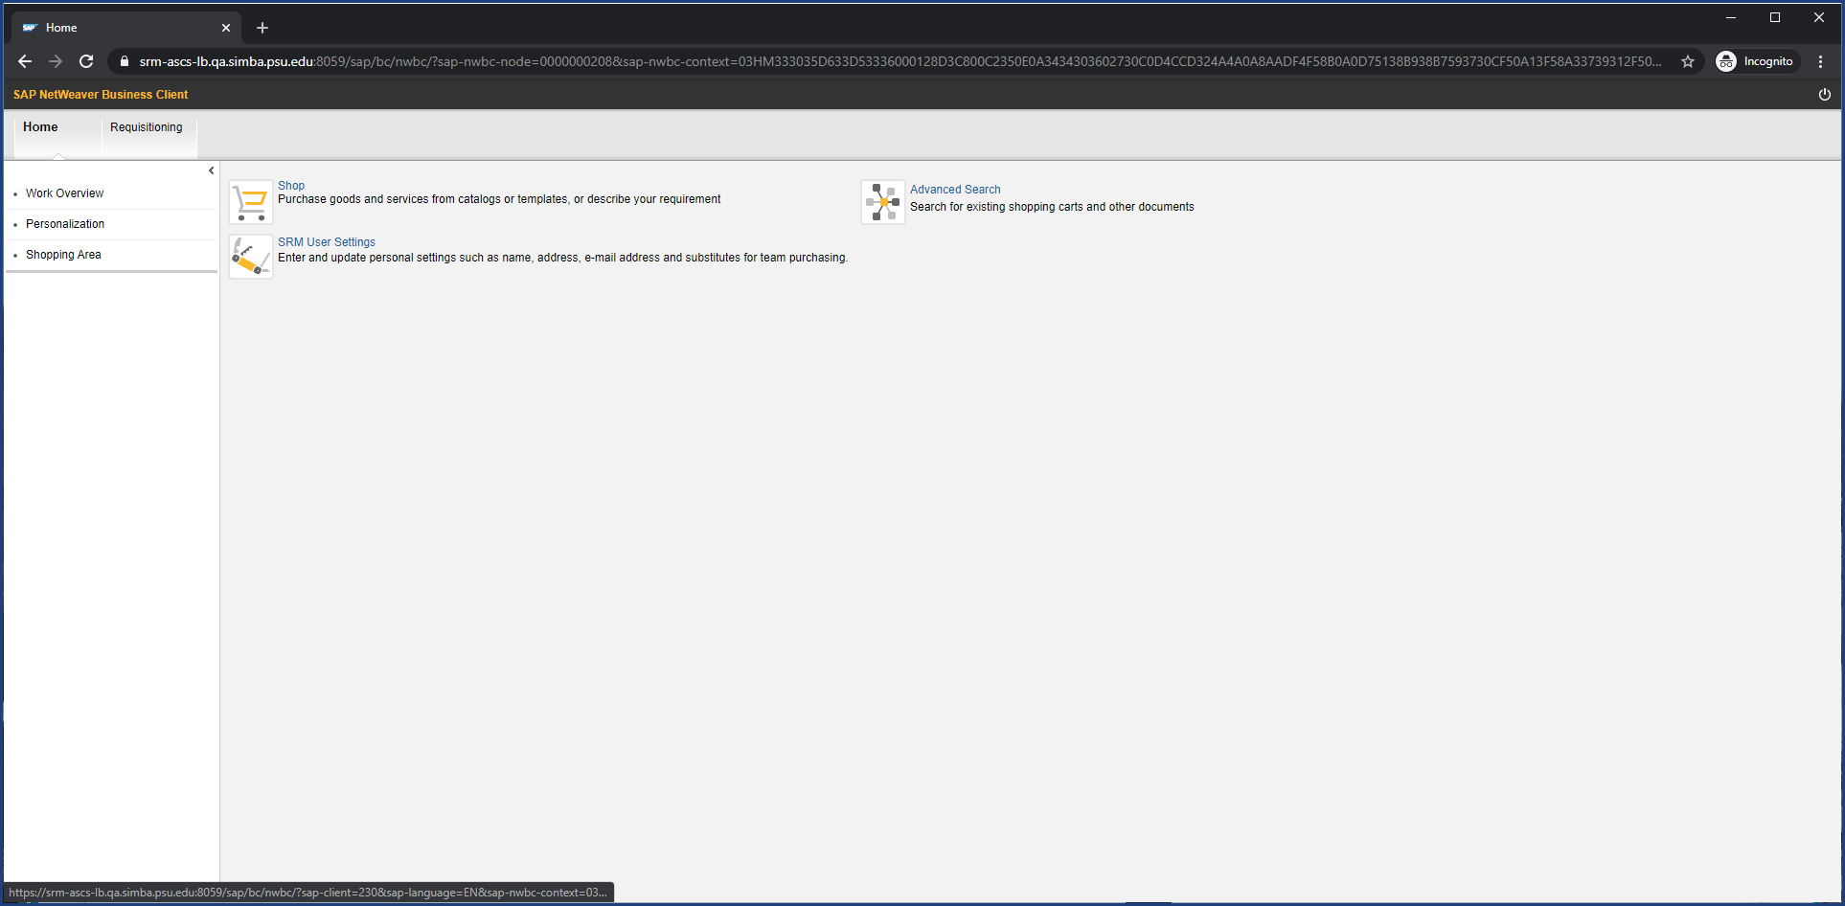

| Step | Action |
| --- | --- |
|  | SIMBA will introduce a new business process to increase an existing purchase order. A new shopping cart will be entered and approved in SIMBA instead of submitting a paper/electronic form. Do not use this process if the request is to cancel, decrease, or modify budgetary information. |

### Home - Google Chrome

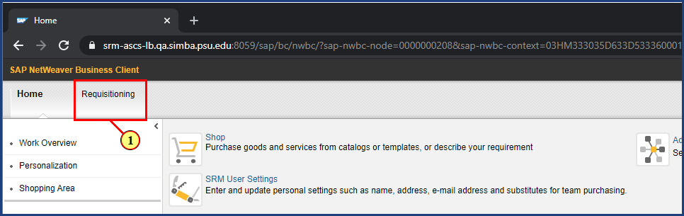

| Step | Action |
| --- | --- |
|  | First locate the reference Purchase Order. |
| 1. | The **Requisitioning** button is clicked. |

### Requisitioning - Google Chrome

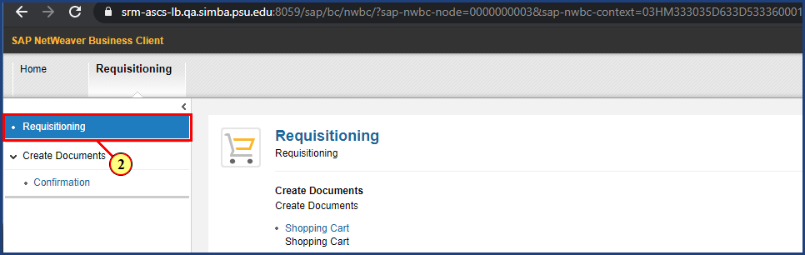

| Step | Action |
| --- | --- |
| 2. | The **Requisitioning** button is clicked. |

### Requisitioning - Google Chrome

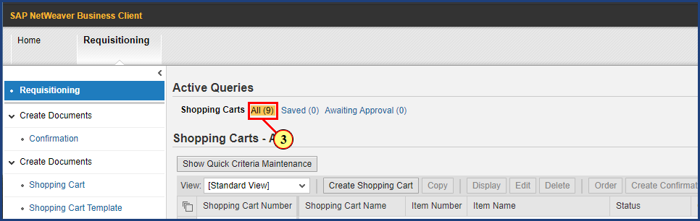

| Step | Action |
| --- | --- |
|  | Use the Active Queries to view all Shopping Carts created by you or one of your purchasing substitutes. |
| 3. | The **Shopping Carts All** button is clicked. |

### Requisitioning - Google Chrome

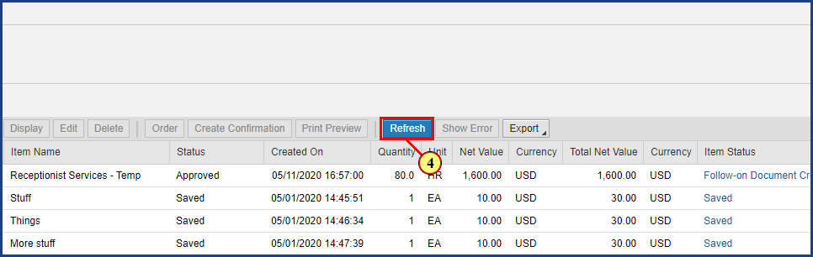

| Step | Action |
| --- | --- |
| 4. | The **Refresh** button is clicked. |

### Requisitioning - Google Chrome

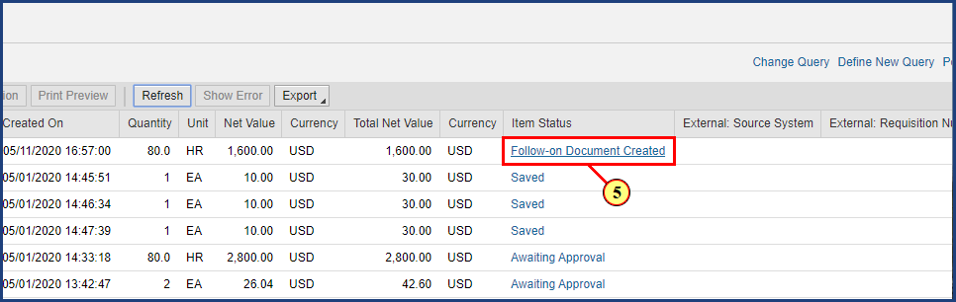

| Step | Action |
| --- | --- |
|  | The Follow-on Document Created link will take you to the Related Documents tab of the selected Shopping Cart. |
| 5. | The **Follow-on Document Created** button is clicked. |

### Display Shopping Cart - Google Chrome

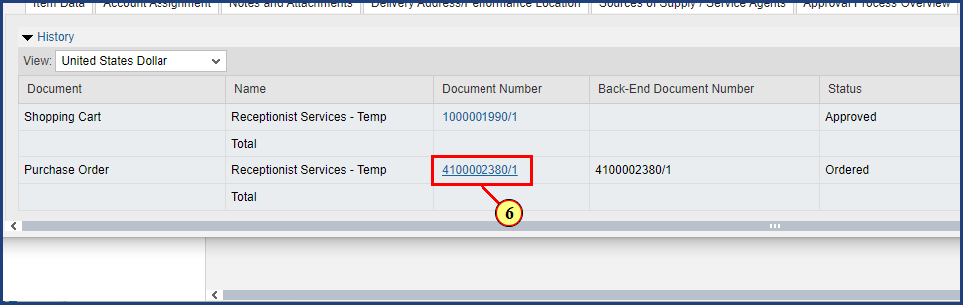

| Step | Action |
| --- | --- |
|  | Select the Purchase Order document number to view the Purchase Order you wish to request a change to. |
| 6. | The **Document Number** button is clicked. |

### Display Purchase Order - Google Chrome

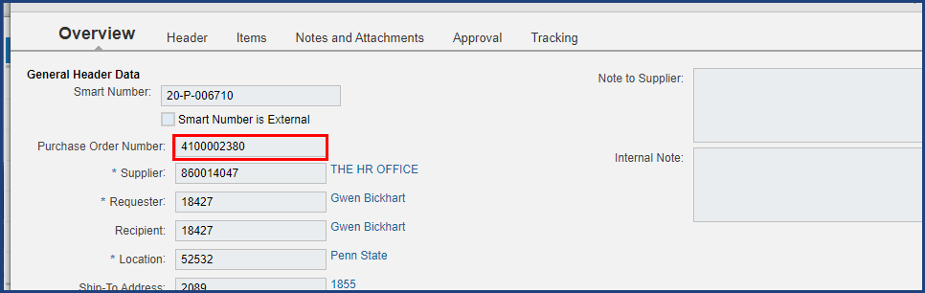

| Step | Action |
| --- | --- |
|  | Record the Purchase Order number to reference it in the new Shopping Cart. Recording the Supplier number will also be helpful. |

### Display Purchase Order - Google Chrome

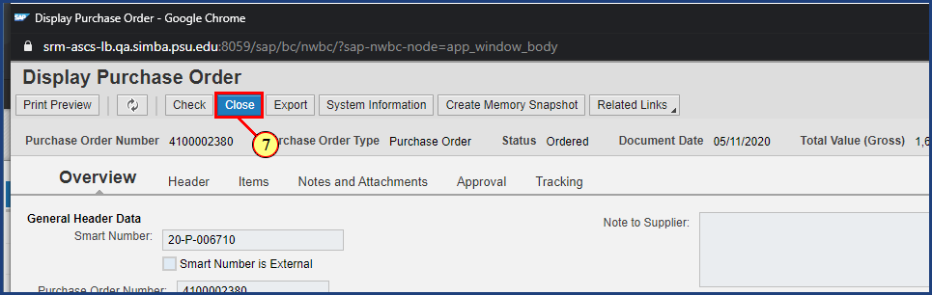

| Step | Action |
| --- | --- |
|  | Close the Display Purchase Order window. |
| 7. | The **Close** button is clicked. |

### Display Shopping Cart - Google Chrome

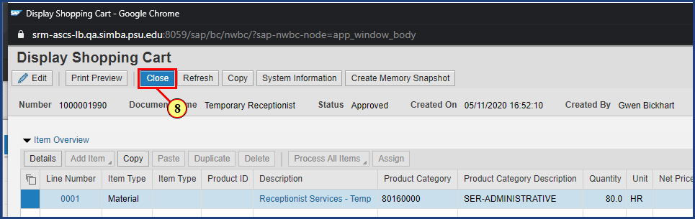

| Step | Action |
| --- | --- |
|  | Close the Display Shopping Cart window and return to the Requisitioning main page. |
| 8. | The **Close** button is clicked. |

### Requisitioning - Google Chrome

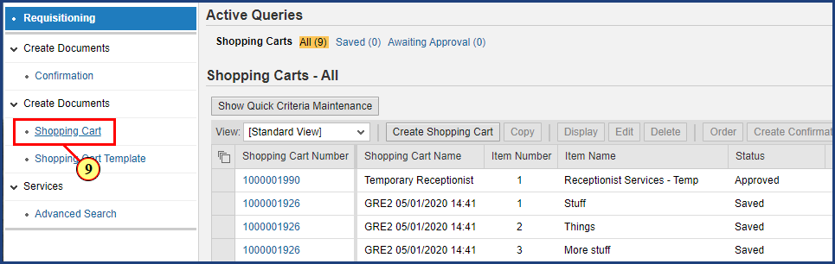

| Step | Action |
| --- | --- |
| 9. | The **Shopping Cart** button is clicked. |

### Create Shopping Cart - Google Chrome

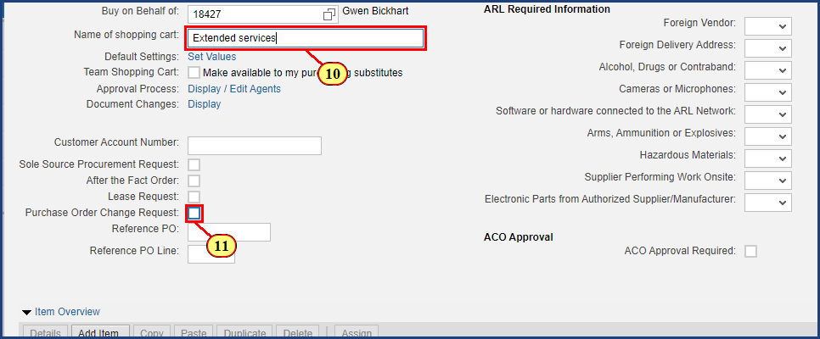

| Step | Action |
| --- | --- |
|  | The system will populate the Name of shopping cart field with your PSU User ID and the date and time your cart was created. You can leave the default value or edit the cart name to help you identify it more easily. |
| 10. | **Extended services** is entered into the **Name of shopping cart** field. |

| Step | Action |
| --- | --- |
|  | Select the Purchase Order Change Request box to alert Purchasing that the shopping cart is a request to change an existing purchase order. |
| 11. | The **Purchase Order Change Request**  checkbox is clicked. |

### Create Shopping Cart - Google Chrome

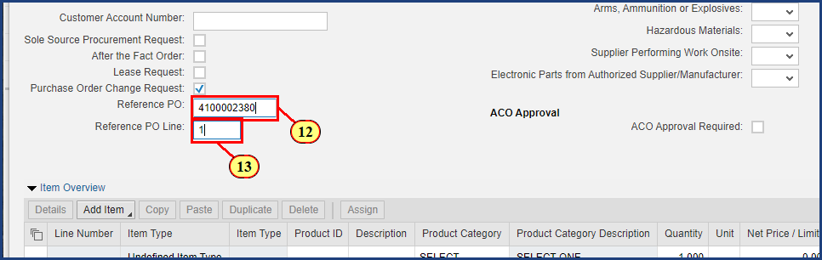

| Step | Action |
| --- | --- |
|  | Enter the purchase order number you are requesting to change. |
| 12. | **4100002380** is typed into the **Reference PO** field. |

| Step | Action |
| --- | --- |
|  | The Reference PO Line field is used to reference an existing line item on the original purchase order, otherwise enter NEW in this field if you are requesting an additional/new line be added to the PO. |
| 13. | **1** is entered into the **Reference PO Line** field. |

### Create Shopping Cart - Google Chrome

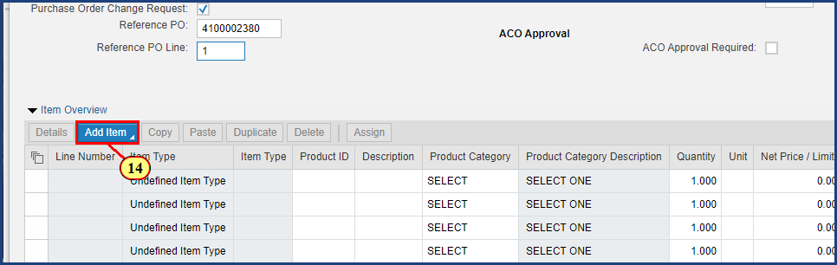

| Step | Action |
| --- | --- |
|  | Now that the header information is complete, select the Add Item button to begin entering line item details. |
| 14. | The **Add Item** button is clicked. |

### Create Shopping Cart - Google Chrome

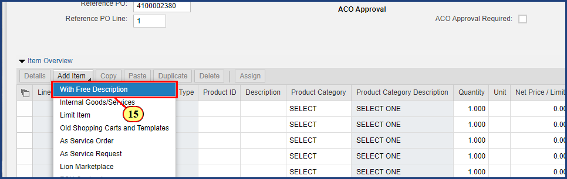

| Step | Action |
| --- | --- |
| 15. | The **With Free Description** button is clicked. |

### Create Shopping Cart - Google Chrome

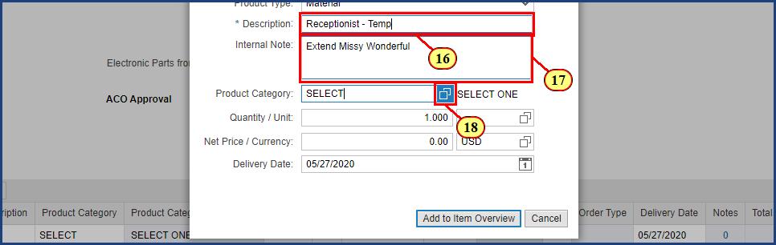

| Step | Action |
| --- | --- |
|  | Enter an item description and any internal notes here.  Note the Description field is only 40 characters long, so the Internal Note can be used to provide additional details about the line item. |
| 16. | **Receptionist - Temp** is typed into the **Description** field. |
| 17. | **Extended Missy Wonderful** is entered into the **Internal Note** field. |

| Step | Action |
| --- | --- |
|  | If you know the 8-digit Product Category code enter it here, otherwise search for a Product Category using the Possible Values button. |
| 18. | The **Possible Values** button is clicked for **Product Category**. |

### Create Shopping Cart - Google Chrome

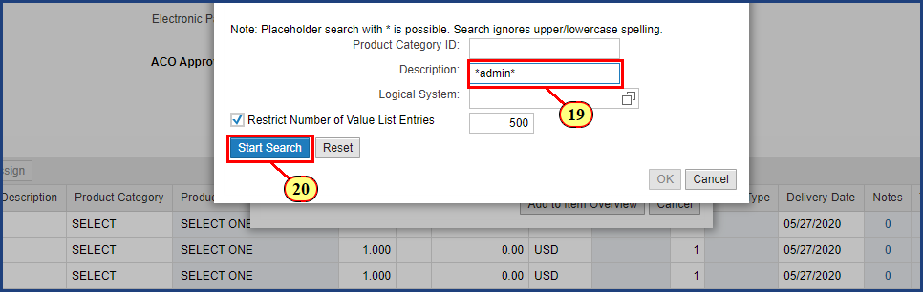

| Step | Action |
| --- | --- |
|  | Enter your search description here.  Using the asterisk (*) or wildcard generates a list of search results that contain the keyword anywhere in the description. |
| 19. | **\*admin\*** is typed into the **Description** field. |
| 20. | The **Start Search** button is clicked. |

### Create Shopping Cart - Google Chrome

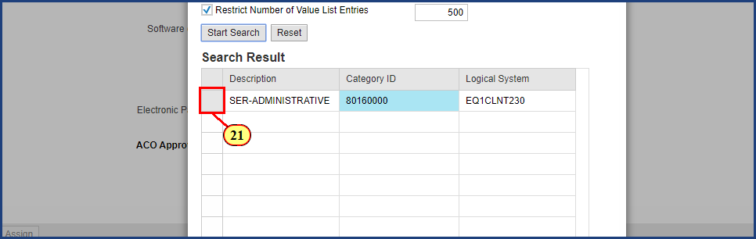

| Step | Action |
| --- | --- |
|  | Select the desired Product Category and click OK to populate the Product Category field in the Add Item with Free Description window. |
| 21. | The **Line Item Selection** button is clicked. |

### Create Shopping Cart - Google Chrome

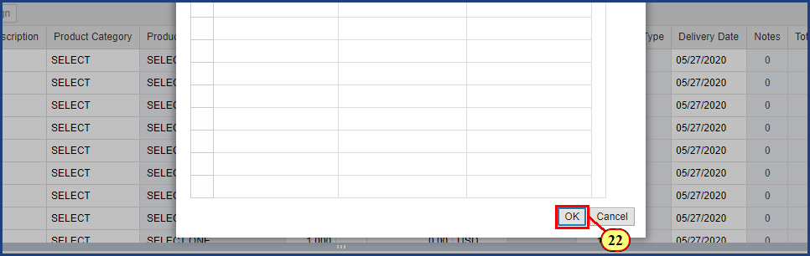

| Step | Action |
| --- | --- |
| 22. | The **OK** button is clicked. |

### Create Shopping Cart - Google Chrome

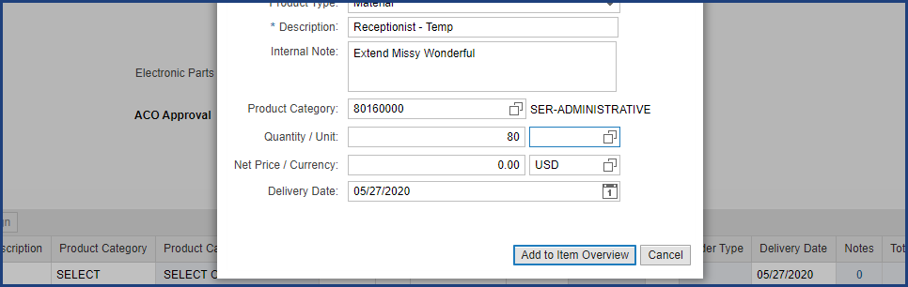

### Create Shopping Cart - Google Chrome

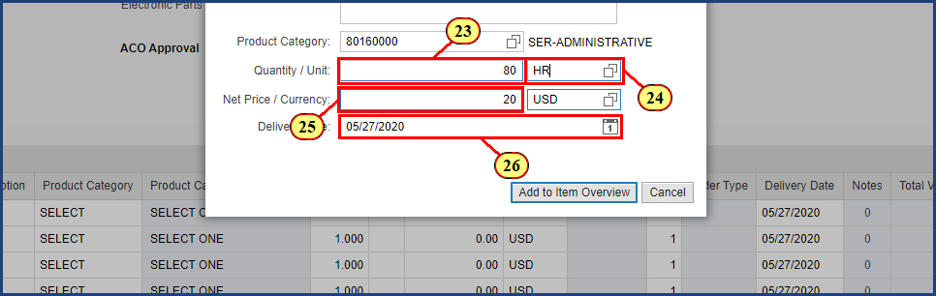

| Step | Action |
| --- | --- |
|  | Specify the quantity and unit of measure. The unit of measure can either be typed in or searched for using the Possible Values button. |
| 23. | **80** is typed into the **Quantity** field. |
| 24. | **HR** is typed into the **Unit** field. |
| 25. | **20** is typed into the **Net Price** field. |

| Step | Action |
| --- | --- |
|  | The delivery date will auto-populate to two weeks out. This can be changed by either typing in the new date or selecting it on the calender icon. When the information is complete, select Add to Item Overview to create the line item in your Shopping Cart. |
| 26. | The **Delivery Date**field is clicked. |

### Create Shopping Cart - Google Chrome

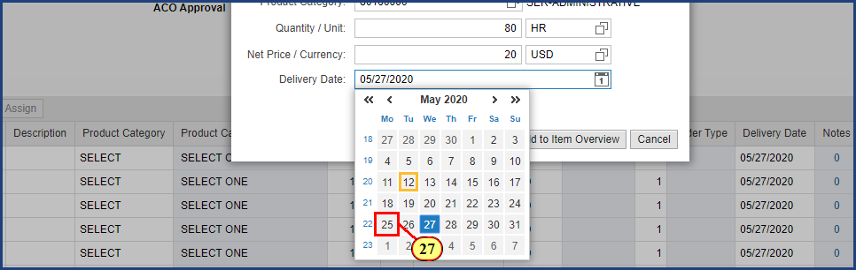

| Step | Action |
| --- | --- |
| 27. | The **Date Selection** button is clicked. |

### Create Shopping Cart - Google Chrome

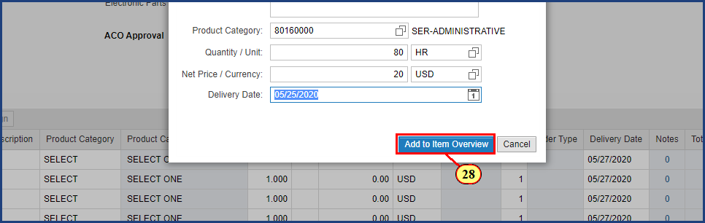

| Step | Action |
| --- | --- |
| 28. | The **Add to Item Overview** button is clicked. |

### Shopping Cart - Google Chrome

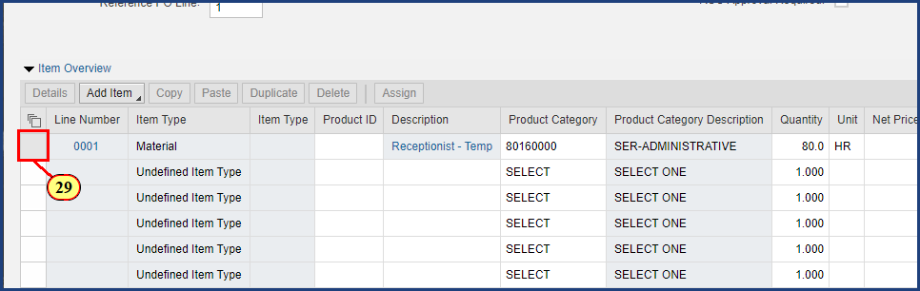

| Step | Action |
| --- | --- |
| 29. | The **Line Item Selection** button is clicked. |

### Shopping Cart - Google Chrome

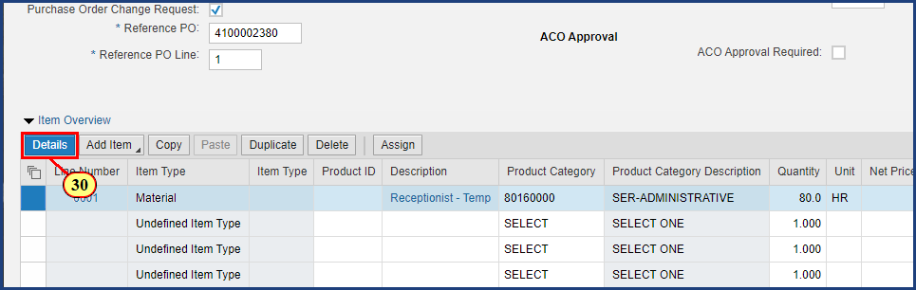

| Step | Action |
| --- | --- |
|  | Once the line item is selected, clicking the Details button will reveal additional information to view, add, and edit. |
| 30. | The **Details** button is clicked. |

### Shopping Cart - Google Chrome

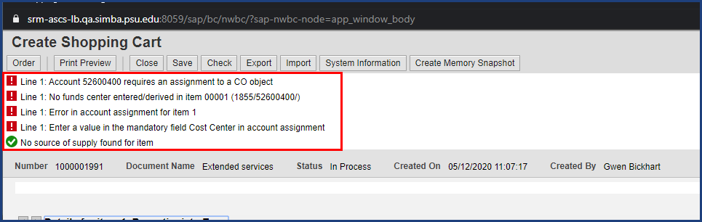

| Step | Action |
| --- | --- |
|  | You may have noticed various errors and warnings in the message area at the top of the screen. Many of these can be resolved by entering funding information for the shopping cart on the Account Assignment tab. |

### Shopping Cart - Google Chrome

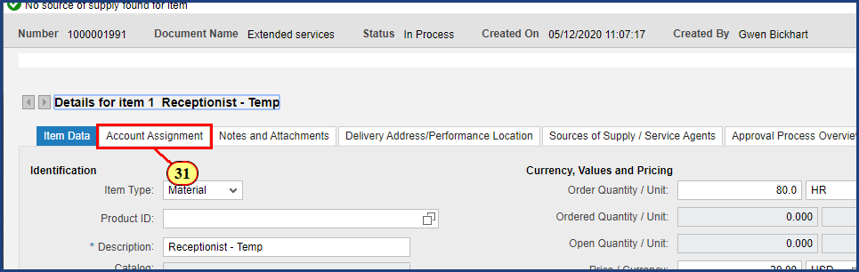

| Step | Action |
| --- | --- |
|  | Verify information on the Item Data tab, including the Goods Recipient, and update if necessary. |
| 31. | The **Account Assignment** button is clicked. |

### Shopping Cart - Google Chrome

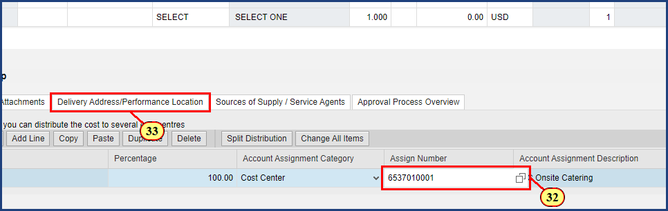

| Step | Action |
| --- | --- |
|  | The Account Assignment Category can be changed by selecting the drop down and selecting the desired Account Assignment Category type. This example uses a Cost Center. Enter the cost center number in the Assign Number field. Note that the General Ledger Account has been auto-populated based on the line item. |
| 32. | **6537010001** is typed into the **Assign Number** field. |
| 33. | The **Delivery Address/Performance Location** button is clicked. |

### Shopping Cart - Google Chrome

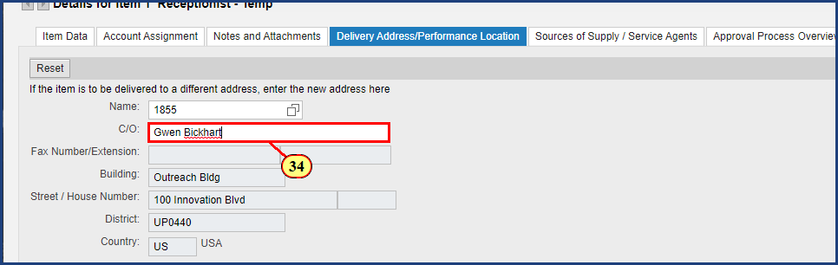

| Step | Action |
| --- | --- |
|  | The delivery address is populated from the default value in SRM User Settings. Verify the delivery address location and input additional information such as Care Of and Phone Number. |
| 34. | **Gwen Bickhart** is entered into the **Care Of** field. |

### Shopping Cart - Google Chrome

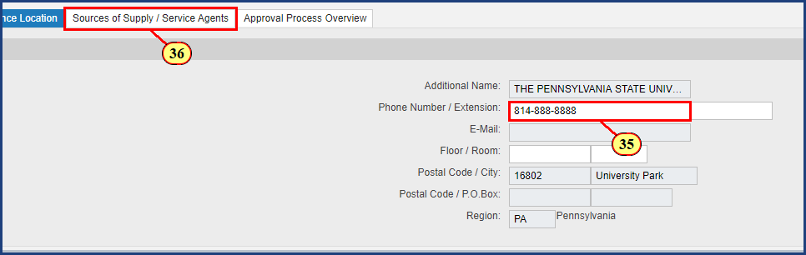

| Step | Action |
| --- | --- |
| 35. | **814-888-8888** is typed into the **Phone Number** field. |

| Step | Action |
| --- | --- |
|  | Next the Source of Supply tab will be reviewed and edited. For a Purchase Order Change Request, the Preferred Supplier must match the Supplier on the original PO. |
| 36. | The **Sources of Supply** tab is clicked. |

### Shopping Cart - Google Chrome

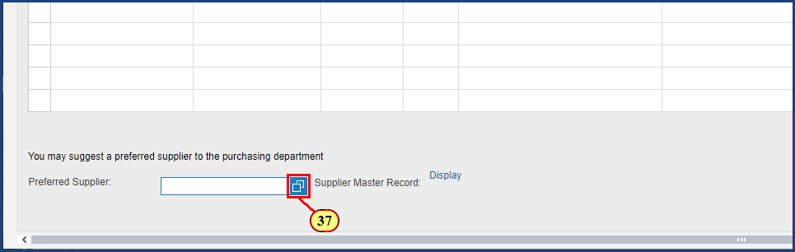

| Step | Action |
| --- | --- |
|  | Enter the 9-digit supplier number recorded from the existing purchase order or search the supplier database by selecting the Possible Values icon. This will prompt the Search: Preferred Supplier window. |
| 37. | The **Possible Values** button is clicked for **Preferred Supplier**. |

### Shopping Cart - Google Chrome

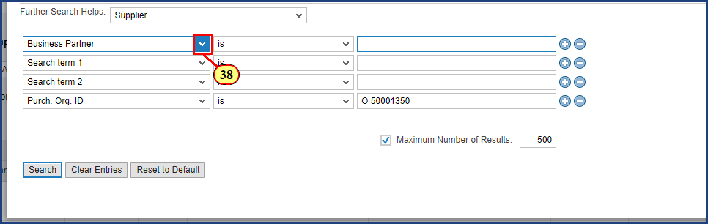

| Step | Action |
| --- | --- |
|  | To change the supplier search options, choose and change the various dropdowns. |
| 38. | The **Business Partner dropdown** button is clicked. |

### Shopping Cart - Google Chrome

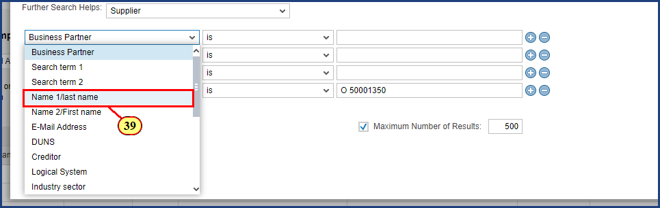

| Step | Action |
| --- | --- |
| 39. | The **Name 1/last name** menu item is clicked. |

### Shopping Cart - Google Chrome

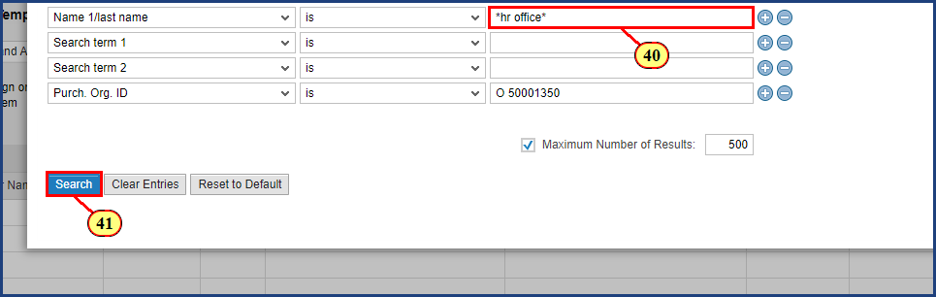

| Step | Action |
| --- | --- |
|  | Enter the supplier name you wish to find here. Adding * to the search broadens the results to contain the text. |
| 40. | **\*hr office\*** is typed into the **Name 1/last name** field. |
| 41. | The **Search** button is clicked. |

### Shopping Cart - Google Chrome

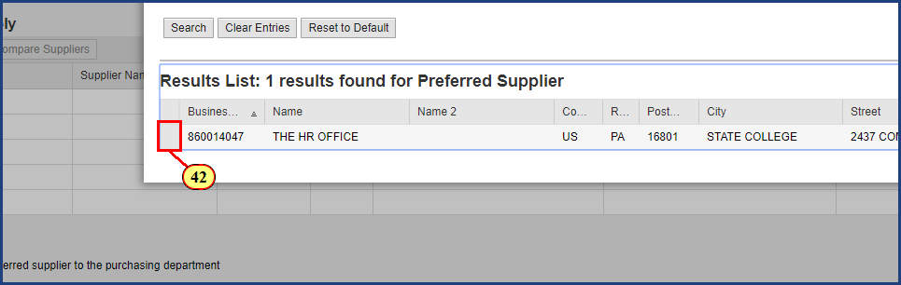

| Step | Action |
| --- | --- |
|  | Select the line with your desired supplier. This will auto-populate the supplier into the preferred supplier field in the Sources of Supply Tab. |
| 42. | The **Line Item Selection** button is clicked. |

### Shopping Cart - Google Chrome

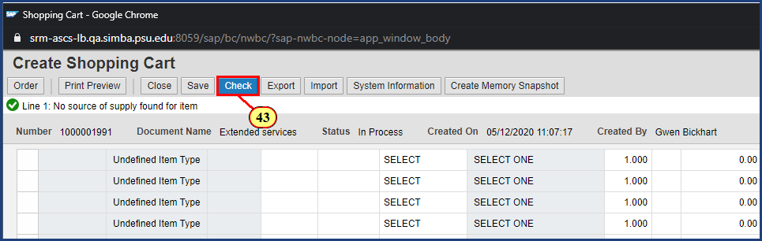

| Step | Action |
| --- | --- |
|  | Remember, for a Purchase Order Change Request, the Preferred Supplier must match the Supplier on the original PO. |
| 43. | The **Check** button is clicked. |

### Shopping Cart - Google Chrome

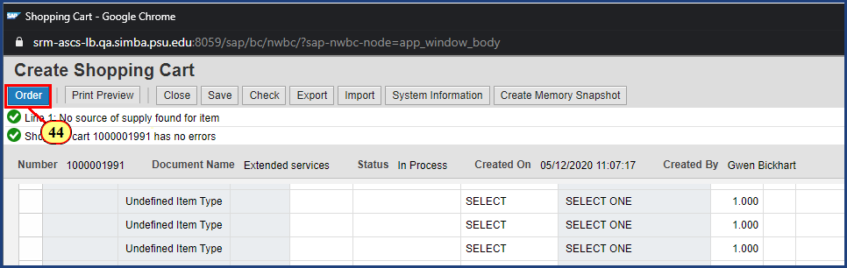

| Step | Action |
| --- | --- |
|  | Click Order to complete the shopping cart. If you are not yet ready to order the cart click Save to revisit it later. |
| 44. | The **Order** button is clicked. |

### Display Document: - Google Chrome

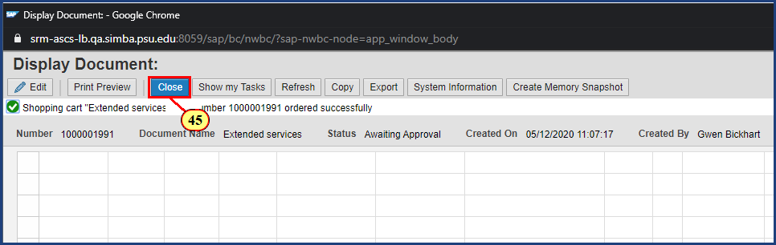

| Step | Action |
| --- | --- |
| 45. | The **Close** button is clicked. |

### Requisitioning - Google Chrome

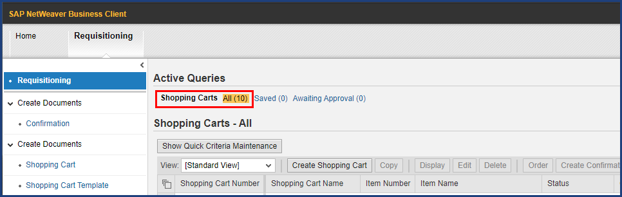

| Step | Action |
| --- | --- |
|  | To review the newly created shopping cart, select Shopping Carts - All in the Active Queries and click the Refresh button to update the query results with new data. |

### Requisitioning - Google Chrome

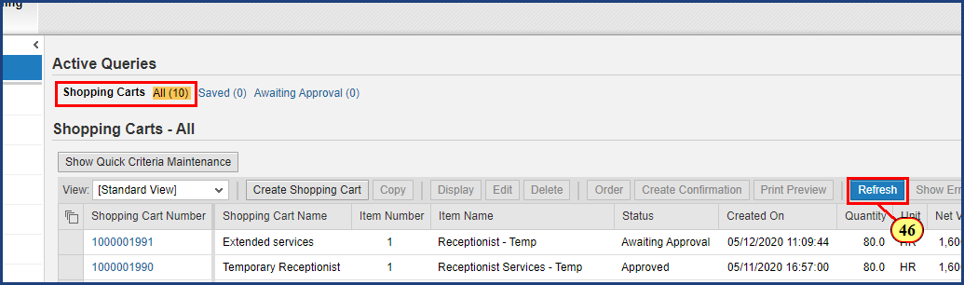

| Step | Action |
| --- | --- |
| 46. | The **Refresh** button is clicked. |

### Requisitioning - Google Chrome

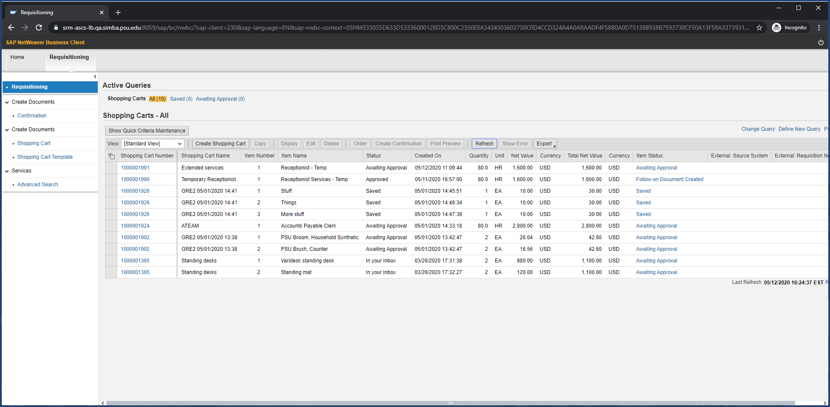

| Step | Action |
| --- | --- |
|  | After the data is refreshed, the new shopping cart line items will be displayed in the query results. The status will reflect Awaiting Approval and will not be sent to purchasing until the approval proccess is completed. |

**Disclaimer**

**Alternative Format Statement**   
This publication is available in alternative media upon request. 

**Statement of Non-Discrimination**

The University is committed to equal access to programs, facilities, admission, and employment for all persons. It is the policy of the University to maintain an environment free of harassment and free of discrimination against any person because of age, race, color, ancestry, national origin, religion, creed, service in uniformed services (as defined in state and federal law), veteran status, sex, sexual orientation, marital or family status, pregnancy, pregnancy-related conditions, physical or mental disability, gender, perceived gender, gender identity, genetic information, or political ideas. Discriminatory conduct and harassment, as well as sexual misconduct and relationship violence, violates the dignity of individuals, impedes the realization of the University’s educational mission, and will not be tolerated. Direct all inquiries regarding the nondiscrimination policy to Affirmative Action Office, The Pennsylvania State University, 328 Boucke Building, University Park, PA 16802-5901; Email: [aao@psu.edu](mailto:aao@psu.edu); Tel: 814-863-0471.