**The Pennsylvania State University**



**SIMBA Hands-On Guide**

**PR2_Shopping Cart - 3 step Free Text**



© 2020 The Pennsylvania State University  
© Copyright 2020 Labyrinth Solutions, Inc. All rights reserved. Labyrinth Solutions, Inc., the LSI logo, and CampusOneTM are trademarks of Labyrinth Consulting, Inc.   
SAP, R/3, SAP NetWeaver, and other SAP products and services mentioned herein as well as their respective logos are trademarks or registered trademarks of SAP AG in Germany and other countries.   
Business Objects and the Business Objects logo, BusinessObjects, Crystal Reports, Crystal Decisions, Web Intelligence, Xcelsius, and other Business Objects products and services mentioned herein as well as their respective logos are trademarks or registered trademarks of Business Objects S.A. in the United States and in other countries. Business Objects is an SAP company.

# PR2_Shopping Cart - 3 step Free Text

## Overview

**Transaction Description:**

This transaction provides a basic shopping cart creation function that allows users to describe items and suggest a preferred supplier when the items cannot be found in the Lion Marketplace or on a contract.

**Penn State Purpose:**

This transaction provides one of two ways to shop in SIMBA. The 3-step cart provides a step-by-step wizard approach and may be helpful for users who primarily shop from catalogs, contracts or simple free text items. It may also be useful for those who shop occasionally and prefer step-by-step screens.

## Process Steps

### Requisitioning and 5 more pages ‎- Microsoft Edge

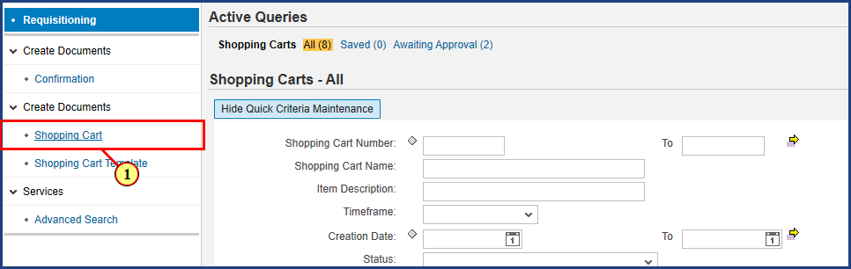

| Step | Action |
| --- | --- |
|  | In the Requesitioning tab, select Requisitioning on the left panel, then select the Shopping Cart Link. |
| 1. | The **Shopping Cart** button is clicked. |

### Create Shopping Cart ‎- Microsoft Edge

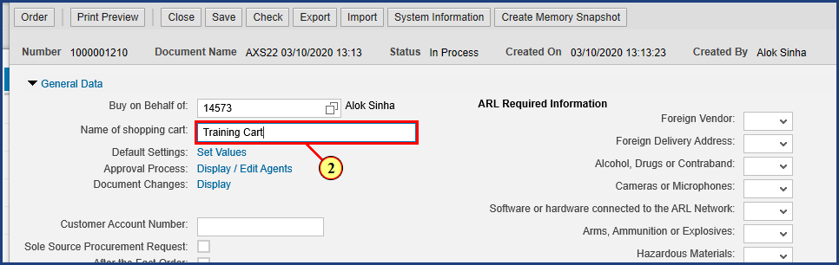

| Step | Action |
| --- | --- |
|  | Rename your shopping cart here. |
| 2. | **Training Cart** is typed into the **Name of shopping cart** field. |

### Create Shopping Cart ‎- Microsoft Edge

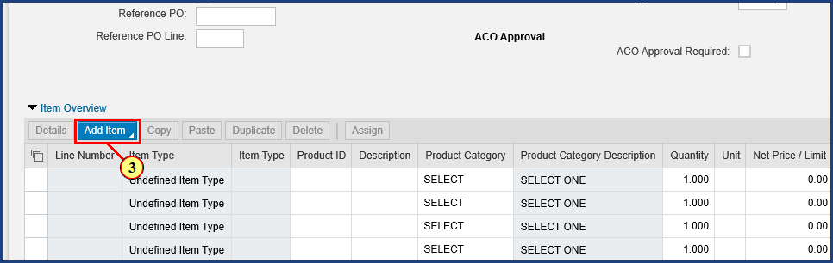

| Step | Action |
| --- | --- |
|  | To add line items, click the Add Item button. |
| 3. | The **Add Item** button is clicked. |

### Create Shopping Cart ‎- Microsoft Edge

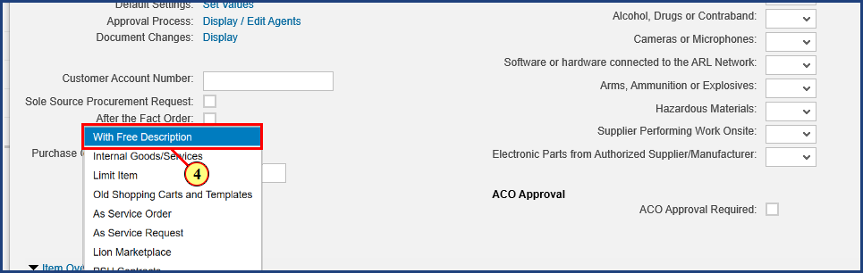

| Step | Action |
| --- | --- |
| 4. | The **With Free Description** menu item is clicked. |

### Create Shopping Cart ‎- Microsoft Edge

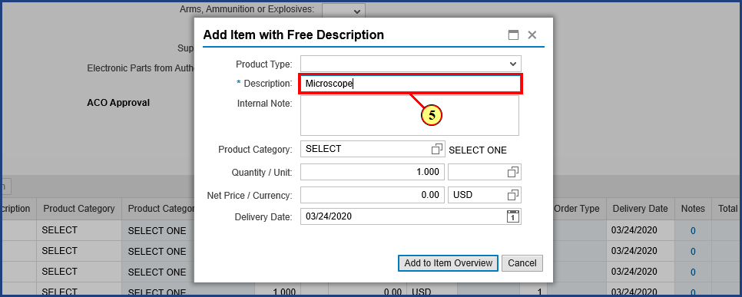

| Step | Action |
| --- | --- |
|  | Enter a description and any internal notes here. |
| 5. | **Microscope** is typed into the **Item Description** field. |

### Create Shopping Cart ‎- Microsoft Edge

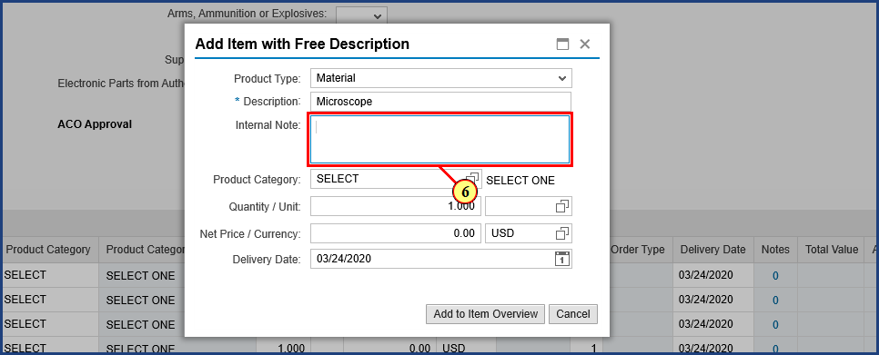

| Step | Action |
| --- | --- |
| 6. | **For biology lab** is typed into the **Internal Note** field. |

### Create Shopping Cart ‎- Microsoft Edge

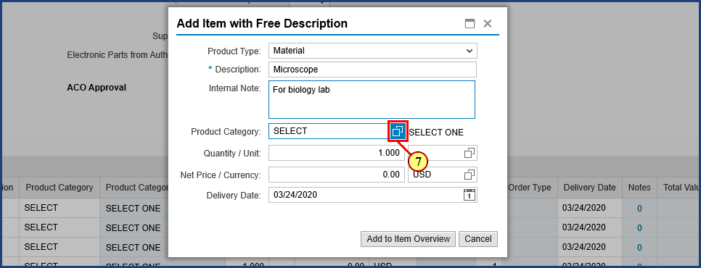

| Step | Action |
| --- | --- |
|  | To search for a Product Category, click the Possible Values button. |
| 7. | The **Possible Values** button is clicked. |

### Create Shopping Cart ‎- Microsoft Edge

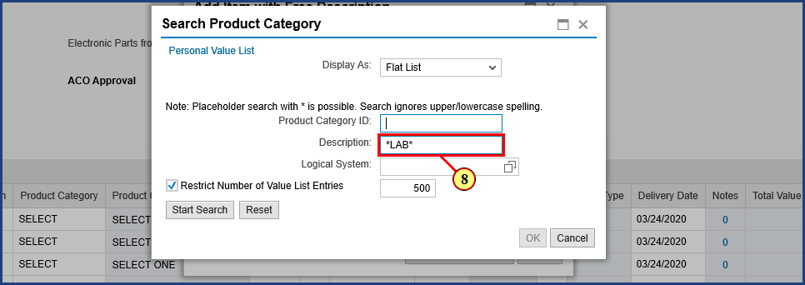

| Step | Action |
| --- | --- |
|  | Enter your search description here. Adding an * will open the search to hits that contain the search term. |
| 8. | **\*LAB\*** is typed into the **Description** field. |

### Create Shopping Cart ‎- Microsoft Edge

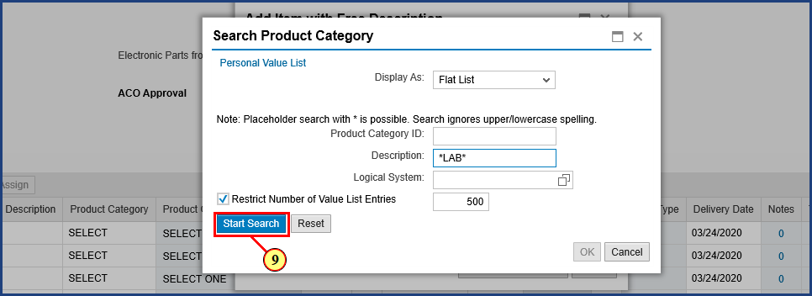

| Step | Action |
| --- | --- |
| 9. | The **Start Search** button is clicked. |

### Shopping Cart ‎- Microsoft Edge

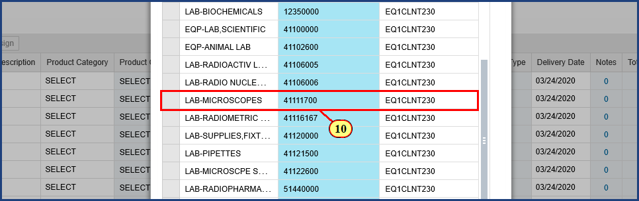

| Step | Action |
| --- | --- |
|  | Select the desired product category and hit OK to populate the product category field in the Add Item with Free Description window. |
| 10. | The **LAB-MICROSCOPES** **line item** button is clicked. |

### Shopping Cart ‎- Microsoft Edge

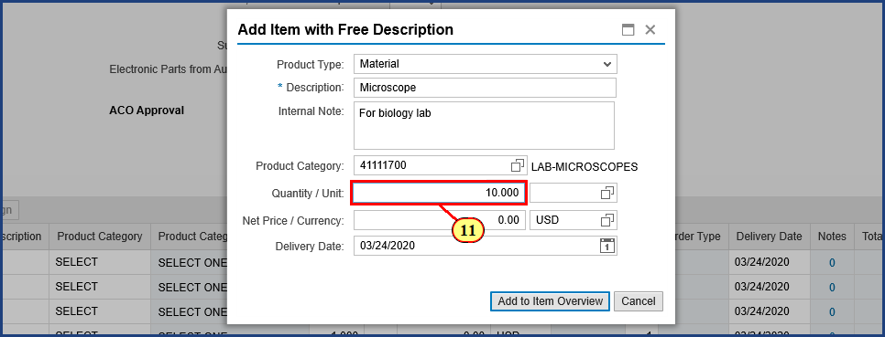

| Step | Action |
| --- | --- |
| 11. | **10.00** is typed into the **Quantity** field. |

### Shopping Cart ‎- Microsoft Edge

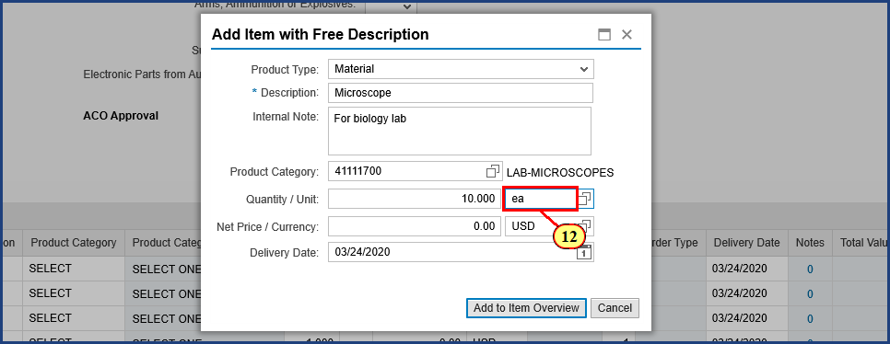

| Step | Action |
| --- | --- |
|  | Change the quantity and unit of measure. The unit of measure can either be typed in or searched for using the Possible Values button. |
| 12. | **ea** is typed into the **Unit for Order Quantity** field. |

### Shopping Cart ‎- Microsoft Edge

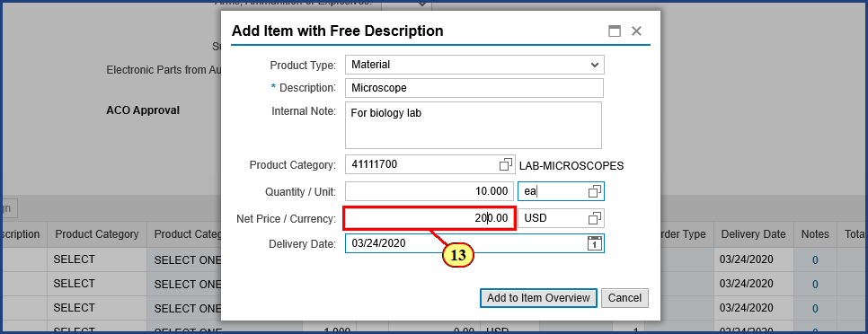

| Step | Action |
| --- | --- |
| 13. | **200.00** is typed into the **Price** field. |

### Shopping Cart ‎- Microsoft Edge

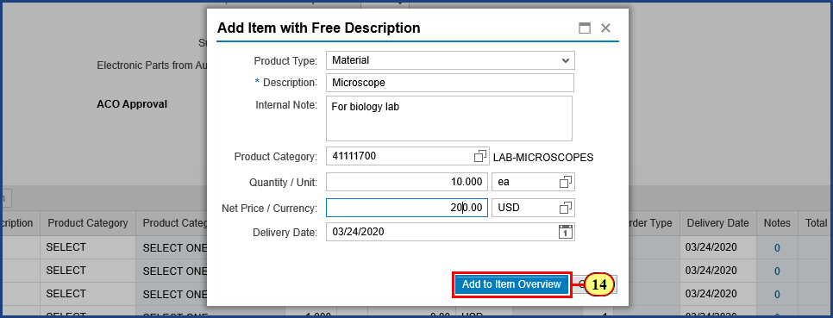

| Step | Action |
| --- | --- |
|  | The delivery date auto-populates to two weeks out. This can also be changed if needed by either typing in the new date or selecting it on the calender icon. When the information is complete, select Add to Item Overview to create the line item in your Shopping Cart. |
| 14. | The **Add to Item Overview** button is clicked. |

### Shopping Cart ‎- Microsoft Edge

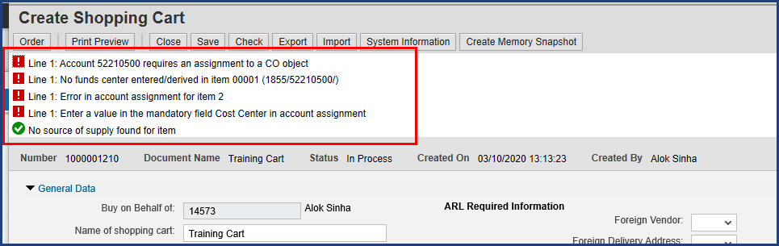

| Step | Action |
| --- | --- |
|  | Once the item has been added to the Shopping Cart, various errors and warnings will appear in the top messages. Many of these can be resolved by entering budget information for the shopping cart. To view, add, or edit additional details for each line item, select the box next to the line item. |

### Shopping Cart ‎- Microsoft Edge

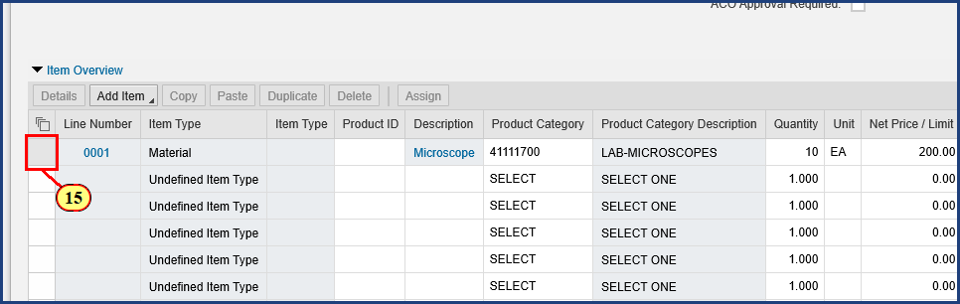

| Step | Action |
| --- | --- |
| 15. | The**line selection** button is clicked. |

### Shopping Cart ‎- Microsoft Edge

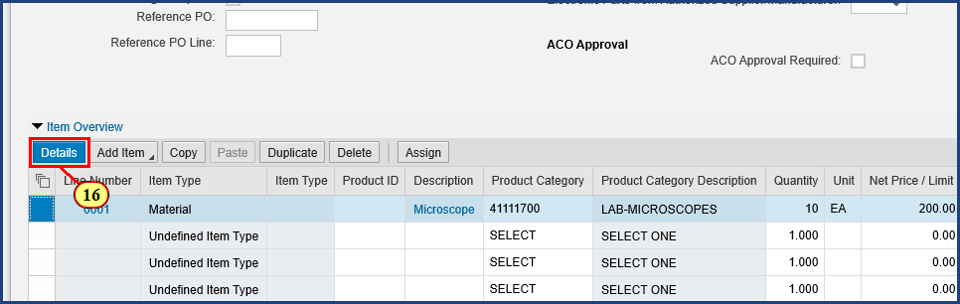

| Step | Action |
| --- | --- |
|  | Once the line item is selected, clicking the Details button will reveal additional information to view, add, and edit. |
| 16. | The **Details** button is clicked. |

### Shopping Cart ‎- Microsoft Edge

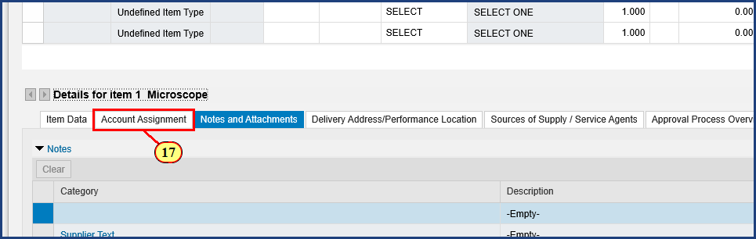

| Step | Action |
| --- | --- |
|  | Selecting the Account Assignment tab will reveal additional budget related information. |
| 17. | The **Account Assignment** button is clicked. |

### Shopping Cart ‎- Microsoft Edge

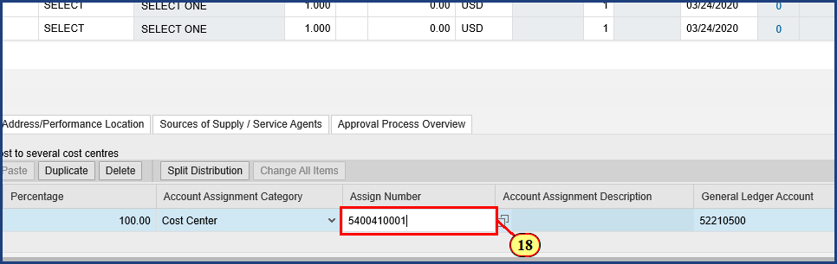

| Step | Action |
| --- | --- |
|  | The Account Assignment Category can be changed by selecting the drop down and selecting the desired Account Assignment Category type. This example uses a Cost Center. Enter the cost center number in the Assign Number field. Note that the General Ledger Account has been auto-populated based on the line item. |
| 18. | **5400410001** is typed into the **Assign Number** field. |

### Shopping Cart ‎- Microsoft Edge

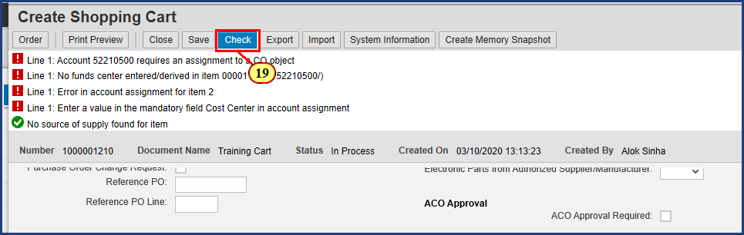

| Step | Action |
| --- | --- |
| 19. | The **Check** button is clicked. |

### Shopping Cart ‎- Microsoft Edge

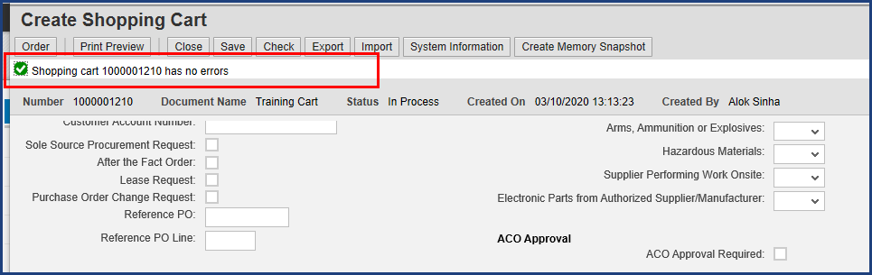

| Step | Action |
| --- | --- |
|  | Clicking the Check button refreshes the system’s error messages and updates based on newly entered information. Note that entering the budget information successfully cleared all red error messages. |

### Shopping Cart ‎- Microsoft Edge

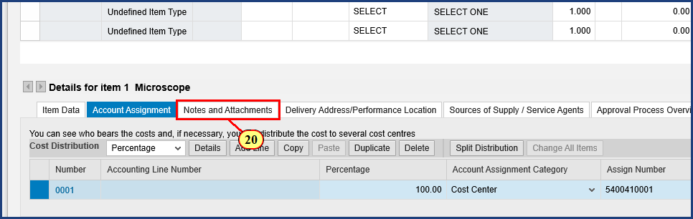

| Step | Action |
| --- | --- |
|  | To add notes and attachments to the Shopping Cart, click the Notes and Attachments tab. |
| 20. | The **Notes and Attachments** button is clicked. |

### Shopping Cart ‎- Microsoft Edge

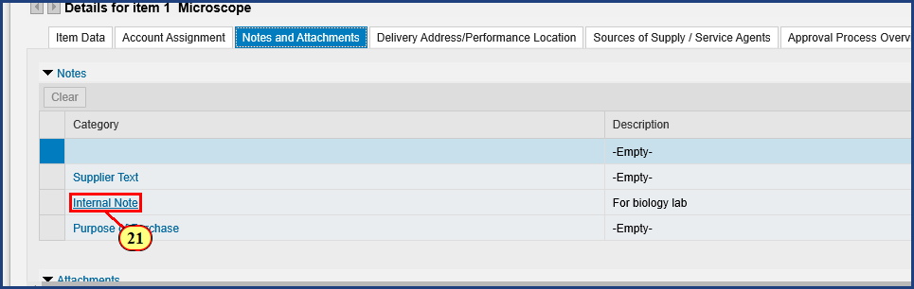

| Step | Action |
| --- | --- |
|  | Add an internal note by selecting the blue Internal Note link. |
| 21. | The **Internal Note** button is clicked. |

### Shopping Cart ‎- Microsoft Edge

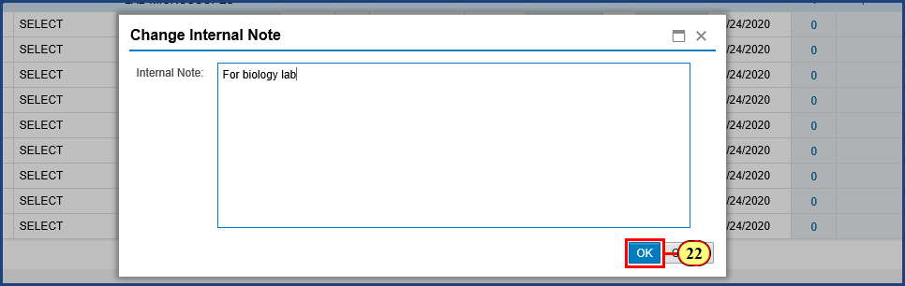

| Step | Action |
| --- | --- |
|  | Enter internal note here and click ok to record. |
| 22. | The **OK** button is clicked. |

### Shopping Cart ‎- Microsoft Edge

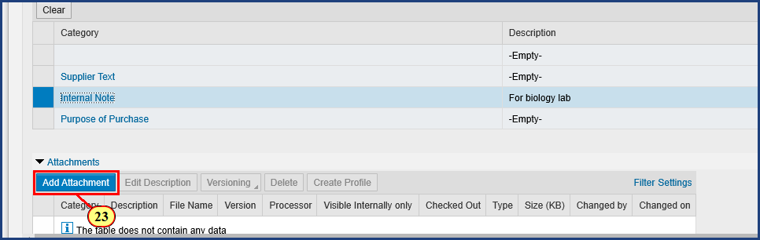

| Step | Action |
| --- | --- |
|  | To add an attachment, select the Add Attachment tab. This will prompt an Add Attachment window. |
| 23. | The **Add Attachment** button is clicked. |

### Shopping Cart ‎- Microsoft Edge

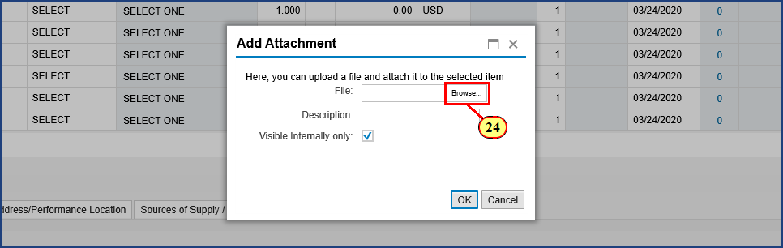

| Step | Action |
| --- | --- |
|  | In the Add Attachment file, choose a file by selecting Browse. |
| 24. | The **Browse** button is clicked. |

### Open

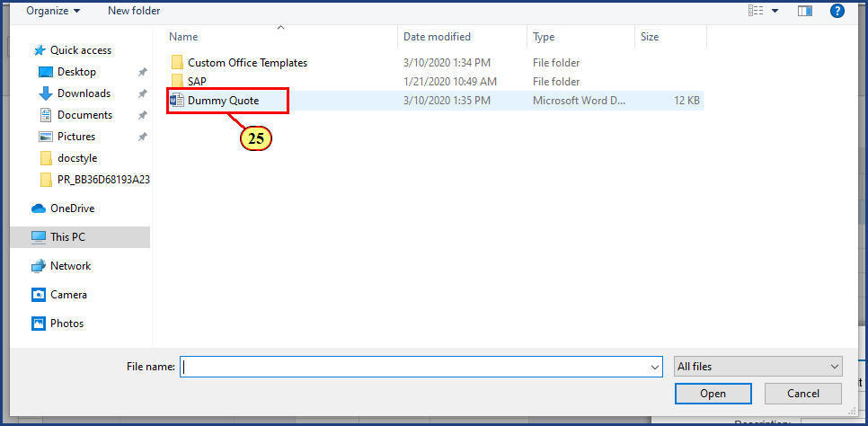

| Step | Action |
| --- | --- |
|  | Select the file you wish to attach. |
| 25. | **Dummy Quote** is clicked. |

### Open

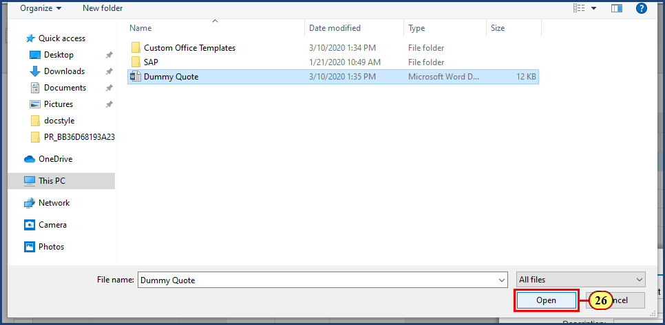

| Step | Action |
| --- | --- |
|  | Click Open to upload the file to the Shopping Cart. |
| 26. | The **Open** button is clicked. |

### Microsoft Edge

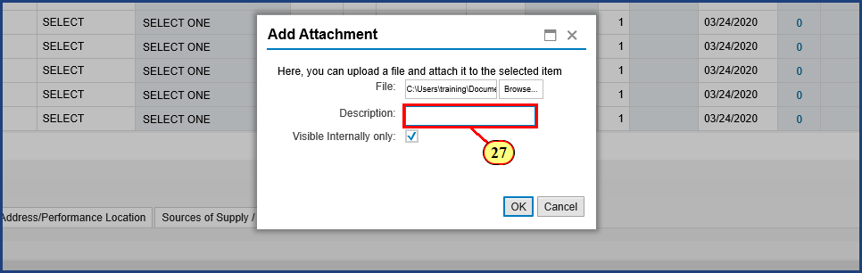

| Step | Action |
| --- | --- |
|  | Add a description for the attachment here, then click the OK button to complete the file attachment. |
| 27. | **Quote** is typed into the **Description** field. |

### Shopping Cart ‎- Microsoft Edge

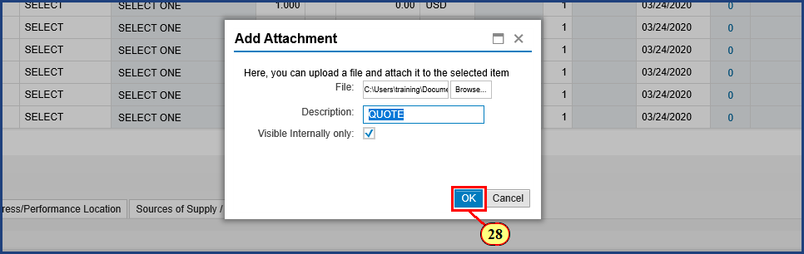

| Step | Action |
| --- | --- |
| 28. | The **OK** button is clicked. |

### Shopping Cart ‎- Microsoft Edge

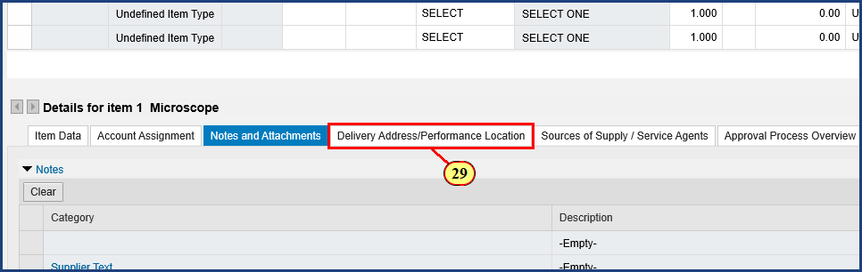

| Step | Action |
| --- | --- |
|  | To view, add, or edit delivery address and performance location information, select the Delivery Address/Performance Location tab. |
| 29. | The **Delivery Address/Performance Location** button is clicked. |

### Shopping Cart ‎- Microsoft Edge

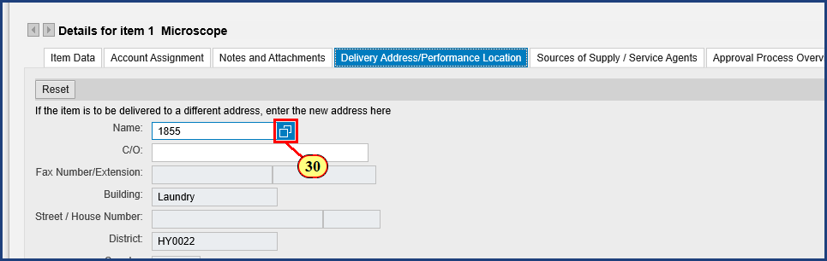

| Step | Action |
| --- | --- |
|  | To search for a Delivery Address location, select the Possible Values button – this is a search function. |
| 30. | The **Possible Values** button is clicked. |

### Shopping Cart ‎- Microsoft Edge

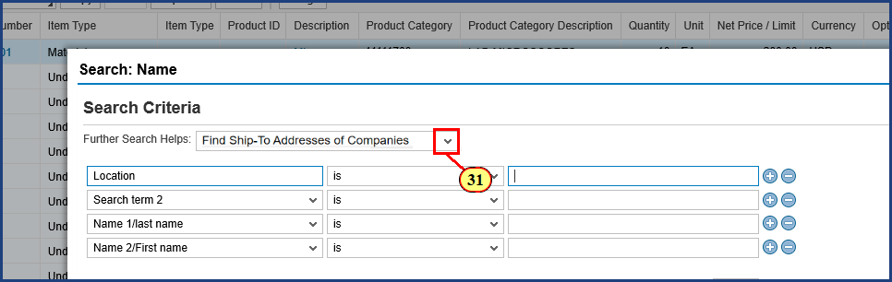

| Step | Action |
| --- | --- |
|  | To change the Further Search Helps field, select the dropdown option. |
| 31. | The dropdown is clicked. |

### Shopping Cart ‎- Microsoft Edge

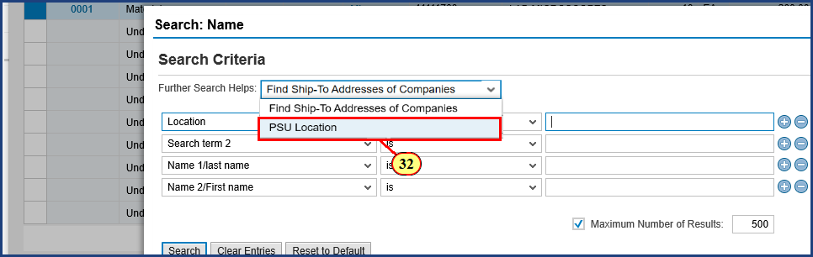

| Step | Action |
| --- | --- |
| 32. | The **PSU Location** menu item is clicked. |

### Shopping Cart ‎- Microsoft Edge

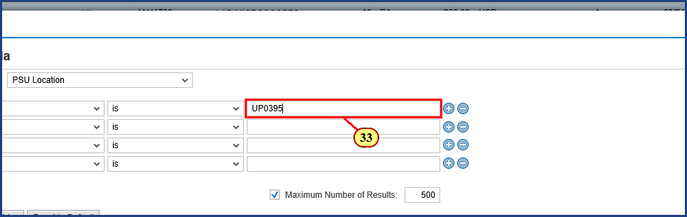

| Step | Action |
| --- | --- |
|  | If you know the exact Location Code, type it into the field here. |
| 33. | **UP0395** is typed into the **Location** field. |

### Shopping Cart ‎- Microsoft Edge

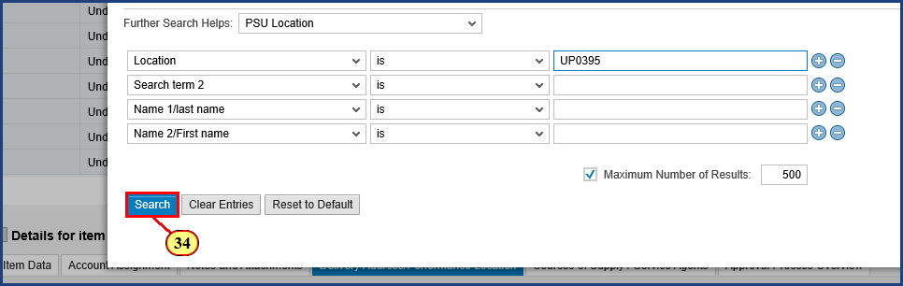

| Step | Action |
| --- | --- |
| 34. | The **Search** button is clicked. |

### Shopping Cart ‎- Microsoft Edge

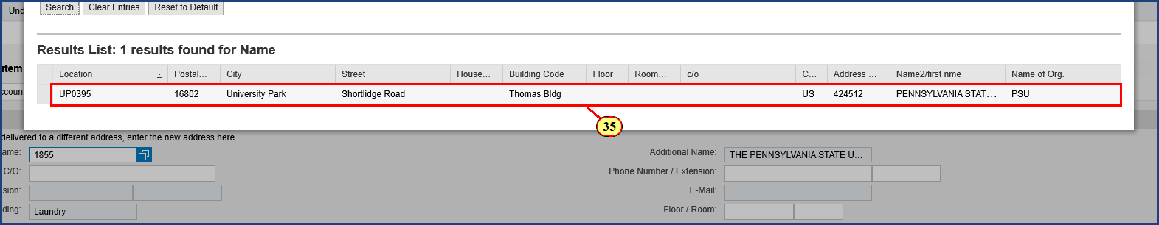

| Step | Action |
| --- | --- |
|  | Click on the Location Code to populate the delivery address location for your shopping cart line item. This will auto-populate back into the Shopping Cart. |
| 35. | The line item is clicked. |

### Shopping Cart ‎- Microsoft Edge

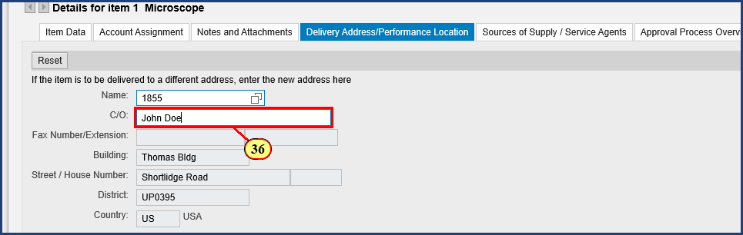

| Step | Action |
| --- | --- |
|  | Type the name of the Care Of Individual here. |
| 36. | **John Doe** is typed into the **Care Of** field. |

### Shopping Cart ‎- Microsoft Edge

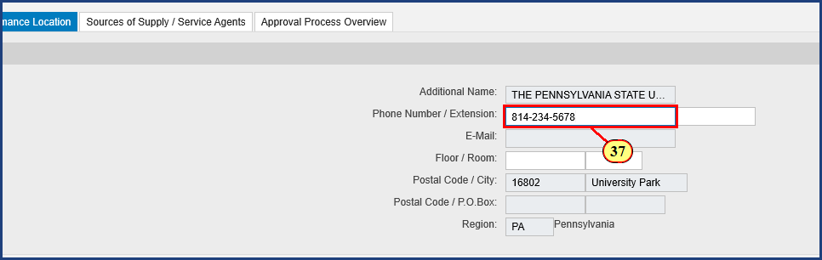

| Step | Action |
| --- | --- |
|  | Enter the appropriate Phone Number and Extension for the delivery Care Of individual here, as well as the floor and room number of the delivery location. |
| 37. | **814-234-5678**  is typed into the field. |

### Shopping Cart ‎- Microsoft Edge

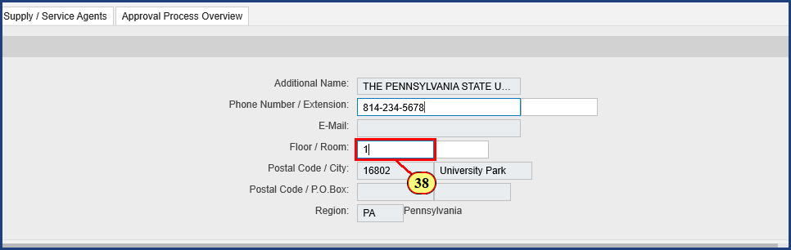

| Step | Action |
| --- | --- |
| 38. | **1** is typed into the **Floor** field. |

### Shopping Cart ‎- Microsoft Edge

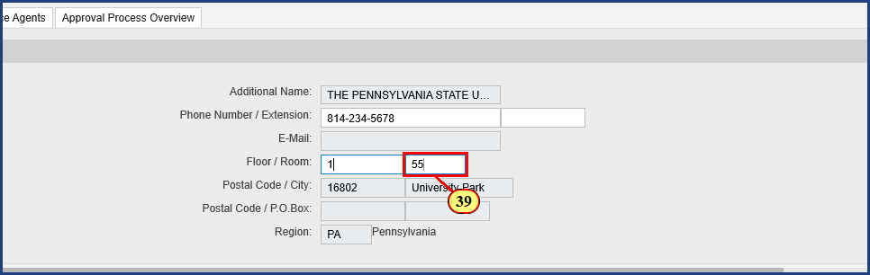

| Step | Action |
| --- | --- |
| 39. | **55** is typed into the **Room** field. |

### Shopping Cart ‎- Microsoft Edge

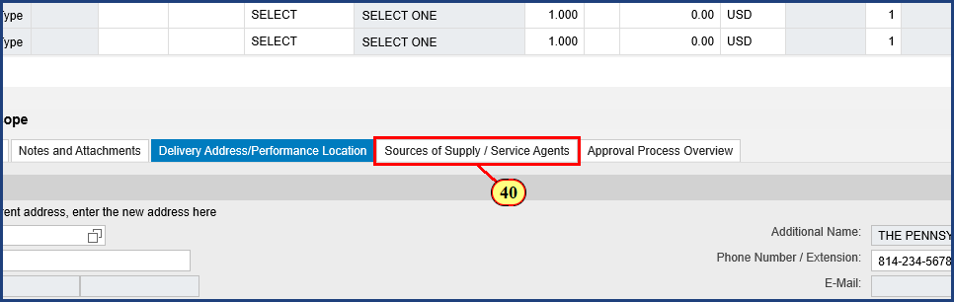

| Step | Action |
| --- | --- |
|  | To suggest a source of supply for the buyer to assign the line item, select the Source of Supply/Service Agents Tab. |
| 40. | The **Sources of Supply / Service Agents** button is clicked. |

### Shopping Cart ‎- Microsoft Edge

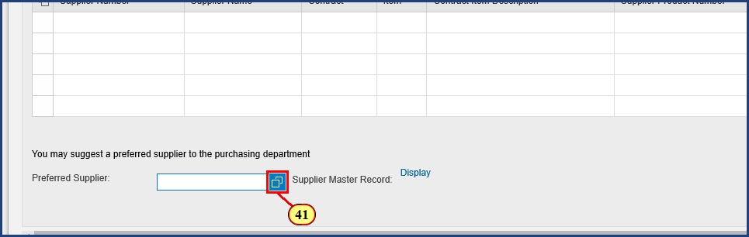

| Step | Action |
| --- | --- |
|  | Search for an existing supplier by selecting the Possible Values icon. This will prompt the Search: Preferred Supplier window. |
| 41. | The **Possible Values** button is clicked. |

### Shopping Cart ‎- Microsoft Edge

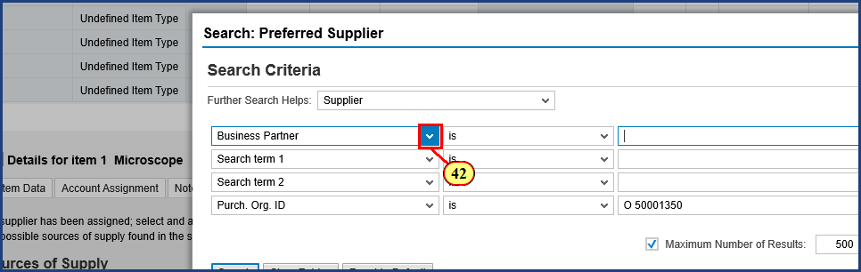

| Step | Action |
| --- | --- |
|  | To change the supplier search options, choose and change the various dropdowns. |
| 42. | The down arrow is clicked. |

### Shopping Cart ‎- Microsoft Edge

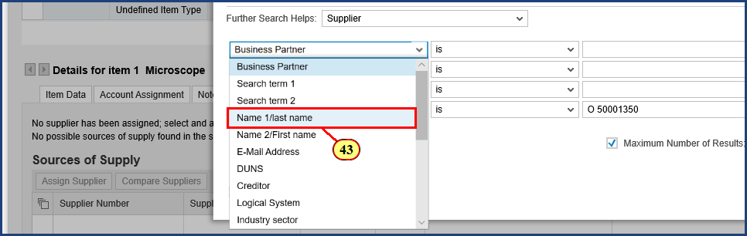

| Step | Action |
| --- | --- |
| 43. | The **Name 1/last name** menu item is clicked. |

### Shopping Cart ‎- Microsoft Edge

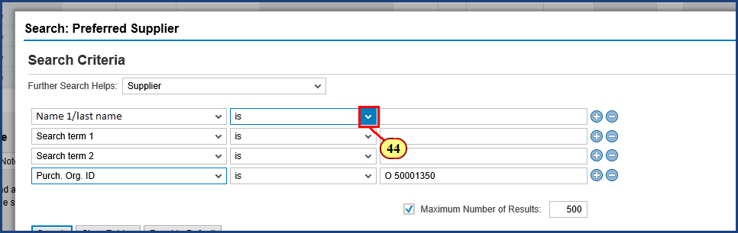

| Step | Action |
| --- | --- |
|  | To change the supplier search options, choose and change the various drop downs. Change "is", which looks for an exact match, to "contains". |
| 44. | The dropdown is clicked. |

### Shopping Cart ‎- Microsoft Edge

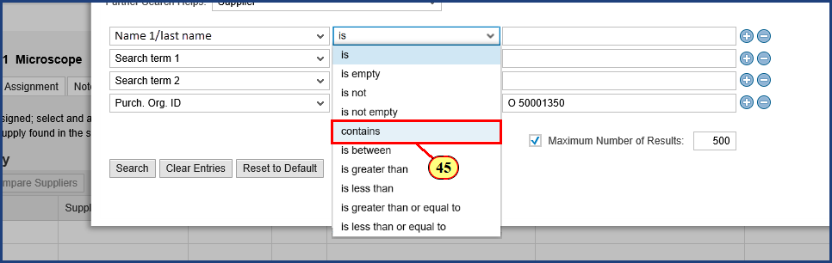

| Step | Action |
| --- | --- |
| 45. | The **Contains** menu item is clicked. |

### Shopping Cart ‎- Microsoft Edge

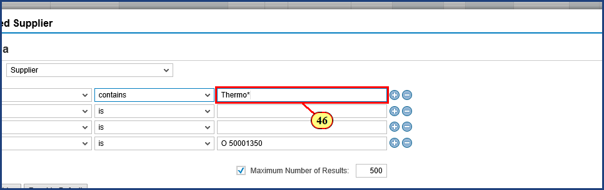

| Step | Action |
| --- | --- |
|  | Type in the supplier you wish to find here. Adding * to the search broadens the hits to options containing the text. |
| 46. | **Thermo\*** is typed into the **Name 1/last name** field. |

### Shopping Cart ‎- Microsoft Edge

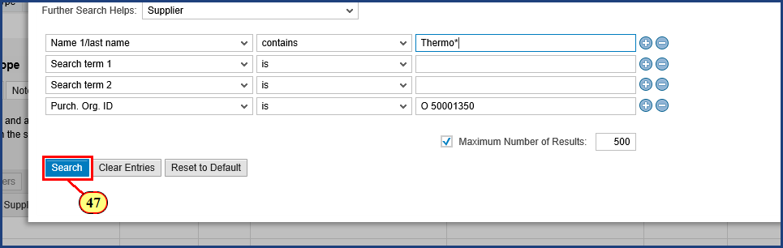

| Step | Action |
| --- | --- |
| 47. | The **Search** button is clicked. |

### Shopping Cart ‎- Microsoft Edge

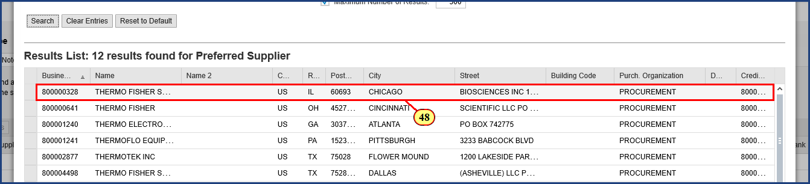

| Step | Action |
| --- | --- |
|  | Click the line with your desired supplier. This will auto-populate the supplier into the preferred supplier field in the Sources of Supply Tab. |
| 48. | The **line item**is clicked. |

### Shopping Cart ‎- Microsoft Edge

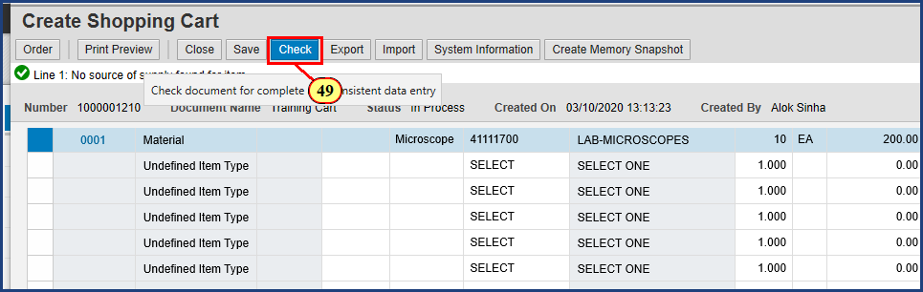

| Step | Action |
| --- | --- |
|  | Click the Check button to address any errors. Only red warning messages will prevent the cart from being ordered successfully. Yellow messages should be noted and considered by the shopper but will not prevent the cart from being ordered. |
| 49. | The **Check** button is clicked. |

### Shopping Cart ‎- Microsoft Edge

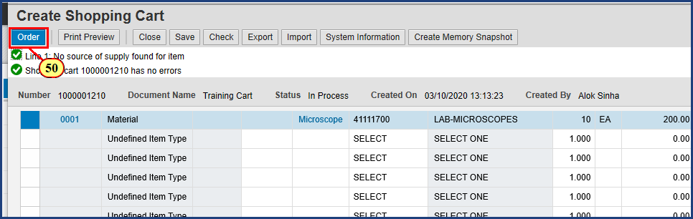

| Step | Action |
| --- | --- |
|  | Click Order to complete the Shopping Cart. Note the shopping cart number in the green message above. |
| 50. | The **Order** button is clicked. |

### Requisitioning and 5 more pages ‎- Microsoft Edge

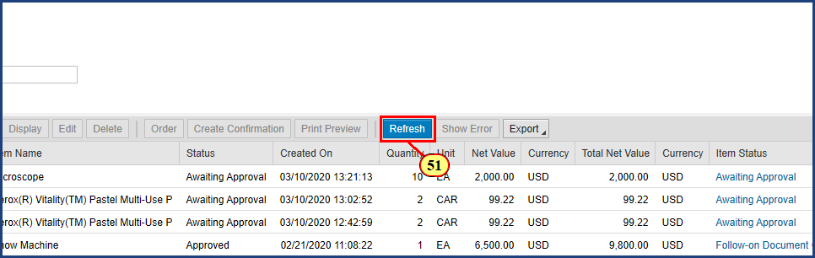

| Step | Action |
| --- | --- |
|  | To review the newly created shopping cart, return to the Active Query screen in the Requisitioning Tab, under the left hand Requisitioning Link. Select Shopping Carts All and click the Refresh button to update the query with new data. |
| 51. | The **Refresh** button is clicked. |

### Requisitioning and 5 more pages ‎- Microsoft Edge

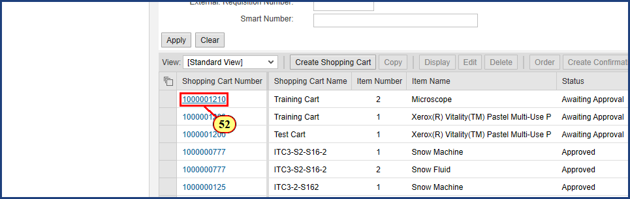

| Step | Action |
| --- | --- |
|  | Once refreshed, the new Shopping Cart will populate in the Active Query section for All Shopping Carts. The status will reflect Awaiting Approval and will not be completely ordered until the approval proccess is completed. Select the blue shopping cart number link to re-open the shopping cart. |
| 52. | **1000001210** is clicked. |

### Display Shopping Cart ‎- Microsoft Edge

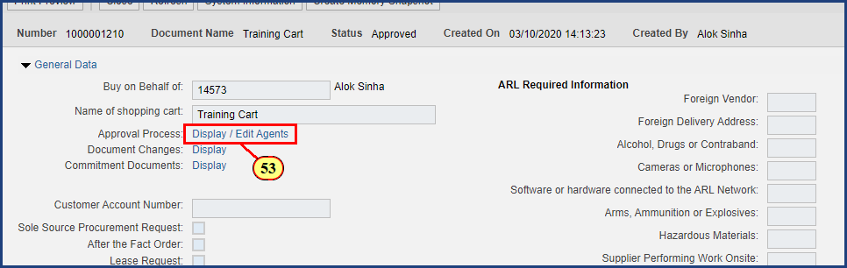

| Step | Action |
| --- | --- |
|  | Select the Display/Edit Agents link to view the Approval steps and approvers. |
| 53. | The **Display / Edit Agents**button is clicked. |

### Shopping Cart ‎- Microsoft Edge

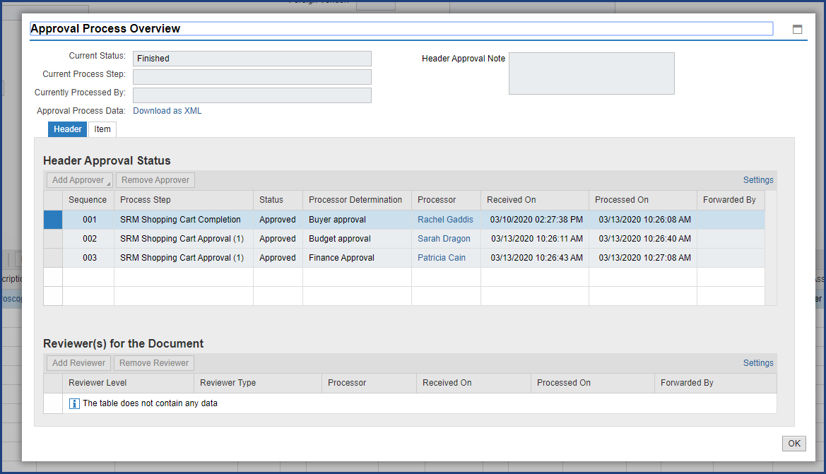

| Step | Action |
| --- | --- |
|  | The Approval steps and approvers are displayed. |

**Disclaimer**

**Alternative Format Statement**   
This publication is available in alternative media upon request. 

**Statement of Non-Discrimination**

The University is committed to equal access to programs, facilities, admission, and employment for all persons. It is the policy of the University to maintain an environment free of harassment and free of discrimination against any person because of age, race, color, ancestry, national origin, religion, creed, service in uniformed services (as defined in state and federal law), veteran status, sex, sexual orientation, marital or family status, pregnancy, pregnancy-related conditions, physical or mental disability, gender, perceived gender, gender identity, genetic information, or political ideas. Discriminatory conduct and harassment, as well as sexual misconduct and relationship violence, violates the dignity of individuals, impedes the realization of the University’s educational mission, and will not be tolerated. Direct all inquiries regarding the nondiscrimination policy to Affirmative Action Office, The Pennsylvania State University, 328 Boucke Building, University Park, PA 16802-5901; Email: [aao@psu.edu](mailto:aao@psu.edu); Tel: 814-863-0471.