**The Pennsylvania State University**



**SIMBA Hands-On Guide**

**PR14_Purchasing Documents - Advanced Search**



© 2020 The Pennsylvania State University  
© Copyright 2020 Labyrinth Solutions, Inc. All rights reserved. Labyrinth Solutions, Inc., the LSI logo, and CampusOneTM are trademarks of Labyrinth Consulting, Inc.   
SAP, R/3, SAP NetWeaver, and other SAP products and services mentioned herein as well as their respective logos are trademarks or registered trademarks of SAP AG in Germany and other countries.   
Business Objects and the Business Objects logo, BusinessObjects, Crystal Reports, Crystal Decisions, Web Intelligence, Xcelsius, and other Business Objects products and services mentioned herein as well as their respective logos are trademarks or registered trademarks of Business Objects S.A. in the United States and in other countries. Business Objects is an SAP company.

# PR14_Purchasing Documents - Advanced Search

## Overview

**Transaction Description:**

This transaction allows document search capabilities using advanced search in Shop OnLion.

**Penn State Purpose:**

This transaction is used by Shoppers, Buyers, and Goods Recipients to locate purchasing documents such as shopping cart and purchase orders.

## Process Steps

### Home - Google Chrome

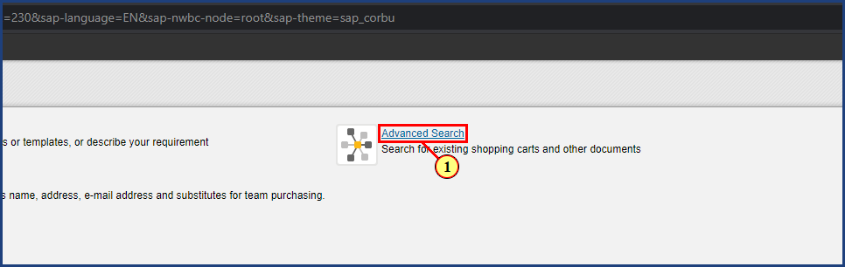

| Step | Action |
| --- | --- |
|  | The advanced search option is utilized to search for various documents by selecting a series of specific parameters. The following examples will demonstrate the steps in searching for a shopping cart, and searching for purchase order by vendor. |
| 1. | The **Advanced Search** button is clicked. |

### Advanced Search - Google Chrome

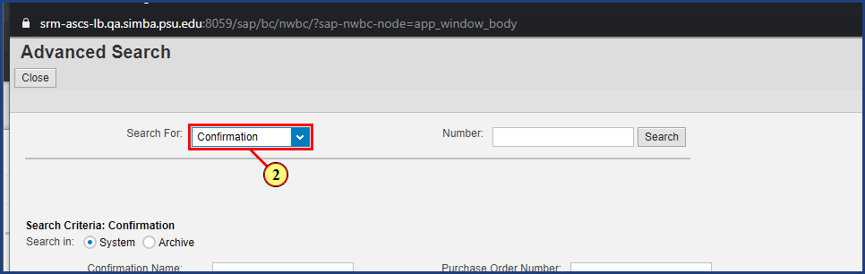

| Step | Action |
| --- | --- |
|  | Select the parameter from the Search For dropdown. For this exercise we are selecting Shopping Cart. |
| 2. | The **Search For** dropdown is clicked. |

### Advanced Search - Google Chrome

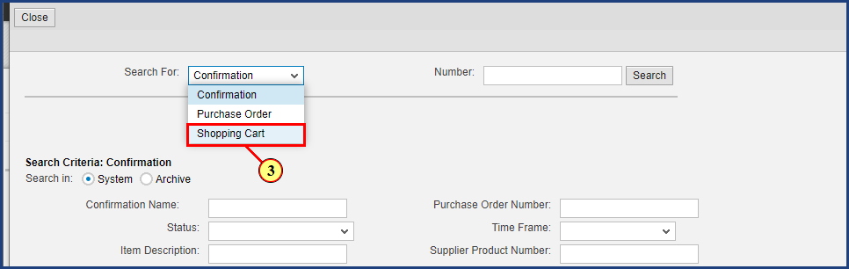

| Step | Action |
| --- | --- |
| 3. | The **Shopping Cart** menu item is clicked. |

### Advanced Search - Google Chrome

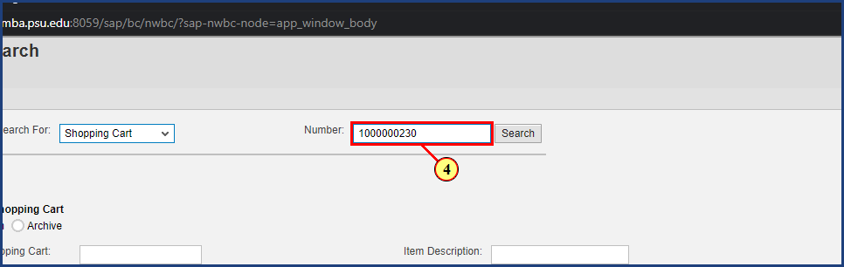

| Step | Action |
| --- | --- |
|  | Enter the number for the particular shopping cart you are searching for. |
| 4. | **1000000230** is typed into the **Number** field. |

### Advanced Search - Google Chrome

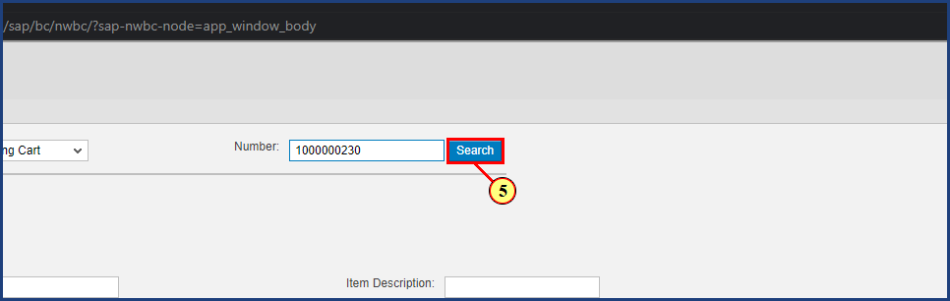

| Step | Action |
| --- | --- |
|  | Click Search and the shopping cart number you’ve entered will open in a new window. |
| 5. | The **Search** button is clicked. |

### Advanced Search - Google Chrome

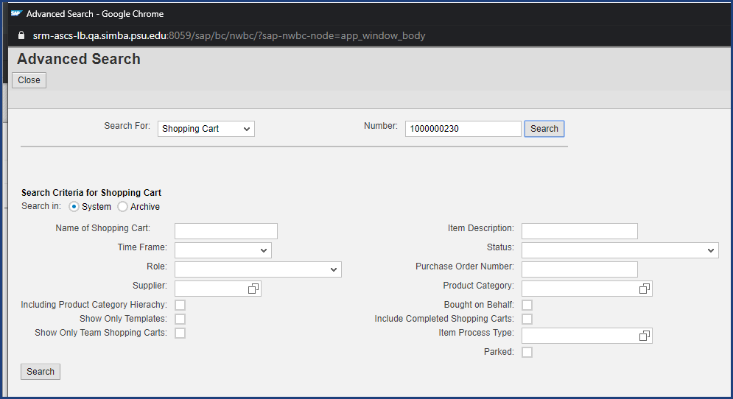

| Step | Action |
| --- | --- |
|  | The Advanced Search options can be combined to search in powerful ways. A range of search criteria, such as Number and Name of the document, can be used to search for various documents, depending on the user's assigned role. Depending on the type of document you want to search (for example, purchase orders), the search parameters change dynamically. For example, if in the Search For field you select Purchase Order, the system only displays parameters related to Purchase Orders. We will now demonstrate the advanced search option for purchase orders for a specific vendor, in a specified timeframe. |

### Advanced Search ‎- Microsoft Edge

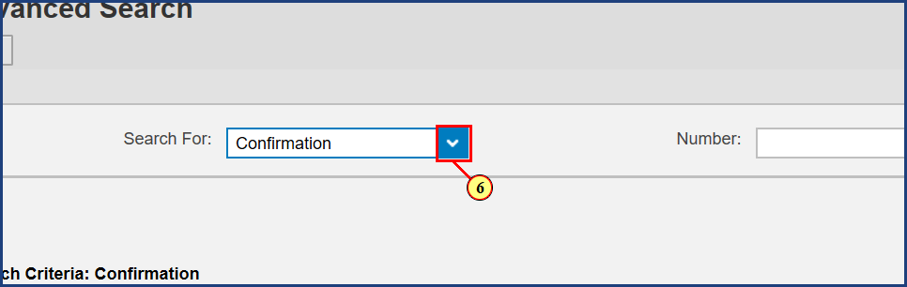

| Step | Action |
| --- | --- |
| 6. | The **Search For** dropdown is clicked. |

### Advanced Search ‎- Microsoft Edge

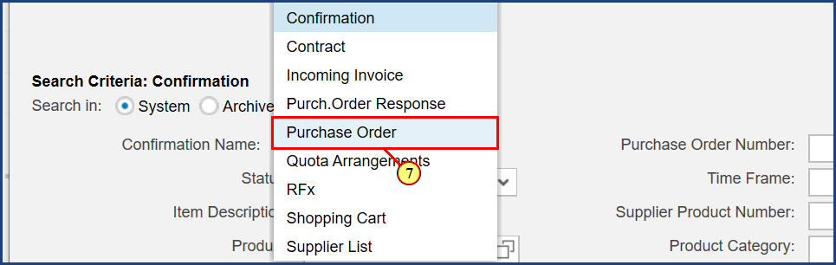

| Step | Action |
| --- | --- |
| 7. | The **Purchase Order** menu item is clicked. |

### Advanced Search ‎- Microsoft Edge

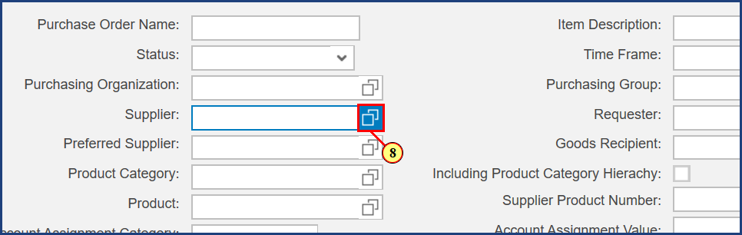

| Step | Action |
| --- | --- |
| 8. | The **Possible Values** button is clicked. |

### Advanced Search ‎- Microsoft Edge

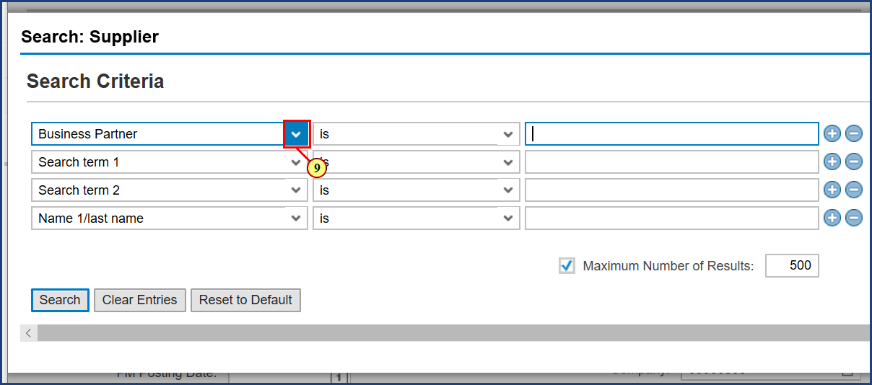

| Step | Action |
| --- | --- |
| 9. | The dropdown is clicked. |

### Advanced Search ‎- Microsoft Edge

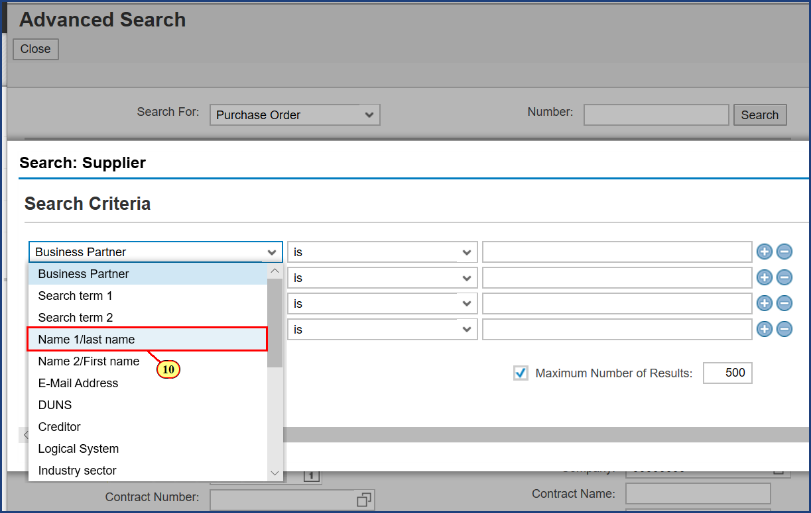

| Step | Action |
| --- | --- |
| 10. | The **Name 1/last name** menu item is clicked. |

### Advanced Search ‎- Microsoft Edge

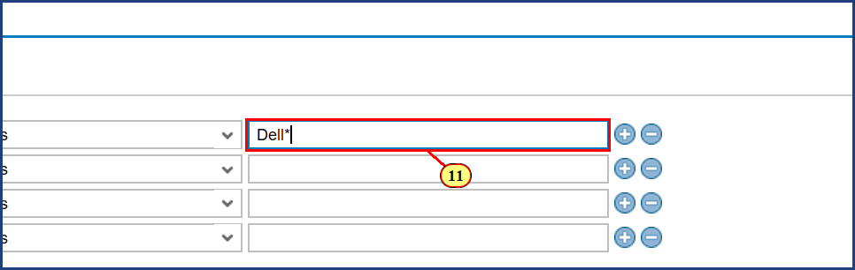

| Step | Action |
| --- | --- |
| 11. | **Dell\*** is typed into the **Name 1/last name** field. |

### Advanced Search ‎- Microsoft Edge

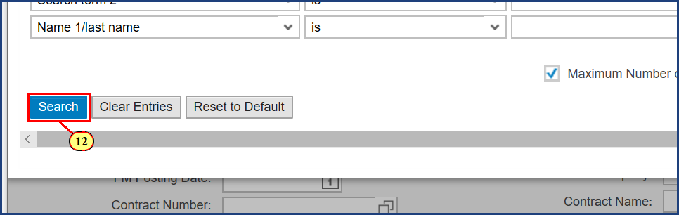

| Step | Action |
| --- | --- |
| 12. | The **Search** button is clicked. |

### Advanced Search ‎- Microsoft Edge

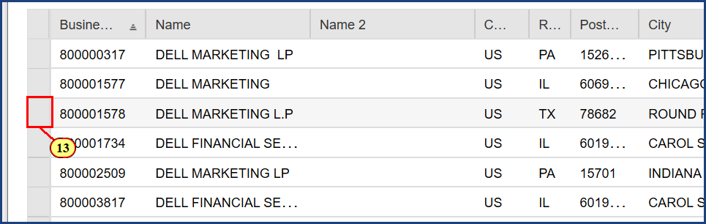

| Step | Action |
| --- | --- |
| 13. | The line selection button is clicked. |

### Advanced Search ‎- Microsoft Edge

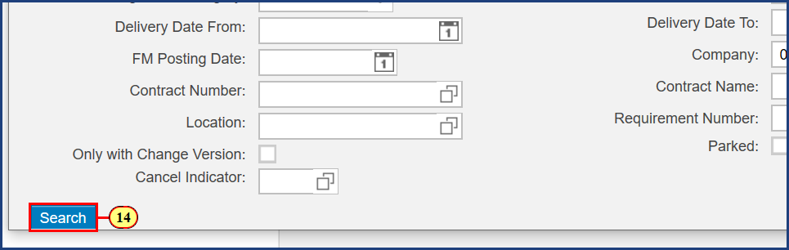

| Step | Action |
| --- | --- |
| 14. | The **Search** button is clicked. |

### Advanced Search ‎- Microsoft Edge

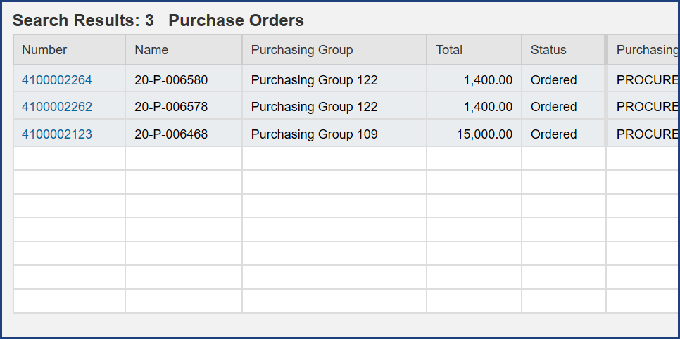

| Step | Action |
| --- | --- |
|  | Search results will display purchase orders for that supplier. |

### Advanced Search ‎- Microsoft Edge

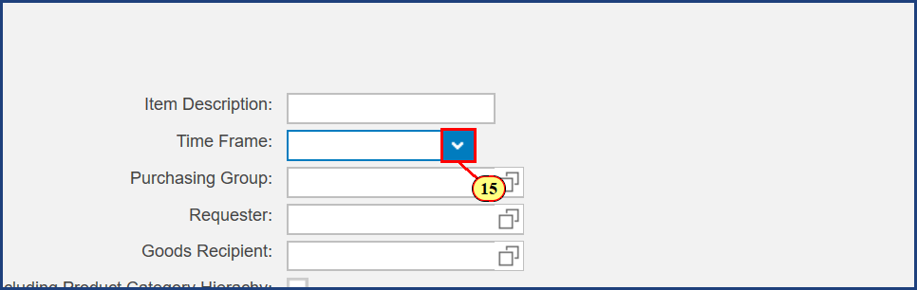

| Step | Action |
| --- | --- |
| 15. | The **Time Frame** dropdown is clicked. |

### Advanced Search ‎- Microsoft Edge

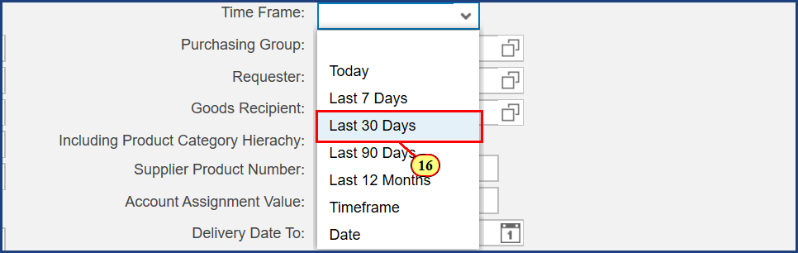

| Step | Action |
| --- | --- |
| 16. | The **Last 30 Days** menu item is clicked. |

### Advanced Search ‎- Microsoft Edge

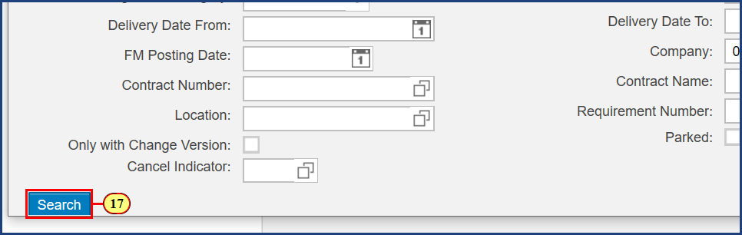

| Step | Action |
| --- | --- |
| 17. | The **Search** button is clicked. |

### Advanced Search ‎- Microsoft Edge

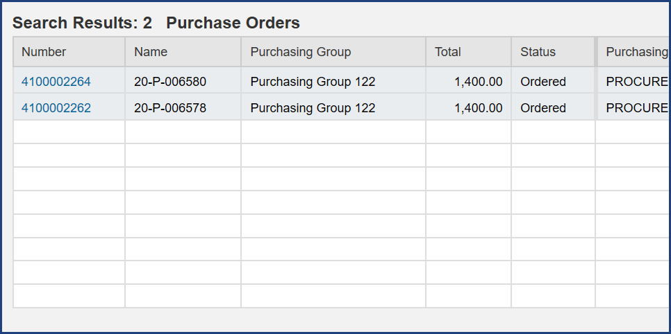

| Step | Action |
| --- | --- |
|  | Search results will display purchase orders within selected time frame. |

**Disclaimer**

**Alternative Format Statement**   
This publication is available in alternative media upon request. 

**Statement of Non-Discrimination**

The University is committed to equal access to programs, facilities, admission, and employment for all persons. It is the policy of the University to maintain an environment free of harassment and free of discrimination against any person because of age, race, color, ancestry, national origin, religion, creed, service in uniformed services (as defined in state and federal law), veteran status, sex, sexual orientation, marital or family status, pregnancy, pregnancy-related conditions, physical or mental disability, gender, perceived gender, gender identity, genetic information, or political ideas. Discriminatory conduct and harassment, as well as sexual misconduct and relationship violence, violates the dignity of individuals, impedes the realization of the University’s educational mission, and will not be tolerated. Direct all inquiries regarding the nondiscrimination policy to Affirmative Action Office, The Pennsylvania State University, 328 Boucke Building, University Park, PA 16802-5901; Email: [aao@psu.edu](mailto:aao@psu.edu); Tel: 814-863-0471.