**The Pennsylvania State University**



**SIMBA Hands-On Guide**

**Export a Report**



© 2020 The Pennsylvania State University  
© Copyright 2020 Labyrinth Solutions, Inc. All rights reserved. Labyrinth Solutions, Inc., the LSI logo, and CampusOneTM are trademarks of Labyrinth Consulting, Inc.   
SAP, R/3, SAP NetWeaver, and other SAP products and services mentioned herein as well as their respective logos are trademarks or registered trademarks of SAP AG in Germany and other countries.   
Business Objects and the Business Objects logo, BusinessObjects, Crystal Reports, Crystal Decisions, Web Intelligence, Xcelsius, and other Business Objects products and services mentioned herein as well as their respective logos are trademarks or registered trademarks of Business Objects S.A. in the United States and in other countries. Business Objects is an SAP company.

# Export a Report

## Description:

You can export Webi reports to Excel, PDF, or CSV.

## Process Steps

### PSU BI LaunchPad QA

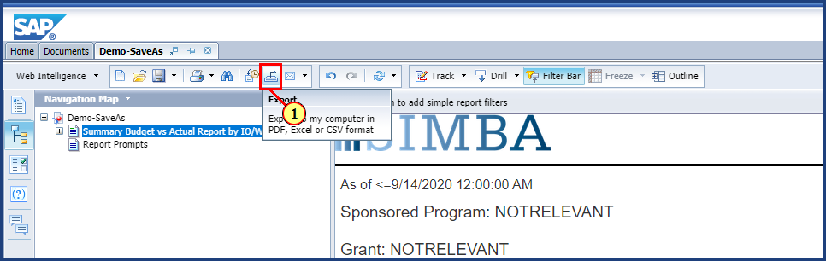

| Step | Action |
| --- | --- |
|  | You can export any Webi report. We'll start by exporting to PDF. The exported PDF will show the report exactly how it is on the screen. |
| 1. | The **Export** button is clicked. |

### PSU BI LaunchPad QA

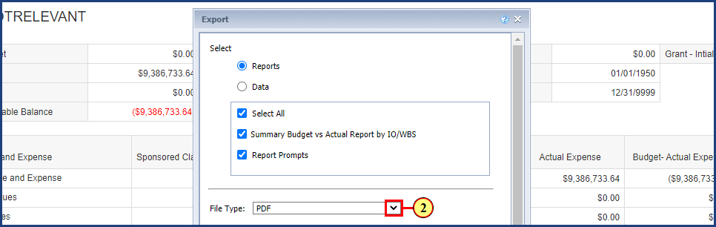

| Step | Action |
| --- | --- |
|  | When you export from Webi, you can select "Reports" or "Data." If you pick Reports, you will be exporting the reports as they are on the screen, including any filters or input controls you have applied. The export can be sent as a PDF or Excel document. If you pick Data, you will be exporting the data from the query. The export will be sent as a CSV file.    If you select to export the Reports, you can choose one or more of the tabs from the report. In this example, we only have two report tabs and will export both tabs. |
| 2. | The **File Type** dropdown is clicked. |

### PSU BI LaunchPad QA

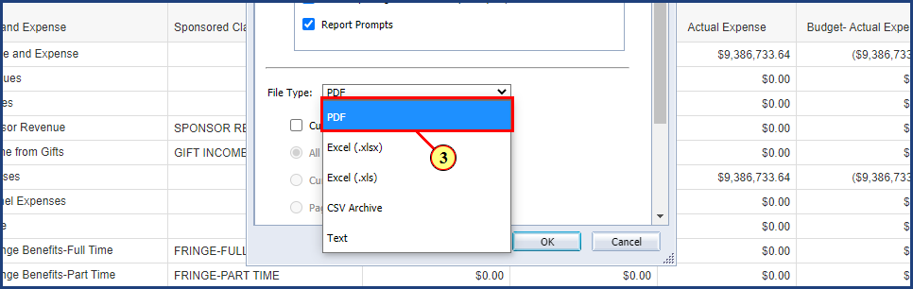

| Step | Action |
| --- | --- |
| 3. | The **PDF** option is clicked. |

### PSU BI LaunchPad QA

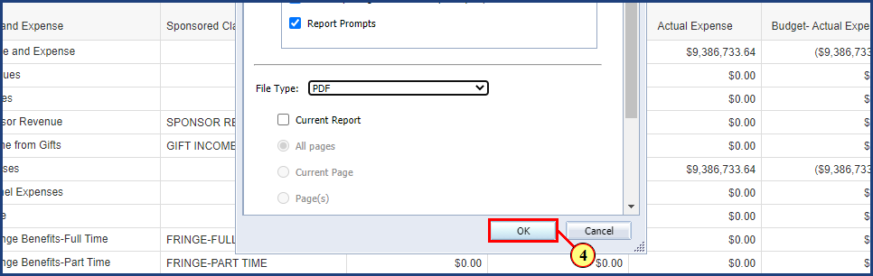

| Step | Action |
| --- | --- |
|  | After you click the OK button in the pop-up window, the PDF will download via your browser's normal download methods. |
| 4. | The **OK** button is clicked. |

### PSU BI LaunchPad QA

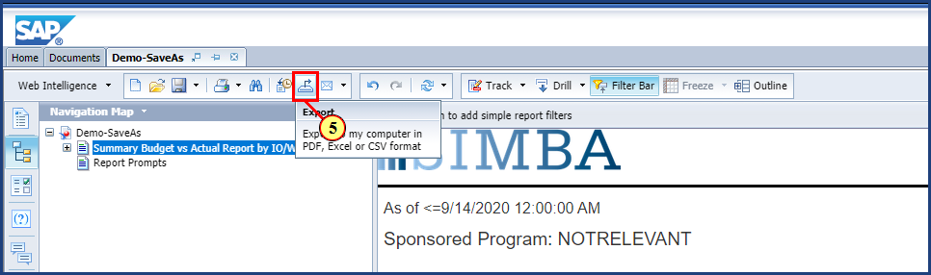

| Step | Action |
| --- | --- |
|  | Next, we will export to Excel. The export to Excel will include all of the information on the screen in the same format you see on the screen. The headers and footers in the report will be excluded. |
| 5. | The **Export**button is clicked. |

### PSU BI LaunchPad QA

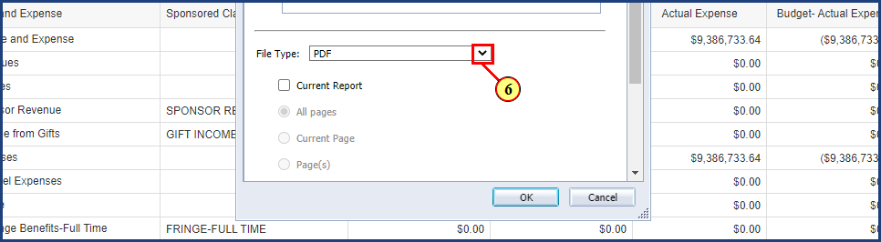

| Step | Action |
| --- | --- |
| 6. | The **File Type** dropdown is clicked. |

### PSU BI LaunchPad QA

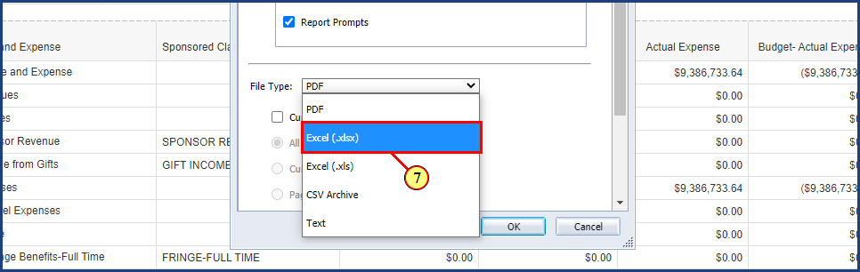

| Step | Action |
| --- | --- |
| 7. | The **Excel (.xlsx)** option is clicked. |

### PSU BI LaunchPad QA

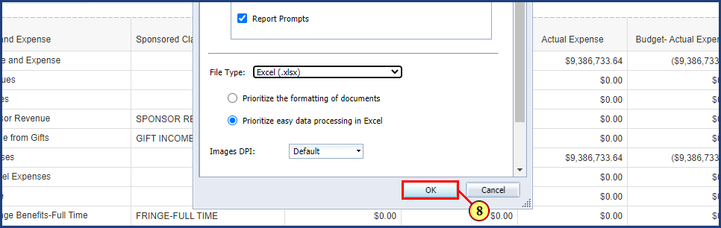

| Step | Action |
| --- | --- |
|  | Just like with the PDF, the Excel file will download via your browser's normal download methods. |
| 8. | The **OK** button is clicked. |

### PSU BI LaunchPad QA

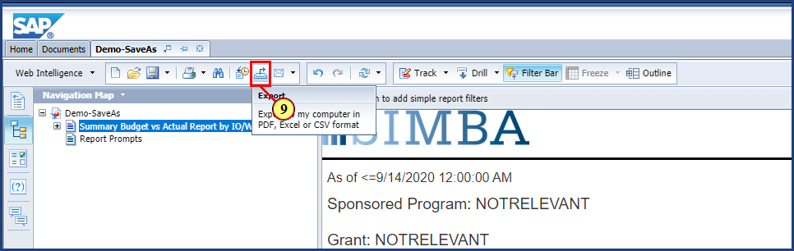

| Step | Action |
| --- | --- |
|  | Next, we will export to CSV. This will provide all of the data from the query, which may be more data than what you are seeing in the Webi report. |
| 9. | The **Export** button is clicked. |

### PSU BI LaunchPad QA

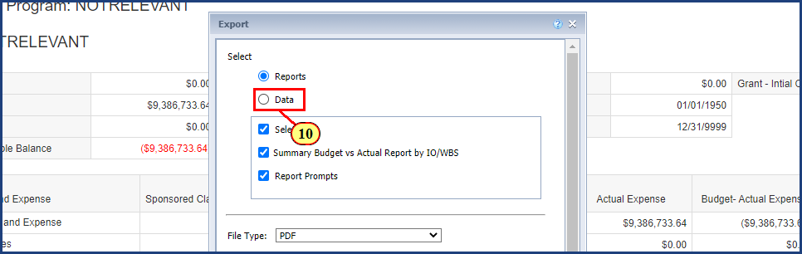

| Step | Action |
| --- | --- |
| 10. | The **Data** button for CSV format is clicked**.** |

### PSU BI LaunchPad QA

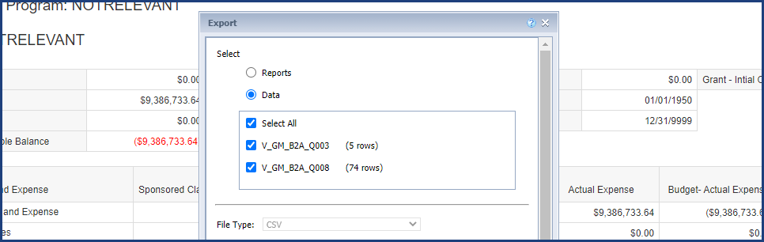

| Step | Action |
| --- | --- |
|  | When you select to export the data, you will see the items in the box change to a technical name, which is the name of the query (or queries) used in the Webi Report. You can adjust the Text qualifier and Column delimiter as needed for your CSV download. |

### PSU BI LaunchPad QA

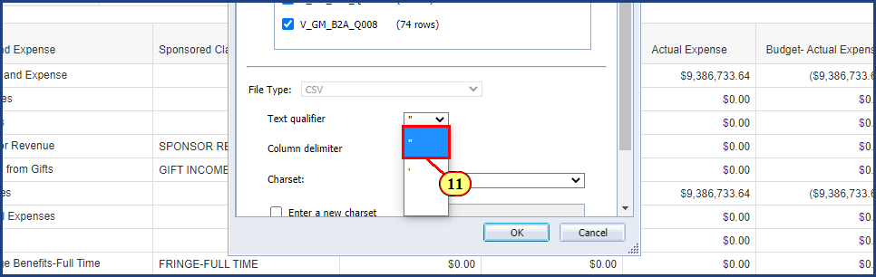

| Step | Action |
| --- | --- |
|  | In this case, we will select the double quotes from the Text qualifier menu. |
| 11. | The **double quotes** optionis clicked in the dropdown. |

### PSU BI LaunchPad QA

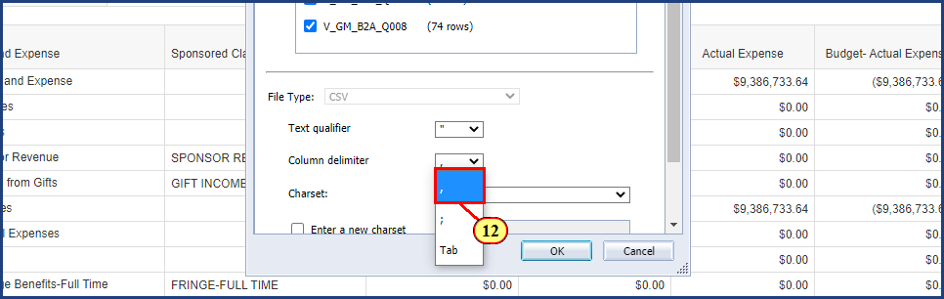

| Step | Action |
| --- | --- |
|  | And we will select the comma from the Column delimiter menu. |
| 12. | The **comma** option is clicked in the dropdown. |

### PSU BI LaunchPad QA

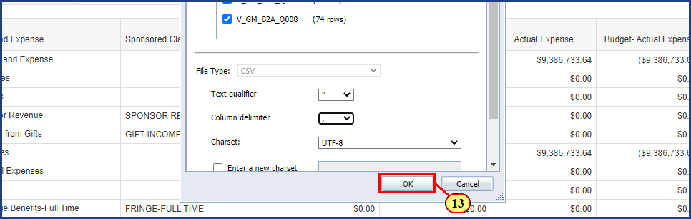

| Step | Action |
| --- | --- |
|  | Just like with the other exports, the CSV will download via your browser's normal download methods. |
| 13. | The **OK** button is clicked. |

### PSU BI LaunchPad QA

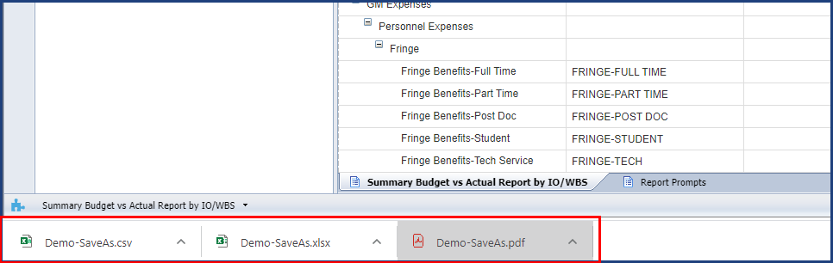

| Step | Action |
| --- | --- |
|  | With our browser, you can see the three exported files at the bottom left of the browser window.    The desired format can be clicked from the list to open the exported document. |

**Disclaimer**

**Alternative Format Statement**   
This publication is available in alternative media upon request. 

**Statement of Non-Discrimination**

The University is committed to equal access to programs, facilities, admission, and employment for all persons. It is the policy of the University to maintain an environment free of harassment and free of discrimination against any person because of age, race, color, ancestry, national origin, religion, creed, service in uniformed services (as defined in state and federal law), veteran status, sex, sexual orientation, marital or family status, pregnancy, pregnancy-related conditions, physical or mental disability, gender, perceived gender, gender identity, genetic information, or political ideas. Discriminatory conduct and harassment, as well as sexual misconduct and relationship violence, violates the dignity of individuals, impedes the realization of the University’s educational mission, and will not be tolerated. Direct all inquiries regarding the nondiscrimination policy to Affirmative Action Office, The Pennsylvania State University, 328 Boucke Building, University Park, PA 16802-5901; Email: [aao@psu.edu](mailto:aao@psu.edu); Tel: 814-863-0471.