**The Pennsylvania State University**



**SIMBA Hands-On Guide**

**PR35_Delivery Address Search**



© 2020 The Pennsylvania State University  
© Copyright 2020 Labyrinth Solutions, Inc. All rights reserved. Labyrinth Solutions, Inc., the LSI logo, and CampusOneTM are trademarks of Labyrinth Consulting, Inc.   
SAP, R/3, SAP NetWeaver, and other SAP products and services mentioned herein as well as their respective logos are trademarks or registered trademarks of SAP AG in Germany and other countries.   
Business Objects and the Business Objects logo, BusinessObjects, Crystal Reports, Crystal Decisions, Web Intelligence, Xcelsius, and other Business Objects products and services mentioned herein as well as their respective logos are trademarks or registered trademarks of Business Objects S.A. in the United States and in other countries. Business Objects is an SAP company.

# PR35_Delivery Address Search

## Overview

**Transaction Description:**

This transaction enables delivery search address capabilities in Shop OnLion.

**Penn State Purpose:**

This transaction describes the process for locating an approved delivery address using the search capabilities and Penn State location code customization in a shopping cart.

## Process Steps

### Shopping Cart - Google Chrome

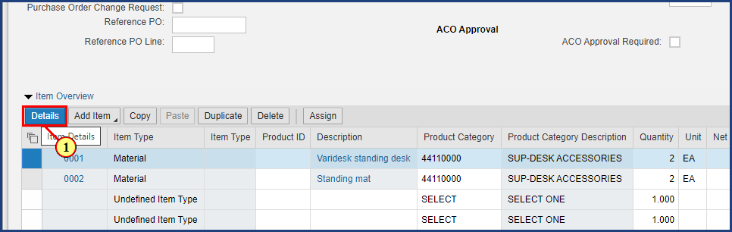

| Step | Action |
| --- | --- |
|  | The Delivery Address fields are located within a shopping cart line item details.  First, select the line item then click the Details button. |
| 1. | The **Details** button is clicked. |

### Shopping Cart - Google Chrome

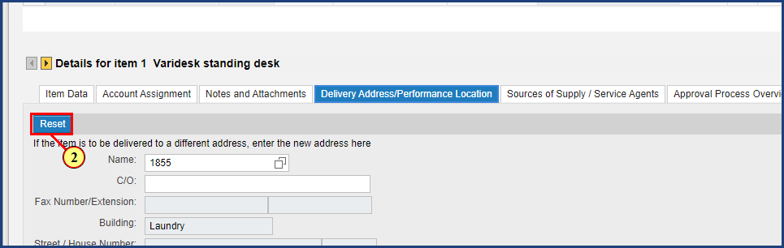

| Step | Action |
| --- | --- |
|  | The shopping cart delivery address will default to the address in your user profile. To select a different address for the supplier to deliver the items on this shopping cart, press Reset to clear your default values. |
| 2. | The **Reset** button is clicked. |

### Shopping Cart - Google Chrome

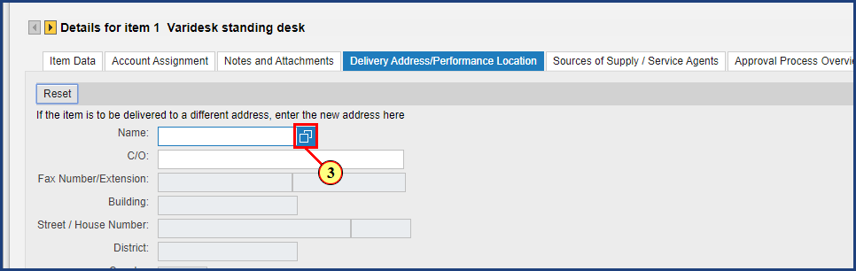

| Step | Action |
| --- | --- |
|  | Use the Possible Values in the Name field to search all delivery addresses. |
| 3. | The **Possible Values** button is clicked for **Name**. |

### Shopping Cart - Google Chrome

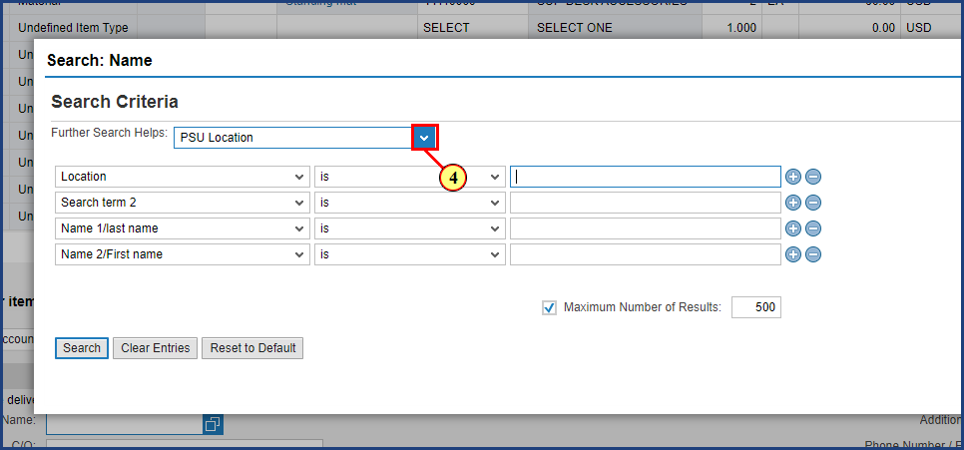

| Step | Action |
| --- | --- |
| 4. | The **Dropdown** button is clicked for **Further Search Helps**. |

### Shopping Cart - Google Chrome

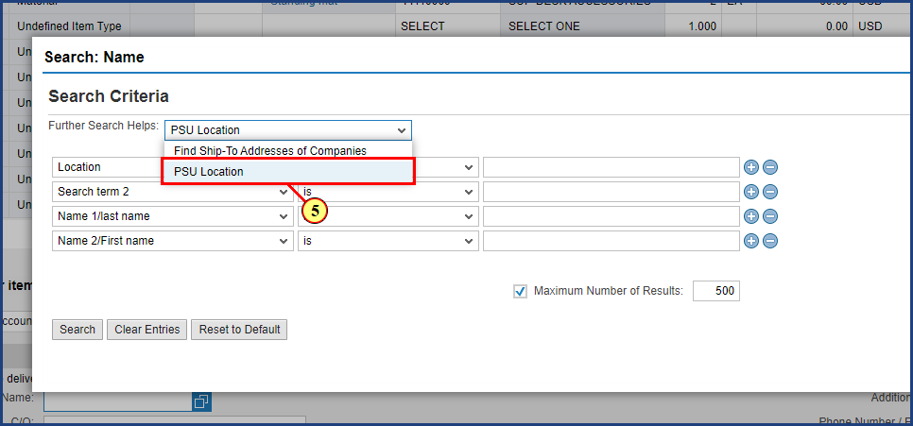

| Step | Action |
| --- | --- |
|  | Select PSU Location to view Penn State-specific delivery address search options. |
| 5. | The **PSU Location** option is clicked. |

### Shopping Cart - Google Chrome

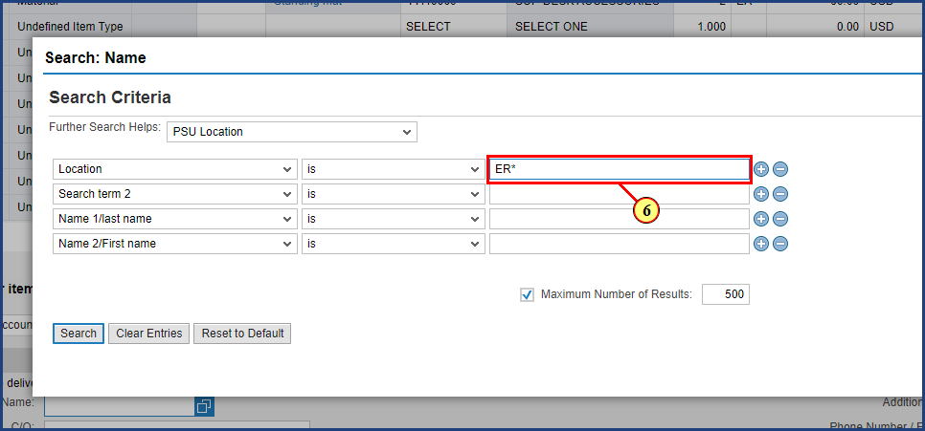

| Step | Action |
| --- | --- |
|  | Use the Location search option to search by campus or location code.  In this example the campus code for Penn State Behrend located in Erie is used with an asterisk (*) to return all location codes. |
| 6. | **ER\*** is typed into the **Location** field. |

### Shopping Cart - Google Chrome

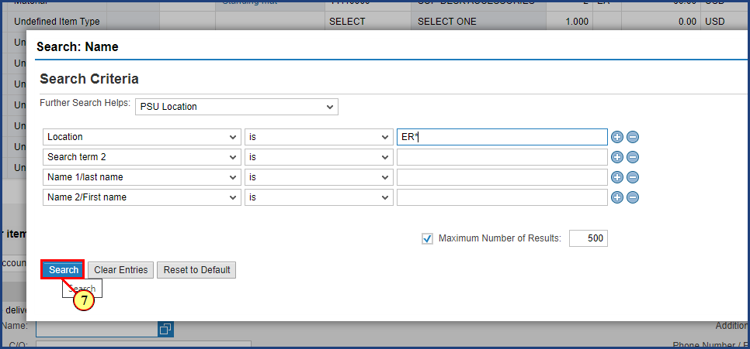

| Step | Action |
| --- | --- |
| 7. | The **Search** button is clicked. |

### Shopping Cart - Google Chrome

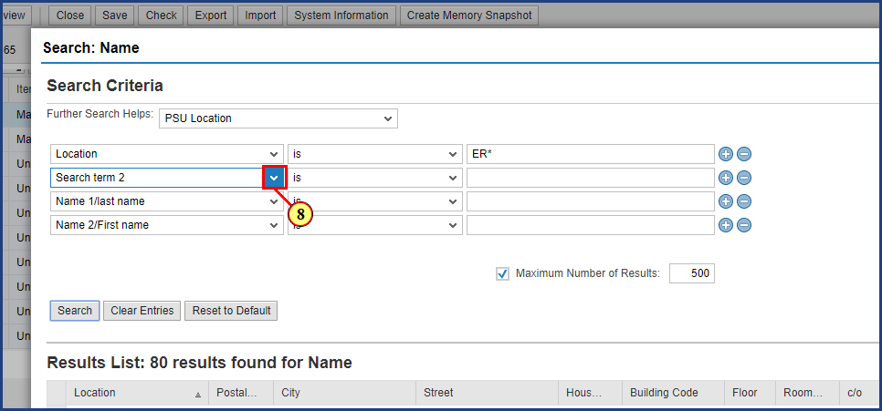

| Step | Action |
| --- | --- |
|  | Results are returned for all Penn State Behrend (Erie) campus delivery addresses.  To further refine these results a second search term is added. |
| 8. | The **Search term 2 dropdown** is clicked. |

### Shopping Cart - Google Chrome

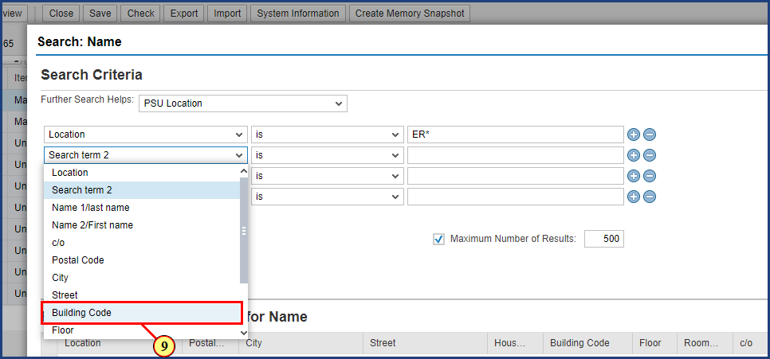

| Step | Action |
| --- | --- |
| 9. | The **Building Code** option is clicked. |

### Shopping Cart - Google Chrome

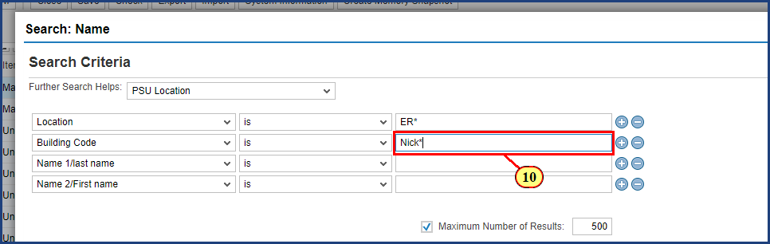

| Step | Action |
| --- | --- |
| 10. | **Nick\*** is typed into the **Building Code** field. |

### Shopping Cart - Google Chrome

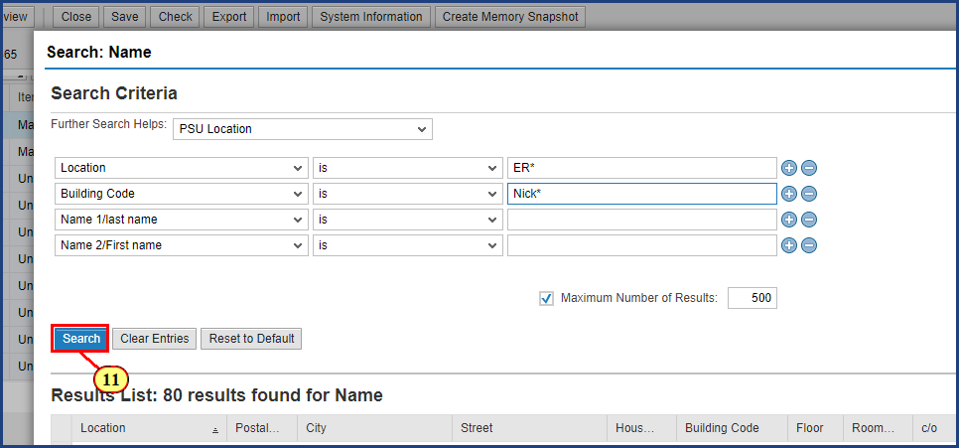

| Step | Action |
| --- | --- |
| 11. | The **Search** button is clicked. |

### Shopping Cart - Google Chrome

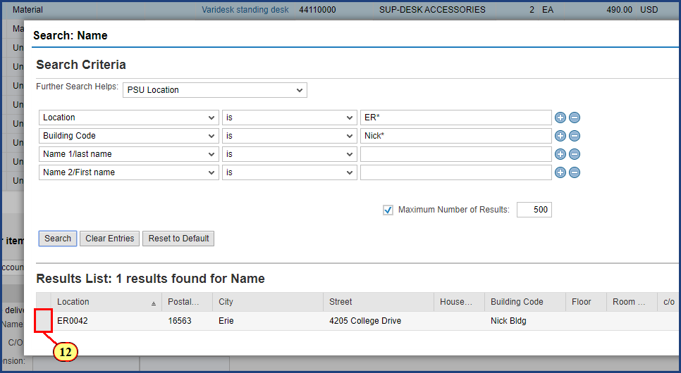

| Step | Action |
| --- | --- |
|  | The delivery address results have been refined down to a single building located on the Behrend campus. |
| 12. | The **Line Item Selection** button is clicked. |

### Shopping Cart - Google Chrome

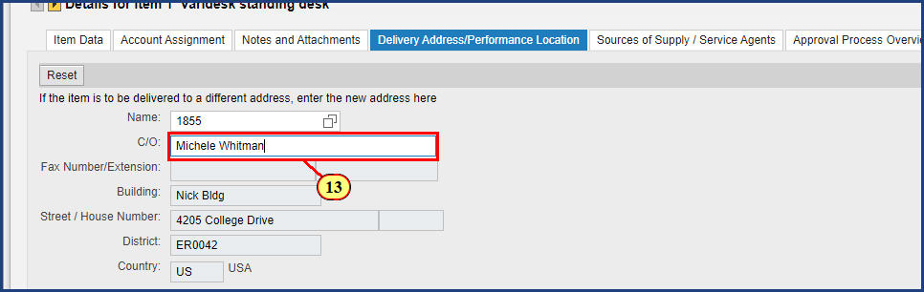

| Step | Action |
| --- | --- |
|  | Address information has been populated and additional details such as a Care Of, Phone Number, Floor and Room number can be added to ensure the supplier delivery is correct. |
| 13. | **Michele Whitman** is typed into the **Care Of** field. |

### Shopping Cart - Google Chrome

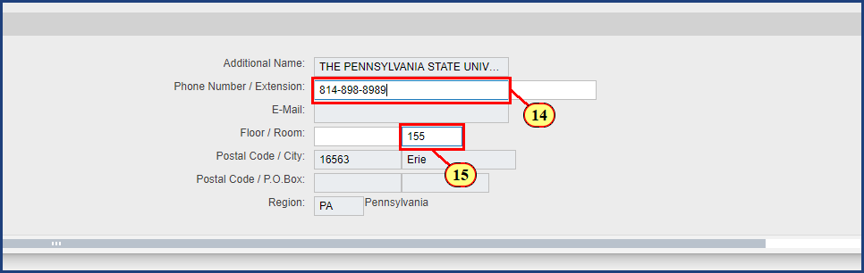

| Step | Action |
| --- | --- |
| 14. | **814-898-8989** is typed into the **Phone Number** field. |
| 15. | **155** is typed into the **Room** field. |

### Shopping Cart - Google Chrome

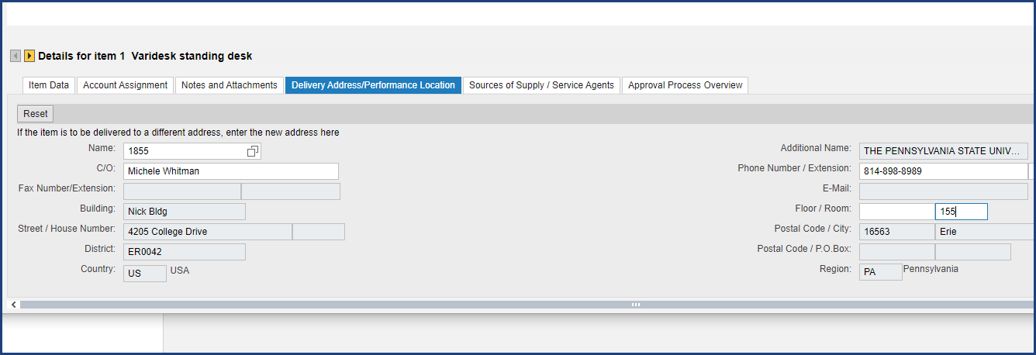

| Step | Action |
| --- | --- |
|  | The Delivery Address information is now complete for line 1 of the shopping cart. |

**Disclaimer**

**Alternative Format Statement**   
This publication is available in alternative media upon request. 

**Statement of Non-Discrimination**

The University is committed to equal access to programs, facilities, admission, and employment for all persons. It is the policy of the University to maintain an environment free of harassment and free of discrimination against any person because of age, race, color, ancestry, national origin, religion, creed, service in uniformed services (as defined in state and federal law), veteran status, sex, sexual orientation, marital or family status, pregnancy, pregnancy-related conditions, physical or mental disability, gender, perceived gender, gender identity, genetic information, or political ideas. Discriminatory conduct and harassment, as well as sexual misconduct and relationship violence, violates the dignity of individuals, impedes the realization of the University’s educational mission, and will not be tolerated. Direct all inquiries regarding the nondiscrimination policy to Affirmative Action Office, The Pennsylvania State University, 328 Boucke Building, University Park, PA 16802-5901; Email: [aao@psu.edu](mailto:aao@psu.edu); Tel: 814-863-0471.