**The Pennsylvania State University**



**SIMBA Hands-On Guide**

**PR12_Create Procurement Substitutions**



© 2020 The Pennsylvania State University  
© Copyright 2020 Labyrinth Solutions, Inc. All rights reserved. Labyrinth Solutions, Inc., the LSI logo, and CampusOneTM are trademarks of Labyrinth Consulting, Inc.   
SAP, R/3, SAP NetWeaver, and other SAP products and services mentioned herein as well as their respective logos are trademarks or registered trademarks of SAP AG in Germany and other countries.   
Business Objects and the Business Objects logo, BusinessObjects, Crystal Reports, Crystal Decisions, Web Intelligence, Xcelsius, and other Business Objects products and services mentioned herein as well as their respective logos are trademarks or registered trademarks of Business Objects S.A. in the United States and in other countries. Business Objects is an SAP company.

# PR12_Create Procurement Substitutions

## Overview

**Transaction Description:**

This transaction uses recommended user settings and personalization for efficient shopping including team cart capabilities.

**Penn State Purpose:**

This transaction allows users to assign procurement substitutes for workflow and to define team shopping access.

## Process Steps

### Home - Google Chrome

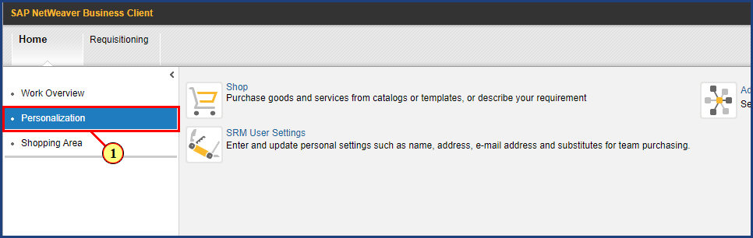

| Step | Action |
| --- | --- |
|  | This demonstration will show two tasks:     1. How to designate a Purchasing Substitute 2. How to create a Team Shopping Cart |
| 1. | The **Personalization** button is clicked. |

### Personalization - Google Chrome

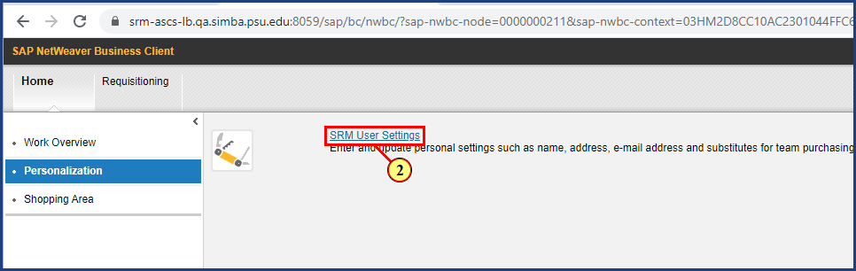

| Step | Action |
| --- | --- |
| 2. | The **SRM User Settings** button is clicked. |

### Personal Settings - Google Chrome

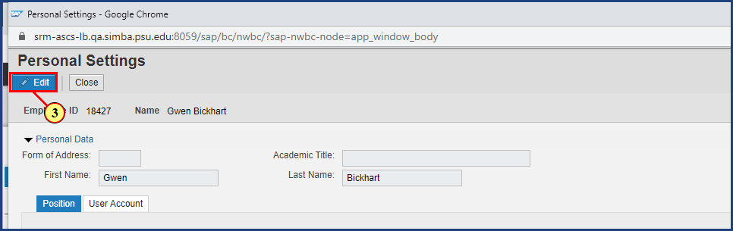

| Step | Action |
| --- | --- |
| 3. | The **Edit** button is clicked. |

### Settings - Google Chrome

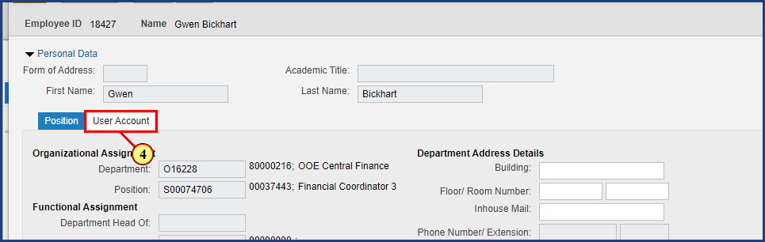

| Step | Action |
| --- | --- |
| 4. | The **User Account** button is clicked. |

### Settings - Google Chrome

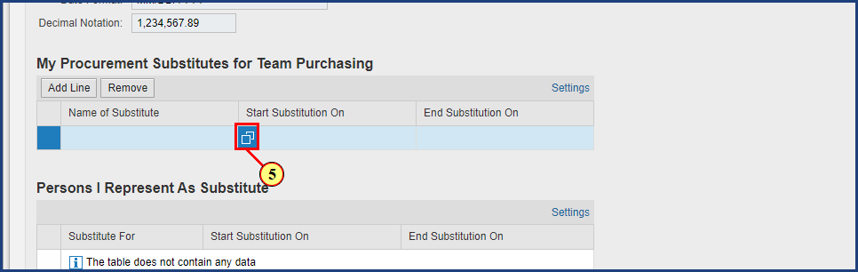

| Step | Action |
| --- | --- |
| 5. | The **Possible Values** button is clicked for **Name of Substitute**. |

### Settings - Google Chrome



| Step | Action |
| --- | --- |
|  | If you know the person's Penn State UserID, you can enter it in the User search field. Otherwise, in the search field next to Last Name, enter a last name and press Search (or Enter). |
| 6. | **Whitman** is typed into the **search** field and **Enter** is pressed. |

### Settings - Google Chrome

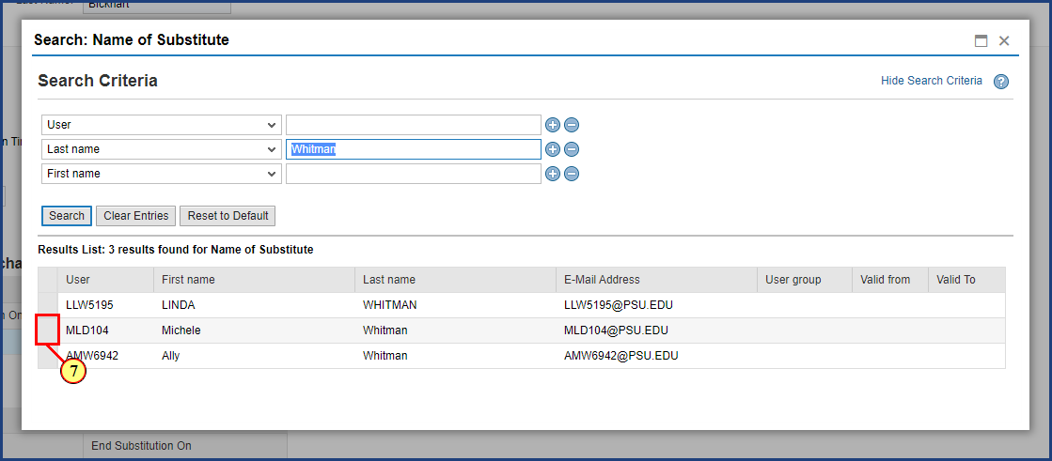

| Step | Action |
| --- | --- |
| 7. | The **line selection** button is clicked. |

### Settings - Google Chrome

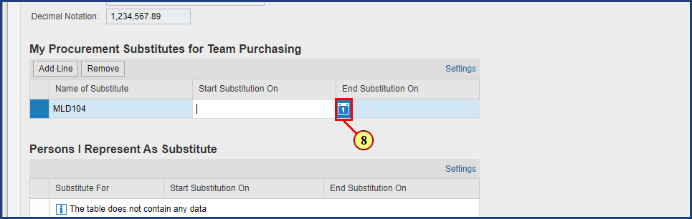

| Step | Action |
| --- | --- |
|  | Substitutions can be used for a short period of time, such as in a vacation or leave situation, or can be entered with longer durations for ongoing teams. |
| 8. | The **Calendar** button is clicked for **Start Substitution On**. |

### Settings - Google Chrome

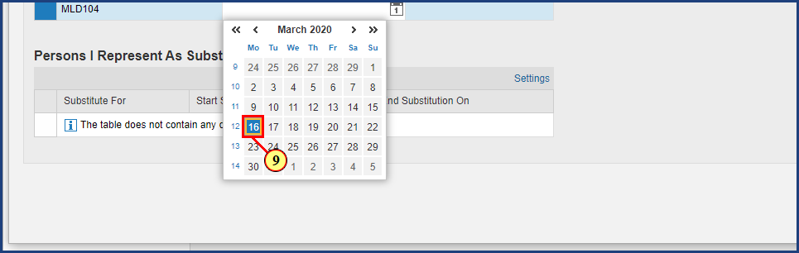

| Step | Action |
| --- | --- |
| 9. | The **Date** button is clicked. |

### Settings - Google Chrome

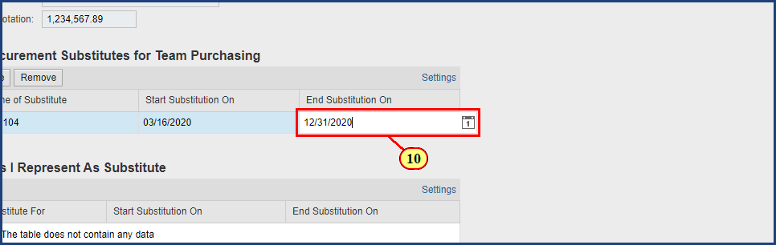

| Step | Action |
| --- | --- |
| 10. | **12/31/2020** is typed into the **End Substitution On** field and **Enter** is pressed. |

### Settings - Google Chrome

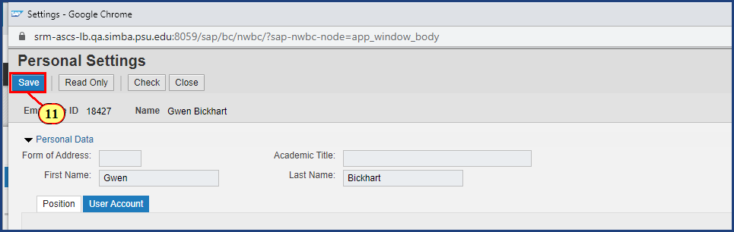

| Step | Action |
| --- | --- |
| 11. | The **Save** button is clicked. |

### Settings - Google Chrome

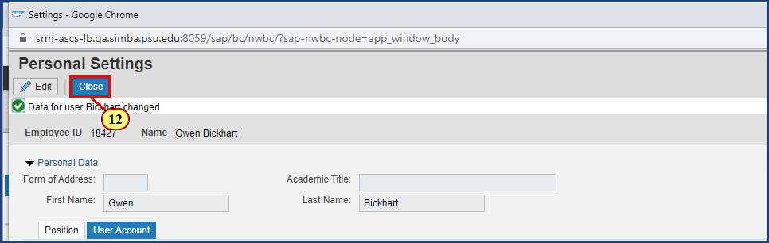

| Step | Action |
| --- | --- |
|  | The green check at the top of the screen indicates data has been changed. |

| Step | Action |
| --- | --- |
|  | **Note**: ARL personnel will be prevented from adding users outside of ARL to their team and will receive an error message when attempting to save the substitute. |
| 12. | The **Close** button is clicked. |

### Personalization - Google Chrome

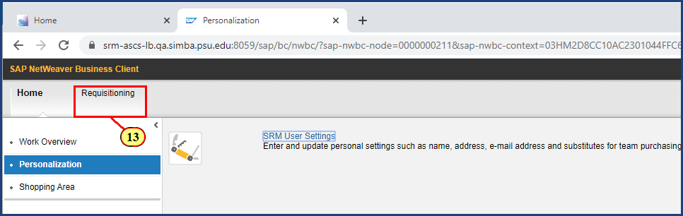

| Step | Action |
| --- | --- |
|  | Now when you create a shopping cart, you will see the option to make it available to your team. |
| 13. | The **Requisitioning** button is clicked. |

### Requisitioning - Google Chrome

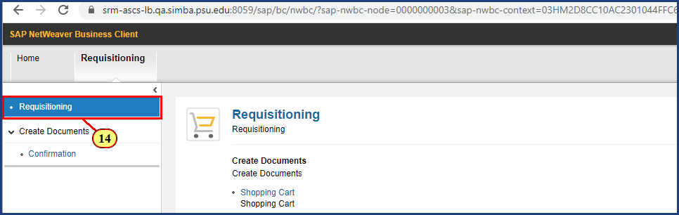

| Step | Action |
| --- | --- |
| 14. | The **Requisitioning** button is clicked. |

### Requisitioning - Google Chrome

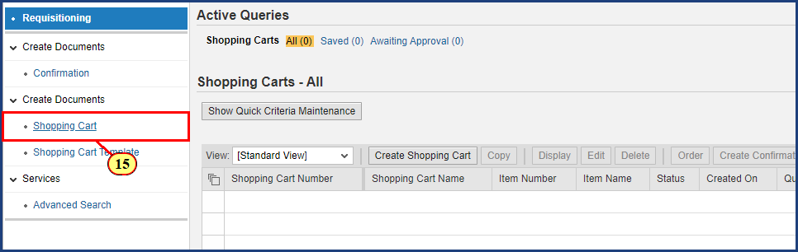

| Step | Action |
| --- | --- |
| 15. | The **Shopping Cart** button is clicked. |

### Create Shopping Cart - Google Chrome

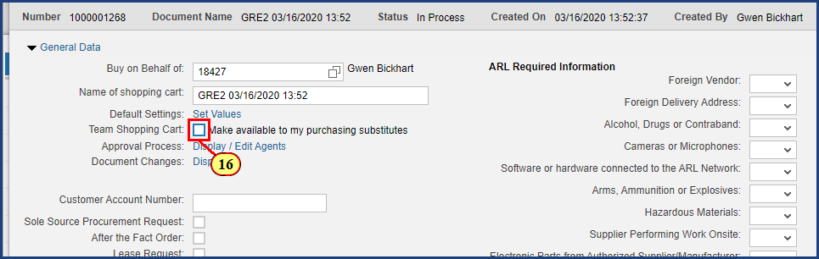

| Step | Action |
| --- | --- |
| 16. | The **Team Shopping Cart** check box is clicked. |

### Create Shopping Cart - Google Chrome

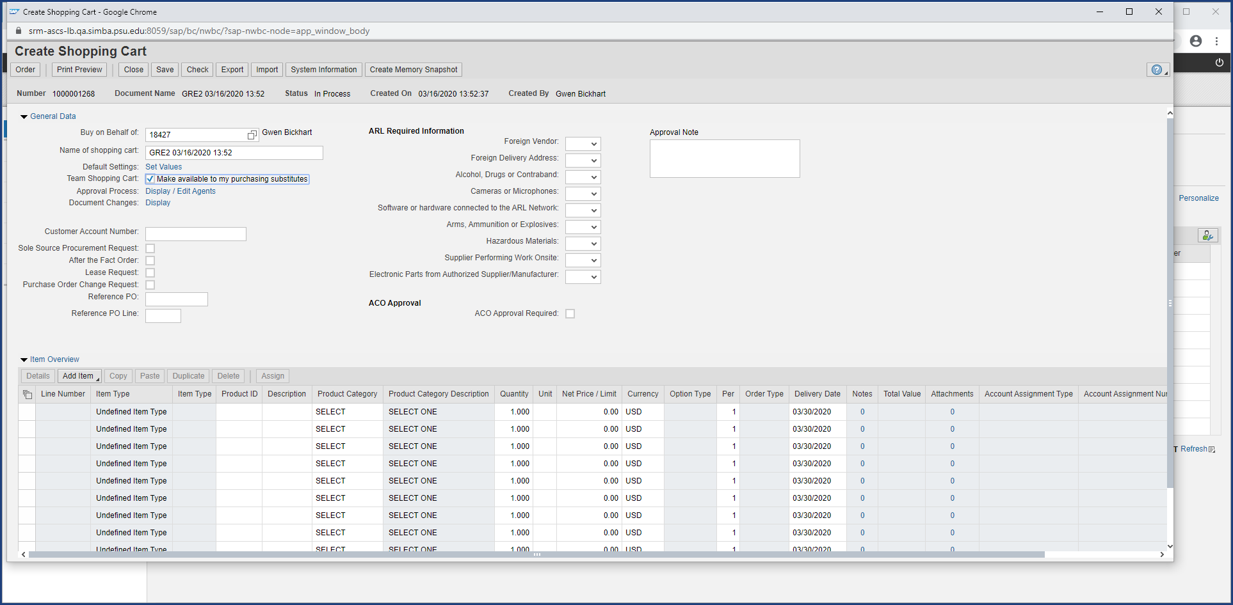

| Step | Action |
| --- | --- |
|  | This shopping cart will now be visible for purchasing substitutes to edit or view. |

**Disclaimer**

**Alternative Format Statement**   
This publication is available in alternative media upon request. 

**Statement of Non-Discrimination**

The University is committed to equal access to programs, facilities, admission, and employment for all persons. It is the policy of the University to maintain an environment free of harassment and free of discrimination against any person because of age, race, color, ancestry, national origin, religion, creed, service in uniformed services (as defined in state and federal law), veteran status, sex, sexual orientation, marital or family status, pregnancy, pregnancy-related conditions, physical or mental disability, gender, perceived gender, gender identity, genetic information, or political ideas. Discriminatory conduct and harassment, as well as sexual misconduct and relationship violence, violates the dignity of individuals, impedes the realization of the University’s educational mission, and will not be tolerated. Direct all inquiries regarding the nondiscrimination policy to Affirmative Action Office, The Pennsylvania State University, 328 Boucke Building, University Park, PA 16802-5901; Email: [aao@psu.edu](mailto:aao@psu.edu); Tel: 814-863-0471.