**The Pennsylvania State University**



**SIMBA Hands-On Guide**

**PR37_Cancel a Goods Confirmation**



© 2020 The Pennsylvania State University  
© Copyright 2020 Labyrinth Solutions, Inc. All rights reserved. Labyrinth Solutions, Inc., the LSI logo, and CampusOneTM are trademarks of Labyrinth Consulting, Inc.   
SAP, R/3, SAP NetWeaver, and other SAP products and services mentioned herein as well as their respective logos are trademarks or registered trademarks of SAP AG in Germany and other countries.   
Business Objects and the Business Objects logo, BusinessObjects, Crystal Reports, Crystal Decisions, Web Intelligence, Xcelsius, and other Business Objects products and services mentioned herein as well as their respective logos are trademarks or registered trademarks of Business Objects S.A. in the United States and in other countries. Business Objects is an SAP company.

# PR37_Cancel a Goods Confirmation

## Overview

**Transaction Description:**

This transaction allows the user to cancel an existing Goods Confirmation against a Purchase Order line item.

**Penn State Purpose:**

This transaction allows users to cancel an existing Goods Confirmation against a Purchase Order line item.

## Process Steps

| Step | Action |
| --- | --- |
|  | **The Four Step Shopping Process**    While shoppers differ in their shopping responsibilities, and the items purchased may vary widely, the shopping process itself remains consistent:     1. Configure Shop OnLion Settings 2. Search for Item Availability 3. Create Shopping Cart (Lion Marketplace, PSU Contracts, or Free Text) 4. Provide Goods Confirmation upon Receiving Goods     If you have not already done so, please complete these simulations:    Step 1   * Personal Settings - Default Delivery Address (to learn how to supply your Shop OnLion settings)   Step 2   * Shopping Cart - Catalog and Contracts Search (to learn how to search for item availability)   Step 3   * Shopping Cart - Standard Lion Marketplace Punch-Out Catalog (to learn the third step in the process) * Shopping Cart - Standard PSU Contracts * Shopping Cart - Standard Free Text   Step 4   * Create Goods Confirmation |

### Home

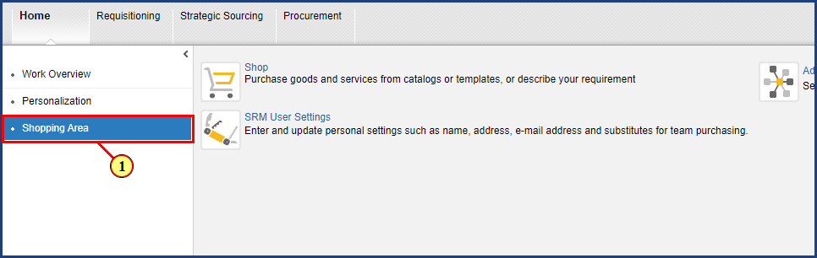

| Step | Action |
| --- | --- |
| 1. | The **Shopping Area** button is clicked. |

### Shopping Area

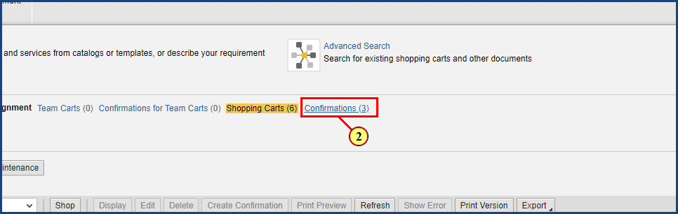

| Step | Action |
| --- | --- |
| 2. | The **Confirmations** button is clicked. |

### Shopping Area

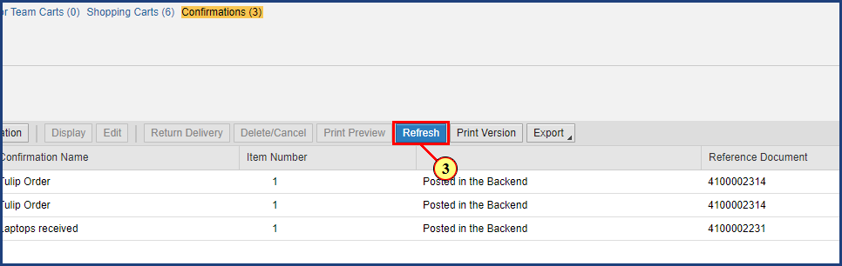

| Step | Action |
| --- | --- |
|  | Be sure to update the Active Queries list to show all Confirmations by clicking on the Refresh button. |
| 3. | The **Refresh** button is clicked. |

### Shopping Area

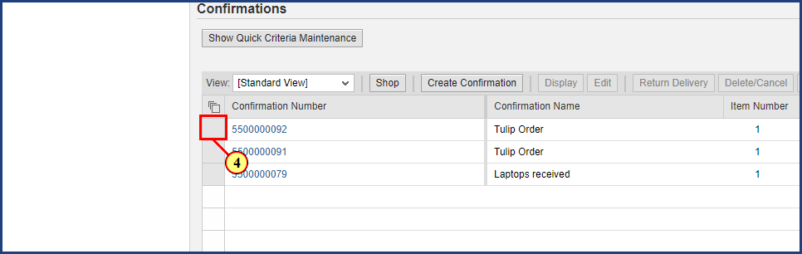

| Step | Action |
| --- | --- |
|  | The line item for the Goods Confirmation to be canceled is selected. |
| 4. | The **line selection** button is clicked. |

### Shopping Area

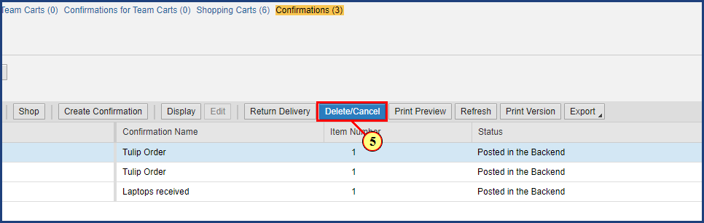

| Step | Action |
| --- | --- |
|  | The Delete/Cancel button is clicked to delete the Goods Confirmation. |
| 5. | The **Delete/Cancel** button is clicked. |

### Shopping Area

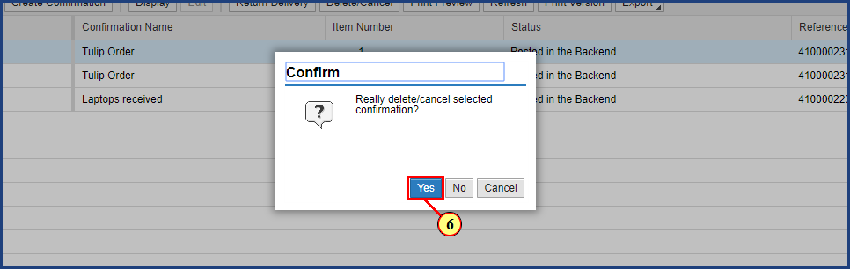

| Step | Action |
| --- | --- |
| 6. | The **Yes** button is clicked. |

### Create Cancellation

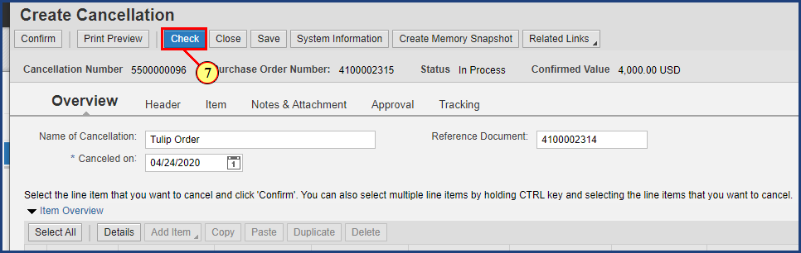

| Step | Action |
| --- | --- |
|  | The Check button is clicked to review the document for errors. |
| 7. | The **Check** button is clicked. |

### Cancellation

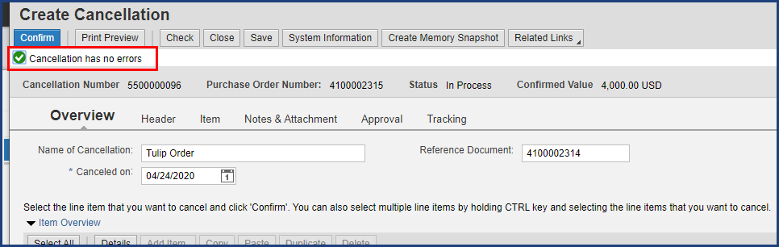

| Step | Action |
| --- | --- |
|  | System Status Bar Confirmation: |

### Cancellation

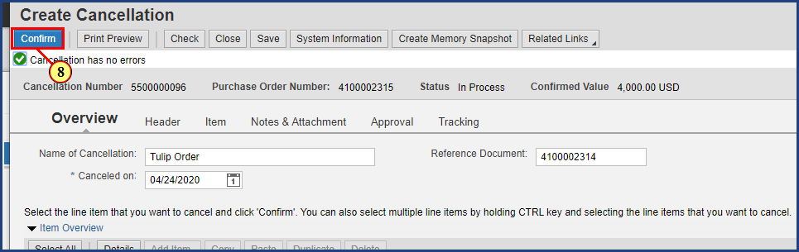

| Step | Action |
| --- | --- |
|  | The Confirm button will be clicked to complete the cancellation. |
| 8. | The **Confirm** button is clicked. |

### Display Cancellation

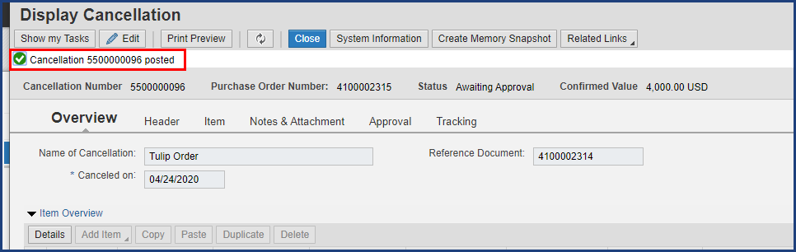

| Step | Action |
| --- | --- |
|  | System Status Bar Confirmation:    Note the green check and new Cancellation number in the message. |

### Display Cancellation

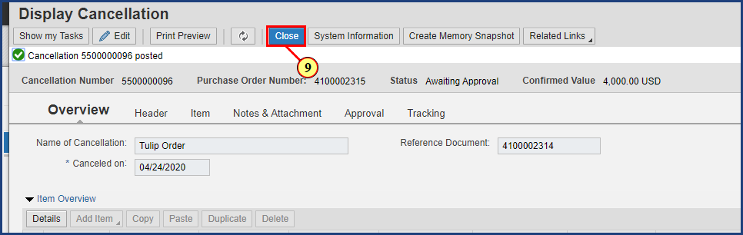

| Step | Action |
| --- | --- |
| 9. | The **Close** button is clicked. |

### Shopping Area

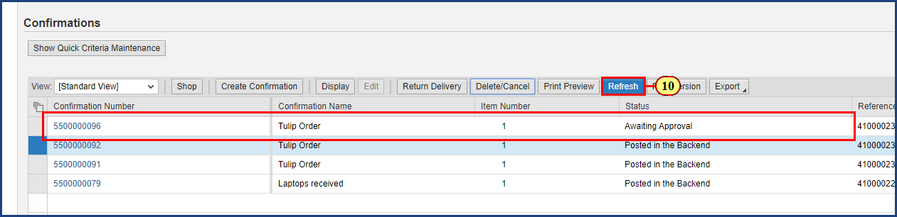

| Step | Action |
| --- | --- |
|  | Back on the Active Queries screen, the Refresh button is clicked to update the list of Confirmations.    Note that the current status for the Confirmation we cancelled says Awaiting Approval. |
| 10. | The **Refresh** button is clicked. |

### Shopping Area

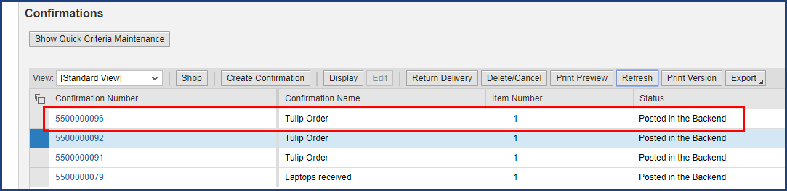

| Step | Action |
| --- | --- |
|  | Note that the new Confirmation cancellation number populates with the status “Posted in the Backend”. |

### Shopping Area

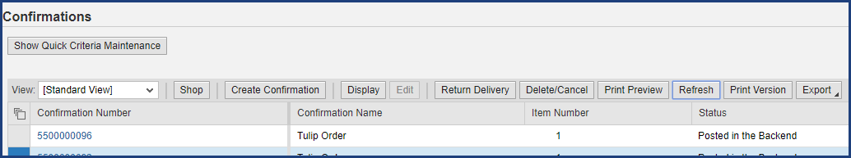

| Step | Action |
| --- | --- |
|  | The process is complete. Please review the four-step shopping process.    **The Four Step Shopping Process**       1. Configure Shop OnLion Settings 2. Search for Item Availability 3. Create Shopping Cart (Lion Marketplace, PSU Contracts, or Free Text) 4. Provide Goods Confirmation upon Receiving Goods       Additional simulations and hands-on-guides are available on the [SIMBA website](https://www.simba.psu.edu). |

**Disclaimer**

**Alternative Format Statement**   
This publication is available in alternative media upon request. 

**Statement of Non-Discrimination**

The University is committed to equal access to programs, facilities, admission, and employment for all persons. It is the policy of the University to maintain an environment free of harassment and free of discrimination against any person because of age, race, color, ancestry, national origin, religion, creed, service in uniformed services (as defined in state and federal law), veteran status, sex, sexual orientation, marital or family status, pregnancy, pregnancy-related conditions, physical or mental disability, gender, perceived gender, gender identity, genetic information, or political ideas. Discriminatory conduct and harassment, as well as sexual misconduct and relationship violence, violates the dignity of individuals, impedes the realization of the University’s educational mission, and will not be tolerated. Direct all inquiries regarding the nondiscrimination policy to Affirmative Action Office, The Pennsylvania State University, 328 Boucke Building, University Park, PA 16802-5901; Email: [aao@psu.edu](mailto:aao@psu.edu); Tel: 814-863-0471.